Supplemental Material

Comorbidities and Mortality Risk in Adults Younger than 50 years of age with Chronic Obstructive Pulmonary Disease

Authors:
Miguel J. Divo, MD MPH, José M. Marin, MD, Ciro Casanova Macario, MD, Carlos Cabrera Lopez, MD, Victor M. Pinto-Plata, MD, Marta Marin-Oto, MD, Francesca Polverino, MD PhD, Juan P. de-Torres, MD, Dean Billheimer, PhD, and Bartolome R. Celli, MD.
The BODE Collaborative group

Content:

Figures:

- e-Figure 1. Comorbidities prevalence bar graph comparing Young (≤ 50 years) and Old COPD (> 50 years) patients.
- e-Figure 2. Primary causes of death in the Young and Old COPD patients.

Tables:

- e-Table 1. Comorbidities prevalence comparison between Young COPD and controls.
- e-Table 2. Comorbidities prevalence comparing Young COPD and Old COPD.

e-Figure 1. Comorbidities prevalence bar graph comparing Young ( <50 years) and older (>50 years) COPD patients.

The bar graph includes those comorbidities with at least 2% prevalence; for a full list refer to e-Table 2.
Footnote: Abbreviations: AAA= Abdominal Aortic Aneurism, BPH= Benign Prostatic Hypertrophy, CA= Cancer, CAD = Coronary Artery Disease, CHF=Congestive Heart Failure, CRF=Chronic Renal Failure, CTD= Connective Tissue Disorders, CVA=Cerebro-Vascular Accident, DJD= Degenerative joint Disease, DVT= Deep Venous Thrombosis, GERD=Gastro-Esophageal Reflux Disease, OSA= Obstructive Sleep Apnea, PAD= peripheral artery disease, PH= Pulmonary Hypertension.
Substance use disorder comprise alcohol, hallucinogens, stimulants, sedatives and/or opioids use

e-Figure 2. Kaplan-Meier survival curve comparing the three groups. In blue is the control group, red for “Young COPD” and green for the older COPD.

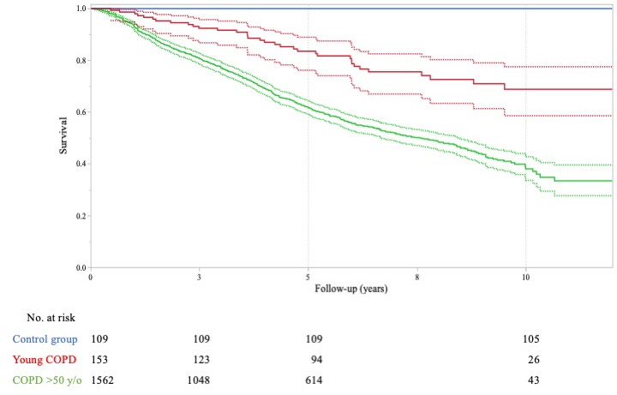

The solid line represents the survival curve, dotted lines represent the 95% confidence interval.
Vital status is missing in 16 controls, 7 “Young COPD”, and 294 older COPD.
The six recorded death in the control group occurred after 16 years of observation.

e-Figure 3. Primary causes of death in the Young (< 50 years) and “Older” COPD patients (>50 years).

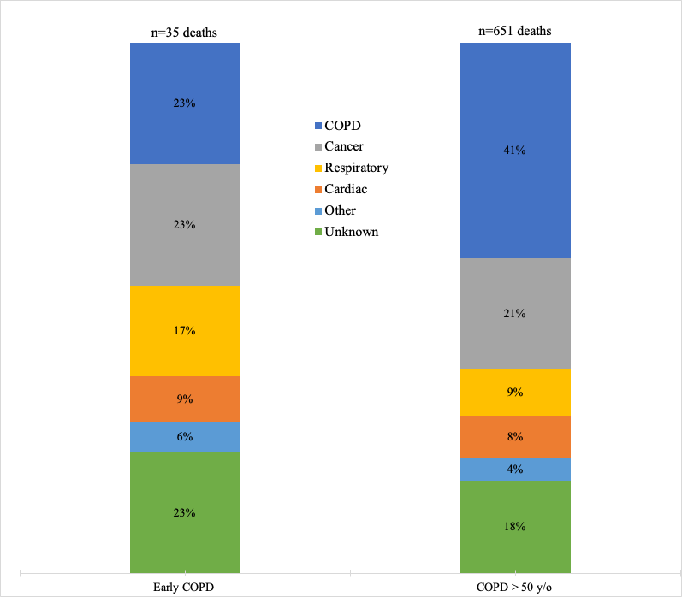
Young COPD
E-Table 1. List of comorbidities with at least 1% prevalence, comparing Young COPD with Controls.

Comorbidity | Young COPD | Controls | Prob>ChiSq
Hyperlipidemia* | 25% | 10% | 0.0457
Hypertension* | 24% | 7% | 0.0259
DJD* | 18% | 2% | 0.0302
Substance use disorder* | 17% | 0% | 0.0005
Depression* | 15% | 5% | 0.0325
GERD | 14% | 3% | 0.0653
CAD | 13% | 2% | 0.307
Anxiety | 9% | 6% | 0.4784
Diabetes Mellitus | 9% | 5% | 0.2015
Hepatitis* | 9% | 0% | 0.0046
BPH | 7% | 2% | 0.3097
Bipolar disorder* | 6% | 0% | 0.0187
CRF* | 6% | 0% | 0.0013
OSA | 6% | 3% | 0.2682
Gastro-Duodenal ulcers | 5% | 1% | 0.5332
Lung cancer | 4% | 0% | 0.219
Tuberculosis* | 4% | 1% | 0.0439
Erectile dysfunction | 3% | 0% | 0.1597
Prostate cancer | 3% | 2% | 0.4314
Nephrolithiasis | 3% | 2% | 0.6443
Osteoporosis* | 3% | 0% | 0.0336
Venous insufficiency | 3% | 2% | 0.3536
Cervical cancer | 3% | 0% | 0.1519
Asthma§ | 3% | 7% | 0.0764
Bronchiectasis | 3% | 1% | 0.2291
Cataract | 3% | 0% | 0.2688
CVA | 3% | 0% | 0.2228
DVT | 3% | 0% | 0.1567
Gout* | 3% | 0% | 0.0417
Hypothyroidism | 3% | 1% | 0.2291
Liver cirrhosis | 3% | 1% | 0.2291
PAD | 3% | 1% | 0.2291
Gallbladder disease | 2% | 1% | 0.3945
Pulmonary Hypertension | 2% | 0% | 0.0556
Pulmonary fibrosis | 2% | 1% | 0.3945
Mitral Valvulopathy | 2% | 0% | 0.0775
CHF | 1% | 0% | 0.1185
CTD | 1% | 5% | 0.0847
DM with Neuropathy | 1% | 0% | 0.1185
Glaucoma | 1% | 0% | 0.1185
Pancreatitis | 1% | 1% | 0.6677
RLS | 1% | 0% | 0.1185
Seizure | 1% | 0% | 0.1185
Ventricular arrhythmias | 1% | 0% | 0.1185
Atrial Fibrillation | 1% | 1% | 0.8971
Bladder cancer | 1% | 1% | 0.8971
Bronchiolitis | 1% | 0% | 0.2703
Dementia | 1% | 0% | 0.2703
Head & Neck cancer | 1% | 1% | 0.8971
HIV | 1% | 0% | 0.2703
Kidney cancer | 1% | 0% | 0.2703
Macular degeneration | 1% | 0% | 0.2703
MAI | 1% | 0% | 0.2703
Pancreatic cancer | 1% | 0% | 0.2703
Pulmonary embolism | 1% | 0% | 0.2703
Celiac disease | 0% | 1% | 0.2086
Colon cancer | 0% | 1% | 0.2086
Thyroid Cancer | 0% | 2% | 0.0749

The asterisk (*) denote those diseases with a statistically significant difference based on the logistic regression, testing the hypothesis that differences in prevalence are due group membership when adjusting for age, gender and cumulative smoking.
§ In the COPD groups, asthma diagnosis was accounted for those participants recruited after 2010, as it was an exclusion criterion in the initial BODE cohort protocol.

Abbreviations: AAA= Abdominal Aortic Aneurism, BPH= Benign Prostatic Hypertrophy, CA= Cancer, CAD = Coronary Artery Disease, CHF=Congestive Heart Failure, CRF=Chronic Renal Failure, CTD= Connective Tissue Disorders, CVA=Cerebro-Vascular Accident, DJD= Degenerative joint Disease, DVT= Deep Venous Thrombosis, GERD=Gastro-Esophageal Reflux Disease, MAI= Mycobacterium Avium-Intracellulare, OSA= Obstructive Sleep Apnea, PAD= peripheral artery disease, PH= Pulmonary Hypertension, RLD= Restless Leg Syndrome.
E-Table 2. List of comorbidities with at least 1% prevalence, comparing Young with Old COPD patients.

Comorbidity | Old COPD  (>50 years) | Young COPD  (≤ 50 years) | p-value
Hypertension* | 53% | 24% | <0.0001
Hyperlipidemia* | 43% | 25% | <0.0001
BPH* | 30% | 7% | <0.0001
CAD* | 27% | 13% | 0.0007
DJD | 27% | 18% | 0.1103
Diabetes Mellitus* | 21% | 9% | 0.0043
PAD* | 16% | 3% | <0.0001
CHF* | 15% | 1% | 0.0011
CRF* | 15% | 6% | 0.0032
Depression | 15% | 15% | 0.9888
GERD | 15% | 14% | 0.6995
Atrial Fibrillation* | 13% | 1% | <0.0001
Anxiety | 12% | 9% | 0.2742
CVA* | 11% | 3% | 0.0019
Gastro-Duodenal ulcers | 11% | 5% | 0.0815
Substance use disorder | 11% | 17% | 0.3185
Erectile dysfunction* | 10% | 3% | 0.0008
Cataract | 9% | 3% | 0.0590
OSA | 9% | 6% | 0.3487
Pulmonary hypertension* | 9% | 2% | 0.0342
Lung cancer | 8% | 4% | 0.2246
Osteoporosis* | 8% | 3% | 0.0333
Prostate cancer | 8% | 3% | 0.3525
Bipolar disorder | 7% | 6% | 0.6706
Breast cancer | 7% | 0% | 0.2865
Hypothyroidism* | 7% | 3% | 0.0480
AAA* | 6% | 0% | <0.0001
DVT13 | 5% | 3% | 0.2107
Pulmonary fibrosis | 5% | 2% | 0.4513
Ventricular arrhythmias | 5% | 1% | 0.7761
Gallbladder disease | 4% | 2% | 0.1276
Glaucoma* | 4% | 1% | 0.0186
Gout | 4% | 3% | 0.5132
Tuberculosis | 4% | 4% | 0.9112
Venous insufficiency | 4% | 3% | 0.7123
Aortic Valvulopathy* | 3% | 0% | 0.0044
Bladder cancer | 3% | 1% | 0.0524
DM w/ Neuropathy | 3% | 1% | 0.1252
Hepatitis§ | 3% | 9% | 0.0015
Nephrolithiasis | 3% | 3% | 0.8563
Asbestosis* | 2% | 0% | 0.0258
Asthma | 2% | 3% | 0.4301
Bronchiectasis | 2% | 3% | 0.5236
Colon cancer* | 2% | 0% | 0.0245
CTD | 2% | 1% | 0.381
Dementia | 2% | 1% | 0.125
Head & Neck cancer | 2% | 1% | 0.2365
Liver cirrhosis | 2% | 3% | 0.6538
Mitral V | 2% | 2% | 0.7071
Pancreatitis | 2% | 1% | 0.7548
Pulmonary embolism | 2% | 1% | 0.2055
Seizure | 2% | 1% | 0.4994
Alzheimer | 1% | 0% | 0.1908
Hyperthyroidism | 1% | 0% | 0.1264
Hypogonadism | 1% | 0% | 0.1414
IBD | 1% | 0% | 0.1399
Kidney cancer | 1% | 1% | 0.8417
Leukemia | 1% | 0% | 0.1399
Macular degeneration | 1% | 1% | 0.5746
MAI | 1% | 1% | 0.9047
Melanoma | 1% | 0% | 0.0774
Parkinson | 1% | 0% | 0.1264
RLS | 1% | 1% | 0.6786
Sarcoidosis | 1% | 0% | 0.1718
Broncholitis | 0% | 1% | 0.226
Cervical cancer | 0% | 3% | 0.0506
HIV | 0% | 1% | 0.5595
Pancreatic cancer | 0% | 1% | 0.5369

The asterisk (*) denote those diseases where the prevalence is significantly higher in the older COPD. The (§) denote those diseases where the prevalence is significantly higher in the Young COPD.

Abbreviations: AAA= Abdominal Aortic Aneurism, BPH= Benign Prostatic Hypertrophy, CA= Cancer, CAD = Coronary Artery Disease, CHF=Congestive Heart Failure, CRF=Chronic Renal Failure, CTD= Connective Tissue Disorders, CVA=Cerebro-Vascular Accident, DJD= Degenerative joint Disease, DVT= Deep Venous Thrombosis, GERD=Gastro-Esophageal Reflux Disease, IBD=Inflammatory Bowel Disease, MAI= Mycobacterium Avium-Intracellulare, OSA= Obstructive Sleep Apnea, PAD= peripheral artery disease, PH= Pulmonary Hypertension, RLD= Restless Leg Syndrome.

