Additional file 1
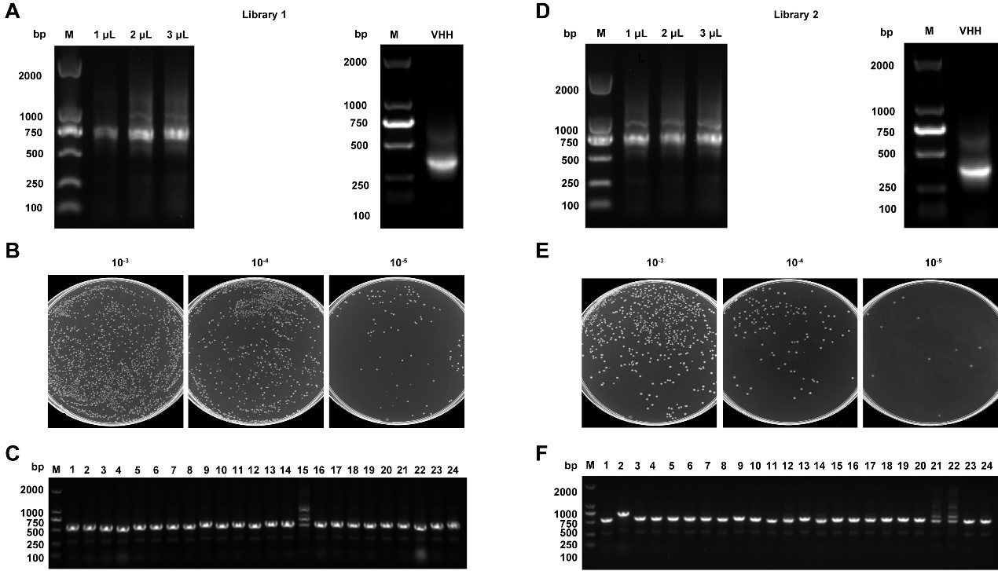
Fig. S1 Construction of the IL-5-specific Nbs library. A The VHH gene fragments were amplified by a first PCR with an event band of 700 bp (left) and a second, nested PCR with an event band of 400 bp (right). B The capacity of library 1 was estimated by counting colony numbers. C The insertion rate of the library 1 was determined by performing PCR on randomly selected 24 colonies. D-F The VHH amplification (D), the capacity (E) and the insertion rate (F) of library 2. The cropping gels of nest-PCR products and library insertion rates were displayed.

