Additional file 3
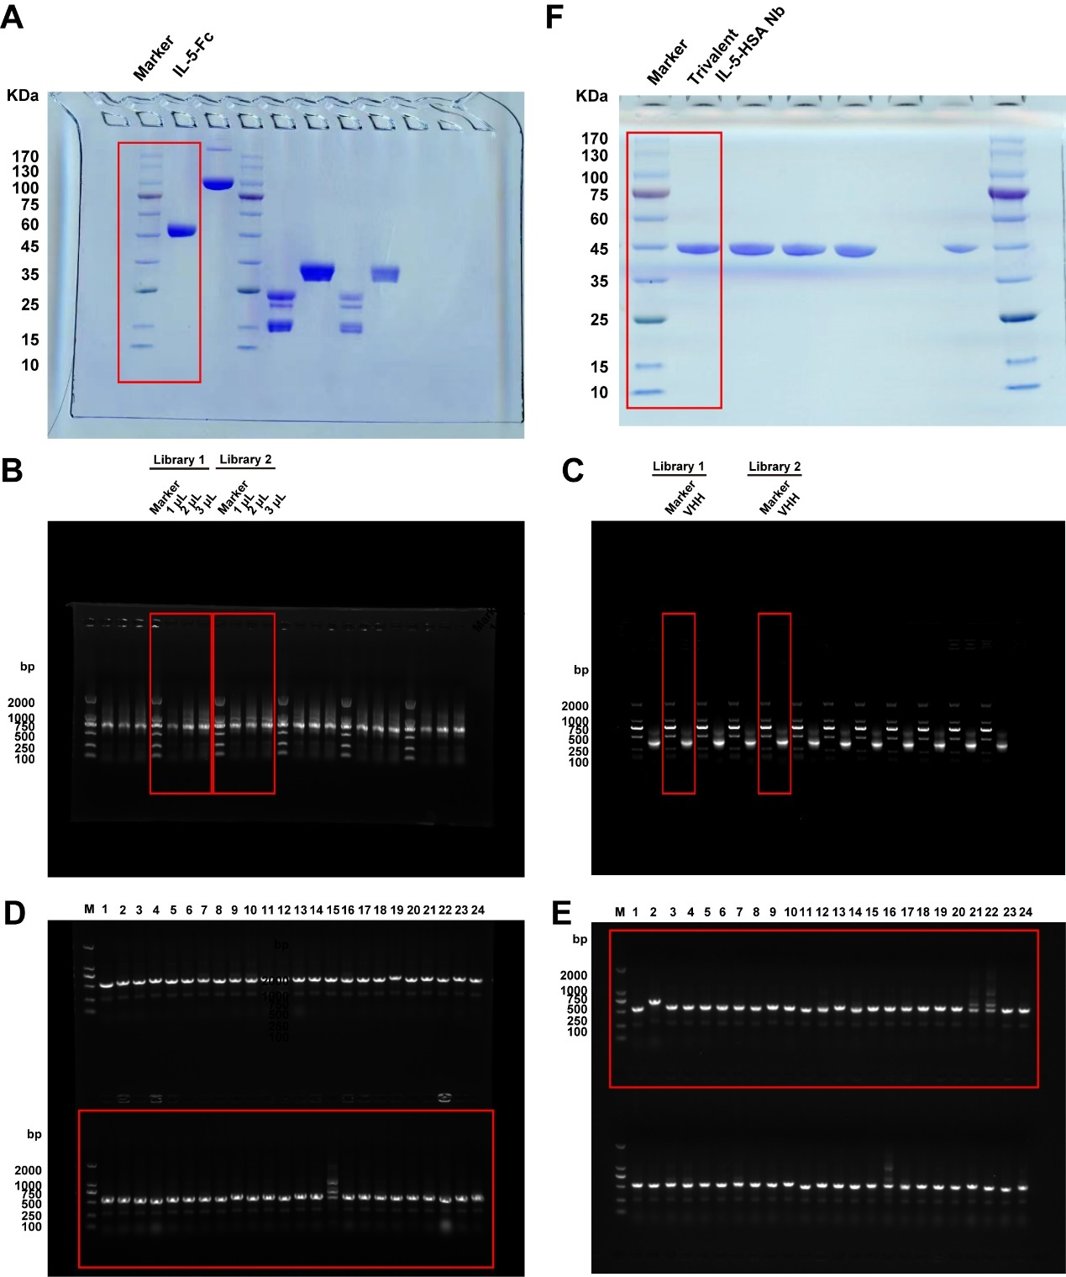
Fig. S3 Original, full-length gel images. (A) The purified IL-5-Fc antigen (B) The amplified first PCR fragments from two libraries. (C) The amplified second PCR fragments from two libraries (D) The insertion rate of library 1. (E) The insertion rate of library 2. (F) The purified trivalent IL-5-HSA Nb. The cropped gel images displayed in Fig.1, Fig. 6 and Fig S1 were derived from the red rectangle labeled region of original images.

