Additional file

Bronchial eosinophils, neutrophils, and CD8+ T cells influence asthma control and lung function in schoolchildren and adolescents with severe treatment-resistant asthma

Authors: Miriam Cardoso Neves Eller¹ MD, MSc; Karina Pierantozzi Vergani¹ MD, MSc; Beatriz Mangueira Saraiva-Romanholo² PhD; Natália de Souza Xavier Costa³ PhD; Jôse Mára de Brito^{3,6} PhD; Leila Antonangelo^{4,5} MD, PhD; Caroline Silvério Faria⁵ MSc; Joaquim Carlos Rodrigues¹ MD, PhD; Thais Mauad³ MD, PhD

¹ Unidade de Pneumologia Pediátrica, Instituto da Criança, Hospital das Clínicas HCFMUSP, Faculdade de Medicina, Universidade de São Paulo, São Paulo,SP, BR
² Universidade da Cidade de São Paulo (UNICID), São Paulo, SP, BR
³ Departamento de Patologia, Faculdade de Medicina, Universidade de São Paulo, SP, BR
⁴ Divisao de Patologia Clinica- Departamento de Patologia, Hospital das Clinicas HCFMUSP, Faculdade de Medicina, Universidade de São Paulo, São Paulo,SP, BR
⁵ Laboratorio de Investigacao Clinica (LIM03), Faculdade de Medicina, Universidade de São Paulo, SP, BR
⁶ Departamento de Patologia e Parasitologia – Universidade Federal de Alfenas, Alfenas, MG, BR

Corresponding author: Miriam Cardoso Neves Eller, Instituto da Criança, HCFMUSP. Mailing address Rua Muniz de Sousa, 1020, apt 132, CEP 01534-000, São Paulo, SP, Brazil.
Email: miriamneves@gmail.com

METHODS

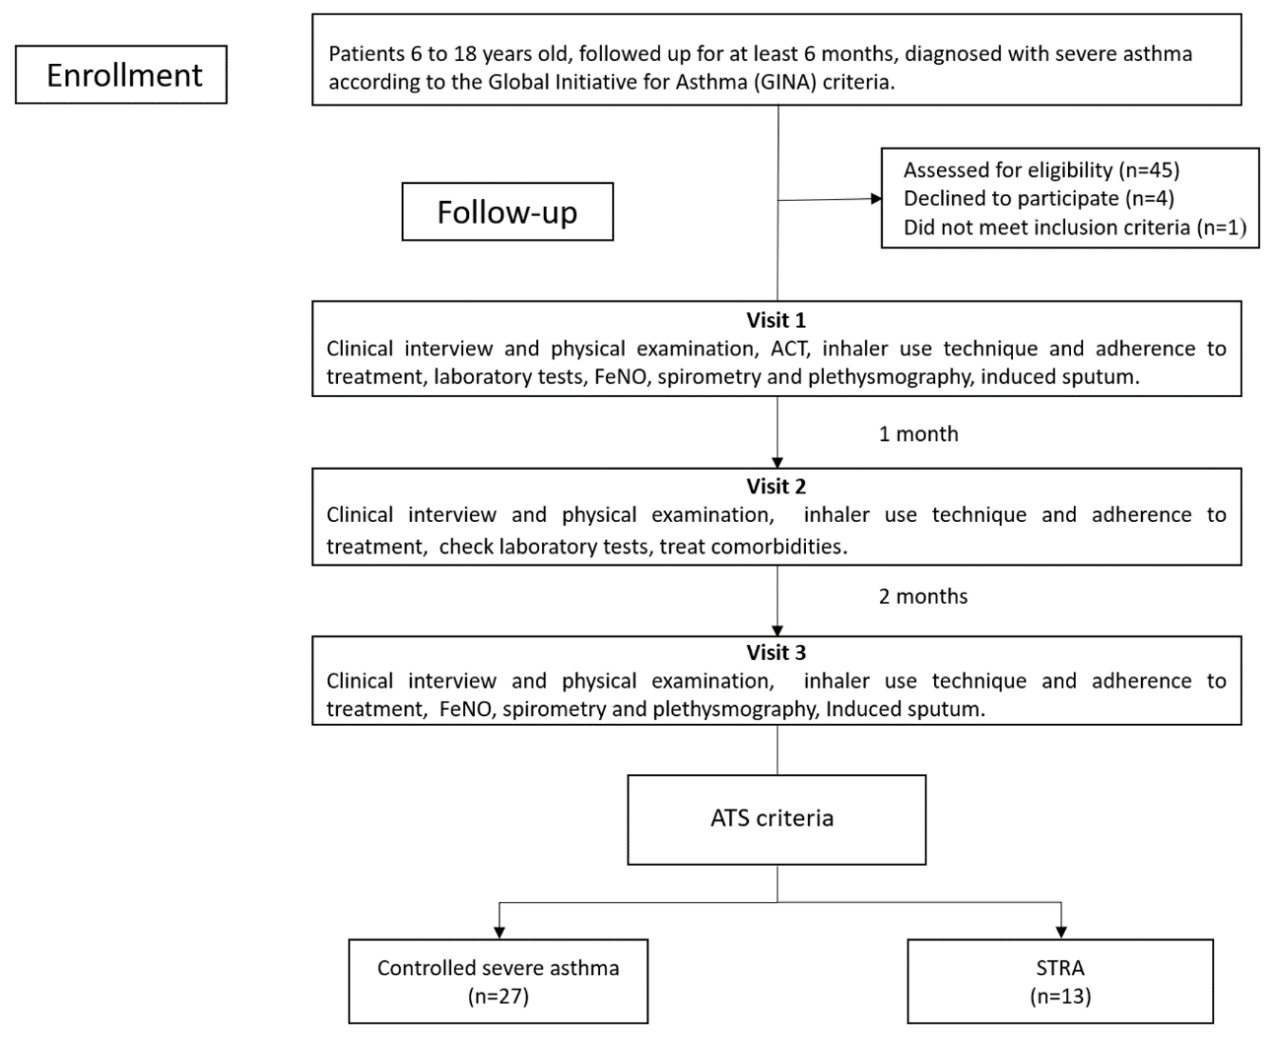
Figure S1. Flow diagram of study design and procedures

Bronchial tissue processing and immunohistochemistry.

Table S I. Antibodies used in the study
Antibody | Dilution | Antigen retrieval | Cod. | Manufacturer
CD4 | 1:75 | High-temperature: pH6 citrate buffer | NCL-L-368 | Leica Biosystems Newcastle Ltd, UK
CD8 | 1:400 | High-temperature: pH6 citrate buffer | M7103 | Dako, Glostrup, Denmark
Tryptase | 1:8000 | High-temperature: pH6 citrate buffer | M705 | Dako, Glostrup, Denmark
Chymase | 1:1000 | High-temperature: pH6 citrate buffer | NCL-MCC | Dako, Glostrup, Denmark
Elastase | 1:100 | Without antigen retrieval | M0752 | Dako, Glostrup, Denmark

RESULTS
BALF |  | Thickness MB (µm) |  | IE (cell/mm BM) |  |  |  |  |  | SM (cell/mm BM) |  |  |  | ASM (cell/mm2 area)
 |  |  |  | Tryptase |  | Chymase |  | CD4 |  | Neutrophils |  | CD8 |  | Eosinophils |  | Neutrophils |  | CD4 |  | CD8
 |  | r | p | r | p | R | p | r | p | r | p | r | P | r | p | r | p | r | p | r | p
Inflammatory cells
 | Neutrophils (%) | -0.600 | 0.067 | -0.450 | 0.224 | -0.883 | 0.002 | 0.433 | 0.244 | 0.582 | 0.06 | -0.333 | 0.347 | 0.086 | 0.872 | -0.143 | 0.76 | 0.200 | 0.704 | -0.464 | 0.294
 | Eosinophils (%) | 0.603 | 0.065 | 0.303 | 0.429 | 0.094 | 0.811 | -0.255 | 0.507 | 0.110 | 0.747 | 0.671 | 0.034 | 0.883 | 0.020 | 0.473 | 0.284 | 0.088 | 0.868 | 0.775 | 0.041
 | Basophils (%) | 0.659 | 0.038 | 0.298 | 0.436 | 0.274 | 0.476 | -0.365 | 0.334 | 0.256 | 0.448 | 0.541 | 0.106 | 0.655 | 0.158 | 0.802 | 0.030 | 0.131 | 0.805 | 0.535 | 0.216
 | Lymphocytes (%) | 0.219 | 0.544 | 0.326 | 0.391 | 0.828 | 0.006 | -0.059 | 0.881 | -0.679 | 0.022 | 0.097 | 0.789 | -0.143 | 0.787 | 0.000 | 1.000 | 0.145 | 0.784 | 0.072 | 0.878
Cytokines
 | IL-6 | -0.591 | 0.072 | -0.077 | 0.845 | -0.227 | 0.557 | 0.706 | 0.034 | -0.009 | 0.978 | -0.257 | 0.473 | 0.143 | 0.787 | -0.036 | 0.939 | 0.493 | 0.321 | -0.291 | 0.527
 | IL-7 | -0.067 | 0.855 | -0.467 | 0.205 | 0.150 | 0.700 | -0.067 | 0.865 | -0.045 | 0.894 | -0.079 | 0.829 | 0.543 | 0.266 | 0.107 | 0.819 | 0.886 | 0.019 | -0.286 | 0.535
 | IL-12 | -0.338 | 0.340 | -0.766 | 0.016 | -0.136 | 0.728 | -0.170 | 0.663 | 0.095 | 0.780 | 0.058 | 0.873 | 0.551 | 0.257 | 0.185 | 0.691 | 0.543 | 0.266 | -0.037 | 0.937
 | IL-13 | -0.129 | 0.722 | -0.780 | 0.013 | 0.042 | 0.915 | -0.269 | 0.484 | 0.023 | 0.946 | -0.069 | 0.850 | 0.441 | 0.381 | 0.356 | 0.434 | 0.377 | 0.461 | 0.074 | 0.875
 | IL-17 | -0.406 | 0.244 | -0.767 | 0.016 | -0.050 | 0.898 | -0.183 | 0.637 | 0.123 | 0.719 | 0.012 | 0.973 | 0.486 | 0.329 | 0.144 | 0.758 | 0.600 | 0.208 | -0.180 | 0.699
 | GMCSF | -0.176 | 0.627 | -0.833 | 0.005 | 0.083 | 0.831 | -0.700 | 0.036 | 0.282 | 0.401 | 0.370 | 0.293 | 0.371 | 0.468 | 0.286 | 0.535 | 0.086 | 0.872 | 0.214 | 0.645
 | IFN-γ | 0.006 | 0.987 | -0.700 | 0.036 | 0.333 | 0.381 | -0.650 | 0.058 | 0.164 | 0.631 | 0.321 | 0.365 | 0.257 | 0.623 | 0.357 | 0.432 | 0.200 | 0.704 | 0.179 | 0.702
Table S II: Relationship between number of cells per compartment in bronchial biopsies of patients with STRA (Intraepithelial – IE, Submucosal – SM and Airway smooth muscle – ASM) with bronchoalveolar lavage (BALF) (n=11).
IL: Interleukin; GMCSF: Granulocyte-macrophage colony-stimulating factor; IFN-γ: Interferon gama; MCP1: Monocyte Chemoattractant Protein-1.

Table S III: Significative correlation between bronchoalveolar lavage (BALF) cytology and cytokines and lung function.
BALF | Pre-BD FEF25-75 (Pred %) |  | Pre-BD RV/TLC (%) |  | Pre-BD FEV1 (Pred %) |  | Pre-BD FEV1/SVC |  | Pre-BD TLC (%) |  | Post-BD RV/TCL (%) |  | Post-BD FEV1/FCV |  | Post-BD FEF25-75 (Pred %) |  | Post-BD FEV1  (Pred %) |  | Post-BD TLC (%) |  | Post-BD RV (%)
BALF | r | p | r | p | r | p | r | p | r | p | r | p | r | p | r | p | r | p | r | p | r | p
Total cells (mm3) | 0.333 | 0.347 | -0.345 | 0.328 | 0.067 | 0.855 | 0.030 | 0.934 | -0.683* | 0.042 | -0.400 | 0.286 | -0.176 | 0.627 | 0.164 | 0.651 | 0.091 | 0.803 | -0.238 | 0.570 | -0.310 | 0.456
Neutrophils (%) | -0.335 | 0.263 | 0.165 | 0.590 | -0.363 | 0.223 | -0.412 | 0.162 | -0.109 | 0.737 | 0.238 | 0.457 | -0.462 | 0.112 | -0.582* | 0.037 | -0.566* | 0.044 | -0.374 | 0.258 | -0.009 | 0.979
Basophils (%) | -0.636* | 0.019 | 0.487 | 0.091 | -0.663* | 0.013 | -0.568* | 0.043 | 0.097 | 0.765 | 0.362 | 0.247 | -0.392 | 0.185 | -0.487 | 0.091 | -0.582* | 0.037 | 0.453 | 0.162 | 0.452 | 0.163
Lymphocytes (%) | 0.509 | 0.076 | -0.358 | 0.230 | 0.553* | 0.050 | 0.547 | 0.053 | -0.111 | 0.732 | -0.301 | 0.341 | 0.696** | 0.008 | 0.746** | 0.003 | 0.740** | 0.004 | 0.055 | 0.873 | -0.132 | 0.699
IL6 | 0.218 | 0.475 | -0.307 | 0.308 | 0.215 | 0.481 | 0.128 | 0.676 | -0.302 | 0.340 | -0.035 | 0.913 | 0.226 | 0.458 | 0.086 | 0.779 | 0.100 | 0.744 | -0.659* | 0.027 | -0.189 | 0.579
IL7 | -0.214 | 0.482 | 0.187 | 0.541 | -0.071 | 0.817 | -0.038 | 0.901 | 0.130 | 0.688 | 0.678* | 0.015 | 0.060 | 0.845 | -0.258 | 0.394 | -0.253 | 0.405 | -0.219 | 0.518 | 0.582 | 0.060
IL10 | -0.387 | 0.191 | 0.376 | 0.206 | -0.269 | 0.375 | -0.040 | 0.896 | 0.287 | 0.366 | 0.595* | 0.041 | -0.078 | 0.800 | -0.344 | 0.250 | -0.298 | 0.323 | -0.040 | 0.908 | 0.591 | 0.056
IL13 | -0.218 | 0.474 | 0.405 | 0.170 | -0.076 | 0.804 | 0.071 | 0.818 | 0.189 | 0.556 | 0.663* | 0.019 | -0.037 | 0.905 | -0.286 | 0.344 | -0.258 | 0.396 | -0.152 | 0.655 | 0.556 | 0.075
IL17 | -0.331 | 0.269 | 0.293 | 0.332 | -0.221 | 0.468 | -0.110 | 0.719 | 0.070 | 0.828 | 0.627* | 0.029 | -0.149 | 0.627 | -0.420 | 0.153 | -0.392 | 0.185 | -0.314 | 0.346 | 0.473 | 0.142
GCSF | 0.177 | 0.563 | -0.149 | 0.627 | 0.210 | 0.491 | 0.177 | 0.563 | -0.265 | 0.406 | 0.186 | 0.564 | 0.254 | 0.402 | 0.033 | 0.914 | 0.039 | 0.900 | -0.651* | 0.030 | -0.059 | 0.863
GMCSF | -0.582* | 0.037 | 0.566* | 0.044 | -0.456 | 0.117 | -0.198 | 0.517 | 0.490 | 0.106 | 0.664* | 0.018 | -0.385 | 0.194 | -0.604* | 0.029 | -0.538 | 0.058 | 0.114 | 0.739 | 0.618* | 0.043
IFN-γ | -0.560* | 0.046 | 0.566* | 0.044 | -0.423 | 0.150 | -0.176 | 0.566 | 0.504 | 0.094 | 0.720** | 0.008 | -0.231 | 0.448 | -0.527 | 0.064 | -0.473 | 0.103 | 0.114 | 0.739 | 0.709* | 0.015
IL: Interleukin; GCSF: Granulocyte colony stimulating factor; GMCSF: Granulocyte-macrophage colony-stimulating factor; IFN-γ: Interferon gama, BD: bronchodilator; FEV1: forced expiratory volume in the first second; FEF 25-75%: forced expiratory flow at 25-75% of FVC; RV/TLC: ratio of residual volume to total lung capacity; FEV1/SVC: ratio of forced expiratory volume in the first second to slow vital capacity; TLC: total lung capacity; ; FEV1/SVC: ratio of forced expiratory volume in the first second to slow vital capacity; RV/TLC: ratio of residual volume to total lung capacity; RV: residual volume.
Table S IV: Results of bronchoalveolar lavage (BAL) cultures, virus and cellularity.
Patient | Culture | BAAR | Fungus | Virus | Neutrophils (%) | Eosinophils (%) | Basophils (%) | Lymphocytes (%) | Monocytes (%) | Macrophages (%) | Epithelial cells (%)
1 | Negative | Negative | Negative | Negative | 3 | 7 | 14 | 4 | 0 | 60 | 25
2 | Negative | Negative | Negative | Coronavirus NL65 | 0 | 0 | 0 | 5 | 0 | 4 | 90
3 | S. pneumonie | Negative | Negative | Negative | 22 | 2 | 0 | 0 | 0 | 60 | 16
4 | Negative | Negative | Negative | Negative | 3 | 3 | 0 | 8 | 0 | 10 | 75
5 | Polimicrobial | Negative | Negative | Negative | 0 | 0 | 0 | 3 | 0 | 1 | 96
6 | Polimicrobial | Negative | Negative | Negative | 13 | 66 | 0 | 4 | 1 | 6 | 10
7 | Polimicrobial | Negative | Aspergillus | Negative | 82 | 0 | 0 | 2 | 1 | 10 | 5
8 | Polimicrobial | Negative | Negative | Negative | 1 | 1 | 0 | 23 | 1 | 24 | 51
9 | Polimicrobial | Negative | Negative | Negative | 48 | 0 | 0 | 2 | 1 | 45 | 5
10 | Polimicrobial | Negative | Negative | Negative | 96 | 1 | 0 | 1 | 0 | 2 | 0
11 | Negative | Negative | Negative | Negative | 12 | 0 | 0 | 18 | 0 | 5 | 65
12 | Polimicrobial | Negative | Negative | Negative | 45 | 18 | 1 | 0 | 0 | 28 | 6
13 | Polimicrobial | Negative | Negative | Negative | 13 | 3 | 0 | 18 | 0 | 40 | 23
Search for 12 respiratory viruses, Mycoplasma pneumoniae, Chlamydophila pneumoniae, and Bordetella pertussis, was performed by multiplex real-time PCR assay FilmArray® Respiratory Panel (BioFire, Utah, US).
BAAR: Alcohol-acid resistant bacillus
Table S V. Relationship between number of cells per compartment (Intraepithelial – IE, Submucosal – SM and Airway smooth muscle – ASM) with pulmonary function test in bronchial biopsies of patients with STRA (n=11).
 | Thickness MB |  | IE (cell/mm BM) |  |  |  |  |  |  |  | SM (cell/mm BM) |  |  |  |  |  |  |  | ASM (cell/mm2 area)
Pulmonary Function Test | (µm) |  | Eosinophils |  | Neutrophils |  | CD4 |  | CD4/CD8 |  | Eosinophils |  | Neutrophils |  | Tryptase |  | CD4/CD8 |  | CD4
 | r | P | r | p | r | p | r | p | r | p | r | p | r | p | r | p | r | p | r | P
FEV1 variation pós-BD(%) | 0.261 | 0.467 | 0.720 | 0.013 | 0.517 | 0.154 | 0.333 | 0.381 | 0.357 | 0.432 | 0.645 | 0.032 | 0.282 | 0.401 | 0.806 | 0.005 | -0.583 | 0.099 | 0.600 | 0.208
Pre-BD FEF25-75 | -0.455 | 0.187 | -0.542 | 0.085 | -0.217 | 0.576 | 0.217 | 0.576 | 0.429 | 0.337 | -0.582 | 0.060 | -0.645 | 0.032 | -0.333 | 0.347 | -0.083 | 0.831 | -0.771 | 0.072
Pre-BD RV/TLC (%) | 0.442 | 0.200 | 0.305 | 0.361 | 0.467 | 0.205 | -0.700 | 0.036 | -0.571 | 0.180 | 0.145 | 0.670 | 0.491 | 0.125 | 0.115 | 0.751 | -0.283 | 0.460 | 0.143 | 0.787
Pre-BD FEV1 | -0.345 | 0.328 | -0.560 | 0.073 | -0.133 | 0.732 | 0.067 | 0.865 | 0.286 | 0.535 | -0.709 | 0.015 | -0.755 | 0.007 | -0.382 | 0.276 | 0.067 | 0.865 | -0.657 | 0.156
Pre-BD FEV1/SVC | -0.467 | 0.174 | -0.487 | 0.128 | -0.330 | 0.932 | -0.183 | 0.637 | 0.393 | 0.383 | -0.664 | 0.026 | -0.636 | 0.035 | -0.455 | 0.187 | 0.133 | 0.732 | -0.886 | 0.019
Pre-BD RV | 0.515 | 0.128 | 0.314 | 0.346 | 0.417 | 0.265 | -0.683 | 0.042 | -0.643 | 0.119 | 0.182 | 0.593 | 0.518 | 0.102 | 0.152 | 0.676 | -0.167 | 0.668 | 0.143 | 0.787
Pre-BD sGawPré | -0.333 | 0.347 | -0.547 | 0.082 | 0.667* | 0.005 | -0.017 | 0.966 | 0.179 | 0.702 | -0.473 | 0.142 | -0.573 | 0.066 | -0.661 | 0.038 | 0.600 | 0.088 | -0.486 | 0.329
Pre-BD Raw | 0.267 | 0.455 | 0.192 | 0.572 | 0.243 | 0.529 | 0.100 | 0.797 | -0.414 | 0.355 | 0.305 | 0.361 | 0.702 | 0.016 | 0.359 | 0.309 | -0.494 | 0.177 | 0.725 | 0.103
Pos-BD VEF1 | -0.176 | 0.627 | -0.146 | 0.669 | 0.200 | 0.606 | 0.217 | 0.576 | 0.464 | 0.294 | -0.327 | 0.326 | -0.700 | 0.016 | 0.164 | 0.651 | -0.300 | 0.433 | -0.314 | 0.544
Pos-BD RV/TCL | 0.367 | 0.332 | 0.182 | 0.614 | 0.357 | 0.385 | -0.683 | 0.042 | -0.679 | 0.094 | 0.006 | 0.987 | 0.200 | 0.58 | -0.150 | 0.700 | 0.405 | 0.320 | 0.314 | 0.544
Pos-BD FEF25-75 | -0.127 | 0.726 | -0.191 | 0.573 | 0.133 | 0.732 | 0.200 | 0.606 | 0.286 | 0.535 | -0.373 | 0.259 | -0.764 | 0.006 | 0.115 | 0.751 | -0.117 | 0.765 | -0.200 | 0.704
Pos-BD FEV1 | -0.176 | 0.627 | -0.146 | 0.669 | 0.200 | 0.606 | 0.217 | 0.576 | 0.464 | 0.294 | -0.327 | 0.326 | -0.700 | 0.016 | 0.164 | 0.651 | -0.300 | 0.433 | -0.314 | 0.544
Pos-BD FEV1/SVC | 0.006 | 0.987 | 0.114 | 0.739 | 0.217 | 0.576 | 0.067 | 0.865 | 0.179 | 0.702 | -0.127 | 0.709 | -0.682 | 0.021 | 0.127 | 0.726 | 0 | 1 | -0.200 | 0.704
Pos-BD RV | 0.550 | 0.125 | 0.340 | 0.336 | 0.476 | 0.233 | -0.717 | 0.003 | -0.857 | 0.014 | 0.115 | 0.751 | 0.261 | 0.467 | 0.083 | 0.831 | 0.310 | 0.456 | 0.314 | 0.544
Functional pulmonary data are expressed as the mean percentages of predictions and standard deviations according to the Global Lung Function Initiative reference values for spirometry and Polgar and Weng’s reference values for plethysmography. Abbreviations: BD: bronchodilator; FEV1: forced expiratory volume in the first second; FVC: forced vital capacity; FEV1/SVC: ratio of forced expiratory volume in the first second to slow vital capacity; FEF 25-75%: forced expiratory flow at 25-75% of FVC; TLC: total lung capacity; RV: residual volume; RV/TLC: ratio of residual volume to total lung capacity
Table S VI. Relationship between number of cells per compartment (Intraepithelial – IE, Submucosal – SM and Airway smooth muscle – ASM) with sputum in bronchial biopsies of patients with STRA (n=11).
Sputum | Thickness MB (µm) |  | IE (cell/mm BM) |  |  |  |  |  | SM (cell/mm BM) |  |  |  |  |  | ASM (cell/mm2 area)
Sputum |  |  | Eosinophils |  | Chymase |  | CD4 |  | Eosinophils |  | Neutrophils |  | CD8 |  | Neutrophils |  | Tryptase
Sputum | r | p | r | p | r | p | R | p | r | p | r | p | r | p | r | p | r | p
IL-1β | 0.500 | 0.391 | -0.810 | 0.015 | -0.821 | 0.023 | 0.464 | 0.294 | -0.500 | 0.207 | 0.381 | 0.352 | -0.786 | 0.036 | 1.000 | 0.000 | -0.400 | 0.505
IL-2 | 0.359 | 0.553 | -0.634 | 0.091 | -0.185 | 0.691 | 0.185 | 0.691 | -0.647 | 0.083 | -0.076 | 0.858 | -0.906 | 0.005 | -0.224 | 0.718 | -0.783 | 0.118
IL-4 | 0.894 | 0.041 | -0.464 | 0.247 | -0.535 | 0.216 | 0.757 | 0.049 | -0.218 | 0.604 | 0.355 | 0.389 | -0.709 | 0.074 | 0.112 | 0.858 | -0.224 | 0.718
IL-5 | 0.700 | 0.188 | -0.699 | 0.054 | -0.198 | 0.670 | 0.306 | 0.504 | -0.687 | 0.060 | -0.169 | 0.690 | -0.837 | 0.019 | 0.051 | 0.935 | -0.821 | 0.089
IL-7 | 0.500 | 0.391 | -0.443 | 0.272 | -0.429 | 0.337 | 0.464 | 0.294 | -0.192 | 0.649 | 0.036 | 0.933 | -0.793 | 0.033 | 0.000 | 1.000 | -0.300 | 0.624
IL-10 | 0.600 | 0.285 | -0.671 | 0.069 | -0.321 | 0.482 | 0.500 | 0.253 | -0.419 | 0.301 | 0.108 | 0.799 | -0.775 | 0.041 | -0.667 | 0.219 | -0.821 | 0.089
IL-12 | 0.200 | 0.747 | -0.395 | 0.333 | 0.090 | 0.848 | -0.054 | 0.908 | -0.335 | 0.417 | -0.335 | 0.417 | -0.883 | 0.008 | -0.500 | 0.391 | -0.600 | 0.285
IL-13 | 0.000 | 1.000 | -0.479 | 0.230 | 0.378 | 0.403 | -0.090 | 0.848 | -0.503 | 0.204 | -0.731 | 0.040 | -0.523 | 0.229 | 0.000 | 1.000 | -0.900 | 0.037
IL-17 | 0.600 | 0.285 | -0.881 | 0.004 | -0.607 | 0.148 | 0.571 | 0.180 | -0.500 | 0.207 | 0.071 | 0.867 | -0.929 | 0.003 | -0.900 | 0.037 | -0.700 | 0.188
GCSF | 0.600 | 0.285 | -0.762 | 0.028 | -0.571 | 0.180 | 0.286 | 0.535 | -0.571 | 0.139 | 0.143 | 0.736 | -0.964 | 0.000 | -0.600 | 0.285 | -0.700 | 0.188
GMCSF | 0.500 | 0.391 | -0.429 | 0.289 | -0.250 | 0.589 | 0.786 | 0.036 | 0.000 | 1.000 | 0.262 | 0.531 | -0.571 | 0.180 | -0.600 | 0.285 | -0.700 | 0.188
IFN-γ | 0.700 | 0.188 | -0.905 | 0.002 | -0.714 | 0.071 | 0.536 | 0.215 | -0.595 | 0.120 | 0.190 | 0.651 | -0.964 | 0.000 | -0.900 | 0.037 | -0.700 | 0.188
MCP1 | 0.300 | 0.624 | -0.690 | 0.058 | -0.321 | 0.482 | 0,000 | 1.000 | -0.762 | 0.028 | -0.048 | 0.911 | -0.929 | 0.003 | -0.600 | 0.285 | -0.800 | 0.104
MIP-1b | 0.900 | 0.037 | -0.929 | 0.001 | -0.429 | 0.337 | 0.429 | 0.337 | -0.524 | 0.183 | -0.095 | 0.823 | -0.714 | 0.071 | -0.500 | 0.391 | -0.700 | 0.188
TNF-α | 0.500 | 0.391 | -0.643 | 0.086 | -0.821 | 0.023 | 0.464 | 0.294 | -0.310 | 0.456 | 0.524 | 0.183 | -0.893 | 0.007 | -0.700 | 0.188 | 0.100 | 0.873
IL-1β: Interleukin-1 beta; IL: Interleukin; GCSF: Granulocyte colony stimulating factor; GMCSF: Granulocyte-macrophage colony-stimulating factor; IFN-γ: Interferon gama; MCP1: Monocyte Chemoattractant Protein-1; MIP-1b: macrophage inflammatory protein 1 beta; TNF-α: Tumor necrosis factor alpha.

Table S VII. Relationship between number of cells per compartment (Intraepithelial – IE, Submucosal – SM and Airway smooth muscle – ASM) with follow-up data and assessment of inflammation in bronchial biopsies of patients with STRA (n=11)
Variables |  | Thickness MB (µm) |  | IE (cell/mm BM) |  |  |  |  |  | SM (cell/mm BM) |  |  |  | ASM (cell/mm2 area)
 |  |  |  | Quimase |  | CD8 |  | CD4/CD8 ratio |  | CD8 SM |  | CD4/CD8 ratio |  | Neutrophils |  | Chymase |  | CD8
 |  | R | p | R | p | r | P | r | p | r | p | r | p | r | p | r | p | r | p
Follow-up data
 | Age | 0.442 | 0.200 | 0.167 | 0.668 | 0.405 | 0.320 | -0.786 | 0.036 | -0.018 | 0.96 | 0.233 | 0.546 | 0 | 1 | 0.071 | 0.879 | -0.500 | 0.253
 | pAQLQ | 0.152 | 0.676 | -0.200 | 0.606 | 0.476 | 0.233 | -0.714 | 0.071 | -0.576 | 0.082 | 0.467 | 0.205 | -0.429 | 0.337 | 0.857 | 0.014 | -0.429 | 0.337
 | ACT | 0.618 | 0.057 | 0.269 | 0.484 | 0.826 | 0.011 | -0.821 | 0.023 | -0.287 | 0.421 | 0.168 | 0.666 | 0 | 1 | 0.919 | 0.003 | 0.073 | 0.877
Assessment of inflammation
 | FeNo (ppb) | 0.535 | 0.111 | 0.828 | 0.006 | 0.587 | 0.126 | -0.631 | 0.129 | 0.498 | 0.143 | 0.059 | 0.881 | 0.643 | 0.119 | 0.595 | 0.159 | 0.288 | 0.531
 | Serum leucocytes/mm³ | 0.248 | 0.489 | 0.033 | 0.932 | 0.571 | 0.139 | -0.536 | 0.215 | -0.212 | 0.556 | 0.667 | 0.050 | 0.214 | 0.645 | 0.679 | 0.094 | -0.357 | 0.432
 | Serum eosinophils (%) | 0.772 | 0.009 | 0.435 | 0.242 | 0.595 | 0.120 | -0.893 | 0.007 | 0.365 | 0.300 | -0.310 | 0.417 | 0.857 | 0.014 | -0.071 | 0.879 | 0.750 | 0.052
 | Serum eosinophils/mm³ | 0.903 | 0.000 | 0.400 | 0.286 | 0.810 | 0.015 | -0.929 | 0.003 | 0.273 | 0.446 | -0.250 | 0.516 | 0.929 | 0.003 | 0.214 | 0.645 | 0.786 | 0.036
 | Serum IgE IU/mL | 0.467 | 0.205 | 0.433 | 0.244 | 0.536 | 0.215 | -0.536 | 0.215 | 0.017 | 0.966 | -0.381 | 0.352 | 0.029 | 0.957 | 0.714 | 0.071 | 0.486 | 0.329
pAQLQ asthma quality of life questionnaire ACT: asthma control test; IgE: immunoglobulin E; FeNO: fractional exhaled nitric oxide measured at 50L/min.

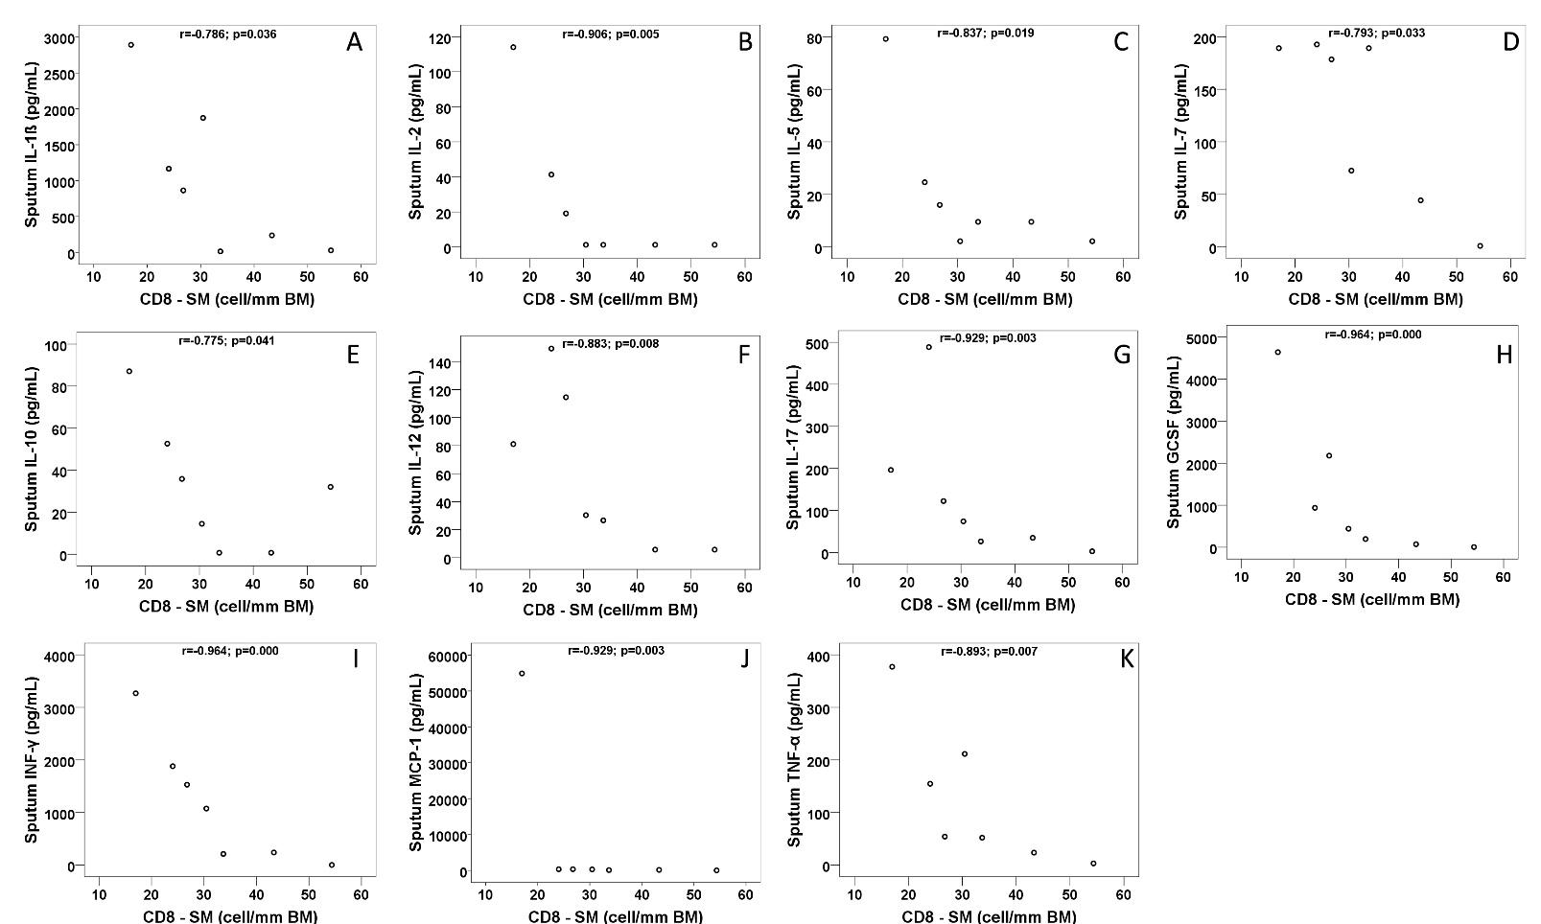
Figure S2. Correlation between CD8 T cells in bronchial biopsies and sputum interleukins in the patients with STRA (n=11)

Figure S3: Heatmap of correlation among cytokine levels in the sputum, bronchoalveolar lavage (BAL), and plasma. The correlation coefficients are color coded from deep red (−1) to deep blue (1).

