Additional file 1
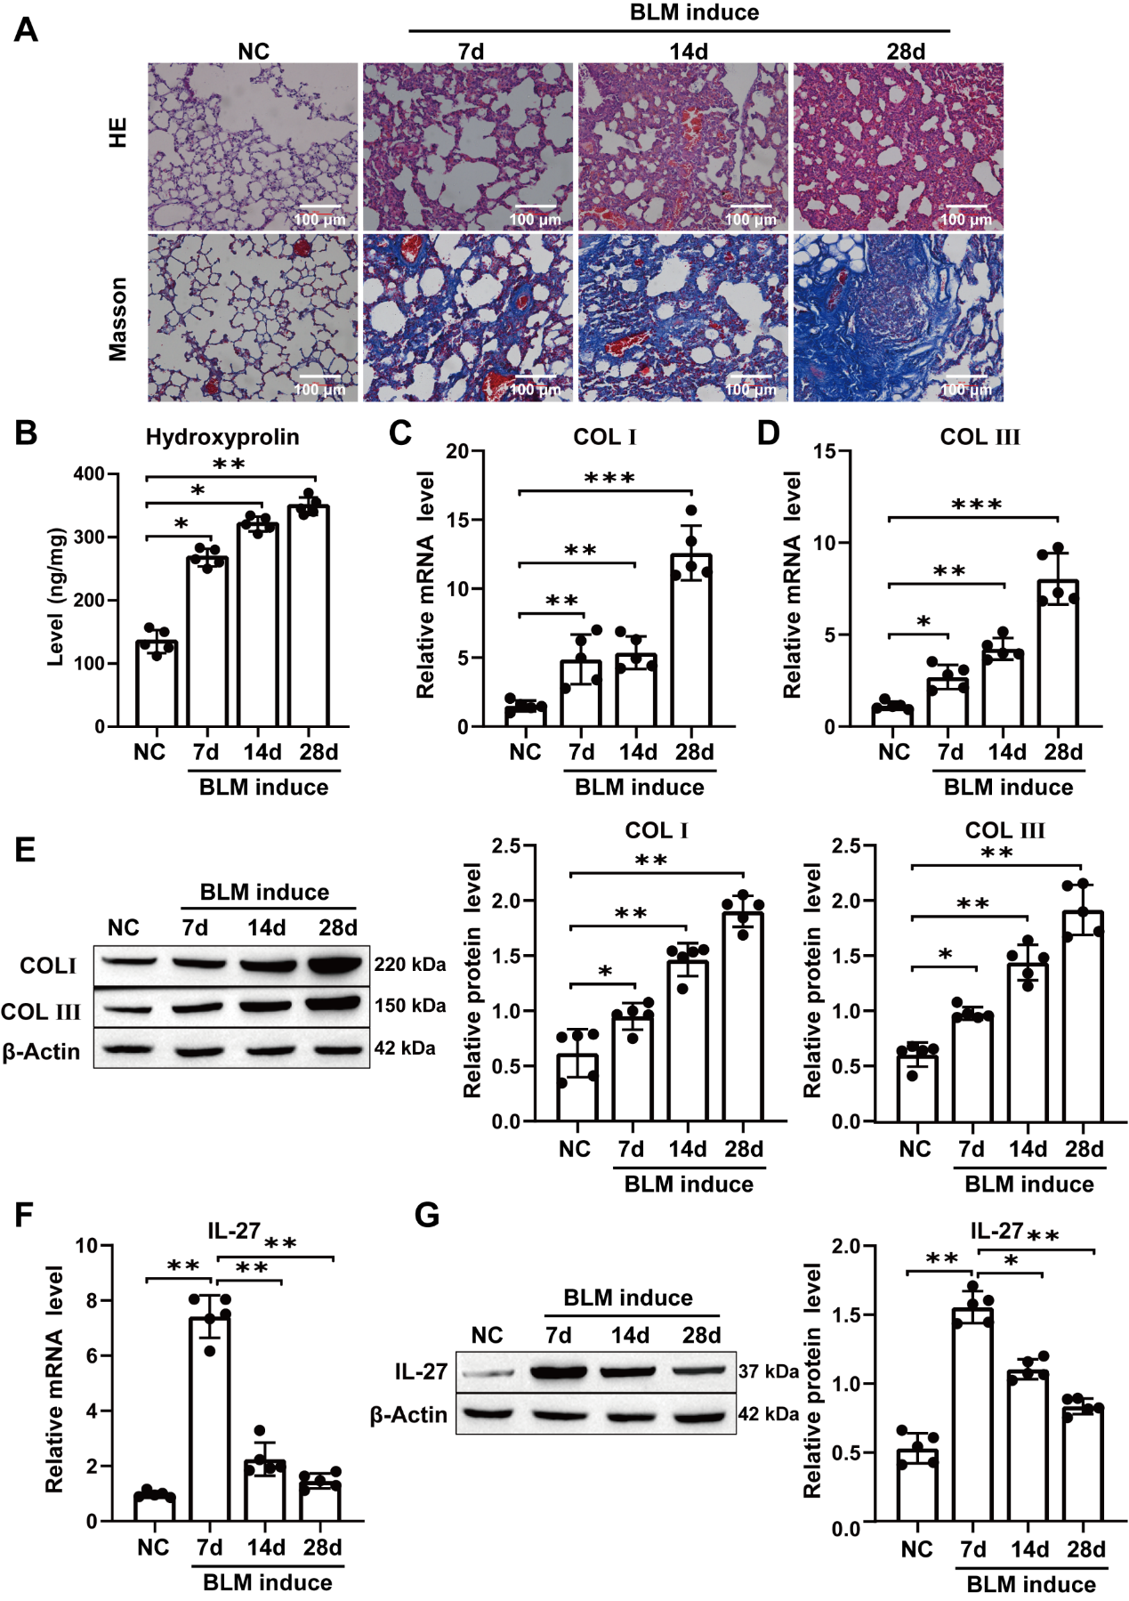
Figure S1 BLM induced PF in mice, and abnormal IL-27 expression was observed

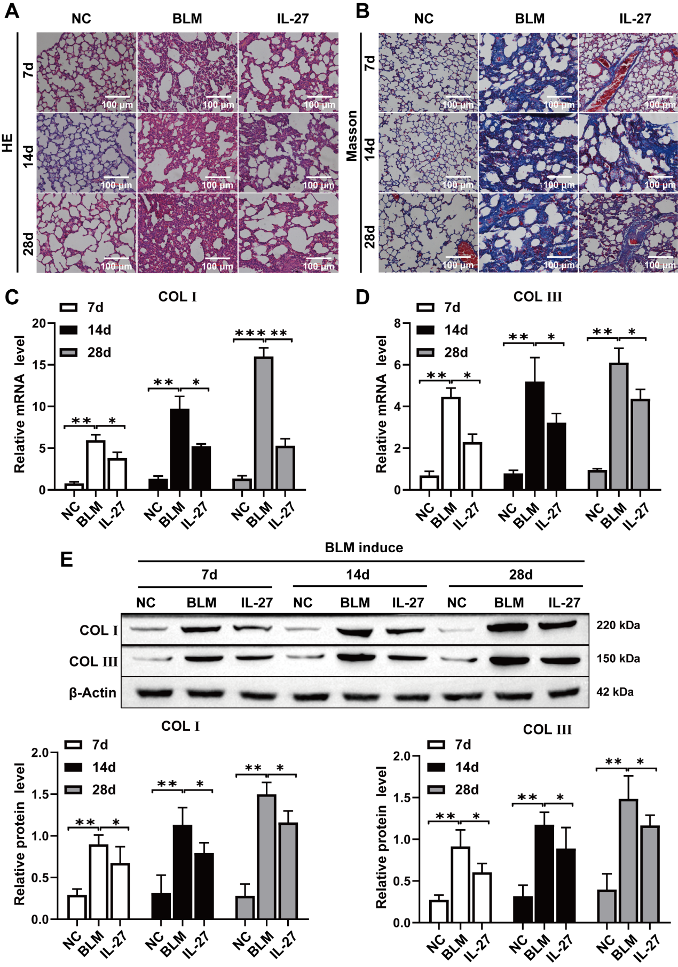
Figure S2 IL-27 attenuates BLM-induced PF in mice

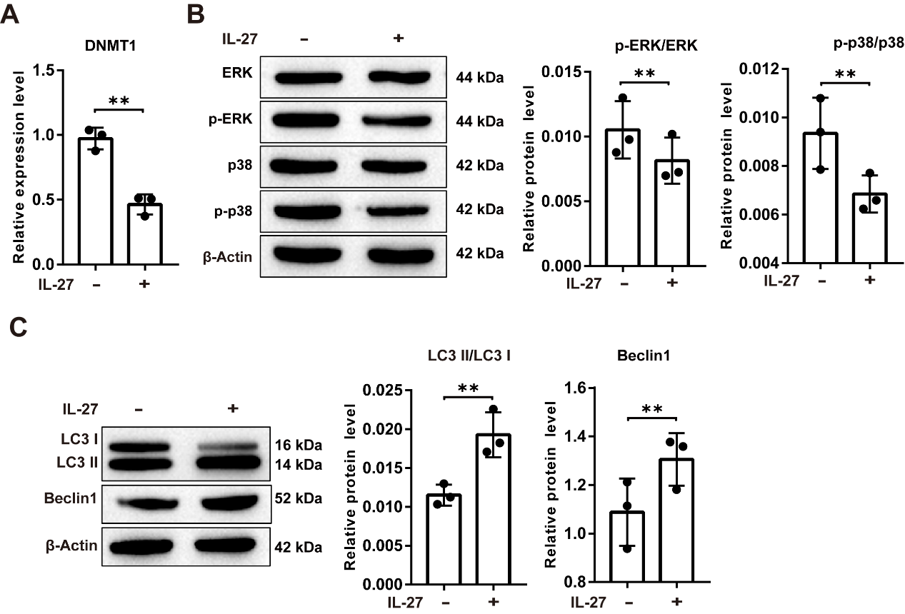
Figure S3 Effects of IL-27 on DNMT1, ERK/p38 signaling pathways and autophagy

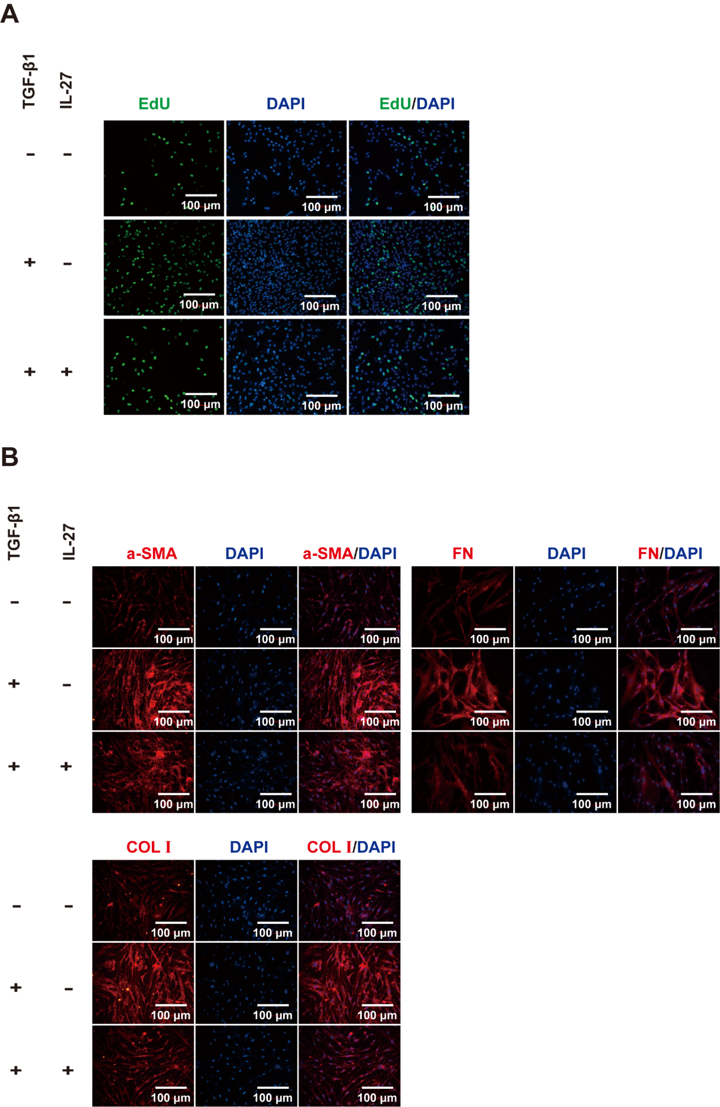
Figure S4 EdU for cell proliferation viability and immunofluorescence to detect α-SMA, FN, and COL Ⅰ fluorescence intensity
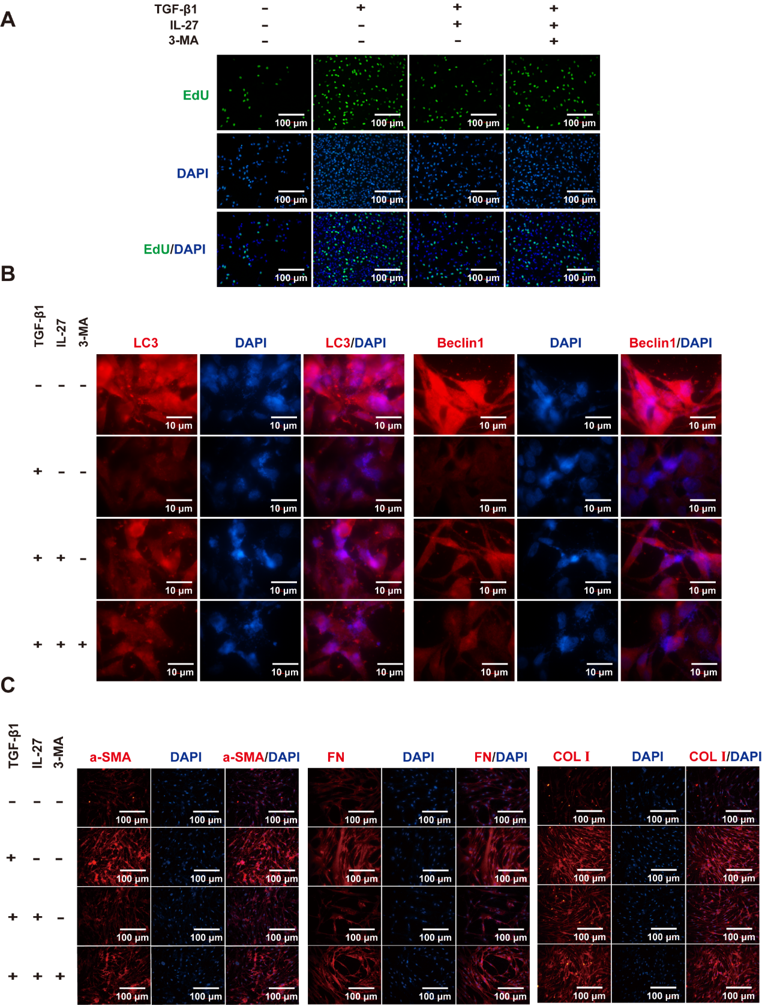
Figure S5 EdU for cell proliferation viability and immunofluorescence to detect LC3, Beclin1, α-SMA, FN, and COL Ⅰ fluorescence intensity

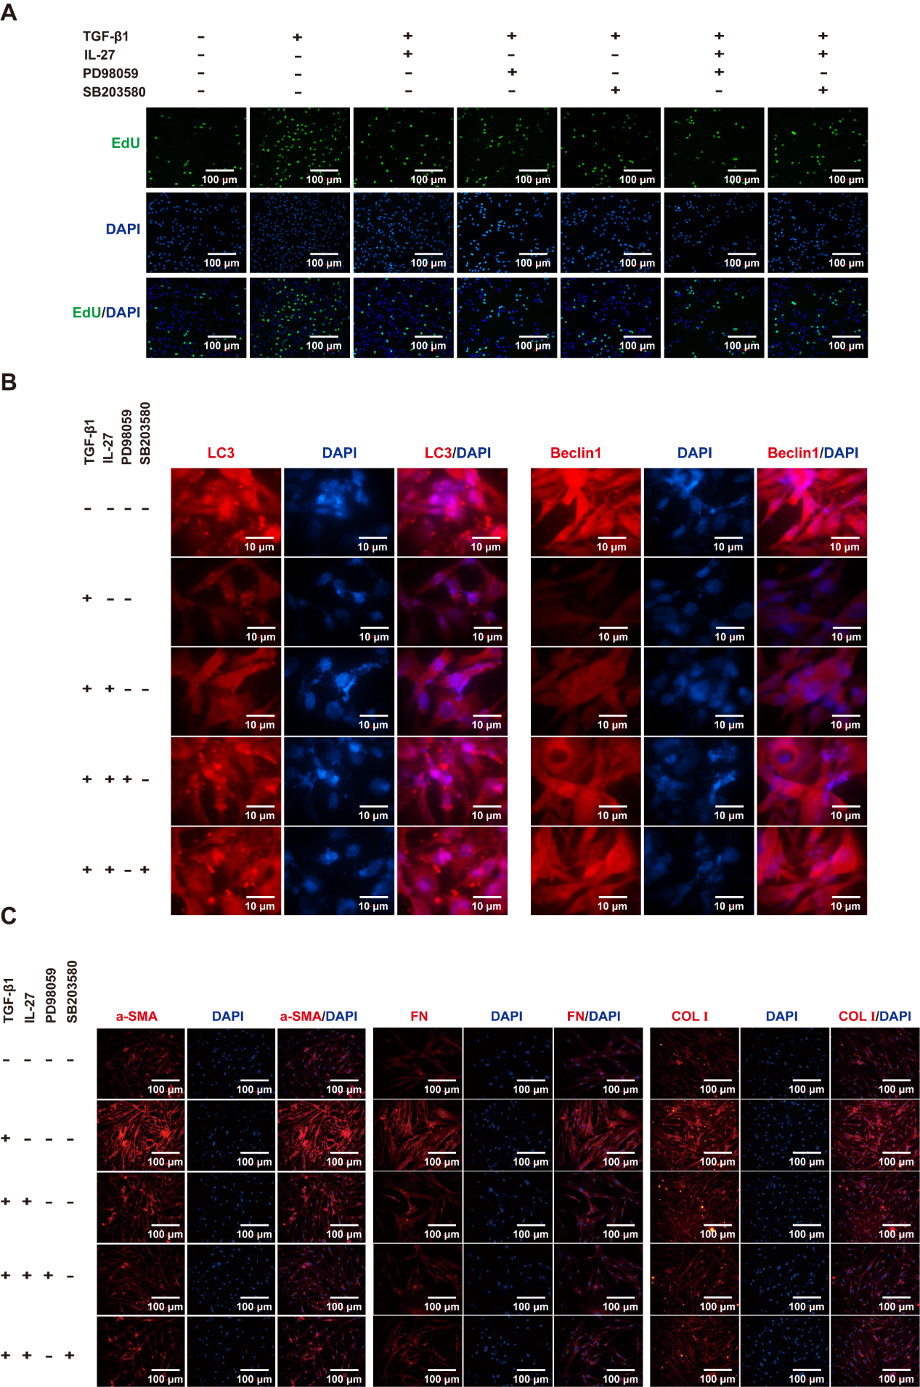
Figure S6 EdU for cell proliferation viability and immunofluorescence to detect LC3, Beclin1, α-SMA, FN, and COL Ⅰ fluorescence intensity

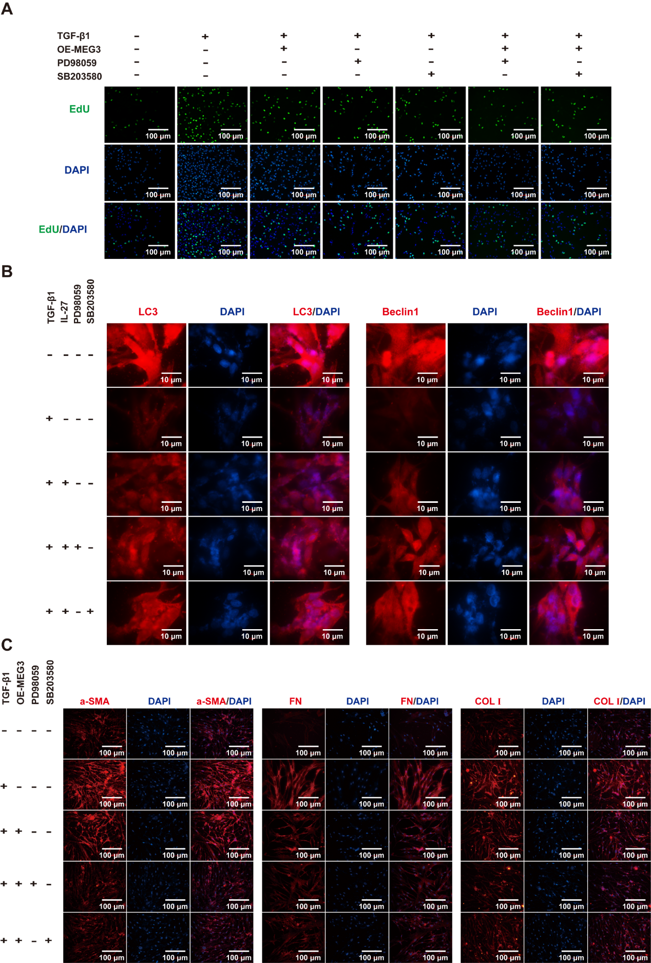
Figure S7 EdU for cell proliferation viability and immunofluorescence to detect LC3, Beclin1, α-SMA, FN, and COL Ⅰ fluorescence intensity

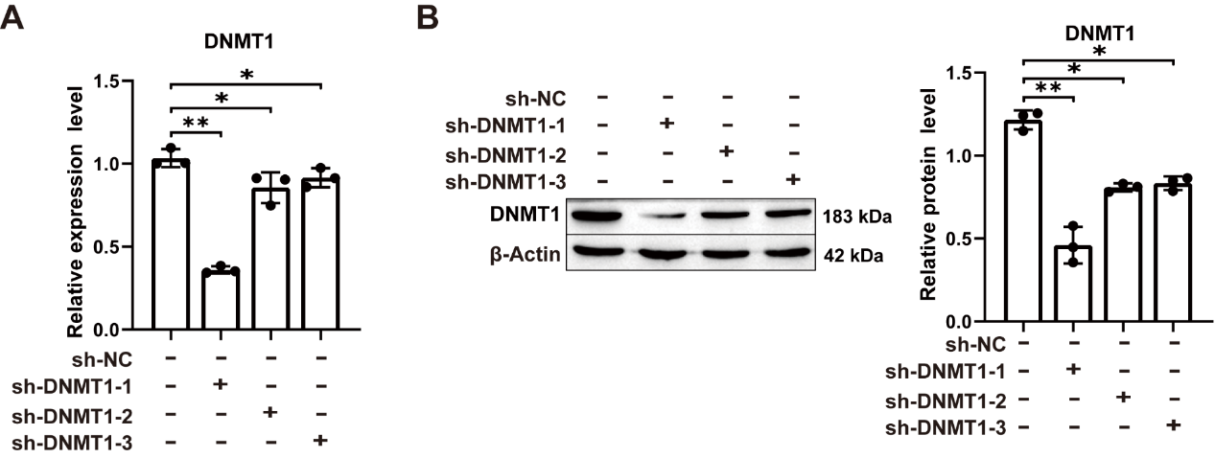
Figure S8 Detecting DNMT1 expression after sh-DNMT1 1-3 treatment by RT‒qPCR and Western blotting

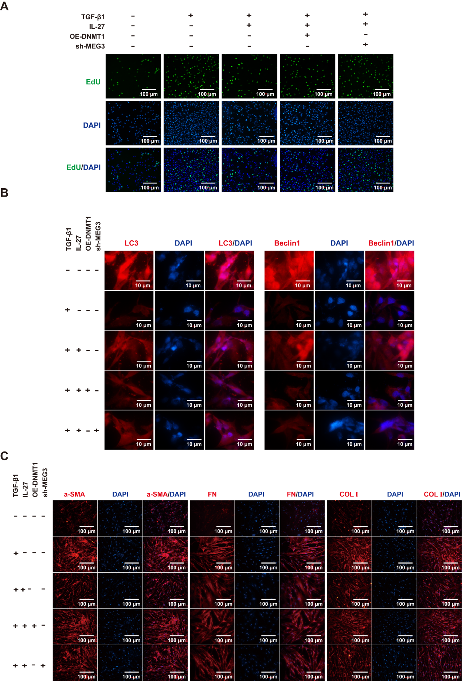
Figure S9 EdU for cell proliferation viability and immunofluorescence to detect LC3, Beclin1, α-SMA, FN, and COL Ⅰ fluorescence intensity

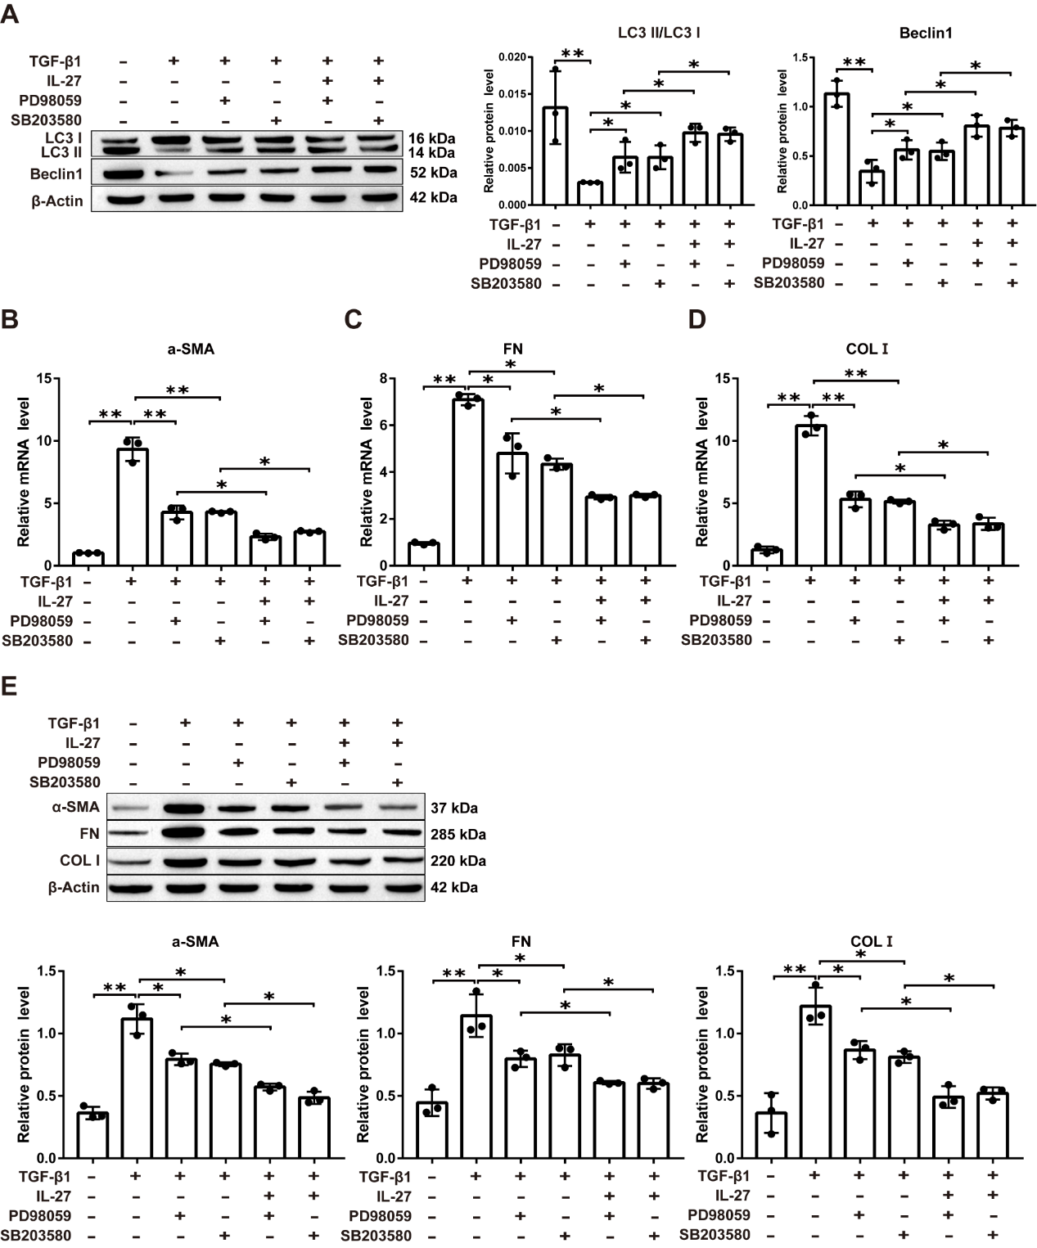
Figure S10 Detecting LC3, Beclin1, α-SMA, FN, and COL Ⅰ by RT‒qPCR and Western blotting

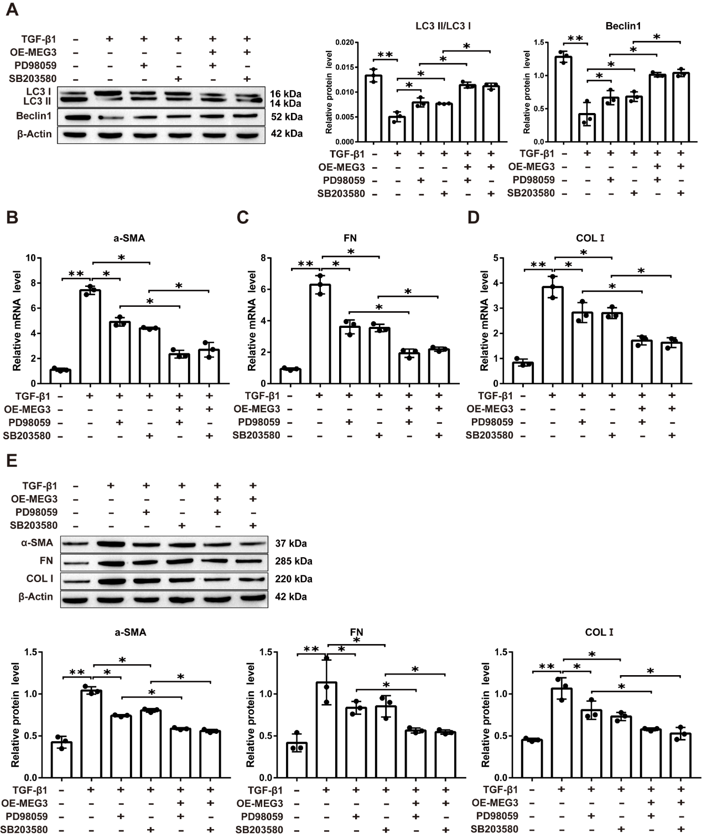
Figure S11 Detecting LC3, Beclin1, α-SMA, FN, and COL Ⅰ by RT‒qPCR and Western blotting

