Additional file 1: Supplementary materials
Table S1 Patient demographics and clinical assessments by physician-assigned diagnosis and physician-assessed severity
Variable | Asthma (N=510) |  |  | Asthma+COPDª (N=510) |  |  | COPD (N=510)
Variable | Mild  (N=181) | Moderate  (N=190) | Severe  (N=139) | Mild  (N=70) | Moderate  (N=233) | Severe  (N=207) | Mild  (N=151) | Moderate  (N=142) | Severe  (N=217)
Age, years, mean (SD) | 52.0 (16.5) | 55.3 (16.1) | 56.9 (13.4) | 63.8 (11.6) | 66.8 (9.1) | 63.9 (9.9) | 64.7 (10.7) | 67.9 (9.0) | 68.7 (8.8)
Female, n (%) | 121 (66.9) | 121 (63.7) | 86 (61.9) | 32 (45.7) | 108 (46.4) | 100 (48.3) | 58 (38.4) | 57 (40.1) | 88 (40.6)
Ethnicity, n (%)
African American | 5 (2.8) | 7 (3.7) | 3 (2.2) | 3 (4.3) | 6 (2.6) | 8 (3.9) | 7 (4.6) | 6 (4.2) | 2 (0.9)
Caucasian | 139 (76.8) | 142 (74.7) | 86 (61.9) | 60 (85.7) | 171 (73.4) | 167 (80.7) | 130 (86.1) | 120 (84.5) | 191 (88.0)
North-east Asian | 27 (14.9) | 28 (14.7) | 27 (19.4) | 7 (10.0) | 48 (20.6) | 21 (10.1) | 11 (7.3) | 15 (10.6) | 9 (4.1)
South-east Asian | 2 (1.1) | 3 (1.6) | 4 (2.9) | 0 | 3 (1.3) | 2 (1.0) | 0 | 0 | 1 (0.5)
Other | 8 (4.4) | 10 (5.3) | 19 (13.7) | 0 | 5 (2.1) | 9 (4.3) | 3 (2.0) | 1 (0.7) | 14 (6.5)
Time since diagnosis, years
Patients with data, n | 167 | 178 | 121 | 65 | 216 | 184 | 140 | 130 | 195
Mean (SD) | 15.3 (15.2) | 18.9 (16.0) | 19.6 (17.1) | 21.3 (22.8) | 18.2 (18.8) | 24.3 (21.3) | 6.6 (9.1) | 8.1 (10.5) | 9.2 (7.9)
Post-bronchodilator FEV₁ (% predicted)
Patients with data, n | 140 | 147 | 113 | 57 | 196 | 180 | 125 | 114 | 181
Mean (SD) | 90.3 (16.9) | 88.0 (18.5) | 76.4 (23.9) | 82.5 (13.8) | 71.6 (17.9) | 56.4 (20.5) | 80.1 (19.9) | 65.1 (17.4) | 43.7 (16.5)
SGRQ total score^{b}
Patients with data, n | 175 | 188 | 137 | 68 | 229 | 205 | 146 | 139 | 216
Mean (SD) | 23.4 (16.7) | 27.2 (19.3) | 40.8 (21.2) | 30.0 (20.0) | 35.2 (20.3) | 50.0 (21.6) | 31.6 (20.4) | 39.0 (20.7) | 50.3 (18.5)
EQ-5D-5L VAS score^{b}
Patients with data, n | 150 | 166 | 118 | 62 | 199 | 190 | 137 | 123 | 190
Mean (SD) | 78.0 (14.4) | 76.0 (17.8) | 67.7 (18.9) | 71.1 (20.0) | 70.8 (18.1) | 62.1 (21.0) | 69.8 (18.5) | 67.9 (21.7) | 59.2 (19.1)
CAAT total score^{c}
Patients with data, n | 181 | 190 | 139 | 70 | 233 | 207 | 151 | 142 | 217
Mean (SD) | 11.3 (7.1) | 12.9 (7.9) | 17.8 (8.5) | 14.0 (8.5) | 15.6 (8.1) | 20.0 (8.3) | 14.2 (8.1) | 15.7 (8.0) | 19.6 (7.5)
CAT total score^{c}
Patients with data, n | NA | NA | NA | 4 | 23 | 10 | 12 | 13 | 21
Mean (SD) | NA | NA | NA | 9.8 (6.5) | 13.7 (8.1) | 20.4 (10.1) | 10.8 (9.0) | 14.2 (8.0) | 21.3 (7.8)
All NOVELTY patients who completed both the CAAT and CAT (N=277)^{d}
CAAT total score^{c}
Patients with data, n | NA | NA | NA | 10 | 34 | 22 | 59 | 76 | 76
Mean (SD) | NA | NA | NA | 11.2 (4.9) | 14.4 (8.9) | 22.6 (9.2) | 12.2 (8.3) | 15.1 (7.8) | 19.9 (8.6)
CAT total score^{c}
Patients with data, n | NA | NA | NA | 10 | 34 | 22 | 59 | 76 | 76
Mean (SD) | NA | NA | NA | 9.6 (4.7) | 13.4 (8.9) | 21.6 (10.1) | 11.4 (8.2) | 13.8 (7.9) | 19.1 (8.1)
CAAT Chronic Airways Assessment Test, CAT COPD Assessment Test, COPD chronic obstructive pulmonary disease, EQ-5D-5L VAS EuroQol 5-dimensions 5-level visual analogue scale, FEV₁ forced expiratory volume in 1 second, N total number of patients in the sample, n number of patients with non-missing data, NA not applicable, SD standard deviation, SGRQ St George’s Respiratory Questionnaire
ªFor patients with asthma+COPD, severity was allocated as the higher of the two severity categories assigned by the physician for their asthma and their COPD; ^{b}Range: 0–100; ^{c}Range: 0–40; ^{d}Data for all NOVELTY patients with asthma+COPD or COPD who completed the CAAT and CAT, including those not represented in the N=1530 total sample
Table S2 Confirmatory factor analysis summary of invariance model testing fit statistics
Model | X² | df | p-value | CFI | RMSEA (90% CI) | SRMR | BIC | AIC
Pooled total sample (N=1530)
No modifications | 643.8 | 20 | 0 | 0.87 | 0.14  (0.13–0.15) | 0.06 | NA | NA
With modificationsª | 76.1 | 13 | 0 | 0.99 | 0.06  (0.04–0.07) | 0.02 | NA | NA
Asthma vs. COPD (N=1020)
Structural invariance^{b} with modifications,  ML estimation | 234.8 | 32 | 0 | 0.93 | 0.11  (0.10–0.13) | 0.12 | 26678.0 | 26402.1
Measurement invariance^{c} with modifications, ML estimation | 166.6 | 32 | 0 | 0.96 | 0.09  (0.08–0.11) | 0.08 | 26609.8 | 26333.8
Asthma vs. Asthma+COPD (N=1020)
Structural invariance^{b} with modifications,  ML estimation | 201.3 | 32 | 0 | 0.95 | 0.10  (0.09–0.12) | 0.11 | 26546.5 | 26270.6
Measurement invariance^{c} with modifications, ML estimation | 137.2 | 32 | 0 | 0.97 | 0.08  (0.07–0.09) | 0.07 | 26482.4 | 26206.5
COPD vs. Asthma+COPD (N=1020)
Structural invariance^{b} with modifications,  ML estimation | 328.3 | 32 | 0 | 0.90 | 0.14  (0.12–0.15) | 0.16 | 27099.2 | 26823.3
Measurement invariance^{c} with modifications, ML estimation | 94.1 | 32 | 0 | 0.98 | 0.06  (0.08–0.15) | 0.03 | 26865.0 | 26589.1
AIC Akaike information criterion, BIC Bayesian information criterion, CAAT Chronic Airways Assessment Test, CFI comparative fit index (Bentler), CI confidence interval, COPD chronic obstructive pulmonary disease, df degrees of freedom, ML maximum likelihood, N total number of patients in the sample, NA not applicable, RMSEA root mean square error of approximation, SRMR standardised root mean residual
ªModifications required to optimise fit by accounting for correlated residuals associated with item types (items 1–3 vs. 4–8). Modifications to the CAAT structural models were permissible and expected to account for covariance patterns due to item and rating scale design; ^{b}Fixed factor loadings; ^{c}Fixed factor loadings and means
Table S3 Pearson’s correlations between CAAT score and additional spirometric assessments
Variableª | Asthma  (N=510) | Asthma+COPD  (N=510) | COPD  (N=510) | Total sample  (N=1530)
Post-bronchodilator FVC (% predicted)
Patients with data available, n | 400 | 432 | 419 | 1251
Pearson’s correlation coefficient | −0.24*** | −0.27*** | −0.29*** | −0.29***
Post-bronchodilator FEV₁/FVC (% predicted)
Patients with data available, n | 400 | 431 | 419 | 1250
Pearson’s correlation coefficient | −0.12* | −0.03 | −0.19** | −0.18***
CAAT Chronic Airways Assessment Test, COPD chronic obstructive pulmonary disease, FEV₁ forced expiratory volume in 1 second, FVC forced vital capacity, N total number of patients in the sample, n number of patients in sample with available data
ªAnalyses were performed for patients with non-missing data; thus, number of observations differed for each variable
*p<0.05; **p<0.001; ***p<0.0001
Table S4 Intraclass correlation coefficient data for CAT vs. CAAT items in all NOVELTY patients who completed both
 | ICC | F | 95% CI | Sigma s | Sigma r | Sigma e
CAT vs. CAAT (total sample; N=271,ª df=270)
Item 1: Cough | 0.750 | 7.0 | (0.693–0.798) | 1.240 | 0 | 0.716
Item 2: Phlegm | 0.825 | 10.4 | (0.783–0.860) | 1.392 | 0 | 0.642
Item 3: Chest tightness | 0.762 | 7.6 | (0.705–0.809) | 1.308 | 0.123 | 0.721
Item 4: Breathlessness | 0.817 | 10.0 | (0.773–0.853) | 1.484 | 0.066 | 0.700
Item 5: Home activity | 0.839 | 11.8 | (0.797–0.873) | 1.480 | 0.122 | 0.636
Item 6: Confidence | 0.793 | 9.2 | (0.734–0.839) | 1.325 | 0.168 | 0.655
Item 7: Sleep | 0.762 | 7.6 | (0.705–0.809) | 1.365 | 0.131 | 0.751
Item 8: Energy | 0.839 | 11.4 | (0.800–0.871) | 1.407 | 0.028 | 0.616
Total | 0.914 | 24.1 | (0.881–0.936) | 8.539 | 0.754 | 2.515
CAT vs. CAAT (Asthma+COPD subgroup; N=63, df=62)
Total | 0.927 | 29.7 | (0.871–0.958) | 9.339 | 0.878 | 2.465
CAT vs. CAAT (COPD subgroup; N=208, df=207)
Total | 0.909 | 22.5 | (0.874–0.933) | 8.298 | 0.699 | 2.534
CAAT Chronic Airways Assessment Test, CAT COPD Assessment Test, CI confidence interval, COPD chronic obstructive pulmonary disease, df degrees of freedom, ICC intraclass correlation coefficient, N number of patients in the sample with non-missing data
ªData for six patients who did not meet inclusion criteria have been excluded

Fig S1 Summary of the number of patients enrolled in NOVELTY and patient samples randomly selected for psychometric analysis, according to physician-assigned diagnostic label
The COPD Assessment Test is the copyright of GlaxoSmithKline; the CAAT will similarly be placed under copyright
CAAT Chronic Airways Assessment Test, COPD chronic obstructive pulmonary disease
Fig S2 Summary of the number of patients enrolled in NOVELTY and patient samples randomly selected for psychometric analysis, according to physician-assigned diagnostic label
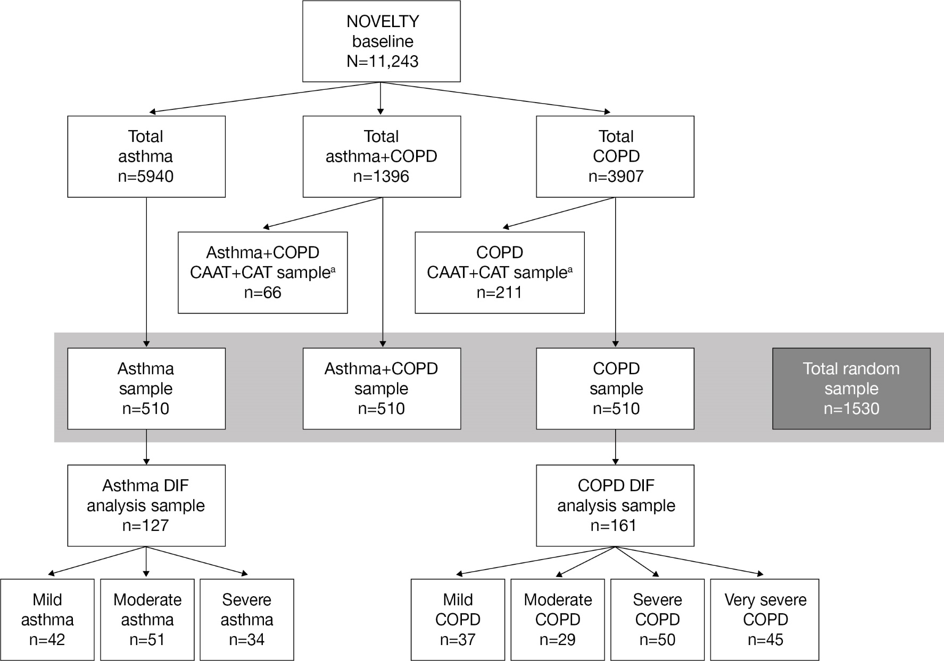
The DIF sample size was larger for COPD than for asthma to reflect an additional severity scoring category of ‘very severe’ for COPD. No patients with asthma were rated by clinicians as having ‘very severe’ disease.
CAAT Chronic Airways Assessment Test, CAT COPD Assessment Test, COPD chronic obstructive pulmonary disease, N total number of patients in the NOVELTY population, n number of patients in the diagnostic group or analysis sample, NOVELTY NOVEL observational longiTudinal studY
ªCAAT + CAT samples include all patients in the asthma+COPD and COPD groups who completed both the CAAT and CAT; these patients were also included in the overall asthma+COPD and COPD samples
Fig S3 Item response theory modelling of CAAT item information functions
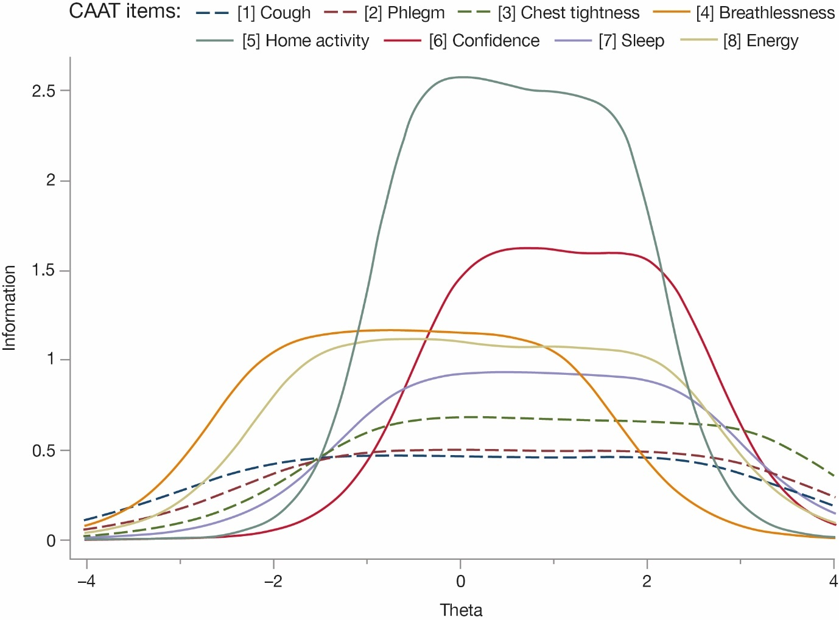
A higher level of information implies more precision [1]. Theta represents the continuum of patient responses to CAAT health status items. Items relating to symptoms (items 1–3) had broad coverage across theta but were less informative; items relating to functional impact (items 4–8) provided more information but had a narrower range
CAAT Chronic Airways Assessment Test
Fig S4 Linearity and dispersion in relationships between CAAT and SGRQ total scores at the individual patient level for patients with asthma and/or COPD in the total sample (A) and for patients with asthma (B), asthma+COPD (C) and COPD (D)
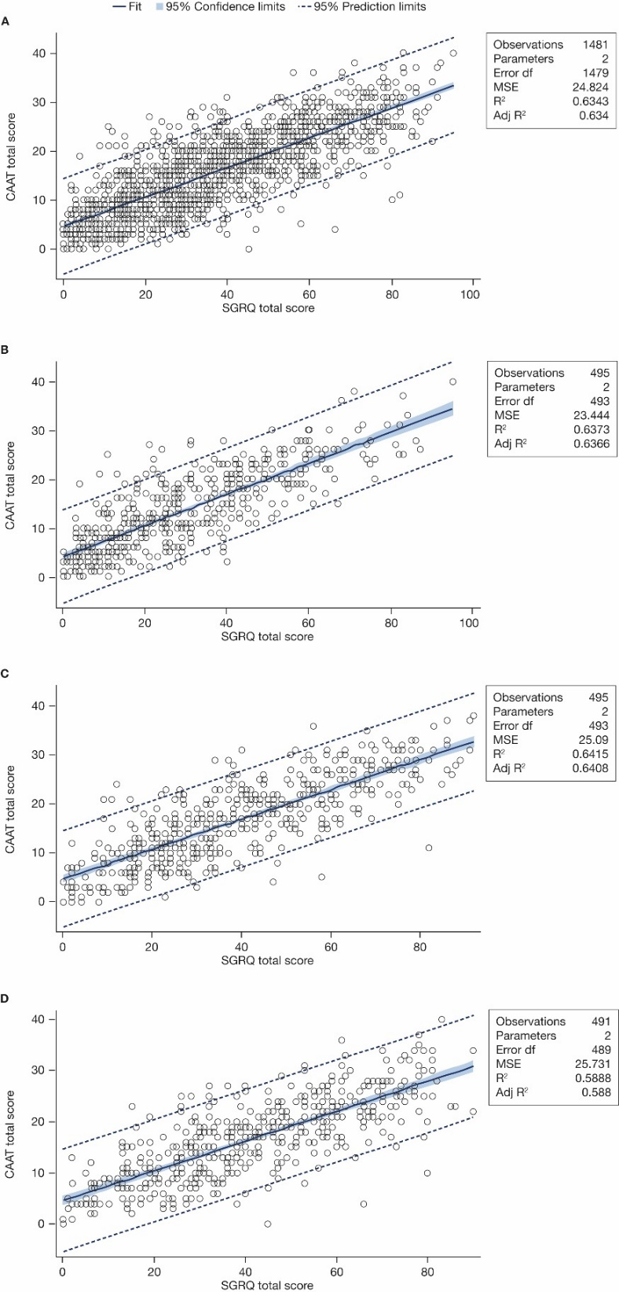
CAAT Chronic Airways Assessment Test, df degrees of freedom, MSE mean squared error, SGRQ St George’s Respiratory Questionnaire

References
1. Cappelleri JC, Lundy JJ, Hays RD. Overview of classical test theory and item response theory for the quantitative assessment of items in developing patient-reported outcomes measures. Clin Ther. 2014;36:648-662.

