A blood microRNA classifier for the prediction of ICU mortality in COVID-19 patients: A multicenter validation study

David de Gonzalo-Calvo,^{1,2} Marta Molinero,^{1,2} Iván D. Benítez,^{1,2} Manel Perez-Pons,^{1,2} Nadia García-Mateo,³ Alicia Ortega,^{2,3} Tamara Postigo,^{2,3} María C. García-Hidalgo,^{1,2} Thalia Belmonte,^{1,2} Carlos Rodríguez-Muñoz,^{1,2} Jessica González,^{1,2} Gerard Torres,^{1,2} Clara Gort-Paniello,^{1,2} Anna Moncusí-Moix,^{1,2} Ángel Estella,⁴ Luis Tamayo Lomas,^{2,5} Amalia Martínez de la Gándara,⁶ Lorenzo Socias,⁷ Yhivian Peñasco,⁸ Maria Del Carmen de la Torre,^{2,9} Elena Bustamante-Munguira,^{2,10} Elena Gallego Curto,^{2,11} Ignacio Martínez Varela,¹² María Cruz Martin Delgado,¹³ Pablo Vidal-Cortés,¹⁴ Juan López Messa,¹⁵ Felipe Pérez-García,^{16,17} Jesús Caballero,¹⁸ José M. Añón,^{2,19} Ana Loza-Vázquez ,²⁰ Nieves Carbonell,²¹ Judith Marin-Corral,²² Ruth Noemí Jorge García,²³ Carmen Barberà,²⁴ Adrián Ceccato,² Laia Fernández-Barat,^{2,25} Ricard Ferrer,^{2,26} Dario Garcia-Gasulla,²⁷ Jose Ángel Lorente-Balanza,^{2,28} Rosario Menéndez,^{2,29} Ana Motos,^{2,25} Oscar Peñuelas,^{2,30} Jordi Riera,^{2,26} Jesús F. Bermejo-Martin,^{2,31} Antoni Torres,^{2,25,32} Ferran Barbé,^{1,2}

1. Translational Research in Respiratory Medicine, University Hospital Arnau de Vilanova and Santa Maria, IRBLleida, Lleida, Spain.
2. CIBER of Respiratory Diseases (CIBERES), Institute of Health Carlos III, Madrid, Spain.
3. Group for Biomedical Research in Sepsis (BioSepsis). Instituto de Investigación Biomédica de Salamanca, (IBSAL), Gerencia Regional de Salud de Castilla y León, Salamanca, Spain.
4. Intensive Care Unit University Hospital of Jerez. Department of Medicine University of Cádiz, INIBiCA, Cádiz, Spain.
5. Critical Care Department, Hospital Universitario Río Hortega de Valladolid, Valladolid, Spain.
6. Department of Intensive Medicine, Hospital Universitario Infanta Leonor, Madrid, Spain.
7. Intensive Care Unit, Hospital Son Llàtzer, Palma de Mallorca, Illes Balears, Spain.
8. Servicio de Medicina Intensiva, Hospital Universitario Marqués de Valdecilla, Santander, Spain.
9. Servei de Medicina Intensiva, Hospital de Mataró (Consorci Sanitari del Maresme), Mataró, Spain.
10. Department of Intensive Care Medicine, Hospital Clínico Universitario Valladolid, Valladolid, Spain.
11. Unidad de Cuidados Intensivos, Hospital Universitario San Pedro de Alcántara, Cáceres, Spain.
12. Critical Care Department, Hospital Universitario Lucus Augusti, Lugo, Spain.
13. Hospital Universitario Torrejón-Universidad Francisco de Vitoria, Madrid, Spain.
14. Intensive Care Unit, Complexo Hospitalario Universitario de Ourense, Ourense, Spain.
15. Complejo Asistencial Universitario de Palencia, Palencia, Spain.
16. Servicio de Microbiología Clínica, Hospital Universitario Príncipe de Asturias – Universidad de Alcalá, Facultad de Medicina, Departamento de Biomedicina y Biotecnología, Madrid, Spain.
17. Centro de Investigación Biomédica en Red en Enfermedades Infecciosas (CIBERINFEC), Instituto de Salud Carlos III, Madrid, Spain.
18. Grup de Recerca Medicina Intensiva, Intensive Care Department Hospital Universitari Arnau de Vilanova, Lleida, Spain.
19. Servicio de Medicina Intensiva. Hospital Universitario La Paz, IdiPAZ, Madrid, Spain.
20. Unidad de Medicina Intensiva, Hospital Universitario Virgen de Valme, Seville, Spain.
21. Intensive Care Unit, Hospital Clínico y Universitario de Valencia, Valencia, Spain.
22. Critical Care Department, Hospital del Mar-IMIM, Barcelona, Spain.
23. Intensive Care Department, Hospital Nuestra Señora de Gracia, Zaragoza, Spain.
24. Intensive Care Department, University Hospital Santa María, IRBLleida, Lleida, Spain.
25. Servei de Pneumologia, Hospital Clinic; Universitat de Barcelona; IDIBAPS, Barcelona, Spain.
26. Intensive Care Department, Vall d’Hebron Hospital Universitari, SODIR Research Group, Vall d’Hebron Institut de Recerca (VHIR), Barcelona, Spain.
27. Barcelona Supercomputing Center (BSC), Barcelona, Spain.
28. Hospital Universitario de Getafe, Madrid, Spain; Dep. of Medicine, Universidad Europea, Madrid, Spain; Dep. of Bioengineering, Universidad Carlos III, Madrid, Spain.
29. Pulmonology Service, University and Polytechnic Hospital La Fe, Valencia, Spain.
30. Hospital Universitario de Getafe, Madrid, Spain
31. Hospital Universitario Río Hortega de Valladolid, Valladolid, Spain; Instituto de Investigación Biomédica de Salamanca (IBSAL), Salamanca, Spain.
32. Institució Catalana de Recerca i Estudis Avançats (ICREA), Barcelona, Spain.

Corresponding author:
Ferran Barbé
Translational Research in Respiratory Medicine, University Hospital Arnau de Vilanova and Santa Maria, IRBLleida
Address: Avda. Alcalde Rovira Roure 80 · 25198 Lleida, Spain
Phone: +34 973702491
Email: febarbe.lleida.ics@gencat.cat

SUPPLEMENTAL MATERIAL

Supplemental Tables

Supplemental Table S1. microRNA panel and its associations with severity and mortality previously reported in de Gonzalo-Calvo et al. Transl Res, 2021.

microRNA ID | Mature sequence | Outcome
hsa-miR-16-5p | UAGCAGCACGUAAAUAUUGGCG | Severity, in-ICU mortality and duration of ICU stay
hsa-miR-27a-3p | UUCACAGUGGCUAAGUUCCGC | Severity
hsa-miR-27b-3p | UUCACAGUGGCUAAGUUCUGC | Severity
hsa-miR-92a-3p | UAUUGCACUUGUCCCGGCCUGU | Severity, in-ICU mortality and duration of ICU stay
hsa-miR-93-5p | CAAAGUGCUGUUCGUGCAGGUAG | ICU stay
hsa-miR-98-5p | UGAGGUAGUAAGUUGUAUUGUU | In-ICU mortality
hsa-miR-132-3p | UAACAGUCUACAGCCAUGGUCG | In-ICU mortality
hsa-miR-148a-3p | UCAGUGCACUACAGAACUUUGU | Severity
hsa-miR-150-5p | UCUCCCAACCCUUGUACCAGUG | Severity and duration of ICU stay
hsa-miR-192-5p | CUGACCUAUGAAUUGACAGCC | In-ICU mortality
hsa-miR-199a-5p | CCCAGUGUUCAGACUACCUGUUC | Severity
hsa-miR-214-3p | ACAGCAGGCACAGACAGGCAGU | Duration of ICU stay
hsa-miR-323a-3p | CACAUUACACGGUCGACCUCU | In-ICU mortality
hsa-miR-451a | AAACCGUUACCAUUACUGAGUU | Severity
hsa-miR-486-5p | UCCUGUACUGAGCUGCCCCGAG | Severity
hsa-miR-491-5p | AGUGGGGAACCCUUCCAUGAGG | Severity

ICU: Intensive care unit

Supplemental Table S2. Impact of confounding factors on the relationship between microRNAs and all-cause in-ICU mortality.
 | Unadjusted |  |  |  | Adjusted
microRNA | Fold Change | p-value |  | microRNA | Fold Change | p-value
miR-16-5p | 0.643 | <0.001 |  | miR-16-5p | 0.764 | 0.0170
miR-92a-3p | 0.811 | 0.0081 |  | miR-92a-3p | 0.875 | 0.1150
miR-93-5p | 0.680 | 0.0011 |  | miR-93-5p | 0.785 | 0.0520
miR-98-5p | 0.593 | 0.0017 |  | miR-98-5p | 0.603 | 0.0050
miR-132-3p | 0.754 | 0.0387 |  | miR-132-3p | 0.752 | 0.0530
miR-150-5p | 0.860 | 0.1025 |  | miR-150-5p | 0.920 | 0.4010
miR-192-5p | 0.695 | 0.0048 |  | miR-192-5p | 0.905 | 0.4550
miR-323a-3p | 0.640 | 0.0013 |  | miR-323a-3p | 0.576 | <0.001
miR-451a | 0.675 | 0.0001 |  | miR-451a | 0.823 | 0.0530
miR-486-5p | 0.738 | 0.0008 |  | miR-486-5p | 0.815 | 0.0320
Adjusted for age, sex, hypertension, chronic pulmonary disease, chronic kidney disease, obesity and diabetes mellitus.

Supplemental Table S3. Association of candidates with all-cause in-ICU mortality.

 | HR (95% CI) | p-value
miR-16-5p | 1.982 (1.405-2.795) | <0.001
miR-92a-3p | 1.371 (0.987-1.904) | 0.06
miR-93-5p | 1.742 (1.249-2.430) | 0.001
miR-98-5p | 2.614 (1.412-4.839) | 0.002
miR-132-3p | 1.536 (1.047-2.251) | 0.028
miR-192-5p | 1.851 (1.323-2.589) | <0.001
miR-323a-3p | 2.014 (1.352-3.000) | 0.001
miR-451a | 1.995 (1.404-2.834) | <0.001
miR-486-5p | 1.715 (1.228-2.396) | 0.002
HR: Hazard ratio, 95% CI: 95% Confidence interval

Supplemental Table S4. Characteristics of patients with COVID-19-related critical excluded and included of the study.
 | ALL | Excluded patients | Included patients | p-value | Available data
 | N=5067 | N=4576 | N=491
Sociodemographic characteristics
Age (years), median [P25; P75] | 63.0 [54.0;71.0] | 63.0 [54.0;70.0] | 65.0 [56.0;73.0] | <0.001 | 5065
Female, n (%) | 1499 (29.6%) | 1344 (29.4%) | 155 (31.6%) | 0.329 | 5061
Body mass index (kg/cm²) , median [P25; P75] | 28.9 [26.0;32.3] | 28.9 [26.0;32.3] | 29.0 [26.1;32.7] | 0.780 | 4447
Smoking history, n (%) |  |  |  | 0.114 | 4334
Former | 1307 (30.2%) | 1162 (30.1%) | 145 (30.7%)
Nonsmoker | 2767 (63.8%) | 2478 (64.2%) | 289 (61.2%)
Current | 260 (6.00%) | 222 (5.75%) | 38 (8.05%)
Comorbidities
Hypertension, n (%) | 2517 (49.7%) | 2242 (49.0%) | 275 (56.0%) | 0.004 | 5062
Diabetes Mellitus, n (%) | 1246 (24.6%) | 1109 (24.3%) | 137 (27.9%) | 0.084 | 5063
Obesity, n (%) | 1832 (36.3%) | 1648 (36.1%) | 184 (37.5%) | 0.590 | 5052
Cardiovascular disease, n (%) | 618 (13.0%) | 552 (12.9%) | 66 (13.5%) | 0.781 | 4766
Chronic lung disease, n (%) | 491 (9.70%) | 432 (9.45%) | 59 (12.0%) | 0.080 | 5064
Chronic kidney disease, n (%) | 358 (7.07%) | 318 (6.95%) | 40 (8.16%) | 0.368 | 5063
Disease chronology
Time since first symptoms to ICU admission (days), median [P25; P75] | 9.00 [7.00;12.0] | 9.00 [7.00;13.0] | 9.00 [7.00;12.0] | 0.097 | 4929
Time since hospital admission to ICU admission (days), median [P25; P75] | 1.00 [0.00;4.00] | 1.00 [0.00;4.00] | 2.00 [0.00;4.00] | 0.470 | 4943
Hospital stay (days), median [P25; P75] | 24.0 [15.0;42.0] | 24.0 [15.0;42.0] | 25.0 [15.0;41.5] | 0.819 | 5063
ICU stay (days), median [P25; P75] | 14.0 [7.00;28.0] | 14.0 [7.00;28.0] | 14.0 [7.00;27.5] | 0.633 | 5031
Blood gases and laboratory parameters at ICU admission
Oxygen saturation (%), median [P25; P75] | 94.9 [91.0;97.0] | 95.0 [91.0;97.0] | 94.0 [90.0;97.0] | 0.018 | 4333
PaCO₂ (mmHg), median [P25; P75] | 39.0 [34.0;47.0] | 39.0 [34.0;47.8] | 38.7 [33.2;45.0] | 0.006 | 4513
pH, median [P25; P75] | 7.41 [7.33;7.46] | 7.41 [7.33;7.46] | 7.41 [7.35;7.45] | 0.633 | 4604
PaO₂/FiO₂, median [P25; P75] | 111 [80.0;162] | 111 [80.0;163] | 107 [76.0;148] | 0.020 | 4292
Glucose (mg/dL), median [P25; P75] | 144 [115;194] | 143 [114;193] | 159 [129;207] | <0.001 | 4554
Creatinine (mg/dL), median [P25; P75] | 0.83 [0.67;1.09] | 0.82 [0.66;1.09] | 0.84 [0.70;1.15] | 0.065 | 4964
C-reactive protein (mg/L), median [P25; P75] | 129 [58.0;223] | 130 [58.3;225] | 121 [57.0;216] | 0.427 | 4687
D-dimer (ng/mL), median [P25; P75] | 1070 [554;2749] | 1080 [553;2940] | 1023 [562;1898] | 0.076 | 4364
Leukocyte count (x10⁹/L), median [P25; P75] | 9.25 [6.58;13.0] | 9.20 [6.51;12.9] | 9.90 [7.20;13.8] | 0.001 | 4966
Neutrophil count (x10⁹/L), median [P25; P75] | 7.94 [5.40;11.4] | 7.81 [5.30;11.3] | 8.90 [6.17;12.5] | <0.001 | 4755
Lymphocyte count (x10⁹/L), median [P25; P75] | 0.67 [0.45;0.98] | 0.68 [0.46;0.99] | 0.63 [0.41;0.88] | 0.015 | 4868
Monocyte count (x10⁹/L), median [P25; P75] | 0.37 [0.20;0.56] | 0.37 [0.20;0.55] | 0.40 [0.23;0.56] | 0.135 | 4494
Platelet count (x10⁹/L), median [P25; P75] | 237 [181;311] | 237 [180;312] | 236 [185;307] | 0.776 | 4962
AST (U/L), median [P25; P75] | 45.0 [31.0;71.9] | 46.0 [31.0;72.0] | 42.6 [29.0;68.0] | 0.018 | 3658
ALT (U/L), median [P25; P75] | 40.0 [25.0;66.0] | 40.0 [25.0;65.0] | 41.0 [25.0;67.0] | 0.821 | 4324
Urea (mg/dL), median [P25; P75] | 46.0 [34.0;64.0] | 45.8 [33.0;63.0] | 52.0 [38.0;73.0] | <0.001 | 4069
Severity scores at ICU admission
APACHE-II score, median [P25; P75] | 12.0 [9.00;15.0] | 12.0 [9.00;15.0] | 12.0 [9.00;17.0] | 0.022 | 2705
SOFA Score, median [P25; P75] | 5.00 [3.00;7.00] | 5.00 [3.00;7.00] | 5.00 [4.00;7.25] | 0.009 | 3260
Interventions during ICU stay
Antibiotics, n (%) | 4750 (94.2%) | 4289 (94.2%) | 461 (94.1%) | 0.995 | 5043
Hydroxychloroquine, n (%) | 2310 (45.8%) | 2278 (50.0%) | 32 (6.54%) | <0.001 | 5042
Tocilizumab, n (%) | 2098 (41.6%) | 1973 (43.3%) | 125 (25.6%) | <0.001 | 5042
Corticoids, n (%) | 4410 (87.9%) | 3927 (86.7%) | 483 (98.8%) | <0.001 | 5018
High flow oxygen nasal cannula, n (%) | 2990 (75.6%) | 2643 (75.0%) | 347 (80.5%) | 0.014 | 3955
Non-invasive positive pressure ventilation, n (%) | 1753 (36.6%) | 1609 (37.4%) | 144 (29.9%) | 0.002 | 4788
Invasive mechanical ventilation, n (%) | 3796 (76.0%) | 3412 (75.8%) | 384 (78.4%) | 0.222 | 4993
Prone positioning, n (%) | 3079 (62.6%) | 2802 (63.3%) | 277 (56.5%) | 0.004 | 4920
Outcome
All-cause in-ICU mortality, n (%) | 1560 (30.8%) | 1416 (30.9%) | 144 (29.3%) | 0.493 | 5067
Continuous variables are expressed as the median [P25;P75] and categorical variables as n. ALT: alanine aminotransferase; AST: aspartate aminotransferase; FiO₂: fraction of inspired oxygen; ICU: Intensive care unit; PaCO₂: carbon dioxide partial pressure; PaO₂: oxygen partial pressure.

Supplemental Figures
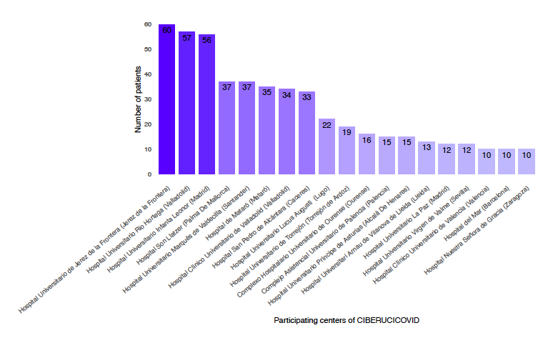

Figure S1. Samples provided by each participating hospital.

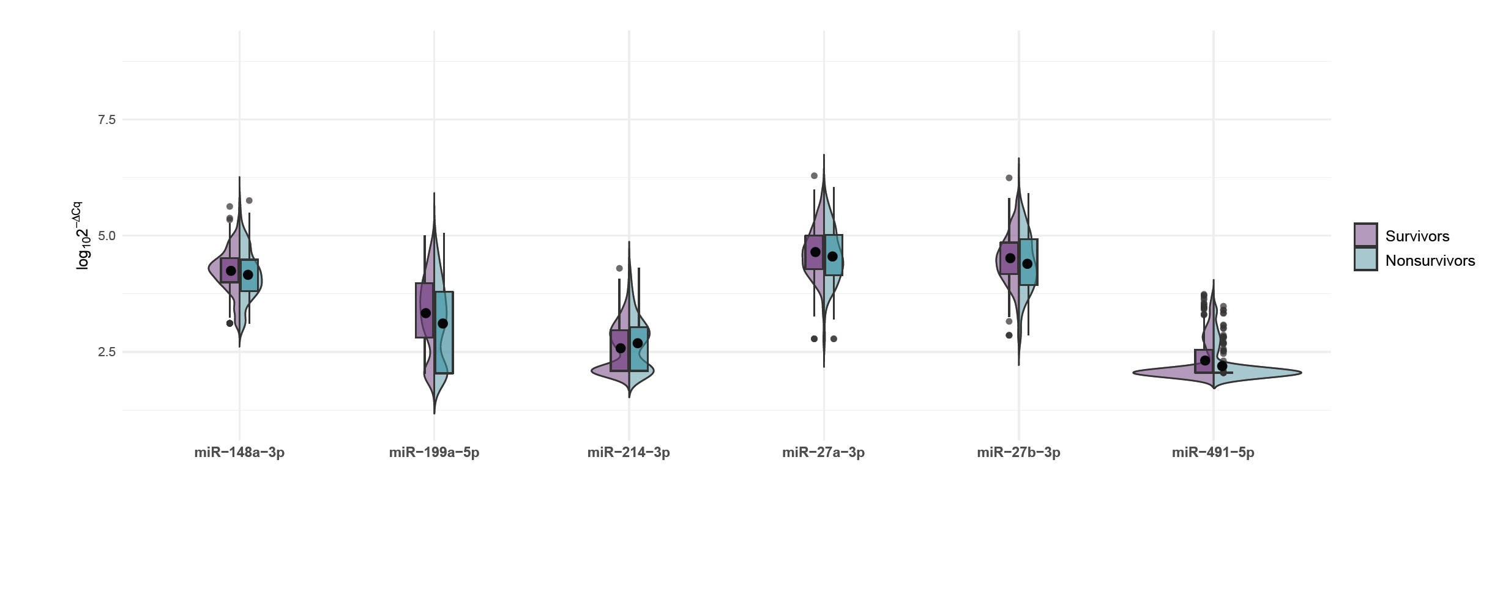
Figure S2. Nonvalidated microRNAs. Violin plot comparing nonvalidated microRNA levels between survivors and nonsurvivors. All these candidates showed contradicting results to that observed in a previous study from our group (de Gonzalo-Calvo et al. Transl Res, 2021).

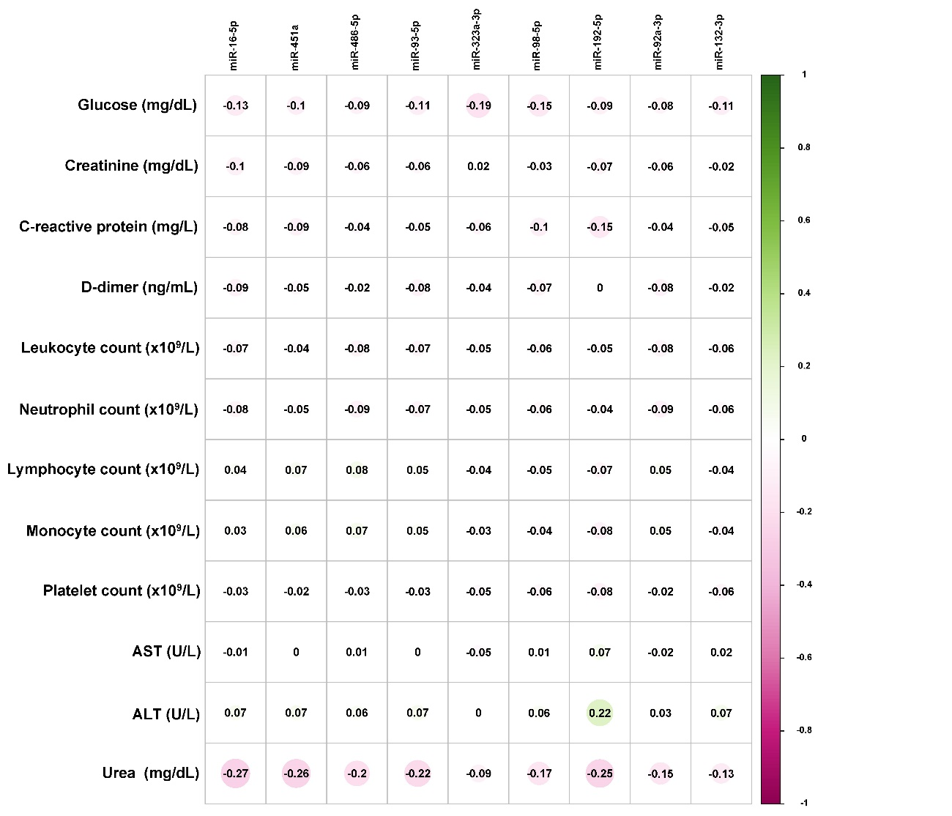

Figure S3. Correlation between validated microRNAs with blood cell counts and biochemical parameters in the whole population. Pearson correlation coefficient was used to assess the correlation between continuous variables. ALT: alanine aminotransferase; AST: aspartate aminotransferase.

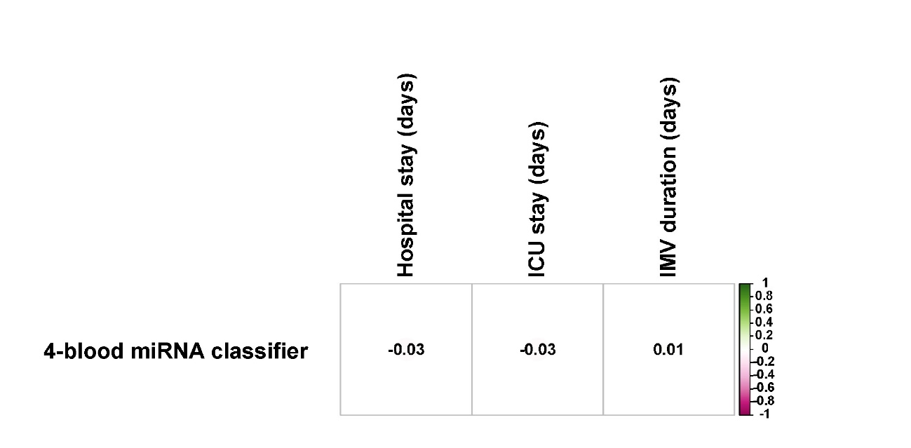

Figure S4. Correlation between the 4-blood microRNA classifier and the duration of hospital stay, ICU stay and invasive mechanical ventilation in critically ill survivors. Pearson correlation coefficient was used to assess the correlation between continuous variables. ICU: Intensive care unit; IMV: invasive mechanical ventilation.

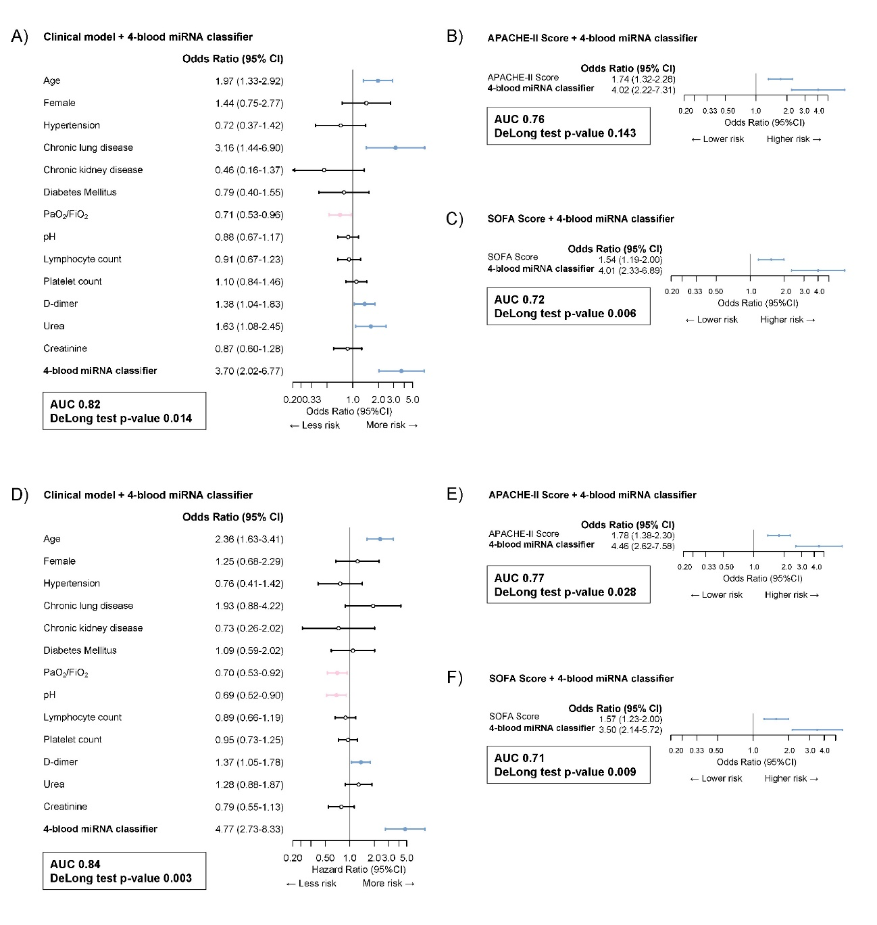
Figure S5. Combination of the 4-blood microRNA classifier with established clinical predictors or contemporaneous prognostic scores for all-cause 28-day mortality (A-C) and all-cause 90-day mortality (D-F). For all-cause 28-day mortality: A) clinical model (n=377); B) APACHE-II (n=355); C) SOFA (n=379). For all-cause 90-day mortality: D) Clinical model (n=377); E) APACHE-II (n=355); F) SOFA (n=379). The graph displays the Hazard Ratio (HR) and 95% confidence interval (90% CI) for each variable. Cox regression models include the dichotomized levels of the 4-blood microRNA classifier. Hazard Ratio (95%CI) are displayed as 1-SD change for continuous predictor.

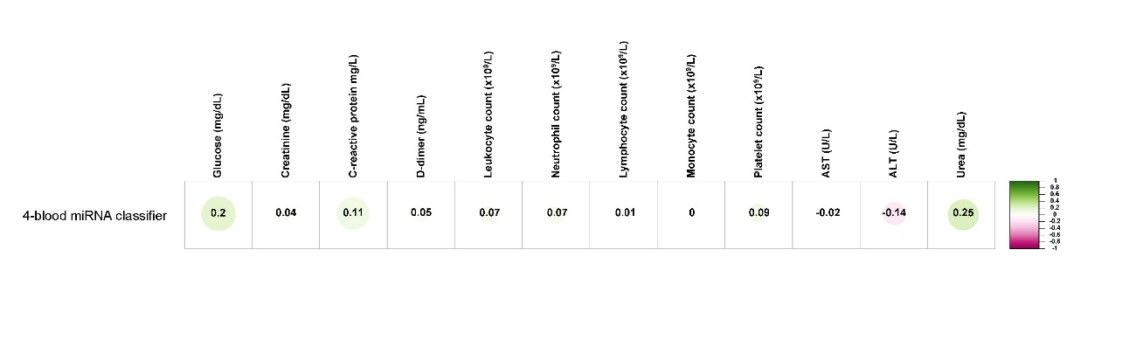
Figure S6. Correlation between the 4-blood miRNA classifier with blood cell counts and biochemical parameters in the whole population. Pearson correlation coefficient was used to assess the correlation between continuous variables. ALT: alanine aminotransferase; AST: aspartate aminotransferase.

