Supplementary materials

Table E1: LCI_{2.5} follow up measurements. LCI data was not linearly collected on participants every six months as intended due to the COVID-19 pandemic. Thus, LCI measurements were taken within three months of LUM/IVA initiation and again at random intervals over the two-year study period.

Number of LCI_{2.5} per patient | Total n=28
1 | 10
2 | 5
3 | 8
4 | 3
5 | 2
6 | 2

Table E2: Correlation coefficients for intra and inter observer agreement
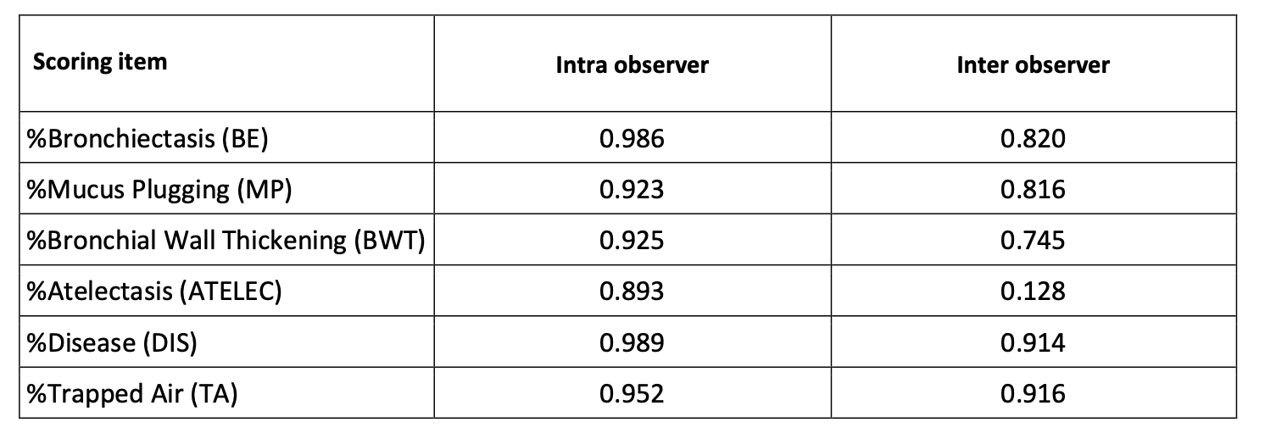

Table E3: Comparison of % disease at baseline in similar cohorts
Cohort | Sample size | Mean age, years (range) | Baseline % disease (95% CI)
CFORMS | 32 | 8.8 (6.05 – 11.56) | 2.78 (2.12 - 3.45)
Bouma et al. 2020 | 61 | 10.65 (8.75 - 11.83) | 1.73 (0.28 - 2.86)
Svedberg et al. 2020 | 75 | 6.8 (6-12) | 4.67 (0.30–17.49)

Figure E1: Stacked histogram sorted by % disease at baseline
(BE = bronchiectasis, Plug = mucus plugging, AWT = airway wall thickness, Atelec = atelectasis)

