Additional file 1

Apoptosis inhibitor of macrophage (AIM)/CD5L is involved in the pathogenesis of COPD

Michiko Takimoto-Sato¹, Masaru Suzuki¹, Hiroki Kimura^{1,2}, Haiyan Ge³, Munehiro Matsumoto¹, Hironi Makita⁴, Satoko Arai^{5,6}, Toru Miyazaki^{6,7}, Masaharu Nishimura^{1,4}, Satoshi Konno¹

- Department of Respiratory Medicine, Faculty of Medicine and Graduate School of Medicine, Hokkaido University, Sapporo, Japan.
- Division of Pulmonary, Critical Care and Sleep Medicine, Department of Medicine, Icahn School of Medicine at Mount Sinai, New York, United States of America.
- Department of Respiratory and Critical Care Medicine, Huadong Hospital, Fudan University, Shanghai, China.
- Hokkaido Medical Research Institute of Respiratory Diseases, Sapporo, Japan.
- Laboratory of Molecular Biomedicine for Pathogenesis, Center for Disease Biology and Integrative Medicine, Faculty of Medicine, University of Tokyo, Japan.
- The Institute for AIM Medicine, Tokyo, Japan.
- LEAP, Japan Agency for Medical Research and Development, Tokyo, Japan.

Corresponding author: Masaru Suzuki, M.D., Ph.D.
Department of Respiratory Medicine, Faculty of Medicine and Graduate School of Medicine, Hokkaido University, Sapporo, Japan
North 15 West 7, Kita-ku, Sapporo 060-8638, Japan
E-mail: suzumasa@med.hokudai.ac.jp

Supplementary figure legends

Figure S1. Gene expressions in the lungs from PPE-treated mice
Gene expression in the lungs during PPE treatment was assessed using qRT-PCR. (A) IL-1β, (B) IL-5, (C) IL-6, (D) MMP--9, (E) CCL2, (F) TNF-α, (G) IFN-γ.
Data are expressed as mean ± SEM (n = 3-5). ✻p <0.05 by the Mann–Whitney U test.

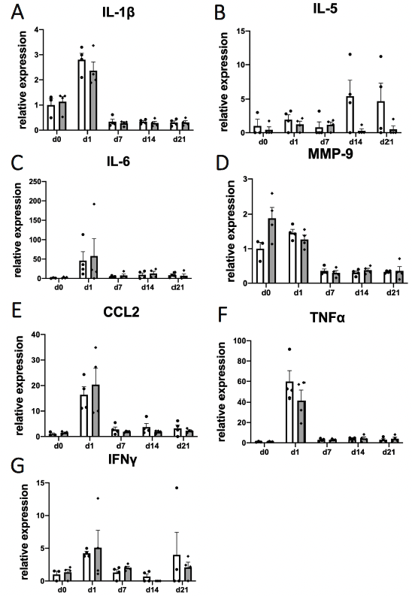

Table S1. Characteristics in the study on patients with different smoking status (n=50)

 | Nonsmokers  (n=16) | Healthy smokers  (n=15) | Smokers with  COPD  (n=19) | p value
Age, years | 70.7 ± 10.5 | 64.5 ± 8.3 | 65.6 ± 8.7 | 0.21
Male, n (%) | 15 (93.8) | 11 (73.3) | 17 (89.5) | 0.22
Pack-years | 1.7 ± 3.3 | 45.9 ± 26.3 | 53.8 ± 19.9 | <0.001
Current smoker, n (%) | 0 (0) | 7 (43.8) | 9 (47.4) | 0.004
FEV₁, % predicted | 125.2 ± 16.5 | 104.5 ± 17.7 | 65.0 ± 19.5 | <0.001
FEV₁/FVC, % | 77.2 ± 3.7 | 76.7 ± 4.4 | 45.8 ± 11.3 | <0.001
Notes: Values are expressed as means ± SD or number (%). Statistical analyses were performed using the Kruskal-Wallis test or the chi-square test.

Abbreviations: COPD, chronic obstructive lung disease; FEV₁, forced expiratory volume in 1 second; FVC, forced vital capacity.

Table S2. Baseline characteristics in the Hokkaido COPD cohort (n=133)
 | Low AIM/IgM (Q1)  (n=33) | Moderate AIM/IgM (Q2-3)  (n=67) | High  AIM/IgM (Q4)  (n=33) | p value
Age, years | 67.1 ± 9.3 | 70.2 ± 8.2 | 72.6 ± 6.1 | 0.046
Male, n (%) | 29 (87.9) | 61 (91.0) | 32 (97.0) | 0.39
Body mass index, kg/m² | 21.6 ± 3.2 | 22.3 ± 3.4 | 21.8 ± 3.1 | 0.64
GOLD stage 1 / 2 / 3 / 4 | 12 / 14 / 5 / 2 | 19 / 32 / 15 / 1 | 7 / 12 / 10 / 4 | 0.21
Pack-years | 61.9 ± 28.4 | 63.3 ± 32.5 | 62.0 ± 25.9 | 0.96
Current smoker, n (%) | 13 (39.4) | 11 (16.4) | 11 (33.3) | 0.03
FEV₁, % predicted | 69.0 ± 25.4 | 66.4 ± 20.4 | 60.5 ± 25.7 | 0.26
FEV₁/FVC, % | 53.2 ± 11.1 | 52.0 ± 12.8 | 48.5 ± 13.1 | 0.37
Bronchodilator responsiveness  of FEV₁, %＊ | 15.2 ± 15.5 | 12.0 ± 11.6 | 12.6 ± 13.5 | 0.90
DL_{CO}, % predicted | 81.7 ± 22.5 | 78.1 ± 24.0 | 73.5 ± 18.8 | 0.42
K_{CO}, % predicted | 62.8 ± 19.5 | 67.3 ± 25.0 | 61.9 ± 20.6 | 0.37
Annual decline in FEV₁, mL/year† | -6.2 ± 4.7 | -6.6 ± 4.1 | -6.2± 4.4 | 0.85
CT emphysema score | 1.3 ± 1.0 | 1.5 ± 0.9 | 1.7 ± 4.3 | 0.19
mMRC dyspnea score ≥2, n (%) | 16 (48.5) | 36 (53.7) | 32 (97.0) | 0.86
SGRQ total score | 30.8 ± 15.8 | 29.5 ± 15.1 | 30.2 ± 20.0 | 0.93
Exacerbation, events/year‡ | 0.11 ± 0.29 | 0.12 ± 0.30 | 0.18 ± 0.33 | 0.32
Notes: Values are expressed as means ± SD or number (%). Statistical analyses were performed using the Kruskal-Wallis test or the chi-square test.
＊n=132; †n=124; ‡n=130.
Abbreviations: COPD, chronic obstructive lung disease; GOLD, Global Initiative for Chronic Obstructive Lung Disease; FEV₁, forced expiratory volume in 1 second; FVC, forced vital capacity; DL_{CO}, carbon monoxide diffusion capacity; K_{CO}, carbon monoxide transfer coefficient; CT, computed tomography; mMRC, modified medical research council; SGRQ, St. George's respiratory questionnaire.

Table S3. Risk factors for prognosis in the Hokkaido COPD cohort

 | Time to first exacerbation |  | All-cause  mortality |  | Respiratory-cause mortality
 | HR  (95% CI) | p value | HR  (95% CI) | p value | HR  (95% CI) | p value
Serum AIM/IgM ratio  (1 increase in natural logarithm) | 2.27  (0.92-5.57) | 0.07 | 2.40  (1.11-5.17) | 0.03 | 5.41  (1.73-16.85) | 0.004
Age (1 year older) | 1.03  (0.99-1.07) | 0.17 | 1.11  (1.06-1.16) | <0.001 | 1.13  (1.05-1.21) | 0.001
Current smoking | 0.91  (0.46-1.81) | 0.80 | 0.88  (0.61-2.09) | 0.69 | 0.81  (0.27-2.44) | 0.71
Notes: Statistical analyses were performed using multivariate Cox proportional hazards model.
Abbreviations: COPD, chronic obstructive lung disease; HR, hazard ratio; CI, confidence interval.

