Additional File 2: Fig. S1 A Total lung, B regional small airways, and C central lung deposition for LAMA components of each treatment
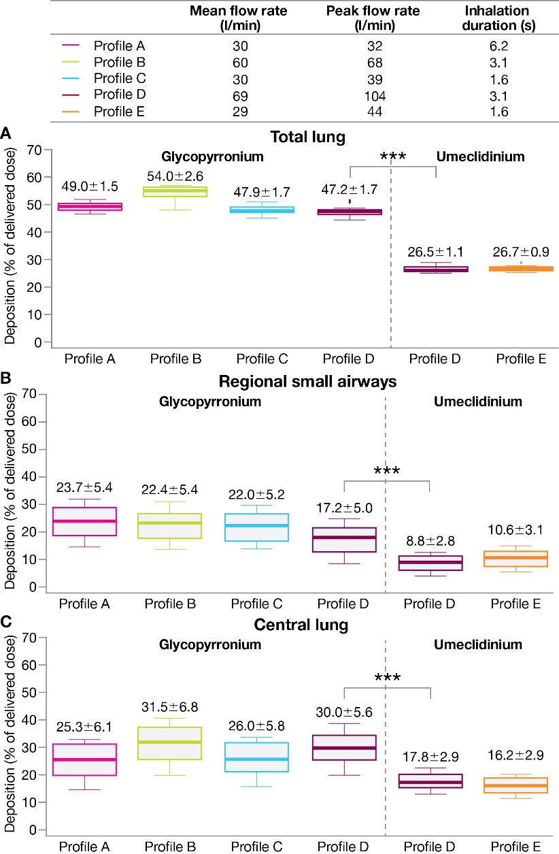
***Nominal p<0.001 (paired t-test) for BGF versus FF/UM/VI based on mean difference (95% CI): total lung, 20.7 (19.9–21.5); regional small airways, 8.4 (7.4–9.5); central lung, 12.3 (10.8–13.7)
Data labels: mean ±SD. Extremes of box: upper and lower quartiles. Horizontal line within box: median. Whiskers: extend to most extreme data points no more than 1.5 times the interquartile range. Individual data points beyond whiskers: outliers beyond 1.5 times the interquartile range
BGF, budesonide/glycopyrronium/formoterol fumarate dihydrate; CI, confidence interval; FF/UM/VI, fluticasone furoate/umeclidinium/vilanterol; LAMA, long-acting muscarinic antagonist; SD, standard deviation

