Additional File 3: Fig. S2 A Total lung, B regional small airways, and C central lung deposition for LABA components of each treatment
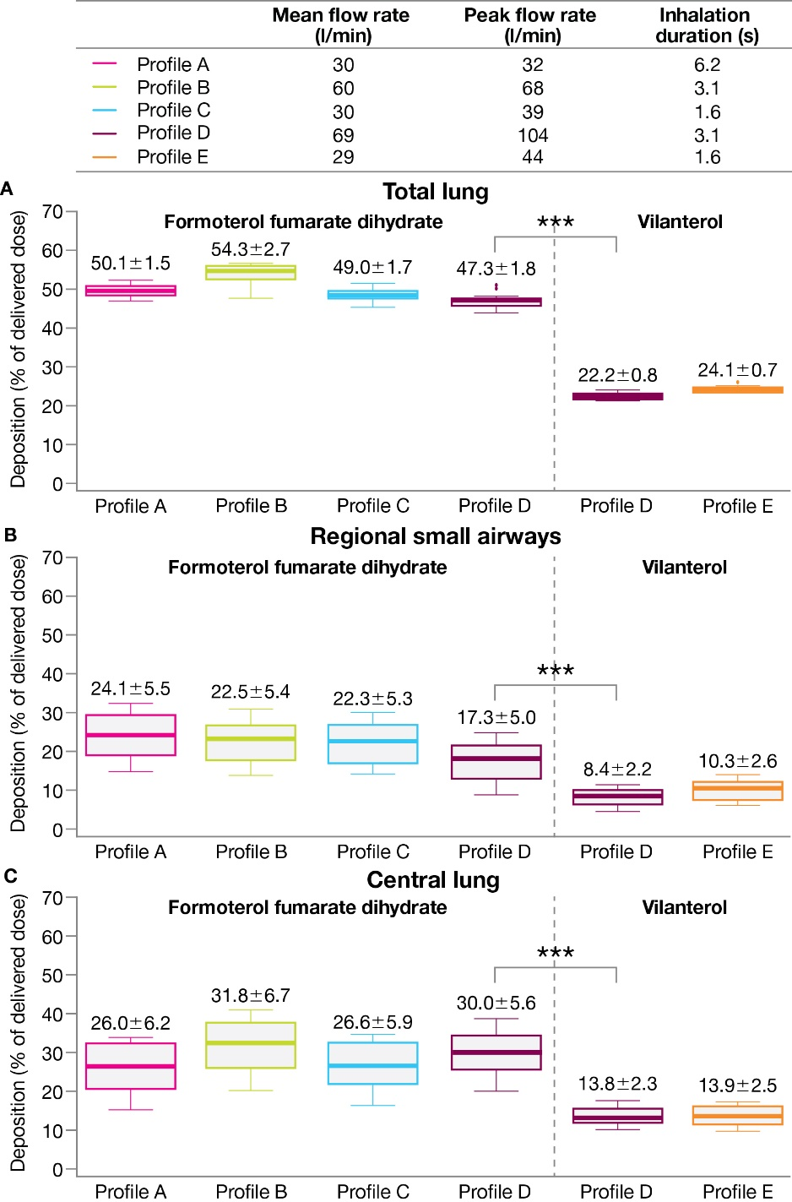
***Nominal p<0.001 (paired t-test) for BGF versus FF/UM/VI based on mean difference (95% CI): total lung, 25.1 (24.4–25.9); regional small airways, 8.9 (7.6–10.3); central lung, 16.2 (14.5–17.8)
Data labels: mean ±SD. Extremes of box: upper and lower quartiles. Horizontal line within box: median. Whiskers: extend to most extreme data points no more than 1.5 times the interquartile range. Individual data points beyond whiskers: outliers beyond 1.5 times the interquartile range
BGF, budesonide/glycopyrronium/formoterol fumarate dihydrate; CI, confidence interval; FF/UM/VI, fluticasone furoate/umeclidinium/vilanterol; LABA, long-acting β₂-agonist; SD, standard deviation

