Supplementary S1
Flow chart demonstrating the number of AATD and Non-AATD patients at each research database
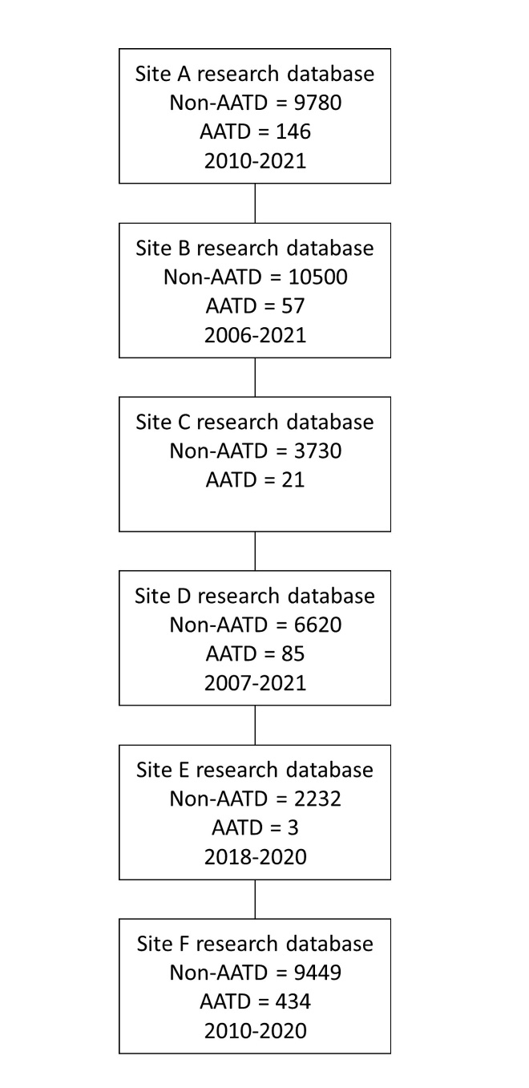
Figure 1. Flow chart demonstrating the number of AATD and Non-AATD patients at each research database and the respective recording period

