Supplement

 |  |  |  |  |  | Number of events in:
N | Events | Censored | Median survival time in months  [95% CI] | Min | Max | Months 1-12 | Months 13-24 | Months 25-36 | Months  37-48 | Months 49-60
601 | 171 (28.5%) | 430 (71.5%) | 58.7 [50.1, n.e.] | 0.1 | 58.7 | 60 (35.1%) | 48 (28.1%) | 35 (20.5%) | 25 (14.6%) | 3  (1.8%)
Table S1 Summary of survival time in months since date of inclusion analysis.
Survival time was defined as time between date of death and date of inclusion + 1 day in months. Individuals who do not experience death until the registry was closed, who were lost to follow up or withdraw from the registry are censored. N= number of patients at risk, CI= confidence interval.

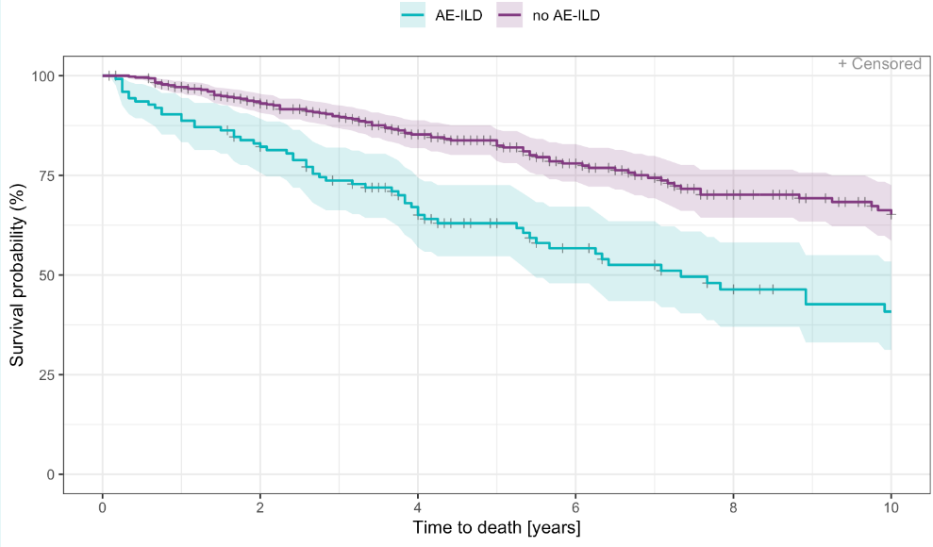
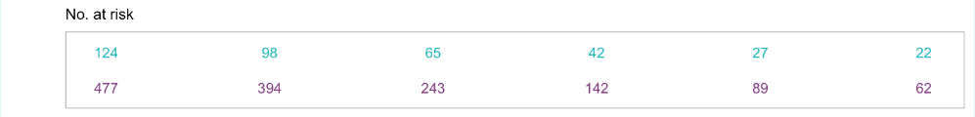

Figure S1 Survival time in years - Kaplan Meier curve (years 0-10) by AE-ILD/no AE-ILD
Survival time was defined as time between date of death and date of inclusion + 1 day. All patients with a recorded acute exacerbation were counted as AE-ILD.

