Increased di-(2-ethylhexyl) phthalate exposure poses a differential risk for adult asthma clusters

Detail
Study design | Cross-sectional study
Duration | Participants were recruited between 2011 and 2015
Location | Kaohsiung City, Taiwan
Control group (N=235) | Undergoing routine checkups; without T2DM, hypertension, and other respiratory and allergic diseases
Case group (N=365) | Current asthma attending clinical visits
Grouping
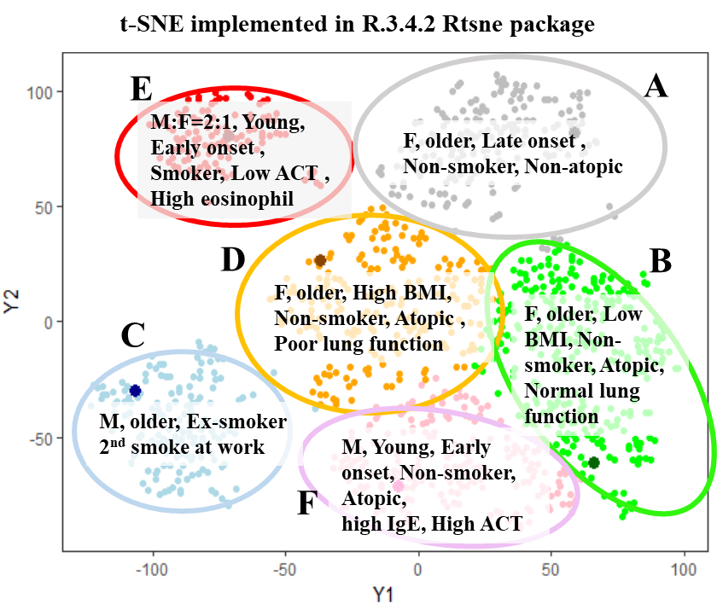  A. Phenotypic clusters  Asthma phenotypic clustering was classified by t-SNE integrating 18 clinical, physiologic, pathologic, and demographic parameters. |  | 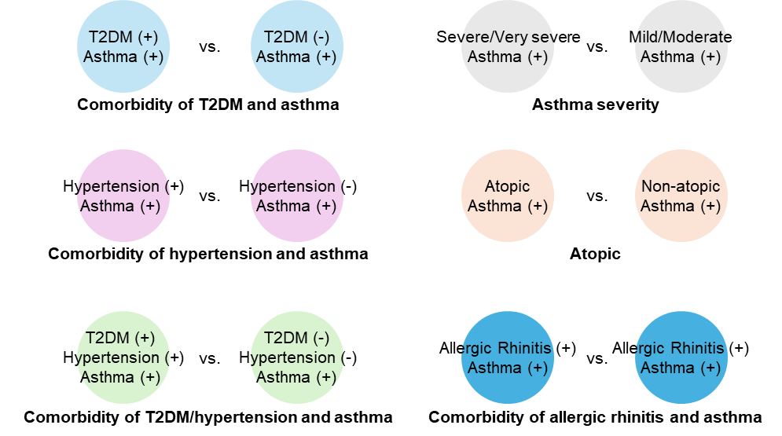  B. Asthma with comorbidity
Collection | Assessment
Urine | DEHP metabolites, such as MEHP and MEHHP; oxidative stress markers
Plasma | Sphingolipid metabolites and inflammation markers
Questionnaire | Demographic information, lifestyle factors, medical history, and medication records, among others

Figure A.1. Study Schematic.

Table A.1. Frequency of using plastic packaging for both food and drinks (N=600).
Cluster | Plastic packaging for food  (times/week) | Plastic packaging for drinks  (times/week)
A | 2 | 2
B | 2 | 3
C | 3 | 3
D | 2 | 3
E | 3 | 4
F | 2 | 2

Table A.2. Correlation between total IgE and urinary DEHP metabolites.
 |  | Urinary DEHP metabolites
 |  | MEHP+MEHHP |  |  | MEHP |  |  | MEHHP
Stratification | Status | ρ | P-value |  | ρ | P-value |  | ρ | P-value
Asthma | + | -0.01 | 0.94 |  | 0.02 | 0.79 |  | -0.05 | 0.50
Asthma | - | NA | NA |  | NA | NA |  | NA | NA
Phenotypic clusters of asthma | A | 0.02 | 0.91 |  | -0.09 | 0.68 |  | 0.10 | 0.64
Phenotypic clusters of asthma | B | -0.07 | 0.62 |  | -0.08 | 0.60 |  | -0.13 | 0.36
Phenotypic clusters of asthma | C | -0.01 | 0.96 |  | 0.10 | 0.58 |  | -0.09 | 0.60
Phenotypic clusters of asthma | D | -0.04 | 0.82 |  | 0.19 | 0.31 |  | -0.17 | 0.38
Phenotypic clusters of asthma | E | 0.21 | 0.61 |  | -0.05 | 0.91 |  | -0.31 | 0.46
Phenotypic clusters of asthma | F | 0.08 | 0.67 |  | -0.01 | 0.95 |  | 0.09 | 0.61
Severityª | ++ | 0.02 | 0.86 |  | 0.09 | 0.45 |  | -0.04 | 0.71
Severityª | + | -0.03 | 0.77 |  | -0.03 | 0.75 |  | -0.04 | 0.69
Atopic | + | 0.01 | 0.94 |  | 0.07 | 0.44 |  | -0.08 | 0.37
Atopic | - | 0.05 | 0.76 |  | -0.12 | 0.50 |  | 0.16 | 0.35
Asthma/T2DM | + | -0.07 | 0.78 |  | -0.13 | 0.60 |  | -0.08 | 0.74
Asthma/T2DM | - | 0.00 | 0.97 |  | 0.04 | 0.66 |  | -0.05 | 0.55
Asthma/hypertension | + | -0.09 | 0.51 |  | -0.07 | 0.59 |  | -0.15 | 0.28
Asthma/hypertension | - | 0.03 | 0.74 |  | 0.06 | 0.54 |  | 0.00 | 0.98
Asthma/T2DM/hypertension | + | 0.13 | 0.70 |  | -0.14 | 0.66 |  | 0.15 | 0.65
Asthma/T2DM/hypertension | - | 0.06 | 0.53 |  | 0.08 | 0.39 |  | 0.03 | 0.79
Asthma/allergic rhinitis | + | 0.01 | 0.88 |  | 0.05 | 0.58 |  | -0.06 | 0.51
Asthma/allergic rhinitis | - | -0.07 | 0.63 |  | -0.06 | 0.64 |  | -0.01 | 0.93
NA, not applicable.
ª ++, severe/very severe; +, mild/moderate.

