Supplementary Table 1. Histopathological observations in three bleomycin-induced lung fibrosis studies

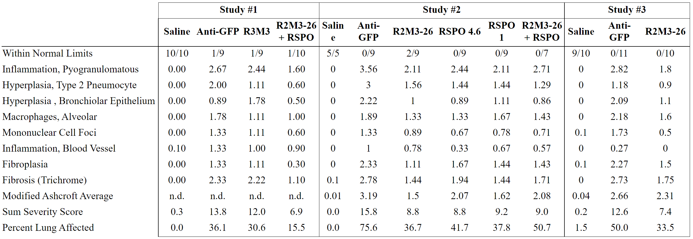

Supplementary Table 1. Histopathological observations in three bleomycin-induced lung fibrosis studies. Animals were euthanized at termination. Samples were processed as described in the Methods, and scored in a blinded manner by a veterinary histopathologist.

Supplementary Table 2. Effect of R2M3-26 on cytokines and BALF in a bleomycin-induced lung fibrosis model.

 | Saline |  | Anti-GFP |  |  | R2M3-26
 | Average | SEM | Average | SEM | vs Saline | Average | SEM | vs anti-GFP
Cytokines | pg/mL
CCL2 | 6.2 | 0.5 | 99.5 | 29.5 | **** | 13.7 | 1.9 | *
CCL3 | 5.6 | 0.9 | 19.1 | 7.7 | ** | 6.8 | 1.4 | *
CCL21 | 337.7 | 33.7 | 5601.5 | 1725.2 | **** | 3481.5 | 997.4
CSF3 | 2.0 | 0.2 | 216.2 | 177.0 | **** | 9.0 | 0.7 | *
IFNB1 | 34.6 | 1.7 | 60.1 | 5.2 | *** | 46.3 | 4.3
IL1A | 26.3 | 2.9 | 14.2 | 1.6 | ** | 15.0 | 2.8
IL5 | 0.2 | 0.2 | 32.1 | 26.2 | **** | 0.9 | 0.3 | *
IL6 | 0.3 | 0.0 | 1367.6 | 729.7 | **** | 5.0 | 2.1 | *
IL11 | 2.0 | 0.3 | 170.3 | 153.1 | ** | 2.5 | 0.5 | *
IL16 | 349.5 | 39.8 | 1151.4 | 172.6 | *** | 747.8 | 147.7
LIF | 0.2 | 0.2 | 27.3 | 16.7 | **** | 2.5 | 0.4 | *
MCP1 | 5.6 | 1.1 | 21.3 | 7.8 |  | 7.7 | 1.4
MCP5 | 2.5 | 0.2 | 33.6 | 10.2 | *** | 25.8 | 4.2
MDC | 17.3 | 1.3 | 55.5 | 6.7 | *** | 48.9 | 6.1
MIP3B | 4.7 | 1.7 | 16.2 | 2.6 | ** | 12.3 | 2.8
TARC | 15.3 | 1.5 | 98.3 | 15.8 | **** | 52.1 | 7.3
TIMP1 | 41.8 | 4.7 | 1160.6 | 449.3 | **** | 262.2 | 43.7 | *
BALF cells | 10E9/L
Total cell count | 0.23 | 0.02 | 0.75 | 0.20 | **** | 0.49 | 0.40
Macrophages | 0.22 | 0.02 | 0.39 | 0.04 | **** | 0.35 | 0.02
Lymphocytes | 0.00 | 0.00 | 0.35 | 0.18 | **** | 0.13 | 0.02
Neutrophils | 0.000 | 0.00 | 0.015 | 0.008 | * | 0.002 | 0.001

Supplementary Table 2. Effect of R2M3-26 on cytokines and cell numbers in the BALF in a bleomycin-induced lung fibrosis model. Cytokine levels are shown in pg/mL of BALF. Cells are shown as a proportion of 10E9/L. Asterisks represent the significance of the p-values for the indicated comparison at the top of each section as follows: * < 0.05, ** < 0.01, *** < 0.001, **** < 0.0001.

Supplementary Table 3
Reagents
REAGENT or RESOURCE | SOURCE | IDENTIFIER
R2M3-26 | Surrozen, Inc. | (63, 65)
R2M3 | Surrozen, Inc. | (65)
RSPO2 (RSPO2 appended to human Fc) | Surrozen, Inc. | (59)
Anti-GFP human IgG1 | Surrozen, Inc. | (65)
Advanced DMEM | Thermo Scientific | 12634-010
HEPES | Thermo Scientific | 15630080
GlutaMAX | Thermo Scientific | 35050061
Penicillin-Streptomycin | Thermo Scientific | 15140122
B27 | Thermo Scientific | 17504044
N-acetylcysteine | Sigma-Aldrich | A9165
CHIR99021 | Tocris | 4423
WNT-C59 | Tocris | 5148
SB431542 | Abcam | Ab120163
BIRB796 | Tocris | 5989
DMH-1 | Tocris | 41-261-0
Heparin | Sigma-Aldrich | H3149
Recombinant Human EGF | Peprotech | AF-100-15
Recombinant Human FGF10 | Peprotech | 100-26
Recombinant Human Noggin | Peprotech | 120-10C
Mouse IL-1ß | BioLegend | 575104
Matrigel™GFR Membrane Matrix | Corning | CB40230C
L-F12578 | Surrozen, Inc. | PCT WO2021/173726, (60)
Direct-Zol RNA Microprep kit | Zymo Research | R2660
Large Capacity cDNA Synthesis Kit | Applied Biosystems | 2616251
Phosphate Buffered Saline without Calcium, Magnesium | Gibco | 20012-027
Fetal Bovine Serum | Gibco | 16000-044
Antibiotic-Antimycotic | Gibco | 15240-062
Serum Free Protein Block | Agilent | X090930-2
Tween-20 | Thermofisher | J-20605-AP
Alcohol, 70%, HistoPrep | Thermo Fisher Scientific | HC-1000-1GL
Formalin solution, neutral buffered, 10% | Sigma Aldrich | HT501128-4L
ACK Lysis Buffer | Gibco | A10492-01
Liberase DL | Roche | 5401160001
Dispase II | Roche | 4942078001
DNAse1 | Sigma-Aldrich | 4716728001
Mouse Anti-ACTA2 Antibody | Abcam | Ab7817
Rabbit Anti-SFTPC Antibody | Invitrogen | PA5-71680
Rat Anti-RAGE/AGER1 Antibody | R & D Systems | MAB1179
HTII-280 Antibody | Terrace Bio | TB-27AHT2-280
Anti-Human EPCAM Antibody, Alexa-488 | Biolegend | 324208
Anti-Mouse EPCAM Antibody, Alexa-647 | Biolegend | 118212
Lysotracker DND Red | Thermofisher | L7528
Goat anti-mouse IgM, Alexa-647 | Thermofisher | A21238
Human Fc receptor block | Miltenyl Biotec | 130-059-901
Mouse Fc receptor block | Miltenyl Biotec | 130-092-575
Donkey anti-rabbit IgG, highly cross adsorbed secondary antibody, Alexa Fluor 647 | Thermofisher | A31573
Donkey anti-mouse IgG, highly cross adsorbed secondary antibody, Alexa Fluor 488 | Thermofisher | A21202
Donkey anti-rat IgG, highly cross adsorbed secondary antibody, Alexa Fluor 568 | Thermofisher | A78946
Alcohol, 70%, HistoPrep | Thermo Fisher Scientific | HC-1000-1GL
Formalin solution, neutral buffered, 10% | Sigma Aldrich | HT501128-4L
Axin2 Mouse C1 probe | Advanced Cell Diagnostics Bio | ACD400331
RNAscope Multiplex Fluorescent Reagent Kit, v2 Assay | ACD Bio | ACD323100
Vectashield Vibrance antifade mounting medium with DAPI | Vector Laboratories | H-1800
Tyramide Signal Amplification Plus Cyanine 3 System | Akoya Biosciences | NEL744001KT
Sircol™ - (Original) Soluble Collagen Assay kit | Biocolor Life Science Assays | S1111
MagMAX™ mirVana™ Total RNA Isolation Kit | Thermo Fisher Scientific | A27828
SuperScript™ VILO™ Master Mix | Thermo Fisher Scientific | 11755050
high-Capacity cDNA Reverse Transcription Kit | Thermo Fisher Scientific | 43-688-14
TaqMan® Fast Advanced Master Mix | Thermo Fisher Scientific | 4444963
TaqMan® mouse Actb Mm02619580_gl | Thermo Fisher Scientific | 4351370
TaqMan® mouse Gapdh Mm99999915_g1 | Thermo Fisher Scientific | 4331182
TaqMan® mouse Sftpc Mm00488144_m1 | Thermo Fisher Scientific | 4331182
TaqMan® mouse Krt5 Mm00503549_m1 | Thermo Fisher Scientific | 4331182
TaqMan® mouse Pdpn Mm01348912_g1 | Thermo Fisher Scientific | 4331182
TaqMan® mouse Hopx Mm00558630_m1 | Thermo Fisher Scientific | 4331182
TaqMan® mouse Axin2 Mm00443610_m1 | Thermo Fisher Scientific | 4331182

