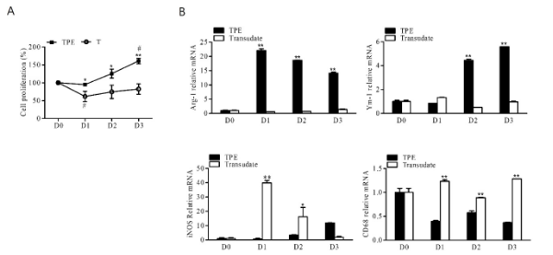
Supplementary Figure 1. Changes in macrophage polarization by day after pleural effusion treatment on BMDM
(a) Cell proliferation rate of macrophages after TPE or T (Transudate) treatment from Day 0
to Day 3. (b) The specific M2 (Arg-1 and YM-1) markers, M1 (iNOS) markers and pan macrophage markers (CD68) were quantified by RT-qPCR after stimulation with TPE or T. The values represent the results of three experiments. TPE vs T: **p< 0.01, *p<0.05, D0 vs other time: #p< 0.05

