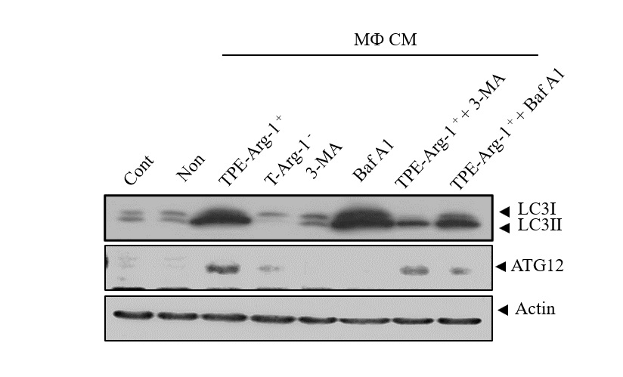

Supplementary Figure 2. Effect of 3-methyladenine(3-MA) and bafilomycin(BafA1) on autophagy in TPE-Arg-1 ⁺ MФ CM treated A549 cells
A549 cells were treated with vehicle control or 10 nM BafA1 or 10mM 3-Ma in the presence or absence of TPE-Arg-1 ⁺ MФ CM for 48 hours. Thereafter, protein expression was examined using western blot analysis for LC3II /LC3I, ATG-12 and actin.

