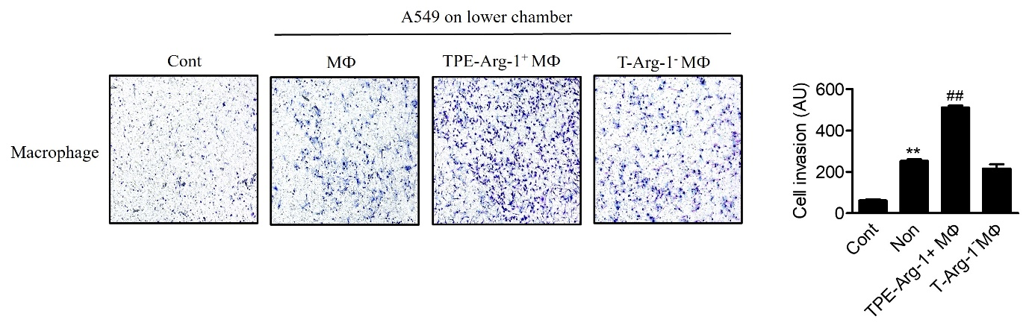ASupplementary Figure 3. Interaction between macrophage and A549 cell after TPE treatment
Transwell assay showed that A549 cells promote migration of TPE-Arg-1 ⁺ MФ compared to T-Arg-1 – MФ. TPE-Arg-1+ MФ or T-Arg-1-+ MФ cells were seeded (1×10⁵ cells/well) in the upper chamber and the A549 cells were seeded to the lower chamber.

