Additional file 4 - Baseline LUS aeration score and mortality in ARDS patients
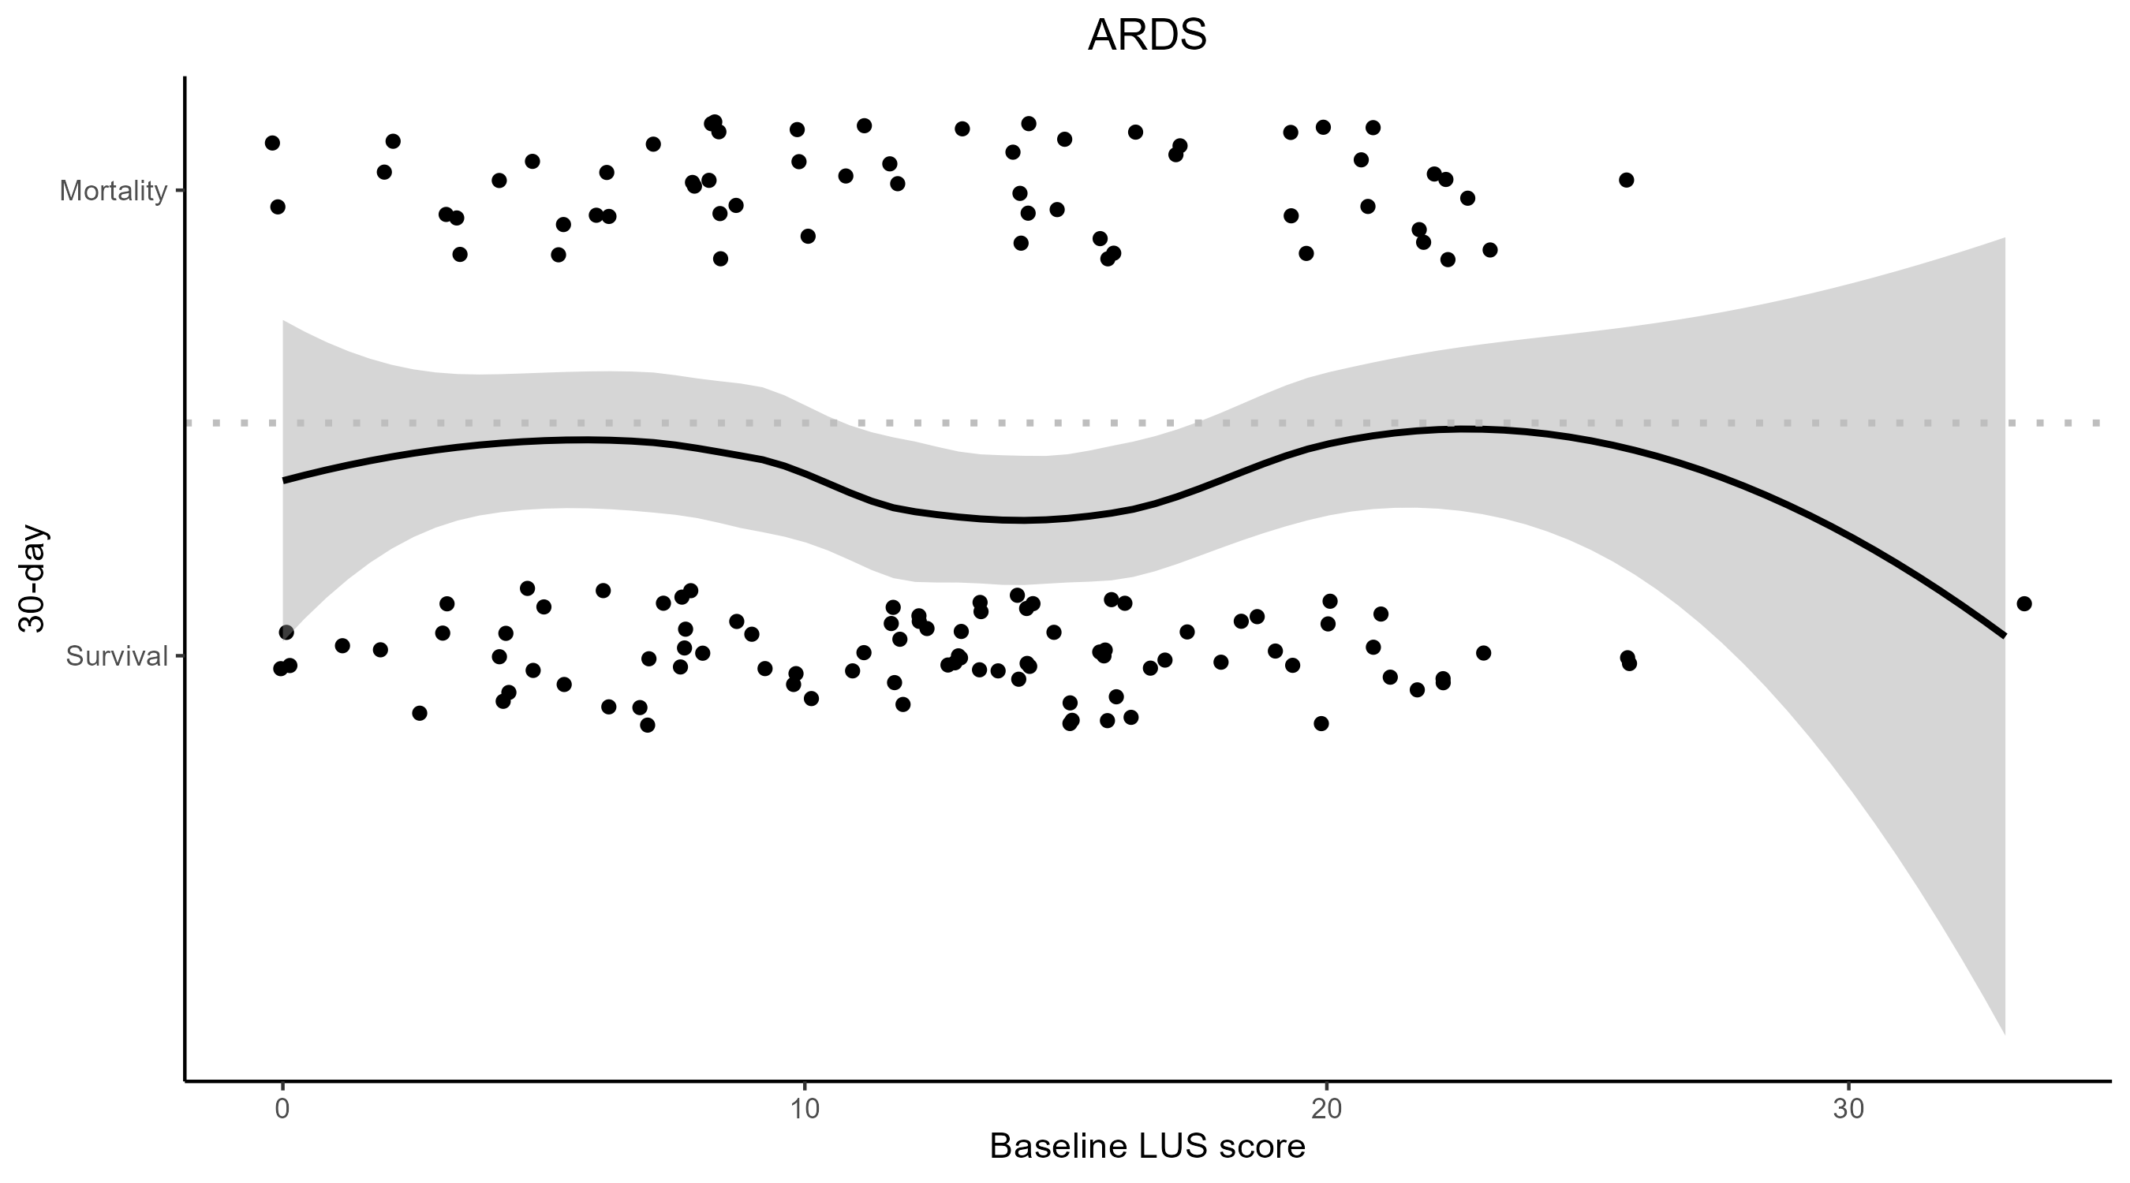
Additional file 4. Individual patient data point of the baseline LUS aeration score presented as dots divided by 30 day mortality on the y-axis in ARDS patients. The black trend line is generated through LOESS regression, and the 95% confidence interval is represented in grey. LUS = Lung Ultrasound; ARDS = Acute Respiratory Distress Syndrome; LOESS = locally estimated scatterplot smoothing.

