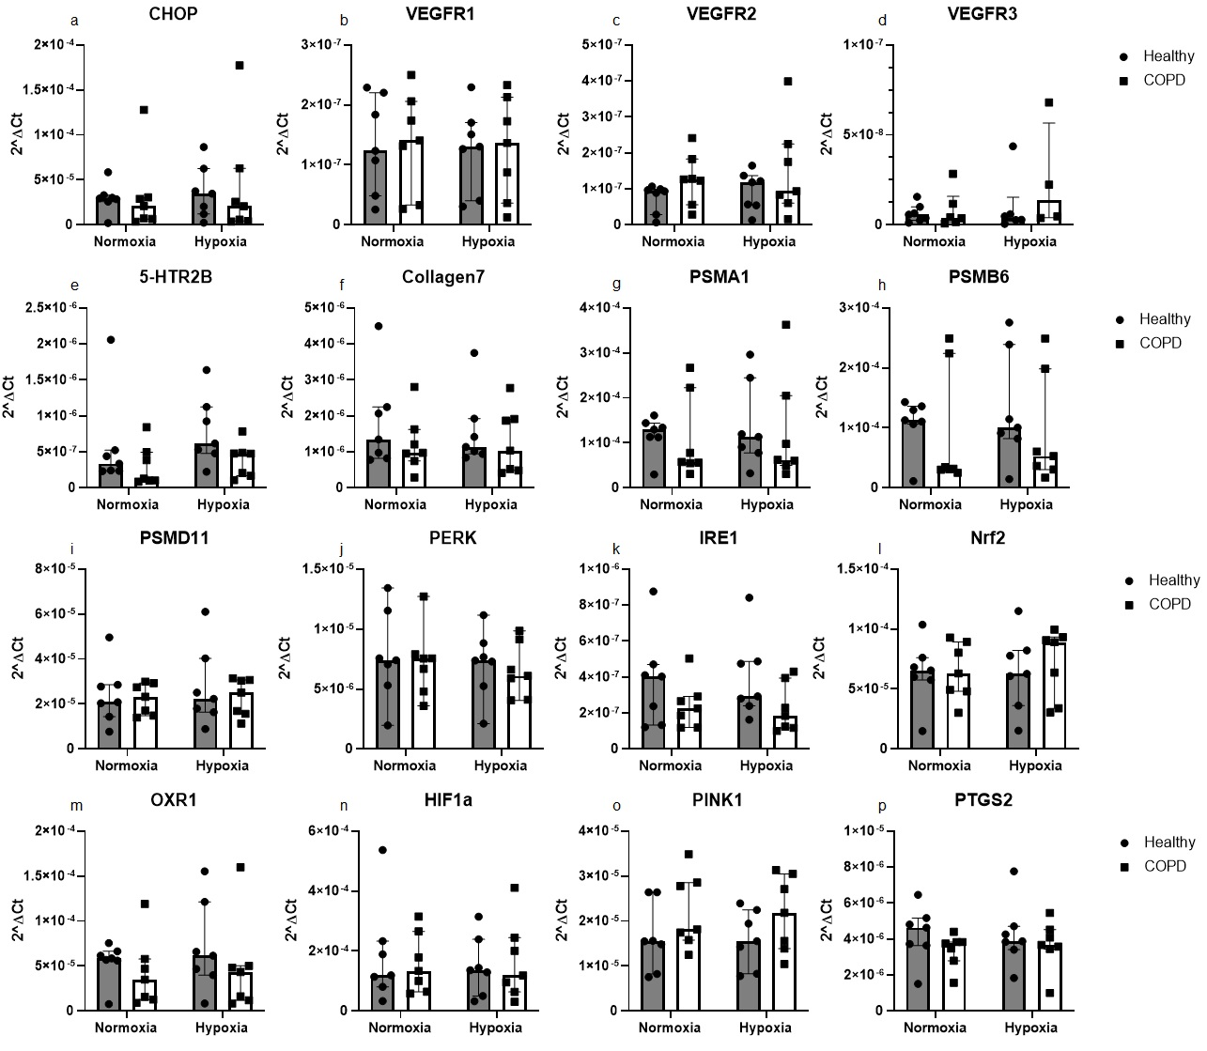
Additional data 4

Figure S3. Effect of 24 hours of hypoxia exposure on gene expression levels. Genes where no statistically significant differences were found in the mRNA measured with RT-qPCR in primary distal lung fibroblasts obtained from healthy subjects (n=7) and COPD patients (n=7) after 24 hours of exposure to normoxic (21% O₂) or hypoxic (1% O₂) conditions. Geomean of beta-actin and 18S were used as housekeeping. The data is presented as median with interquartile range. Ordinary two-way ANOVA or RM two-way ANOVA were used for unpaired and paired comparisons and the post-hoc test Fisher’s LSD was used for statistical analysis.

