Supplement materials

Figure 1. The expression level of Mfn2 in PASCMs after transfection with Ad-Mfn2 for 48 hours.

Figure 2. The expression of Mfn2 in pulmonary vascular after injecting Ad-mfn2 for 3, 5, 7 and 14 days.

Figure 3. Biological coefficient of variation of the two experimental NGS samples.

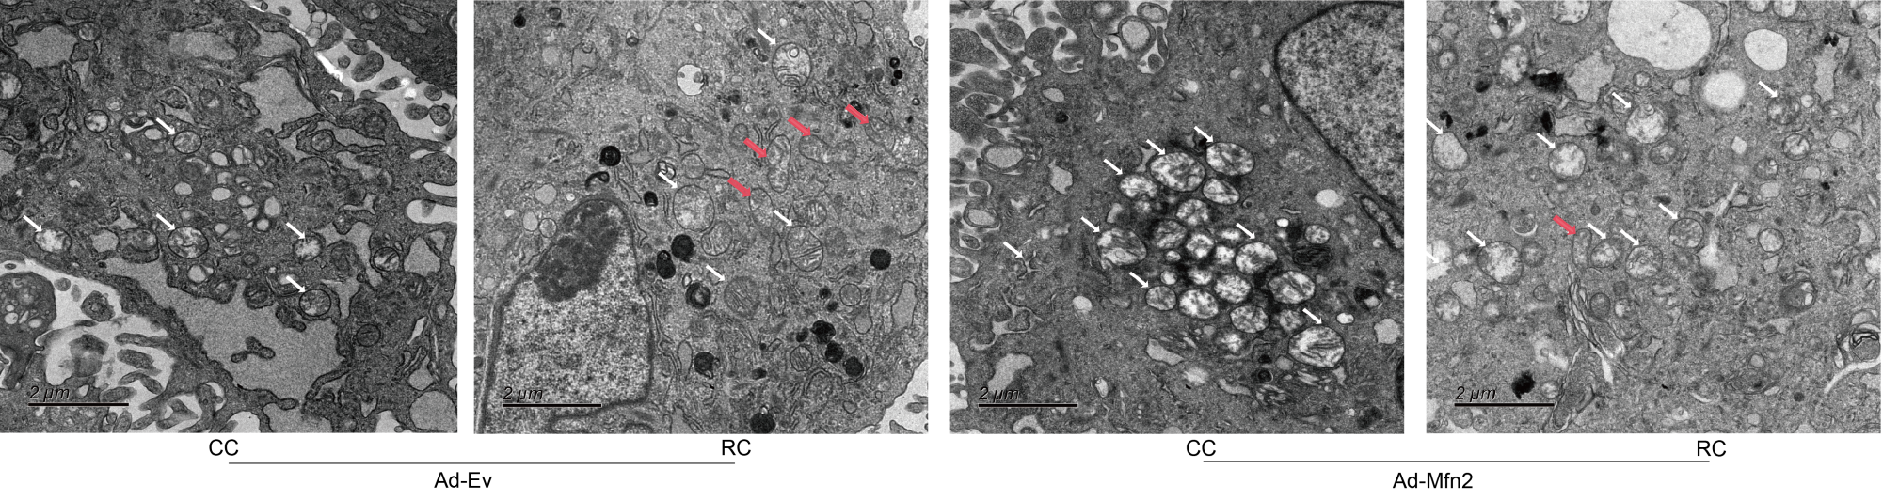
Figure 4. Representative transmission electron microscopic images of the PASMC, mitochondria were labeled by arrows, elongated mitochondria were labeled by red arrows. Scale bar = 2 μm.
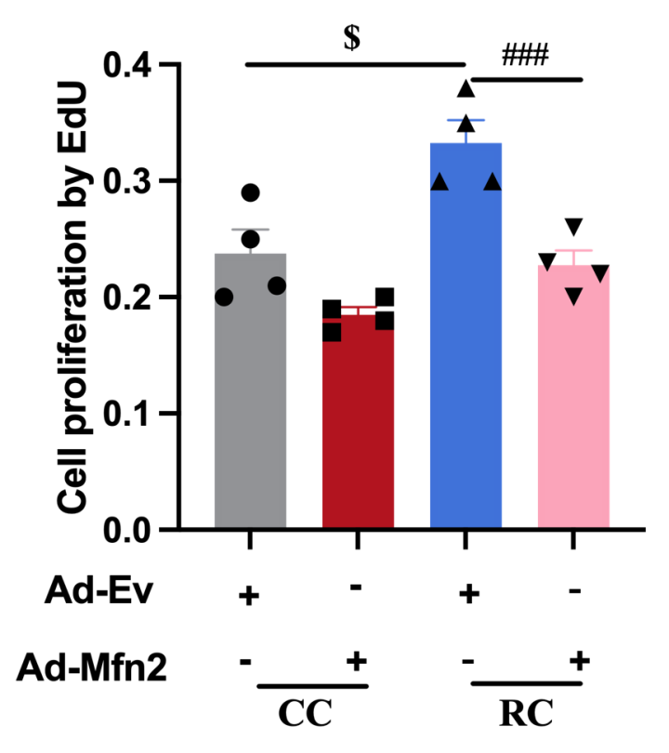
Figure 5. Statistics of the PASMCs proliferation with overexpression of Mfn2. Ad-EV, control adenovirus; Ad-Mfn2, recombinant adenovirus encoding Mfn2. All data throughout the figures represent the mean ± SEM and analyzed by one-way analysis of variance (ANOVA) and Newman-keuls post-hoc test. $ p <0.05 vs. Con + Ad-EV, ### p <0.001 vs. RC+ Ad-EV.

Table 1. Primers for RT-qPCR
Gene name | Forward | Reverse
B2M | TCTGCAAGCCTGTGTGCGGT | TGGGGCCAGCACGTCTGAAA
Mfn2 | GCTCAGTCGGTTGGAAGTCA | GAAAGGAGTGCCTGCCTGAT
Drp1 | AGGTTGCCCGTGACAAATGA | CACAGGCATCAGCAAAGTC
Fis1 | ACGCCTGCCGTTACTTCTTC | GCAACCCTGCAATCCTTCAC
OPA1 | GGCACTTCAAGGTCGTCTCA | CACTGCTCTTGGGTCCGATT

Table 2. The expression levels of differential expressed genes related to mitochondrial metabolism
Gene id | Gene name | LogFC | P-Value | Regulated
ENSRNOG00000014052 | Ccna1 | 3.6897 | 0.0157 | up
ENSRNOG00000047663 | Gata1 | 3.2335 | 0.0262 | up
ENSRNOG00000016348 | Tat | 2.8349 | 0.0182 | up
ENSRNOG00000001160 | Triap1 | 2.7397 | 0.1861 | up
ENSRNOG00000000167 | Alas2 | 2.3576 | 0.0008 | up
ENSRNOG00000002265 | Casr | 2.0135 | 0.1111 | up
ENSRNOG00000023493 | Creb3l4 | 1.9411 | 0.0086 | up
ENSRNOG00000017619 | Aldh1a1 | 1.6500 | 0.0109 | up
ENSRNOG00000020733 | Camp | 1.6023 | 0.0139 | up
ENSRNOG00000021097 | Hpn | 1.3223 | 0.0122 | up
ENSRNOG00000017325 | Cldn7 | 1.2139 | 0.0156 | up
ENSRNOG00000055672 | Gpx2 | 1.2044 | 0.0019 | up
ENSRNOG00000046007 | Cldn3 | 1.1702 | 0.0434 | up
ENSRNOG00000002598 | Hnf1b | 1.1655 | 0.0084 | up
ENSRNOG00000002754 | Areg | 1.1013 | 0.1133 | up
ENSRNOG00000046449 | Npy | 0.8838 | 0.5961 | up
ENSRNOG00000018710 | Pidd1 | -0.8114 | 0.4388 | down
ENSRNOG00000010349 | Ghrl | -1.0560 | 0.0953 | down
ENSRNOG00000033397 | Adamts20 | -1.1891 | 0.0459 | down
ENSRNOG00000010625 | Dnmt3b | -1.1925 | 0.0096 | down
ENSRNOG00000006675 | Fabp1 | -1.2232 | 0.0485 | down
ENSRNOG00000015036 | Ccn2 | -1.2689 | 0.0038 | down
ENSRNOG00000050647 | Hspa1b | -1.2861 | 0.0204 | down
ENSRNOG00000028708 | Ntsr1 | -1.2952 | 0.0834 | down
ENSRNOG00000037456 | P2rx2 | -1.2993 | 0.0273 | down
ENSRNOG00000032941 | Mab21l1 | -1.3487 | 0.0062 | down
ENSRNOG00000013074 | Wt1 | -1.3967 | 0.0584 | down
ENSRNOG00000001414 | Serpine1 | -1.4180 | 0.0323 | down
ENSRNOG00000011923 | Mgarp | -1.5763 | 0.0738 | down
ENSRNOG00000005964 | Nr4a3 | -1.5832 | 0.0698 | down
ENSRNOG00000009308 | Bcl2l10 | -1.5833 | 0.3177 | down
ENSRNOG00000025012 | Chat | -1.7487 | 0.0226 | down
ENSRNOG00000003745 | Atf3 | -1.8062 | 0.0233 | down
ENSRNOG00000003171 | Mpz | -1.8593 | 0.0004 | down
ENSRNOG00000025130 | Ltk | -1.8944 | 0.0055 | down
ENSRNOG00000060782 | Nkx3-2 | -2.1170 | 0.0315 | down
ENSRNOG00000042080 | Il31ra | -2.2448 | 0.0005 | down
ENSRNOG00000008310 | Mpo | -2.2718 | 0.0042 | down
ENSRNOG00000010079 | Ca3 | -2.4896 | 0.0036 | down
ENSRNOG00000028616 | Pck1 | -2.9350 | 0.0007 | down
ENSRNOG00000001821 | Lep | -3.1448 | 0.0009 | down
ENSRNOG00000020410 | Th | -3.5530 | 0.0019 | down
ENSRNOG00000002460 | Serpinb2 | -3.8358 | 0.0053 | down

