Supplementary Materials
Treatment patterns and patient pathways in progressive pulmonary fibrosis: a cross-sectional survey
Nazia Chaudhuri, Paolo Spagnolo, Claudia Valenzuela, Valeria C. Amatto, Oliver-Thomas Carter, Lauren Lee, Mark Small, Michael Kreuter

Supplementary Methods
Sample size and confidence intervals
As the objectives are descriptive, the sample size impacted the precision of estimates. Precision can be measured by the width of 95% confidence intervals (CIs). A larger sample would produce narrower CIs, indicating more precise estimates. The tables below show the width of 95% CIs for a categorical and a continuous variable for selected sample sizes (Table S1–2). For the categorical variable, a proportion of 50% was chosen as that produces the widest CI. For the continuous variable, a standardised version was chosen, where the standard deviation is 1.

Table S1. Physician survey: Half-width/precision
Type | 95% CI parameter | n=40 | n=50 | n=53 | n=61 | n=265
Categoricalª | Max half-width  (occurs around 50%) | ±16.2% | ±14.5% | ±14.9% | ±13.9% | ±6.4%
Continuous^{b} | Half-width  (standardised) | ±0.320 | ±0.284 | ±0.276 | ±0.256 | ±0.121
ªUsing the Clopper-Pearson method.
^{b}Assumes a normally distributed continuous variable and uses the t distribution.
CI, confidence interval.

Table S2. Physician-reported patient data (PRF): Half-width/precision
Type | 95% CI parameter | n=184 | n=271 | n=276 | n=328 | n=1335
Categorical* | Max half-width  (occurs around 50%) | ±7.4% | ±6.3% | ±6.1% | ±5.5% | ±2.8%
Continuous† | Half-width  (standardised) | ±0.145 | ±0.120 | ±0.118 | ±0.109 | ±0.054
*Using the Clopper-Pearson method.
†Assumes a normally distributed continuous variable and uses the t distribution.
CI, confidence interval.

Supplementary Results
Figure S1. Physician-rated severity of ILD
A. Physician-rated severity of ILD by country
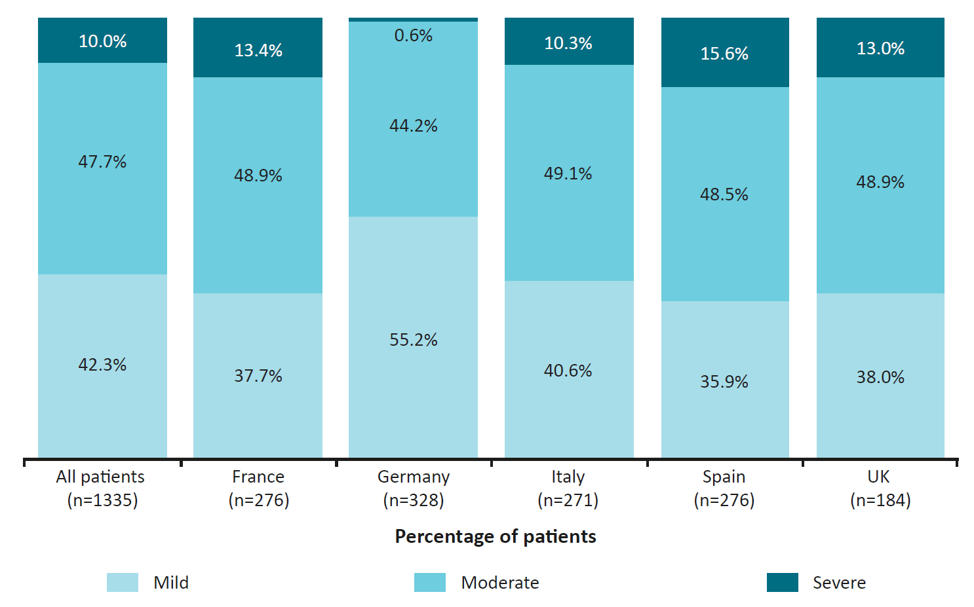

B. Physician-rated severity of ILD by physician speciality
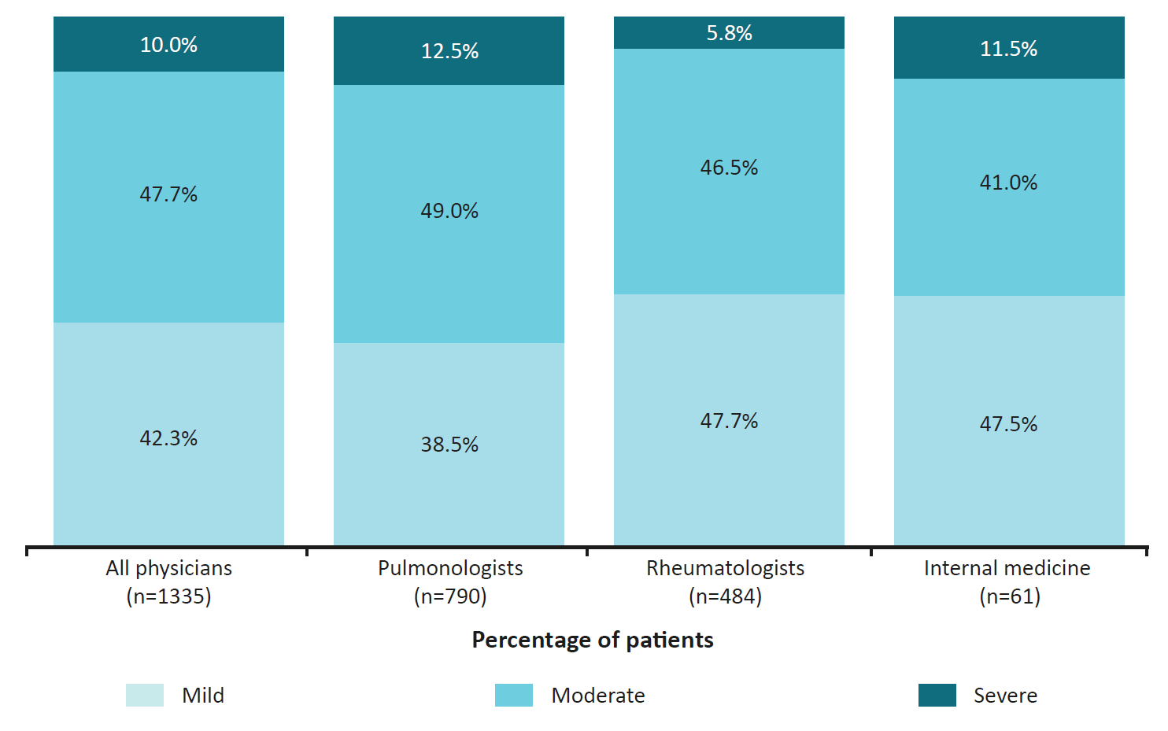
C. Physician-rated severity of ILD by type of ILD
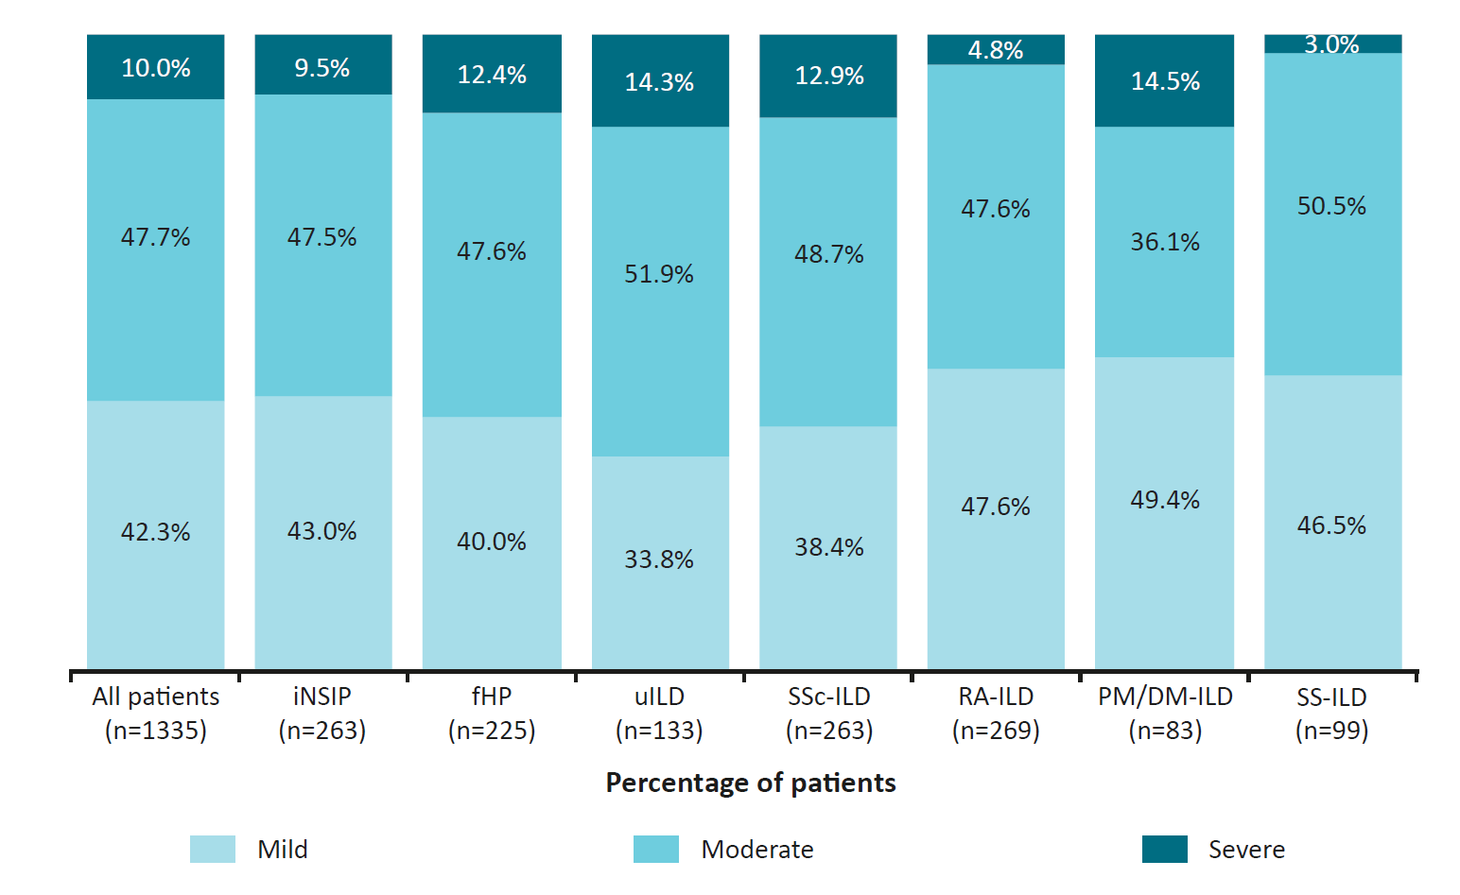
fHP, fibrotic hypersensitivity pneumonitis; ILD, interstitial lung disease; IM, internal medicine; iNSIP, idiopathic non-specific interstitial pneumonia; PM/DM-ILD, polymyositis- / dermatomyositis-associated ILD; PPF, progressive pulmonary fibrosis; RA-ILD, rheumatoid arthritis-associated ILD; SSc-ILD, systemic sclerosis-associated ILD; SS-ILD, Sjögren's-associated ILD; uILD, unclassifiable ILD; UK, United Kingdom.

Figure S2. Physician-reported patient disease status over last 12 months according to time since diagnosis of ILD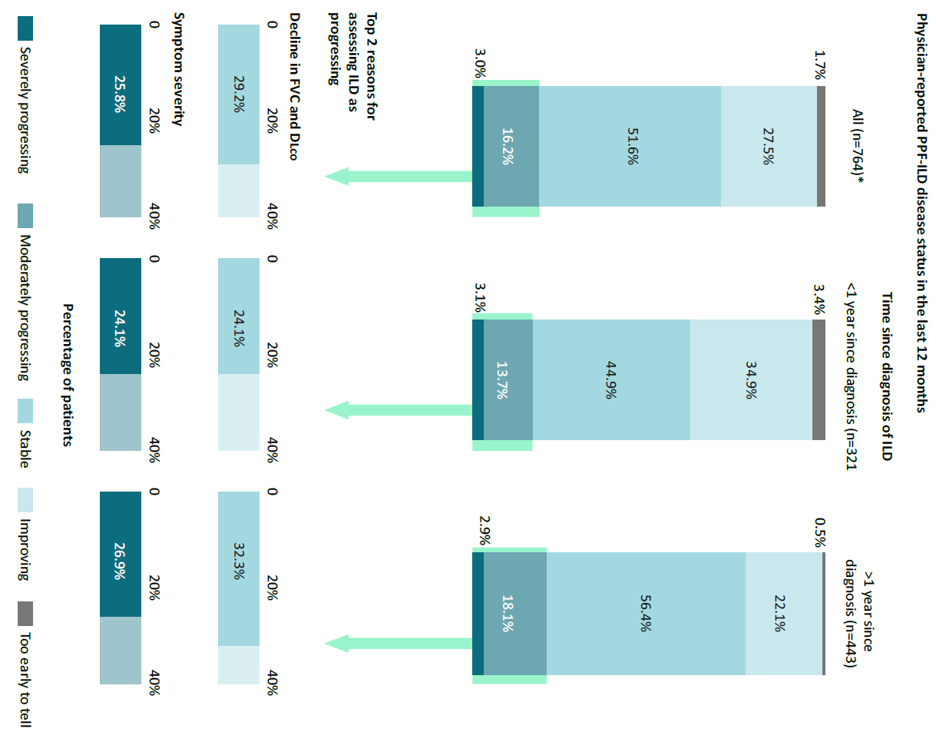
DLco, diffusing capacity of the lung for carbon monoxide; FVC, forced vital capacity; ILD, interstitial lung disease; PPF, progressive pulmonary fibrosis.

Figure S3. Expected progression in the next 12 months according to lung function parameters
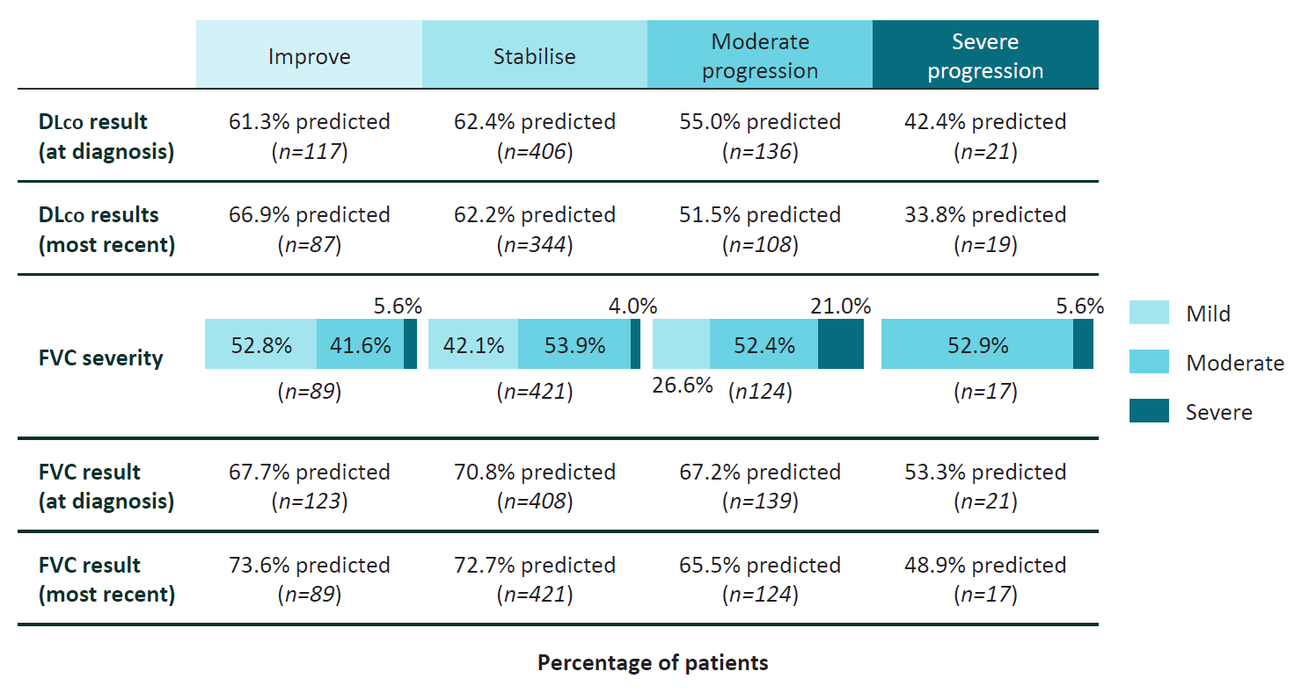
DLco, diffusing capacity of the lung for carbon monoxide; FVC, forced vital capacity; ILD, interstitial lung disease; PPF, progressive pulmonary fibrosis
Figure S4. Next course of action if current treatment were inadequate by country
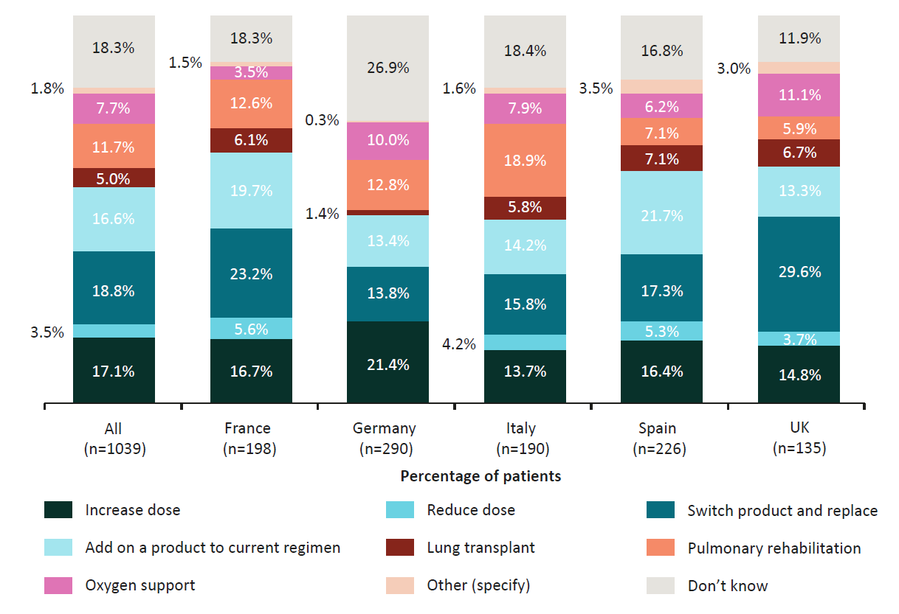
UK, United Kingdom.
Table S3. PPF-ILD DSP study sample
 |  | Physician specialty
 | Total | Pulmonologist | Rheumatologist | Internal medicine
Physician surveys | 265 | 175 | 82 | 8
France | 40 | 22 | 10 | 8
Germany | 61 | 41 | 20 | 0
Italy | 61 | 41 | 20 | 0
Spain | 53 | 37 | 16 | 0
UK | 50 | 34 | 16 | 0
Patient record forms | 1335 | 790 | 484 | 61
France | 276 | 131 | 84 | 61
Germany | 328 | 208 | 120 | 0
Italy | 271 | 171 | 100 | 0
Spain | 276 | 180 | 96 | 0
UK | 184 | 100 | 84 | 0
DSP, Disease Specific Programme; PPF, progressive pulmonary fibrosis; UK, United Kingdom.
Table S4. Patient demographics by country
 | All patients | Country
 | All patients | France | Germany | Italy | Spain | UK
Physician-reported patient age, years | 1334 | 276 | 328 | 271 | 276 | 183
Mean (SD) | 60.38 (11.59) | 60.89 (12.43) | 56.40 (9.99) | 61.70 (11.60) | 63.20 (11.35) | 60.56 (11.52)
BMI, kg/m² | 1335 | 276 | 328 | 271 | 276 | 184
Mean (SD) | 25.31 (3.89) | 24.64 (4.15) | 24.81 (3.36) | 24.96 (4.03) | 26.17 (3.36) | 26.39 (4.45)
Sex, n (%) | 1335 | 276 | 328 | 271 | 276 | 183
Female | 776 (58.13) | 163 (59.06) | 177 (53.96) | 163 (60.15) | 160 (57.97) | 113 (61.75)
Patient ethnicity, n (%) | 1335 | 276 | 328 | 271 | 276 | 184
White/Caucasian | 1217 (91.16) | 231 (83.70) | 314 (95.73) | 262 (96.68) | 259 (93.84) | 151 (82.07)
Asian (Indian subcontinent) | 11 (0.82) | 0 (0.00) | 1 (0.30) | 0 (0.00) | 0 (0.00) | 10 (5.43)
Asian (other) | 5 (0.37) | 1 (0.36) | 0 (0.00) | 0 (0.00) | 0 (0.00) | 4 (2.17)
Hispanic / Latino | 30 (2.25) | 3 (1.09) | 2 (0.61) | 8 (2.95) | 13 (4.71) | 4 (2.17)
Middle Eastern | 25 (1.87) | 18 (6.52) | 4 (1.22) | 0 (0.00) | 1 (0.36) | 2 (1.09)
Mixed race | 10 (0.75) | 1 (0.36) | 7 (2.13) | 0 (0.00) | 2 (0.72) | 0 (0.00)
Afro-Caribbean | 28 (2.10) | 20 (7.25) | 0 (0.00) | 1 (0.37) | 0 (0.00) | 7 (3.80)
Southeast Asian | 9 (0.67) | 2 (0.72) | 0 (0.00) | 0 (0.00) | 1 (0.36) | 6 (3.26)
Other | 0 (0.00) | 0 (0.00) | 0 (0.00) | 0 (0.00) | 0 (0.00) | 0 (0.00)
Patient smoking status, n (%) | 1335 | 276 | 328 | 271 | 276 | 184
Current smoker | 98 (7.34) | 28 (10.14) | 19 (5.79) | 21 (7.75) | 20 (7.25) | 10 (5.43)
Ex-smoker | 612 (45.84) | 104 (37.68) | 201 (61.28) | 120 (44.28) | 108 (39.13) | 79 (42.93)
Never smoked | 588 (44.04) | 143 (51.81) | 100 (30.49) | 110 (40.59) | 146 (52.90) | 89 (48.37)
Don't know | 37 (2.77) | 1 (0.36) | 8 (2.44) | 20 (7.38) | 2 (0.72) | 6 (3.26)
Patient employment status, n (%) | 1335 | 276 | 328 | 271 | 276 | 184
Working full time | 336 (25.17) | 71 (25.72) | 124 (37.80) | 62 (22.88) | 54 (19.57) | 25 (13.59)
Working part time | 145 (10.86) | 17 (6.16) | 31 (9.45) | 43 (15.87) | 21 (7.61) | 33 (17.93)
On long-term sick leave | 76 (5.69) | 19 (6.88) | 15 (4.57) | 4 (1.48) | 21 (7.61) | 17 (9.24)
Homemaker | 161 (12.06) | 11 (3.99) | 53 (16.16) | 29 (10.70) | 51 (18.48) | 17 (9.24)
Student | 1 (0.07) | 0 (0.00) | 0 (0.00) | 0 (0.00) | 1 (0.36) | 0 (0.00)
Retired | 517 (38.73) | 137 (49.64) | 91 (27.74) | 102 (37.64) | 110 (39.86) | 77 (41.85)
Unemployed | 68 (5.09) | 21 (7.61) | 14 (4.27) | 11 (4.06) | 14 (5.07) | 8 (4.35)
Don’t know | 31 (2.32) | 0 (0.00) | 0 (0.00) | 20 (7.38) | 4 (1.45) | 7 (3.80)
SD, standard deviation; UK, United Kingdom.
Table S5. Patient demographics by physician specialty
 | All patients | Physician speciality
 | All patients | Pulmonologist | Rheumatologist | Internal medicine
Physician-reported patient age, years | 1334 | 789 | 484 | 61
Mean (SD) | 60.38 (11.59) | 62.63 (11.42) | 58.03 (10.69) | 49.98 (11.36)
BMI, kg/m² | 1335 | 790 | 484 | 61
Mean (SD) | 25.31 (3.89) | 25.73 (3.89) | 24.86 (3.79) | 23.37 (3.71)
Sex, n (%) | 1335 | 790 | 484 | 61
Female | 776 (58.13) | 390 (49.43) | 342 (70.66) | 44 (72.13)
Patient ethnicity, n (%) | 1335 | 790 | 484 | 61
White/Caucasian | 1217 (91.16) | 735 (93.04) | 436 (90.08) | 46 (75.41)
Asian (Indian subcontinent) | 11 (0.82) | 2 (0.25) | 9 (1.86) | 0 (0.00)
Asian (other) | 5 (0.37) | 4 (0.51) | 1 (0.21) | 0 (0.00)
Hispanic / Latino | 30 (2.25) | 16 (2.03) | 14 (2.89) | 0 (0.00)
Middle Eastern | 25 (1.87) | 11 (1.39) | 9 (1.86) | 5 (8.20)
Mixed race | 10 (0.75) | 9 (1.14) | 0 (0.00) | 1 (1.64)
Afro-Caribbean | 28 (2.10) | 9 (1.14) | 11 (2.27) | 8 (13.11)
Southeast Asian | 9 (0.67) | 4 (0.51) | 4 (0.83) | 1 (1.64)
Other | 0 (0.00) | 0 (0.00) | 0 (0.00) | 0 (0.00)
Patient smoking status, n (%) | 1335 | 790 | 484 | 61
Current smoker | 98 (7.34) | 64 (8.10) | 24 (4.96) | 10 (16.39)
Ex-smoker | 612 (45.84) | 360 (45.57) | 239 (49.38) | 13 (21.31)
Never smoked | 588 (44.04) | 348 (44.05) | 202 (41.74) | 38 (62.30)
Don't know | 37 (2.77) | 18 (2.28) | 19 (3.93) | 0 (0.00)
Patient employment status, n (%) | 1335 | 790 | 484 | 61
Working full time | 336 (25.17) | 183 (23.16) | 127 (26.24) | 26 (42.62)
Working part time | 145 (10.86) | 60 (7.59) | 80 (16.53) | 5 (8.20)
On long-term sick leave | 76 (5.69) | 46 (5.82) | 22 (4.55) | 8 (13.11)
Homemaker | 161 (12.06) | 89 (11.27) | 68 (14.05) | 4 (6.56)
Student | 1 (0.07) | 0 (0.00) | 1 (0.21) | 0 (0.00)
Retired | 517 (38.73) | 362 (45.82) | 145 (29.96) | 10 (16.39)
Unemployed | 68 (5.09) | 31 (3.92) | 29 (5.99) | 8 (13.11)
Don’t know | 31 (2.32) | 19 (2.41) | 12 (2.48) | 0 (0.00)
SD, standard deviation.
Table S6. Patient demographics by type of ILD
 | All patients | Type of ILD
 | All patients | iNSIP | fHP | uILD | SSc-ILD | RA-ILD | PM/DM-ILD | SS-ILD
Physician-reported patient age, years | 1334 | 262 | 225 | 133 | 263 | 269 | 83 | 99
Mean (SD) | 60.38 (11.59) | 62.50 (11.09) | 62.08 (11.68) | 66.41 (12.02) | 56.14 (10.56) | 61.06 (10.56) | 53.83 (11.68) | 57.76 (10.73)
BMI, kg/m² | 1335 | 263 | 225 | 133 | 263 | 269 | 83 | 99
Mean (SD) | 25.31 (3.89) | 25.53 (3.24) | 26.29 (4.00) | 25.88 (4.20) | 24.07 (3.99) | 25.42 (4.08) | 25.41 (3.57) | 24.58 (3.39)
Sex, n (%) | 1335 | 263 | 225 | 133 | 263 | 269 | 83 | 99
Female | 776 (58.13) | 126 (47.90) | 68 (30.22) | 56 (42.10) | 223 (84.79) | 166 (61.71) | 53 (63.86) | 84 (84.84)
Patient ethnicity, n (%) | 1335 | 263 | 225 | 133 | 263 | 269 | 83 | 99
White/Caucasian | 1217 (91.16) | 245 (93.16) | 216 (96.00) | 121 (90.98) | 237 (90.11) | 251 (93.31) | 61 (73.49) | 86 (86.87)
Asian (Indian subcontinent) | 11 (0.82) | 0 (0.00) | 1 (0.44) | 1 (0.75) | 4 (1.52) | 0 (0.00) | 2 (2.41) | 3 (3.03)
Asian (other) | 5 (0.37) | 0 (0.00) | 0 (0.00) | 1 (0.75) | 2 (0.76) | 0 (0.00) | 2 (2.41) | 0 (0.00)
Hispanic / Latino | 30 (2.25) | 5 (1.90) | 3 (1.33) | 3 (2.26) | 6 (2.28) | 6 (2.23) | 5 (6.02) | 2 (2.02)
Middle Eastern | 25 (1.87) | 1 (0.38) | 1 (0.44) | 4 (3.01) | 7 (2.66) | 5 (1.86) | 5 (6.02) | 2 (2.02)
Mixed race | 10 (0.75) | 8 (3.04) | 0 (0.00) | 0 (0.00) | 0 (0.00) | 1 (0.37) | 0 (0.00) | 1 (1.01)
Afro-Caribbean | 28 (2.10) | 3 (1.14) | 3 (1.33) | 2 (1.50) | 5 (1.90) | 3 (1.12) | 7 (8.43) | 5 (5.05)
Southeast Asian | 9 (0.67) | 1 (0.38) | 1 (0.44) | 1 (0.75) | 2 (0.76) | 3 (1.12) | 1 (1.20) | 0 (0.00)
Other | 0 (0.00) | 0 (0.00) | 0 (0.00) | 0 (0.00) | 0 (0.00) | 0 (0.00) | 0 (0.00) | 0 (0.00)
Patient smoking  status, n (%) | 1335 | 263 | 225 | 133 | 263 | 269 | 83 | 99
Current smoker | 98 (7.34) | 25 (9.51) | 19 (8.44) | 12 (9.02) | 11 (4.18) | 20 (7.43) | 5 (6.02) | 6 (6.06)
Ex-smoker | 612 (45.84) | 128 (48.67) | 104 (46.22) | 59 (44.36) | 107 (40.68) | 140 (52.04) | 32 (38.55) | 42 (42.42)
Never smoked | 588 (44.04) | 103 (39.16) | 99 (44.00) | 60 (45.11) | 132 (50.19) | 99 (36.80) | 46 (55.42) | 49 (49.49)
Don't know | 37 (2.77) | 7 (2.66) | 3 (1.33) | 2 (1.50) | 13 (4.94) | 10 (3.72) | 0 (0.00) | 2 (2.02)
Patient employment status, n (%) | 1335 | 263 | 225 | 133 | 263 | 269 | 83 | 99
Working full time | 336 (25.17) | 70 (26.62) | 64 (28.44) | 20 (15.04) | 60 (22.81) | 65 (24.16) | 28 (33.73) | 29 (29.29)
Working part time | 145 (10.86) | 20 (7.60) | 19 (8.44) | 6 (4.51) | 42 (15.97) | 27 (10.04) | 14 (16.87) | 17 (17.17)
On long-term sick leave | 76 (5.69) | 10 (3.80) | 14 (6.22) | 7 (5.26) | 24 (9.13) | 13 (4.83) | 7 (8.43) | 1 (1.01)
Homemaker | 161 (12.06) | 37 (14.07) | 15 (6.67) | 11 (8.27) | 49 (18.63) | 29 (10.78) | 5 (6.02) | 15 (15.15)
Student | 1 (0.07) | 0 (0.00) | 0 (0.00) | 0 (0.00) | 0 (0.00) | 0 (0.00) | 1 (1.20) | 0 (0.00)
Retired | 517 (38.73) | 114 (43.35) | 98 (43.56) | 79 (59.40) | 64 (24.33) | 116 (43.12) | 17 (20.48) | 29 (29.29)
Unemployed | 68 (5.09) | 7 (2.66) | 6 (2.67) | 10 (7.52) | 15 (5.70) | 13 (4.83) | 10 (12.05) | 7 (7.07)
Don’t know | 31 (2.32) | 5 (1.90) | 9 (4.00) | 0 (0.00) | 9 (3.42) | 6 (2.23) | 1 (1.20) | 1 (1.01)
fHP, fibrotic hypersensitivity pneumonitis; ILD, interstitial lung disease; iNSIP, idiopathic non-specific interstitial pneumonia; PM/DM-ILD, polymyositis- / dermatomyositis-associated ILD; RA-ILD, rheumatoid arthritis-associated ILD; SD, standard deviation; SSc-ILD, systemic sclerosis-associated ILD; SS-ILD, Sjögren's-associated ILD; uILD, unclassifiable ILD.
Table S7. Physician-reported reasons for disease progression by country
 | All patients  (n=260) | County
 | All patients  (n=260) | France  (n=58) | Germany  (n=32) | Italy  (n=65) | Spain  (n=60) | UK  (n=45)
Reasons for progressing, n (%)
Acute exacerbation of ILD | 13 (5.00) | 4 (6.90) | 0 (0.00) | 4 (6.15) | 3 (5.00) | 2 (4.44)
Symptom severity | 71 (27.31) | 13 (22.41) | 11 (34.38) | 19 (29.23) | 9 (15.00) | 19 (42.22)
Symptom frequency | 20 (7.69) | 6 (10.34) | 5 (15.62) | 6 (9.23) | 2 (3.33) | 1 (2.22)
Decline in FVC only | 19 (7.31) | 7 (12.07) | 3 (9.38) | 2 (3.08) | 5 (8.33) | 2 (4.44)
Decline in DLco only | 14 (5.38) | 0 (0.00) | 2 (6.25) | 2 (3.08) | 6 (10.00) | 4 (8.89)
Decline in FVC and DLco | 67 (25.77) | 13 (22.41) | 5 (15.62) | 18 (27.69) | 24 (40.00) | 7 (15.56)
Requires lung transplant | 8 (3.08) | 4 (6.90) | 0 (0.00) | 1 (1.54) | 2 (3.33) | 1 (2.22)
Change in underlying disease severity | 2 (0.77) | 0 (0.00) | 0 (0.00) | 0 (0.00) | 0 (0.00) | 2 (4.44)
Initiation of new treatment to treat their ILD | 5 (1.92) | 1 (1.72) | 0 (0.00) | 1 (1.54) | 1 (1.67) | 2 (4.44)
Change in the dose / frequency of their current treatment | 0 (0.00) | 0 (0.00) | 0 (0.00) | 0 (0.00) | 0 (0.00) | 0 (0.00)
Increased fibrosis of the lungs as demonstrated by CT / HRCT scan | 37 (14.23) | 9 (15.52) | 6 (18.75) | 11 (16.92) | 6 (10.00) | 5 (11.11)
Other | 3 (1.15) | 1 (1.72) | 0 (0.00) | 1 (1.54) | 1 (1.67) | 0 (0.00)
None | 1 (0.38) | 0 (0.00) | 0 (0.00) | 0 (0.00) | 1 (1.67) | 0 (0.00)
CT, computed tomography; DLco, diffusing capacity of the lung for carbon monoxide; FVC, forced vital capacity; HRCT, high-resolution CT; ILD, interstitial lung disease; PPF, progressive pulmonary fibrosis; UK, United Kingdom.
Table S8. Physician-reported reasons for disease progression by physician specialty
 | All patients  (n=260) | Physician speciality
 | All patients  (n=260) | Pulmonologist  (n=208) | Rheumatologist  (n=46) | Internal medicine  (n=6)
Reasons for progressing, n (%) | 260 | 208 | 46 | 6
Acute exacerbation of ILD | 13 (5.00) | 9 (4.33) | 4 (8.70) | 0 (0.00)
Symptom severity | 71 (27.31) | 55 (26.44) | 15 (32.61) | 1 (16.67)
Symptom frequency | 20 (7.69) | 17 (8.17) | 3 (6.52) | 0 (0.00)
Decline in FVC only | 19 (7.31) | 15 (7.21) | 3 (6.52) | 1 (16.67)
Decline in DLco only | 14 (5.38) | 11 (5.29) | 3 (6.52) | 0 (0.00)
Decline in FVC and DLco | 67 (25.77) | 57 (27.40) | 8 (17.39) | 2 (33.33)
Requires lung transplant | 8 (3.08) | 5 (2.40) | 1 (2.17) | 2 (33.33)
Change in underlying disease severity | 2 (0.77) | 1 (0.48) | 1 (2.17) | 0 (0.00)
Initiation of new treatment to treat their ILD | 5 (1.92) | 4 (1.92) | 1 (2.17) | 0 (0.00)
Change in the dose / frequency of their current treatment | 0 (0.00) | 0 (0.00) | 0 (0.00) | 0 (0.00)
Increased fibrosis of the lungs as demonstrated by CT / HRCT scan | 37 (14.23) | 32 (15.38) | 5 (10.87) | 0 (0.00)
Other | 3 (1.15) | 1 (0.48) | 2 (4.35) | 0 (0.00)
None | 1 (0.38) | 1 (0.48) | 0 (0.00) | 0 (0.00)
CT, computed tomography; DLco, diffusing capacity of the lung for carbon monoxide; FVC, forced vital capacity; HRCT, high-resolution CT; ILD, interstitial lung disease; PPF, progressive pulmonary fibrosis.
Table S9. Physician-reported reasons for disease progression by type of ILD
 | All patients  (n=260) | Type of ILD
 | All patients  (n=260) | iNSIP  (n=66) | fHP  (n=44) | uILD  (n=46) | SSc-ILD  (n=55) | RA-ILD  (n=24) | PM/DM-ILD  (n=12) | SS-ILD  (n=13)
Reasons for progressing, n (%) | 260 | 66 | 44 | 46 | 55 | 24 | 12 | 13
Acute exacerbation of ILD | 13 (5.00) | 4 (6.06) | 0 (0.00) | 2 (4.35) | 0 (0.00) | 5 (20.83) | 2 (16.67) | 0 (0.00)
Symptom severity | 71 (27.31) | 17 (25.76) | 13 (29.55) | 14 (30.43) | 16 (29.09) | 6 (25.00) | 2 (16.67) | 3 (23.08)
Symptom frequency | 20 (7.69) | 6 (9.09) | 3 (6.82) | 2 (4.35) | 5 (9.09) | 2 (8.33) | 1 (8.33) | 1 (7.69)
Decline in FVC only | 19 (7.31) | 6 (9.09) | 1 (2.27) | 6 (13.04) | 2 (3.64) | 2 (8.33) | 1 (8.33) | 1 (7.69)
Decline in DLco only | 14 (5.38) | 6 (9.09) | 0 (0.00) | 3 (6.52) | 4 (7.27) | 1 (4.17) | 0 (0.00) | 0 (0.00)
Decline in FVC and DLco | 67 (25.77) | 17 (25.76) | 15 (34.09) | 7 (15.22) | 16 (29.09) | 7 (29.17) | 2 (16.67) | 3 (23.08)
Requires lung transplant | 8 (3.08) | 0 (0.00) | 2 (4.55) | 2 (4.35) | 2 (3.64) | 1 (4.17) | 1 (8.33) | 0 (0.00)
Change in underlying disease severity | 2 (0.77) | 0 (0.00) | 0 (0.00) | 0 (0.00) | 2 (3.64) | 0 (0.00) | 0 (0.00) | 0 (0.00)
Initiation of new treatment to treat their ILD | 5 (1.92) | 2 (3.03) | 1 (2.27) | 0 (0.00) | 1 (1.82) | 0 (0.00) | 0 (0.00) | 1 (7.69)
Change in the dose / frequency of their current treatment | 0 (0.00) | 0 (0.00) | 0 (0.00) | 0 (0.00) | 0 (0.00) | 0 (0.00) | 0 (0.00) | 0 (0.00)
Increased fibrosis of the lungs as demonstrated by CT / HRCT scan | 37 (14.23) | 7 (10.61) | 9 (20.45) | 9 (19.57) | 5 (9.09) | 0 (0.00) | 3 (25.00) | 4 (30.77)
Other | 3 (1.15) | 0 (0.00) | 0 (0.00) | 1 (2.17) | 2 (3.64) | 0 (0.00) | 0 (0.00) | 0 (0.00)
None | 1 (0.38) | 1 (1.52) | 0 (0.00) | 0 (0.00) | 0 (0.00) | 0 (0.00) | 0 (0.00) | 0 (0.00)
CT, computed tomography; DLco, diffusing capacity of the lung for carbon monoxide; fHP, fibrotic hypersensitivity pneumonitis; FVC, forced vital capacity; HRCT, high-resolution CT; ILD, interstitial lung disease; iNSIP, idiopathic non-specific interstitial pneumonia; PM/DM-ILD, polymyositis- / dermatomyositis-associated ILD; RA-ILD, rheumatoid arthritis-associated ILD; SSc-ILD, systemic sclerosis-associated ILD; SS-ILD, Sjögren's-associated ILD; uILD, unclassifiable ILD.

Table S10. Most frequent comorbidities reported at survey date by country
 |  | Country
 | All patients  (n=1335) | France  (n=276) | Germany  (n=328) | Italy  (n=271) | Spain  (n=276) | UK  (n=184)
Comorbidities, n (%)
Anxiety | 226 (16.93) | 62 (22.46) | 10 (3.05) | 67 (24.72) | 53 (19.20) | 34 (18.48)
Gastroesophageal reflux | 207 (15.51) | 37 (13.41) | 16 (4.88) | 83 (30.63) | 42 (15.22) | 29 (15.76)
Depression | 179 (13.41) | 33 (11.96) | 22 (6.71) | 41 (15.13) | 50 (18.12) | 33 (17.93)
Diabetes without chronic complications | 134 (10.04) | 24 (8.70) | 42 (12.80) | 24 (8.86) | 32 (11.59) | 12 (6.52)
Pulmonary hypertension | 120 (8.99) | 21 (7.61) | 16 (4.88) | 34 (12.55) | 29 (10.51) | 20 (10.87)
Chronic obstructive pulmonary disease | 102 (7.64) | 26 (9.42) | 22 (6.71) | 27 (9.96) | 13 (4.71) | 14 (7.61)
Myocardial infarction | 84 (6.29) | 25 (9.06) | 9 (2.74) | 25 (9.23) | 13 (4.71) | 12 (6.52)
Coronary artery disease | 79 (5.92) | 20 (7.25) | 14 (4.27) | 15 (5.54) | 11 (3.99) | 19 (10.33)
Peripheral vascular disease | 75 (5.62) | 15 (5.43) | 10 (3.05) | 25 (9.23) | 12 (4.35) | 13 (7.07)
Obstructive sleep apnoea / apnoea | 68 (5.09) | 20 (7.25) | 9 (2.74) | 9 (3.32) | 23 (8.33) | 7 (3.80)
UK, United Kingdom.
Table S11. Most frequent comorbidities reported at survey date by physician specialty
 |  | Physician specialty
 | All patients  (n=1335) | Pulmonologist  (n=790) | Rheumatologist  (n=484) | Internal medicine  (n=61)
Comorbidities, n (%)
Anxiety | 226 (16.93) | 134 (16.96) | 79 (16.32) | 13 (21.31)
Gastroesophageal reflux | 207 (15.51) | 134 (16.96) | 62 (12.81) | 11 (18.03)
Depression | 179 (13.41) | 98 (12.41) | 73 (15.08) | 8 (13.11)
Diabetes without chronic complications | 134 (10.04) | 93 (11.77) | 35 (7.23) | 6 (9.84)
Pulmonary hypertension | 120 (8.99) | 77 (9.75) | 42 (8.68) | 1 (1.64)
Chronic obstructive pulmonary disease | 102 (7.64) | 79 (10.00) | 18 (3.72) | 5 (8.20)
Myocardial infarction | 84 (6.29) | 67 (8.48) | 14 (2.89) | 3 (4.92)
Coronary artery disease | 79 (5.92) | 60 (7.59) | 19 (3.93) | 0 (0.00)
Peripheral vascular disease | 75 (5.62) | 52 (6.58) | 23 (4.75) | 0 (0.00)
Obstructive sleep apnoea / apnoea | 68 (5.09) | 58 (7.34) | 7 (1.45) | 3 (4.92)

Table S12. Most frequent comorbidities reported at survey date by type of ILD
 |  | Type of ILD
 | All patients  (n=1335) | iNSIP  (n=263) | fHP  (n=225) | uILD  (n=133) | SSc-ILD  (n=263) | RA-ILD  (n=269) | PM/DM-ILD  (n=83) | SS-ILD  (n=99)
Comorbidities, n (%)
Anxiety | 226 (16.93) | 38 (14.45) | 35 (15.56) | 21 (15.79) | 59 (22.43) | 42 (15.61) | 15 (18.07) | 16 (16.16)
Gastroesophageal reflux | 207 (15.51) | 38 (14.45) | 32 (14.22) | 23 (17.29) | 70 (26.62) | 24 (8.92) | 8 (9.64) | 12 (12.12)
Depression | 179 (13.41) | 31 (11.79) | 27 (12.00) | 20 (15.04) | 42 (15.97) | 32 (11.90) | 13 (15.66) | 14 (14.14)
Diabetes without chronic complications | 134 (10.04) | 40 (15.21) | 24 (10.67) | 17 (12.78) | 20 (7.60) | 21 (7.81) | 3 (3.61) | 9 (9.09)
Pulmonary hypertension | 120 (8.99) | 23 (8.75) | 16 (7.11) | 15 (11.28) | 38 (14.45) | 16 (5.95) | 5 (6.02) | 7 (7.07)
Chronic obstructive pulmonary disease | 102 (7.64) | 25 (9.51) | 22 (9.78) | 21 (15.79) | 8 (3.04) | 19 (7.06) | 1 (1.20) | 6 (6.06)
Myocardial infarction | 84 (6.29) | 24 (9.13) | 20 (8.89) | 21 (15.79) | 4 (1.52) | 13 (4.83) | 2 (2.41) | 0 (0.00)
Coronary artery disease | 79 (5.92) | 21 (7.98) | 22 (9.78) | 11 (8.27) | 5 (1.90) | 19 (7.06) | 0 (0.00) | 1 (1.01)
Peripheral vascular disease | 75 (5.62) | 11 (4.18) | 19 (8.44) | 12 (9.02) | 18 (6.84) | 10 (3.72) | 3 (3.61) | 2 (2.02)
Obstructive sleep apnoea / apnoea | 68 (5.09) | 15 (5.70) | 23 (10.22) | 17 (12.78) | 2 (0.76) | 6 (2.23) | 2 (2.41) | 3 (3.03)
fHP, fibrotic hypersensitivity pneumonitis; ILD, interstitial lung disease; iNSIP, idiopathic non-specific interstitial pneumonia; PM/DM-ILD, polymyositis- / dermatomyositis-associated ILD; RA-ILD, rheumatoid arthritis-associated ILD; SSc-ILD, systemic sclerosis-associated ILD; SS-ILD, Sjögren's-associated ILD; uILD, unclassifiable ILD.
Table S13. Patients currently receiving treatment and reasons for never prescribing treatment by country
 | All patients | Country
 | All patients | France | Germany | Italy | Spain | UK
Patients currently prescribed a treatment for their ILD, n (%) | 1335 | 276 | 328 | 271 | 276 | 184
Yes | 1039 (77.8) | 198 (71.7) | 290 (88.4) | 190 (70.1) | 226 (81.9) | 135 (73.4)
No, but previously prescribed treatment | 88 (6.6) | 16 (5.8) | 7 (2.1) | 24 (8.9) | 19 (6.9) | 22 (12.0)
No, has never been prescribed treatment | 208 (15.6) | 62 (22.5) | 31 (9.5) | 57 (21.0) | 31 (11.2) | 27 (14.7)
Reason for never prescribing treatment for ILD, n (%) | 208 | 62 | 31 | 57 | 31 | 27
Profile is manageable without treatment | 101 (48.6) | 23 (37.1) | 11 (35.5) | 30 (52.6) | 17 (54.8) | 20 (74.1)
Patient request | 34 (16.4) | 8 (12.9) | 12 (38.7) | 5 (8.8) | 5 (16.1) | 4 (14.8)
Patient concerns over side effects | 33 (15.9) | 13 (21.0) | 2 (6.5) | 8 (14.0) | 7 (22.6) | 3 (11.1)
Disease-modifying treatment considered last option of care | 3 (1.4) | 0 (0.00) | 1 (3.2) | 1 (1.8) | 1 (3.2) | 0 (0.0)
Symptoms not severe enough to warrant treatment | 43 (20.7) | 17 (27.4) | 6 (19.4) | 10 (17.5) | 2 (6.5) | 8 (29.6)
Diagnosed too recently | 36 (17.3) | 12 (19.4) | 6 (19.4) | 9 (15.8) | 3 (9.7) | 6 (22.2)
Lack of information in current treatment guidelines | 10 (4.8) | 4 (6.5) | 0 (0.0) | 2 (3.5) | 4 (12.9) | 0 (0.0)
Lack of evidence of the efficacy of current drug treatments available | 9 (4.3) | 4 (6.5) | 1 (3.2) | 0 (0.0) | 4 (12.9) | 0 (0.0)
Due to the underlying autoimmune disease | 10 (4.8) | 1 (1.6) | 5 (16.1) | 1 (1.8) | 2 (6.5) | 1 (3.7)
No approved therapies specifically for ILD | 8 (3.9) | 4 (6.5) | 0 (0.0) | 1 (1.8) | 2 (6.5) | 1 (3.7)
Medication is not covered by the patient’s insurance | 2 (1.0) | 1 (1.6) | 0 (0.0) | 0 (0.0) | 0 (0.0) | 1 (3.7)
Waiting for new drugs / products to be approved by regulatory bodies | 7 (3.4) | 4 (6.5) | 0 (0.0) | 2 (3.5) | 1 (3.2) | 0 (0.0)
Other | 14 (6.7) | 5 (8.1) | 1 (3.2) | 2 (3.5) | 3 (9.7) | 3 (11.1)
ILD, interstitial lung disease; UK, United Kingdom.
Table S14. Patients currently receiving treatment and reasons for never prescribing treatment by physician specialty
 | All patients | Physician specialty
 | All patients | Pulmonologist | Rheumatologist | Internal medicine
Patients currently prescribed a treatment for their ILD, n (%) | 1335 | 790 | 484 | 61
Yes | 1039 (77.8) | 589 (74.56) | 400 (82.64) | 50 (81.97)
No, but previously prescribed treatment | 88 (6.6) | 69 (8.73) | 18 (3.72) | 1 (1.64)
No, has never been prescribed treatment | 208 (15.6) | 132 (16.71) | 132 (16.71) | 10 (16.39)
Reason for never prescribing treatment for ILD, n (%) | 208 | 132 | 66 | 10
Profile is manageable without treatment | 101 (48.6) | 57 (43.18) | 38 (57.58) | 6 (60.00)
Patient request | 34 (16.4) | 26 (19.70) | 7 (10.61) | 1 (10.00)
Patient concerns over side effects | 33 (15.9) | 27 (20.45) | 5 (7.58) | 1 (10.00)
Disease-modifying treatment considered last option of care | 3 (1.4) | 2 (1.52) | 1 (1.52) | 0 (0.00)
Symptoms not severe enough to warrant treatment | 43 (20.7) | 27 (20.45) | 11 (16.67) | 5 (50.00)
Diagnosed too recently | 36 (17.3) | 24 (18.18) | 11 (16.67) | 1 (10.00)
Lack of information in current treatment guidelines | 10 (4.8) | 8 (6.06) | 2 (3.03) | 0 (0.00)
Lack of evidence of the efficacy of current drug treatments available | 9 (4.3) | 7 (5.30) | 2 (3.03) | 0 (0.00)
Due to the underlying autoimmune disease | 10 (4.8) | 4 (3.03) | 5 (7.58) | 1 (10.00)
No approved therapies specifically for ILD | 8 (3.9) | 6 (4.55) | 2 (3.03) | 0 (0.00)
Medication is not covered by the patient’s insurance | 2 (1.0) | 2 (1.52) | 0 (0.00) | 0 (0.00)
Waiting for new drugs / products to be approved by regulatory bodies | 7 (3.4) | 7 (5.30) | 0 (0.00) | 0 (0.00)
Other | 14 (6.7) | 12 (9.09) | 2 (3.03) | 0 (0.00)
ILD, interstitial lung disease.

Table S15. Patients currently receiving treatment and reasons for never prescribing treatment by type of ILD
 | Type of ILD
 | iNSIP | fHP | uILD | SSc-ILD | RA-ILD | PM/  DM-ILD | SS-ILD
Patients currently prescribed a treatment for their ILD, n (%) | 263 | 225 | 133 | 263 | 269 | 83 | 99
Yes | 213 (81.0) | 168 (74.7) | 72 (54.1) | 217 (82.5) | 217 (80.7) | 73 (88.0) | 79 (79.8)
No, but previously prescribed treatment | 19 (7.2) | 24 (10.7) | 15 (11.3) | 9 (3.4) | 9 (3.4) | 4 (4.8) | 8 (8.1)
No, has never been prescribed treatment | 31 (11.8) | 33 (14.7) | 46 (34.6) | 37 (14.1) | 43 (16.0) | 6 (7.2) | 12 (12.1)
Reason for never prescribing treatment for ILD, n (%) | 31 | 33 | 46 | 37 | 43 | 6 | 12
Profile is manageable without treatment | 13 (41.9) | 17 (51.5) | 16 (34.8) | 17 (46.0) | 28 (65.1) | 3 (50.0) | 7 (58.3)
Patient request | 7 (22.6) | 8 (24.2) | 7 (15.2) | 5 (13.5) | 4 (9.3) | 1 (16.7) | 2 (16.7)
Patient concerns over side effects | 7 (22.6) | 7 (21.2) | 11 (23.9) | 2 (5.4) | 4 (9.3) | 1 (16.7) | 1 (8.3)
Disease-modifying treatment considered last option of care | 1 (3.2) | 0 (0.0) | 1 (2.2) | 1 (2.7) | 0 (0.0) | 0 (0.0) | 0 (0.0)
Symptoms not severe enough to warrant treatment | 6 (19.4) | 8 (24.2) | 10 (21.7) | 9 (24.3) | 7 (16.3) | 3 (50.0) | 0 (0.0)
Diagnosed too recently | 10 (32.3) | 3 (9.1) | 8 (17.4) | 4 (10.8) | 7 (16.3) | 2 (33.3) | 2 (16.7)
Lack of information in current treatment guidelines | 0 (0.0) | 3 (9.1) | 4 (8.7) | 1 (2.7) | 1 (2.3) | 0 (0.0) | 1 (8.3)
Lack of evidence of the efficacy of current drug treatments available | 1 (3.2) | 3 (9.1) | 3 (6.5) | 1 (2.7) | 1 (2.3) | 0 (0.0) | 0 (0.0)
Due to the underlying autoimmune disease | 0 (0.0) | 0 (0.0) | 0 (0.0) | 5 (13.5) | 4 (9.3) | 0 (0.0) | 1 (8.3)
No approved therapies specifically for ILD | 1 (3.2) | 3 (9.1) | 0 (0.0) | 0 (0.0) | 1 (2.3) | 1 (16.7) | 2 (16.7)
Medication is not covered by the patient’s insurance | 1 (3.2) | 0 (0.0) | 1 (2.2) | 0 (0.0) | 0 (0.0) | 0 (0.0) | 0 (0.0)
Waiting for new drugs / products to be approved by regulatory bodies | 1 (3.2) | 1 (3.0) | 5 (10.9) | 0 (0.0) | 0 (0.0) | 0 (0.0) | 0 (0.0)
Other | 2 (6.5) | 3 (9.1) | 4 (8.7) | 3 (8.1) | 2 (4.7) | 0 (0.0) | 0 (0.0)
fHP, fibrotic hypersensitivity pneumonitis; ILD, interstitial lung disease; iNSIP, idiopathic non-specific interstitial pneumonia; PM/DM-ILD, polymyositis- / dermatomyositis-associated ILD; RA-ILD, rheumatoid arthritis-associated ILD; SSc-ILD, systemic sclerosis-associated ILD; SS-ILD, Sjögren's-associated ILD; uILD, unclassifiable ILD.

Table S16. Patient milestones by country
 | All patients | Country
 | All patients | France | Germany | Italy | Spain | UK
Age at first symptom of ILD, years | 534 | 114 | 120 | 79 | 144 | 77
Mean (SD) | 56.92 (12.01) | 57.24 (13.79) | 52.16 (9.51) | 56.98 (12.24) | 59.97 (11.20) | 58.14 (11.95)
Age at first HCP visit for ILD, years | 534 | 114 | 120 | 79 | 144 | 77
Mean (SD) | 57.57 (12.12) | 58.00 (14.05) | 53.06 (9.83) | 57.97 (12.50) | 60.31 (11.12) | 58.47 (12.05)
Age at confirmed diagnosis of ILD, years | 534 | 114 | 120 | 79 | 144 | 77
Mean (SD) | 58.22 (12.2) | 58.46 (14.08) | 53.58 (10.04) | 58.73 (12.55) | 61.18 (11.18) | 59.06 (11.95)
Duration from first symptoms to first HCP visit (months) | 534 | 114 | 120 | 79 | 144 | 77
Mean (SD) | 7.81 (22.65) | 9.16 (16.10) | 10.79 (33.69) | 11.91 (24.01) | 4.08 (15.74) | 3.92 (17.33)
Duration between first HCP visit and confirmed diagnosis of ILD, months | 534 | 114 | 120 | 79 | 144 | 77
Mean (SD) | 7.73 (12.83) | 5.52 (7.16) | 6.07 (13.33) | 9.03 (15.20) | 10.51 (14.46) | 7.08 (11.84)
Data presented only for patients with data available for all milestones.
HCP, healthcare professional; ILD, interstitial lung disease; SD, standard deviation; UK, United Kingdom.
Table S17. Patient milestones by physician specialty
 | All patients | Physician specialty
 | All patients | Pulmonologist | Rheumatologist | Internal medicine
Age at first symptom of ILD, years | 534 | 335 | 169 | 30
Mean (SD) | 56.92 (12.01) | 59.37 (11.46) | 54.56 (11.24) | 42.90 (10.09)
Age at first HCP visit for ILD, years | 534 | 335 | 169 | 30
Mean (SD) | 57.57 (12.12) | 60.20 (11.54) | 54.92 (11.21) | 43.21 (10.22)
Age at confirmed diagnosis of ILD, years | 534 | 30 | 335 | 33
Mean (SD) | 58.22 (12.2) | 43.63 (10.38) | 60.97 (11.58) | 56.74 (12.34)
Duration from first symptoms to first HCP visit (months) | 534 | 355 | 169 | 30
Mean (SD) | 7.81 (22.65) | 9.93 (23.92) | 4.34 (21.49) | 3.67 (4.79)
Duration between first HCP visit and confirmed diagnosis of ILD, months | 534 | 335 | 169 | 30
Mean (SD) | 7.73 (12.83) | 9.14 (13.95) | 5.44 (10.81) | 5.01 (6.62)
Data presented only for patients with data available for all milestones.
HCP, healthcare professional; ILD, interstitial lung disease; SD, standard deviation.
Table S18. Patient milestones by type of ILD
 | All patients | Type of ILD
 | All patients | iNSIP | fHP | uILD | SSc-ILD | RA-ILD | PM/DM-ILD | SS-ILD
Age at first symptom of ILD, years | 534 | 116 | 109 | 47 | 101 | 102 | 26 | 33
Mean (SD) | 56.92 (12.01) | 60.73 (10.89) | 58.52 (11.73) | 61.01 (12.35) | 52.10 (11.04) | 56.57 (10.96) | 47.63 (13.52) | 55.60 (12.59)
Age at first HCP visit for ILD, years | 534 | 116 | 109 | 47 | 101 | 102 | 26 | 33
Mean (SD) | 57.57 (12.12) | 61.17 (10.93) | 59.58 (11.92) | 61.87 (12.49) | 52.55 (11.30) | 57.24 (10.79) | 47.85 (13.82) | 56.24 (12.34)
Age at confirmed diagnosis of ILD, years | 534 | 534 | 116 | 109 | 47 | 101 | 102 | 26
Mean (SD) | 58.22 (12.2) | 58.22 (12.2) | 61.80 (11.05) | 60.39 (11.92) | 62.79 (12.39) | 53.05 (11.34) | 57.90 (10.84) | 48.23 (14.04)
Duration from first symptoms to first HCP visit (months) | 534 | 116 | 109 | 47 | 101 | 102 | 26 | 33
Mean (SD) | 7.81  (22.65) | 5.32 (16.01) | 12.74 (27.04) | 10.34 (20.62) | 5.39 (20.47) | 7.95 (29.63) | 2.58 (11.24) | 7.76 (14.38)
Duration between first HCP visit and confirmed diagnosis of ILD, months | 534 | 116 | 109 | 47 | 101 | 102 | 26 | 33
Mean (SD) | 7.73 (12.83) | 7.46 (9.67) | 9.60 (16.38) | 10.99 (11.95) | 5.84 (7.18) | 7.87 (17.77) | 4.50 (6.22) | 5.81 (7.40)
Data presented only for patients with data available for all milestones.
fHP, fibrotic hypersensitivity pneumonitis; HCP, healthcare professional; ILD, interstitial lung disease; iNSIP, idiopathic non-specific interstitial pneumonia; PM/DM-ILD, polymyositis- / dermatomyositis-associated ILD; RA-ILD, rheumatoid arthritis-associated ILD; SD, standard deviation; SSc-ILD, systemic sclerosis-associated ILD; SS-ILD, Sjögren's-associated ILD; uILD, unclassifiable ILD.
Table S19. Other conditions suspected or investigated before confirmed diagnosis of ILD by country
 | All patients | Country
 | All patients | France | Germany | Italy | Spain | UK
Other conditions suspected / investigated before diagnosis of ILD confirmed, n (%) | 232 | 35 | 54 | 58 | 52 | 33
Angina | 4 (1.72) | 1 (2.86) | 0 (0.00) | 0 (0.00) | 0 (0.00) | 3 (9.09)
Anxiety | 29 (12.50) | 4 (11.43) | 2 (3.70) | 13 (22.41) | 5 (9.62) | 5 (15.15)
Asthma | 52 (22.41) | 3 (8.57) | 6 (11.11) | 15 (25.86) | 17 (32.69) | 11 (33.33)
Acute bronchitis | 14 (6.03) | 2 (5.71) | 3 (5.56) | 4 (6.90) | 3 (5.77) | 2 (6.06)
Bronchiectasis | 5 (2.16) | 2 (5.71) | 0 (0.00) | 0 (0.00) | 2 (3.85) | 1 (3.03)
Bronchitis | 24 (10.34) | 2 (5.71) | 3 (5.56) | 12 (20.69) | 4 (7.69) | 3 (9.09)
COPD | 91 (39.22) | 11 (31.43) | 42 (77.78) | 16 (27.59) | 11 (21.15) | 11 (33.33)
Connective tissue disease | 9 (3.88) | 1 (2.86) | 1 (1.85) | 5 (8.62) | 2 (3.85) | 0 (0.00)
Congestive heart failure | 18 (7.76) | 6 (17.14) | 3 (5.56) | 2 (3.45) | 3 (5.77) | 4 (12.12)
Emphysema | 5 (2.16) | 0 (0.00) | 2 (3.70) | 0 (0.00) | 0 (0.00) | 3 (9.09)
Influenza | 2 (0.86) | 0 (0.00) | 0 (0.00) | 2 (3.45) | 0 (0.00) | 0 (0.00)
GERD | 20 (8.62) | 4 (11.43) | 0 (0.00) | 9 (15.52) | 3 (5.77) | 4 (12.12)
Heart failure | 18 (7.76) | 3 (8.57) | 8 (14.81) | 4 (6.90) | 3 (5.77) | 0 (0.00)
Lack of fitness | 12 (5.17) | 0 (0.00) | 6 (11.11) | 4 (6.90) | 0 (0.00) | 2 (6.06)
Lung cancer | 3 (1.29) | 0 (0.00) | 2 (3.70) | 1 (1.72) | 0 (0.00) | 0 (0.00)
Myocardial infarction | 4 (1.72) | 1 (2.86) | 1 (1.85) | 1 (1.72) | 0 (0.00) | 1 (3.03)
Obesity | 7 (3.02) | 0 (0.00) | 0 (0.00) | 4 (6.90) | 0 (0.00) | 3 (9.09)
Pneumonia | 12 (5.17) | 3 (8.57) | 3 (5.56) | 2 (3.45) | 3 (5.77) | 1 (3.03)
Pulmonary embolism | 1 (0.43) | 1 (2.86) | 0 (0.00) | 0 (0.00) | 0 (0.00) | 0 (0.00)
Pulmonary hypertension | 8 (3.45) | 0 (0.00) | 4 (7.41) | 2 (3.45) | 2 (3.85) | 0 (0.00)
Sarcoidosis | 2 (0.86) | 1 (2.86) | 0 (0.00) | 1 (1.72) | 0 (0.00) | 0 (0.00)
Tuberculosis | 2 (0.86) | 0 (0.00) | 0 (0.00) | 1 (1.72) | 1 (1.92) | 0 (0.00)
Other ILD | 2 (0.86) | 0 (0.00) | 0 (0.00) | 0 (0.00) | 2 (3.85) | 0 (0.00)
Other condition | 14 (6.03) | 4 (11.43) | 1 (1.85) | 3 (5.17) | 4 (7.69) | 2 (6.06)
None | 1 (0.43) | 1 (2.86) | 0 (0.00) | 0 (0.00) | 0 (0.00) | 0 (0.00)
Don't know | 0 (0.00) | 0 (0.00) | 0 (0.00) | 0 (0.00) | 0 (0.00) | 0 (0.00)
COPD, chronic obstructive pulmonary disease; GERD, gastroesophageal reflux disease; ILD, interstitial lung disease; UK, United Kingdom.
Table S20. Other conditions suspected or investigated before confirmed diagnosis of ILD by physician specialty
 | All patients | Physician speciality
 | All patients | Pulmonologist | Rheumatologist | Internal medicine
Other conditions suspected / investigated before diagnosis of ILD confirmed, n (%) | 232 | 164 | 60 | 8
Angina | 4 (1.72) | 4 (2.44) | 0 (0.00) | 0 (0.00)
Anxiety | 29 (12.50) | 16 (9.76) | 13 (21.67) | 0 (0.00)
Asthma | 52 (22.41) | 42 (25.61) | 10 (16.67) | 0 (0.00)
Acute bronchitis | 14 (6.03) | 9 (5.49) | 5 (8.33) | 0 (0.00)
Bronchiectasis | 5 (2.16) | 4 (2.44) | 1 (1.67) | 0 (0.00)
Bronchitis | 24 (10.34) | 12 (7.32) | 12 (20.00) | 0 (0.00)
COPD | 91 (39.22) | 60 (36.59) | 29 (48.33) | 2 (25.00)
Connective tissue disease | 9 (3.88) | 6 (3.66) | 2 (3.33) | 1 (12.50)
Congestive heart failure | 18 (7.76) | 12 (7.32) | 4 (6.67) | 2 (25.00)
Emphysema | 5 (2.16) | 3 (1.83) | 2 (3.33) | 0 (0.00)
Influenza | 2 (0.86) | 1 (0.61) | 1 (1.67) | 0 (0.00)
GERD | 20 (8.62) | 14 (8.54) | 6 (10.00) | 0 (0.00)
Heart failure | 18 (7.76) | 17 (10.37) | 1 (1.67) | 0 (0.00)
Lack of fitness | 12 (5.17) | 4 (2.44) | 8 (13.33) | 0 (0.00)
Lung cancer | 3 (1.29) | 2 (1.22) | 1 (1.67) | 0 (0.00)
Myocardial infarction | 4 (1.72) | 3 (1.83) | 1 (1.67) | 0 (0.00)
Obesity | 7 (3.02) | 4 (2.44) | 3 (5.00) | 0 (0.00)
Pneumonia | 12 (5.17) | 8 (4.88) | 2 (3.33) | 2 (25.00)
Pulmonary embolism | 1 (0.43) | 0 (0.00) | 0 (0.00) | 1 (12.50)
Pulmonary hypertension | 8 (3.45) | 7 (4.27) | 1 (1.67) | 0 (0.00)
Sarcoidosis | 2 (0.86) | 1 (0.61) | 0 (0.00) | 1 (12.50)
Tuberculosis | 2 (0.86) | 1 (0.61) | 1 (1.67) | 0 (0.00)
Other ILD | 2 (0.86) | 2 (1.22) | 0 (0.00) | 0 (0.00)
Other condition | 14 (6.03) | 9 (5.49) | 5 (8.33) | 0 (0.00)
None | 1 (0.43) | 0 (0.00) | 0 (0.00) | 1 (12.50)
Don't know | 0 (0.00) | 0 (0.00) | 0 (0.00) | 0 (0.00)
COPD, chronic obstructive pulmonary disease; GERD, gastroesophageal reflux disease; ILD, interstitial lung disease.
Table S21. Other conditions suspected or investigated before confirmed diagnosis of ILD by type of ILD
 | All patients | Type of ILD
 | All patients | iNSIP | fHP | uILD | SSc-ILD | RA-ILD | PM/DM-ILD | SS-ILD
Other conditions suspected / investigated before diagnosis of ILD confirmed, n (%) | 232 | 58 | 55 | 31 | 31 | 33 | 9 | 15
Angina | 4 (1.72) | 2 (3.45) | 0 (0.00) | 2 (6.45) | 0 (0.00) | 0 (0.00) | 0 (0.00) | 0 (0.00)
Anxiety | 29 (12.50) | 7 (12.07) | 3 (5.45) | 2 (6.45) | 8 (25.81) | 3 (9.09) | 2 (22.22) | 4 (26.67)
Asthma | 52 (22.41) | 10 (17.24) | 24 (43.64) | 7 (22.58) | 3 (9.68) | 5 (15.15) | 0 (0.00) | 3 (20.00)
Acute bronchitis | 14 (6.03) | 4 (6.90) | 3 (5.45) | 2 (6.45) | 3 (9.68) | 2 (6.06) | 0 (0.00) | 0 (0.00)
Bronchiectasis | 5 (2.16) | 1 (1.72) | 1 (1.82) | 1 (3.23) | 2 (6.45) | 0 (0.00) | 0 (0.00) | 0 (0.00)
Bronchitis | 24 (10.34) | 4 (6.90) | 5 (9.09) | 3 (9.68) | 4 (12.90) | 3 (9.09) | 1 (11.11) | 4 (26.67)
COPD | 91 (39.22) | 23 (39.66) | 20 (36.36) | 10 (32.26) | 8 (25.81) | 21 (63.64) | 3 (33.33) | 6 (40.00)
Connective tissue disease | 9 (3.88) | 2 (3.45) | 0 (0.00) | 2 (6.45) | 5 (16.13) | 0 (0.00) | 0 (0.00) | 0 (0.00)
Congestive heart failure | 18 (7.76) | 7 (12.07) | 3 (5.45) | 4 (12.90) | 0 (0.00) | 3 (9.09) | 0 (0.00) | 1 (6.67)
Emphysema | 5 (2.16) | 2 (3.45) | 1 (1.82) | 0 (0.00) | 0 (0.00) | 2 (6.06) | 0 (0.00) | 0 (0.00)
Influenza | 2 (0.86) | 0 (0.00) | 0 (0.00) | 0 (0.00) | 1 (3.23) | 0 (0.00) | 1 (11.11) | 0 (0.00)
GERD | 20 (8.62) | 2 (3.45) | 1 (1.82) | 6 (19.35) | 7 (22.58) | 3 (9.09) | 0 (0.00) | 1 (6.67)
Heart failure | 18 (7.76) | 9 (15.52) | 1 (1.82) | 6 (19.35) | 0 (0.00) | 1 (3.03) | 0 (0.00) | 1 (6.67)
Lack of fitness | 12 (5.17) | 2 (3.45) | 1 (1.82) | 0 (0.00) | 1 (3.23) | 5 (15.15) | 1 (11.11) | 2 (13.33)
Lung cancer | 3 (1.29) | 0 (0.00) | 1 (1.82) | 1 (3.23) | 0 (0.00) | 1 (3.03) | 0 (0.00) | 0 (0.00)
Myocardial infarction | 4 (1.72) | 0 (0.00) | 0 (0.00) | 3 (9.68) | 0 (0.00) | 1 (3.03) | 0 (0.00) | 0 (0.00)
Obesity | 7 (3.02) | 1 (1.72) | 0 (0.00) | 2 (6.45) | 2 (6.45) | 1 (3.03) | 0 (0.00) | 1 (6.67)
Pneumonia | 12 (5.17) | 2 (3.45) | 4 (7.27) | 0 (0.00) | 1 (3.23) | 2 (6.06) | 3 (33.33) | 0 (0.00)
Pulmonary embolism | 1 (0.43) | 0 (0.00) | 0 (0.00) | 0 (0.00) | 0 (0.00) | 0 (0.00) | 1 (11.11) | 0 (0.00)
Pulmonary hypertension | 8 (3.45) | 3 (5.17) | 1 (1.82) | 2 (6.45) | 1 (3.23) | 1 (3.03) | 0 (0.00) | 0 (0.00)
Sarcoidosis | 2 (0.86) | 0 (0.00) | 1 (1.82) | 0 (0.00) | 0 (0.00) | 0 (0.00) | 1 (11.11) | 0 (0.00)
Tuberculosis | 2 (0.86) | 1 (1.72) | 0 (0.00) | 0 (0.00) | 1 (3.23) | 0 (0.00) | 0 (0.00) | 0 (0.00)
Other ILD | 2 (0.86) | 0 (0.00) | 0 (0.00) | 1 (3.23) | 0 (0.00) | 0 (0.00) | 0 (0.00) | 1 (6.67)
Other condition | 14 (6.03) | 5 (8.62) | 2 (3.64) | 1 (3.23) | 2 (6.45) | 2 (6.06) | 1 (11.11) | 1 (6.67)
None | 1 (0.43) | 0 (0.00) | 0 (0.00) | 0 (0.00) | 0 (0.00) | 0 (0.00) | 0 (0.00) | 1 (6.67)
Don't know | 0 (0.00) | 0 (0.00) | 0 (0.00) | 0 (0.00) | 0 (0.00) | 0 (0.00) | 0 (0.00) | 0 (0.00)
COPD, chronic obstructive pulmonary disease; fHP, fibrotic hypersensitivity pneumonitis; GERD, gastroesophageal reflux disease; HCP, healthcare professional; ILD, interstitial lung disease; iNSIP, idiopathic non-specific interstitial pneumonia; PM/DM-ILD, polymyositis- / dermatomyositis-associated ILD; RA-ILD, rheumatoid arthritis-associated ILD; SSc-ILD, systemic sclerosis-associated ILD; SS-ILD, Sjögren's-associated ILD; uILD, unclassifiable ILD.

