Supplementary Appendices
Appendix S1. Search strategy
Humanistic, clinical and epidemiology burden - Embase search strategies (conducted on October 28, 2022)
Clinical
No. | Query | Results
#1 | 'recurrent respiratory papillomatosis'/syn OR 'recurrent respiratory papillomatosis' | 1212
#2 | recur* AND respiratory AND papillom* | 1845
#3 | 'respiratory papillomatosis':ab,ti,kw OR 'laryngeal papillomatosis':ab,ti,kw OR 'glottal papillomatosis':ab,ti,kw OR 'laryngeal papilloma*':ab,ti,kw OR 'respiratory papilloma*':ab,ti,kw | 2482
#4 | #1 OR #2 OR #3 | 2868
#5 | 'randomised controlled trial' OR 'randomized controlled trial' OR 'randomised controlled trials' OR 'randomized controlled trials' OR 'randomisation' OR 'randomization' OR 'rct' OR 'clinical trial'/de OR 'random allocation' OR 'randomly allocated' OR 'allocated randomly' OR 'randomly assigned' OR random* OR 'controlled clinical trial' OR 'placebo' OR 'placebos' OR 'controlled clinical study' OR 'randomised controlled':ab,ti OR 'randomized controlled':ab,ti OR 'phase 2 clinical trial' OR 'phase 3 clinical trial' OR 'phase 4 clinical trial' OR 'comparative study' OR 'multicenter study' OR 'multi- center study' OR 'multicenter trial' OR 'multi-center trial' OR 'prospective study' OR 'prospective trial' OR 'control groups' OR 'control group' OR random*:ab,ti,kw OR sham:ab,ti,kw OR placebo*:ab,ti,kw OR ((control* NEAR/3 (study OR studies OR trial* OR group*)):ab,ti,kw) OR (((equivalence OR superiority OR 'non inferiority' OR noninferiority) NEAR/3 (study OR studies OR trial*)):ab,ti,kw) OR ((pragmatic:ab,ti,kw AND study:ab,ti,kw OR pragmatic:ab,ti,kw) AND studies:ab,ti,kw) OR (((pragmatic OR practical) NEAR/3 trial*):ab,ti,kw) OR (((quasiexperimental  OR 'quasi experimental') NEAR/3 (study OR studies OR trial*)):ab,ti,kw) OR ((phase NEAR/3 (iii OR '3') NEAR/3 (study OR studies OR trial*)):ab,ti,kw) | 5575326
#6 | (allocat* OR assign*) NEAR/2 random* | 218117
#7 | 'double-blind' OR 'double blind' OR 'double-blind method' OR 'double blind method' OR 'double- blind procedure' OR 'double blind procedure' OR 'double-blind study' OR 'double blind study' OR 'single-blind' OR 'single blind' OR 'single-blind method' OR 'single blind method' OR 'single-blind procedure' OR 'single blind procedure' OR 'single-blind study' OR 'single blind study' OR 'cross-over procedure' OR 'cross over procedure' OR (((singl* OR doubl* OR tripl* OR trebl*) NEAR/1 (blind*  OR mask* OR dumm*)):ab,ti) OR ((('open label' OR 'open-label') NEAR/5 ('study' OR 'studies' OR trial*)):ab,ti) | 423467
#8 | (('parallel' NEXT/1 'group'):ab,ti) OR 'crossover':ab,ti OR 'cross-over':ab,ti OR 'cross over':ab,ti | 145359
#9 | 'compare':ab,ti OR 'compared':ab,ti OR 'comparison':ab,ti | 7226623
#10 | ('evaluated':ab,ti OR 'evaluate':ab,ti OR 'evaluating':ab,ti OR 'assessed':ab,ti OR 'assess':ab,ti) AND ('compare':ab,ti OR 'compared':ab,ti OR 'comparing':ab,ti OR 'comparison':ab,ti) | 2653291
#11 | (assign* OR 'match' OR 'matched' OR 'allocation') NEAR/5 ('alternate' OR 'group' OR 'groups' OR 'intervention' OR 'interventions' OR 'patient' OR 'patients' OR 'subject' OR 'subjects' OR 'participant'  OR 'participants') | 390745
#12 | 'non-random' OR 'nonrandom' OR 'nrct' OR 'n rct' OR n?rct OR (('non' OR 'not') NEAR/3 ('randomised' OR 'randomized')) | 52051
#13 | 'single-arm' OR 'single arm' OR 'single-agent' OR 'single agent' | 61022
#14 | 'cohort study' OR cohort* OR (('follow up' OR 'followup') NEXT/1 ('study' OR 'studies')) OR 'retrospective study'/exp OR 'cohort analysis'/exp OR 'longitudinal study'/exp OR 'prospective study'/exp OR 'observational study' OR (cohort NEXT/1 stud*) OR (cohort NEXT/1 analy*) OR 'register' OR 'registry' OR ('database' NEAR/2 'study') OR ('real' NEXT/1 'world') OR ('healthcare' NEXT/1 'record') OR 'pragmatic trial' OR 'real-world clinical trial' OR 'pragmatic clinical trial' OR  'retrospective' OR 'prospective' OR 'database' OR 'retrospective observational' OR 'prospective observational' | 6565412
#15 | #5 OR #6 OR #7 OR #8 OR #9 OR #10 OR #11 OR #12 OR #13 OR #14 | 14152565

Epidemiology
No. | Query | Results
#1 | 'recurrent respiratory papillomatosis'/syn OR 'recurrent respiratory papillomatosis' | 1212
#2 | recur* AND respiratory AND papillom* | 1845
#3 | 'respiratory papillomatosis':ab,ti,kw OR 'laryngeal papillomatosis':ab,ti,kw OR 'glottal papillomatosis':ab,ti,kw OR 'laryngeal papilloma*':ab,ti,kw OR 'respiratory papilloma*':ab,ti,kw | 2482
#4 | #1 OR #2 OR #3 | 2868
#5 | epidemiolog* NEAR/2 ('study' OR 'studies' OR 'data') | 209442
#6 | epidemiology:ab,ti,kw OR incidence:ab,ti,kw OR prevalence:ab,ti,kw OR mortality:ab,ti,kw | 3502320
#7 | #5 OR #6 | 3611895
#8 | #4 AND #7 | 406
#9 | #4 AND #7 AND ([conference review]/lim OR [editorial]/lim OR [letter]/lim OR [note]/lim) | 3
#10 | #4 AND #7 AND [animals]/lim NOT ([humans]/lim AND [animals]/lim) | 10
#11 | #9 OR #10 | 13
#12 | #8 NOT #11 | 393

Quality of life + utilities
No. | Query | Results
#1 | 'recurrent respiratory papillomatosis'/syn OR 'recurrent respiratory papillomatosis' | 1212
#2 | recur* AND respiratory AND papillom* | 1845
#3 | respiratory papillomatosis':ab,ti,kw OR 'laryngeal papillomatosis':ab,ti,kw OR 'glottal papillomatosis':ab,ti,kw OR 'laryngeal papilloma*':ab,ti,kw OR 'respiratory papilloma*':ab,ti,kw | 2482
#4 | #1 OR #2 OR #3 | 2868
#5 | 'quality of life'/syn OR 'health related quality of life'/exp OR 'health-related quality of life'/exp | 749197
#6 | 'hrqol' OR 'hrql'/exp OR 'qol' OR 'quality life' OR 'life quality' OR 'health-related qol' | 626005
#7 | 'quality adjusted life' OR 'quality-adjust-life' OR 'qaly' OR 'qald' OR 'qale' OR 'qtime' OR 'quality adjusted life year'/syn | 39241
#8 | 'quality' NEAR/3 'life' | 756268
#9 | 'qols' OR 'quality of life scale' | 5541
#10 | 'euroqol' OR 'euro-qol' OR 'euro qol' OR 'eq5d' OR 'eq-5d' OR 'eq 5d' OR 'european quality of life 5 dimensions questionnaire'/syn | 30450
#11 | 'european quality of life 5 dimensions 3 level questionnaire'/syn OR 'eq-5d-3l' | 3228
#12 | 'european quality of life 5 dimensions 5 level questionnaire'/syn OR 'eq-5d-5l' | 5348
#13 | 'european quality of life 5 dimensions visual analogue scale'/syn | 3971
#14 | 'sf6d' OR 'sf 6d' OR 'sf-6d' OR 'short form 6d' OR 'shortform 6d' OR 'shortform6d' | 1804
Economic burden - Embase search strategy (conducted on October 28, 2022)
No. |  | Query | Results
#1 |  | 'recurrent respiratory papillomatosis'/syn OR 'recurrent respiratory papillomatosis' | 1212
#2 |  | recur* AND respiratory AND papillom* | 1845
#3 |  | 'respiratory papillomatosis':ab,ti,kw OR 'laryngeal papillomatosis':ab,ti,kw OR 'glottal papillomatosis':ab,ti,kw OR 'laryngeal papilloma*':ab,ti,kw OR 'respiratory papilloma*':ab,ti,kw | 2482
#4 |  | #1 OR #2 OR #3 | 2868
#5 |  | 'cost' NEAR/2 (effective* OR efficien* OR utilit* OR minimi* OR consequen* OR benefit* OR unit* OR estimate* OR variable*) | 406115
#6 |  | 'budget impact analysis' OR 'budget impact model' OR ('budget impact' NEAR/3 (method* OR analys* OR model* OR simulation* OR assessment*)) OR 'bia':ab,ti,kw | 10459
#7 |  | 'economic evaluation'/syn OR 'economic model'/syn OR 'pharmacoeconomics'/syn | 559264
#8 |  | ('markov' NEAR/3 (method* OR analys* OR model* OR simulation* OR assessment* OR chain*)) OR 'hidden markov model'/syn OR 'markov chain'/syn | 38025
#9 |  | 'monte carlo method'/syn OR ('monte carlo' NEAR/3 (method* OR analys* OR model* OR simulation* OR assessment* OR chain*)) OR 'monte carlo simulation' OR 'monte carlo technique' | 62105
#10 |  | 'cost effectiveness analysis'/syn OR (('cost effectiveness' OR 'cost effective') NEAR/3 (method* OR  analys* OR model* OR simulation* OR assessment*)) OR 'cost effectiveness ratio' OR 'cost effectiveness' OR 'cost-effectiveness' OR 'cea':ab,ti,kw OR 'cer':ab,ti,kw | 256673
#11 |  | 'cost efficiency analysis'/exp OR ('cost efficiency' NEAR/3 (method* OR analys* OR model* OR simulation* OR assessment*)) OR 'cost efficiency' OR 'cost-efficiency' | 175131
#12 |  | 'cost benefit analysis'/syn OR ('cost benefit' NEAR/3 (method* OR analys* OR model* OR simulation* OR assessment*)) OR 'cost benefit' OR 'cost-benefit' OR 'cost benefit ratio' OR 'cost- benefit ratio' OR 'cba' OR 'cbr' | 130484
#13 |  | 'cost utility analysis'/syn OR (('cost utility' OR 'cost utilities') NEAR/3 (method* OR analys* OR model* OR simulation* OR assessment*)) OR 'cost utility' OR 'cost-utility' OR 'cua' | 16993
#14 |  | 'cost minimization analysis'/syn OR (('cost minimization' OR 'cost minimisation') NEAR/3 (method*  OR analys* OR model* OR simulation* OR assessment*)) OR 'cost minimisation' OR 'cost minimization' OR 'cost-minimisation' OR 'cost-minimization' OR 'cma' | 78376
#15 |  | 'cost consequence analysis' OR ('cost consequence' NEAR/3 (method* OR analys* OR model* OR simulation* OR assessment*)) OR 'cost consequence' OR 'cost- consequence' OR 'cca' | 26335
#16 |  | (('cost' OR 'economic') NEAR/3 (method* OR analys* OR model* OR simulation* OR assessment*)) OR ('health economic' NEXT/1 stud*) OR 'decision analytic' OR 'decision-analytic' | 319888
#17 |  | 'decision tree':ab,ti,kw OR 'decision trees':ab,ti,kw | 18620
#18 |  | 'economics' OR 'economic aspect' OR 'cost' OR 'health care cost' OR 'drug cost' OR 'hospital cost' OR 'socioeconomics' OR 'health economics' OR 'fee' OR 'budget' OR 'hospital finance' OR 'financial management' OR 'health care financing' OR 'low cost' OR 'high cost' OR (health*care NEXT/1 cost*)  OR ('health care' NEXT/1 cost*) OR 'fiscal' OR 'funding' OR 'financial' OR 'finance' OR ('unit' NEXT/1 cost*) OR price* OR 'pricing' OR expenditure* | 1990709
#19 |  | (econ* NEAR/2 ('burden' OR 'disease' OR 'assessment')) OR (cost* NEAR/2 (illness* OR health* OR 'burden' OR 'disease' OR 'assessment')) | 294958
#20 |  | ('out' NEAR/2 'pocket') OR (patient* NEAR/2 cost*) OR copay* OR (privat* NEAR/2 expendit*) OR ((carer* OR caregiv*) NEAR/2 (cost* OR expendit* OR time)) | 51829
#21 |  | ('value' NEAR/2 ('money' OR 'monetary')) OR (cost* NEAR/3 (treat* OR therap*)) | 72798
#22 |  | 'costly' OR 'costing' OR pharmacoeconomic* OR 'pharmaco economic*' OR 'finances' OR 'financed' OR 'cost analysis' OR 'cost assessment' OR 'cost study' | 194310
#23 |  | 'societal cost' OR 'social cost' OR 'social care cost' OR 'out of pocket' OR 'patient cost' OR 'co- payment' OR 'private expenditure' OR 'patient time' OR 'carer cost' OR 'carer expenditure' OR 'carer time' OR 'caregiver cost' OR 'caregiver expenditure' OR 'caregiver time' OR 'economic burden' OR 'cost burden' OR 'resource burden' OR 'financial burden' OR 'economic consequences' OR 'cost of  illness' OR 'healthcare cost' OR 'cost of disease' | 82207
#24 |  | 'deductibles' AND 'coinsurance' | 173
#25 |  | 'value' NEAR/3 'money' | 3005
#26 |  | (health*care NEAR/2 (utilisation OR utilization)) OR ('health care' NEAR/2 (utilisation OR utilization)) OR ('resource' NEAR/2 (utilisation OR utilization OR use)) | 132058
#27 |  | 'resource use' OR 'healthcare resources' OR 'resource utilization' OR 'resource' OR 'health resource' OR 'healthcare resource' | 385981
#28 |  | 'patient readmission' OR 'patient admission' OR 'length of stay' OR readmi* OR rehosp* OR 'hospital readmission' OR 'reoperation' OR 'emergency room' | 492492
#29 |  | 'stay' NEAR/2 ('length' OR 'duration') | 270514
#30 |  | (outpatient* OR 'clinic' OR physician* OR 'office' OR specialist* OR 'professional' OR 'practitioner') NEAR/2 (visit* OR 'care') | 200891
#31 |  | ('resource' OR 'staff') NEAR/4 (utilis* OR 'allocation') | 35707
#32 |  | ('high dependency' OR 'intensive') NEAR/2 ('unit' OR 'care') | 606196
#33 |  | 'resource allocation'/exp OR 'healthcare utilization' | 35108
#34 | ('healthcare' OR 'health care' OR service* OR resource* OR hospital* OR 'clinic' OR 'clinics') NEAR/3 ('visits' OR 'utilisation' OR 'utilization' OR 'frequency' OR 'number' OR 'access') NEAR/3 ('patient' OR 'patients' OR 'parents' OR 'subjects' OR 'elderly' OR 'adults') |  |  | 16810
#35 | 'health care rationing' OR 'medical savings accounts' OR 'resource allocation' OR 'hospital stay' OR 'hospitalization' OR 'hospitalisation' OR 'hospitalised' OR 'hospitalized' |  |  | 821201
#36 | #5 OR #6 OR #7 OR #8 OR #9 OR #10 OR #11 OR #12 OR #13 OR #14 OR #15 OR #16 OR #17  OR #18 OR #19 OR #20 OR #21 OR #22 OR #23 OR #24 OR #25 OR #26 OR #27 OR #28 OR #29  OR #30 OR #31 OR #32 OR #33 OR #34 OR #35 |  |  | 4261986
#37 | #4 AND #36 |  |  | 295
#38 | #4 AND #36 AND ([conference review]/lim OR [editorial]/lim OR [letter]/lim OR [note]/lim) |  |  | 19
#39 | #4 AND #36 AND [animals]/lim NOT ([humans]/lim AND [animals]/lim) |  |  | 5
#40 | #38 OR #39 |  |  | 24
#41 | #37 NOT #40 |  |  | 271

Appendix S2: PRISMA flow diagrams for epidemiology (A), clinical burden (B), humanistic burden (C) and economic burden (D)
A
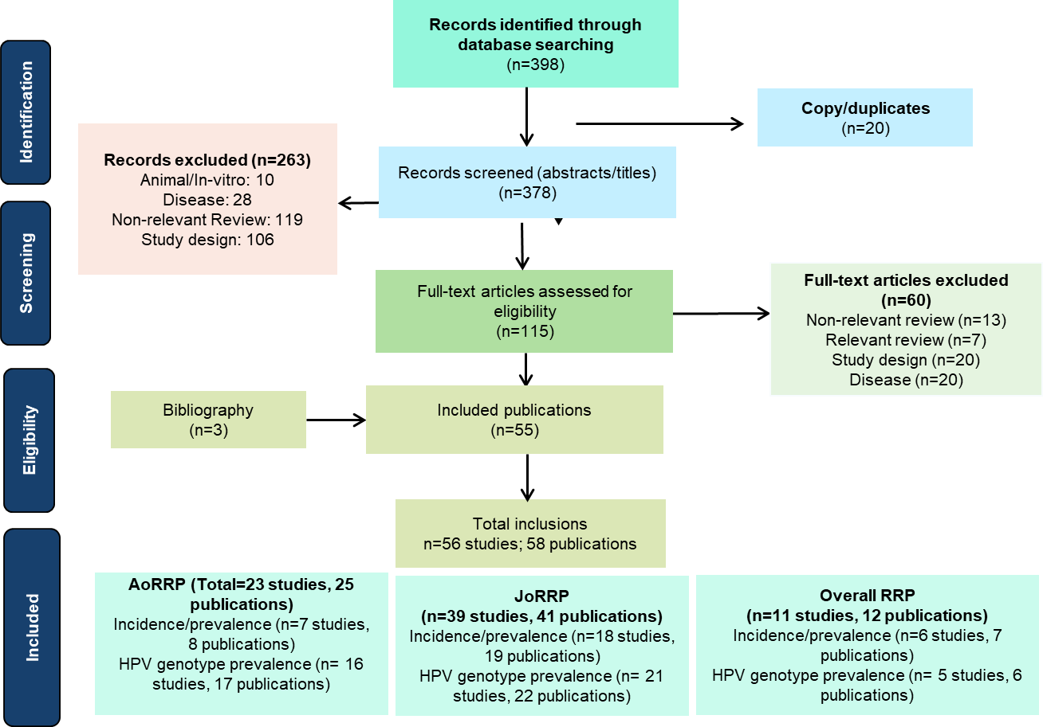

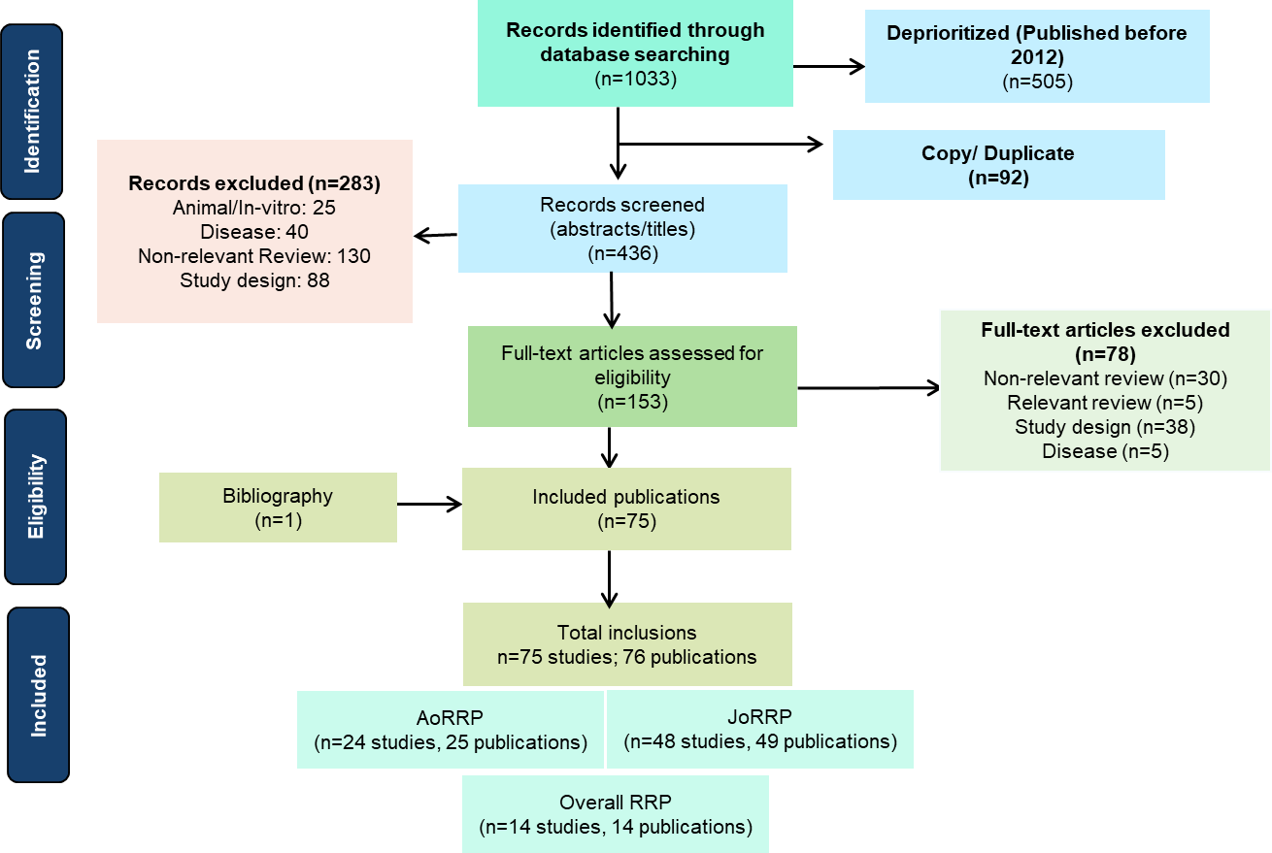
B
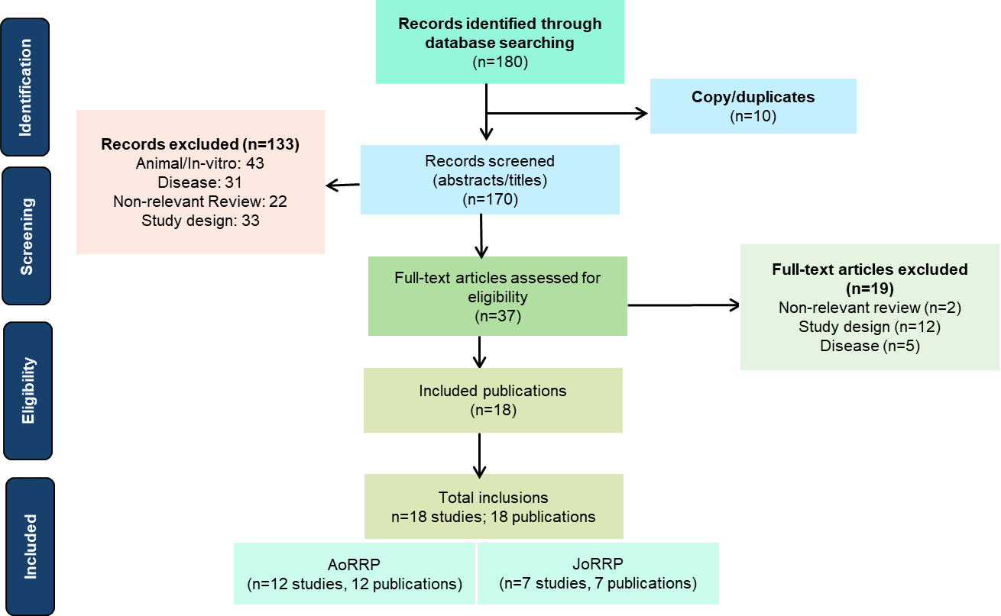
C

D
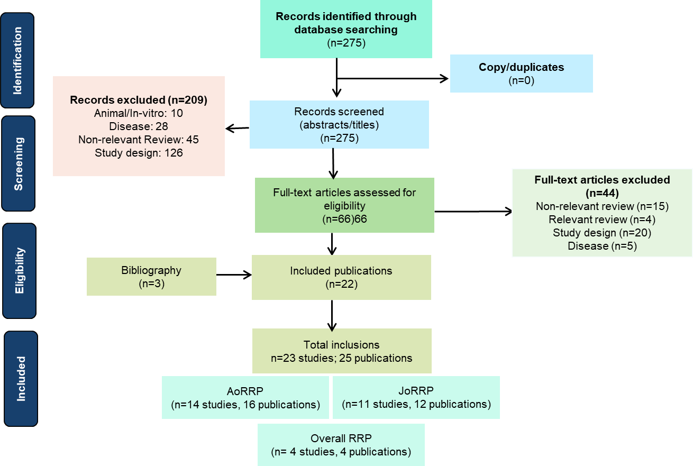

Abbreviations: AoRRP: adult-onset recurrent respiratory papillomatosis; JoRRP: juvenile onset recurrent respiratory papillomatosis.

Appendix S3. Summary of the studies included in the clinical burden review

Study | Study Design | Sample Size | Age at diagnosis | Age at onset | Male | HPV 6 | HPV11 | Other HPV | Ethnicity | Derkay Score
Adebola 2013 (64), JA | Retrospective | JoRRP: 27 | - | - | 66.7% | - | - | - | - | -
Amiling 2021 (58), JA | Cross-sectional | JoRRP: 215 | - | - | 54% | - | - | - | Non-Hispanic White: 50%  Hispanic: 22%  Non-Hispanic Black: 21%  Non-Hispanic multiracial: 5%  Non-Hispanic Asian: 1% | -
Bedard 2021 (140) JA  Bedard 2021 (140) JA | Prospective | JoRRP:20 | - | Mean: 4.15 | 70% | 88% | 12% | - | African American: 25%  White: 70%  Hispanic: 5% | Mean: 8.0
Bertinazzi 2022 (89), JA | Retrospective | JoRRP: 20 | Median: 3.0 | - | 35% | 40% | 15% | - | - | Median value: 14
Carvahlo 2021 (68), JA | Retrospective | JoRRP: 17 | Mean: 5.23 | - | 35% | - | - | - | - | -
Costa 2020 (47), JA | Retrospective | JoRRP: 36 | - | - | 50% | 53% | 53% | - | - | High: 14%
Delgado 2017 (80), CA | Prospective | JoRRP: 20 | - | - | 55% | - | - | - | - | -
Eftekhaar 2017 (74), JA | Retrospective | JoRRP: 12 | - | - | 50% | 75% | 17% | 6/11: 8% | Iranian: 100% | -
Figueiredo 2019 (50), JA | Retrospective | JoRRP: 25 | - | - | 56% | 28% | 24% | 6/11: 48% | - | -
Gandhi 2012 (141), JA | Retrospective | JoRRP: 30 | - | - | 67% | - | - | - | - | -
Gruber 2016 (88), JA | Retrospective | JoRRP: 20 | Mean: 4.5 | - | - | 50% | 40% | 6/11: 5% | European:8  Maori:7  Cook Island: 2  Chinese:1  Indian:1  Samaon:1 | -
Hermann 2012 (70) JA | Retrospective | JoRRP: 50 | - | Mean: 2.6 | 52% | - | - |  | - | Mean: 13.2
Hock 2022 (69) JA | Retrospective | JoRRP: 68 | Mean (4.2) | - | 49% | - | - | - | Black: 19%  White: 81% | -
Intakorn 2014 (75), JA | Prospective | JoRRP: 15 | Mean (2.6) | - | 53% | 40% | 90% | - | Thai: 100% | -
Khan and Naidu 2019 (71) JA | Retrospective | JoRRP: 184 | Mean (5.2) | - | 61% | - | - | - | - | -
Labedz 2021 (65) JA | Retrospective | JoRRP: 82 | - | Median: 3.5 | 46% | 34% | 26% | - | - | -
Lawlor 2020 (142), JA | Retrospective | JoRRP: 11 | - | - | - | - | - | - | - | -
Lepine 2020 (91) JA  Lepine 2020 (91) JA | Retrospective | JoRRP: 38 | Mean (3.8) | - | 46% | 65% | 27% | 6/11: 6% | - | -
Martha 2012 (76), CA | Ambidirectional | JoRRP: 301 | - | - | - | - | - | - | - | -
Matinhara 2019 (77), JA | Prospective | JoRRP:52 | Median: 3 yrs | - | 67% | 29% | 25% | 16: 6%  18: 4% | - | -
Meacham 2017 (97) | Retrospective | JoRRP: 15 | - | - | 47% | - | - | - | - | -
Montano Velaquez 2017 (35), JA | Cross-sectional | JoRRP:12 | - | - | 66% | 67% | 33% | - | - | -
Moreddu 2019 (94), JA | Retrospective | JoRRP: 32 | Mean (5.4) | - | 41% |  |  |  | - | -
Mudd 2020(81) JA | Retrospective | JoRRP: 54 | - | - | 41% | - | - | - | Caucasian: 19%  African American: 65%  Hispanic: 9%  Asian: 7% | -
Niu 2022 (72) JA | Retrospective | JoRRP: 342 | Median (2.65) | - | 56% | - | - | - | - | -
Niu 2022 (73) JA | Retrospective | JoRRP: 77 | Median (2.3) | - | 52% | - | - | - | - | -
Nogueira 2022 (36) JA | Prospective | JoRRP: 15 |  | - | 53% | 47% | - | - | - | -
Omland 2014 (61) JA | Retrospective | JoRRP: 50 | Median: 34 | - | 62% | - | - | - | - | -
Orji 2013 (79) JA | Retrospective | JoRRP: 40 | - | - | 53% | - | - | - | - | -
Perdana 2020 (143) | Retrospective | JoRRP: 28 | - | - | 61% | - | - | - | - | -
Perdana 2020 (144) | Cross-sectional | JoRRP: 15 | - | - | 66% | - | - | - | - | -
Rasmussen 2017 (145) JA | Retrospective | JoRRP: 4 | - | Mean: 8.5 | 25% | - | - | - | - | -
Ribeiro 2018 (146), JA | Retrospective | JoRRP: 36 | - | - | 50% | - | - | - | - | Mean: 10.9
Rodier 2013 (60) JA | Retrospective | JoRRP: 31 | Median: 3.5 | - | 61% | 55% | 19% | 6/7: 7%  HPV 30: 3.2% | - | Mean: 13.8
Rogers 2013, (82) JA | Prospective | JoRRP: 10 | - | - | 40% | 60% | 40% | - | - | Mean: 19
Ruiz 2022 (96), JA | Retrospective | JoRRP: 7 | - | - | 71% | - | - | - | - | -
Scatolini 2020, (66) JA | Retrospective | JoRRP: 79 | - | Median: 3.5 | 53% | 29% | 25% | - | - | -
See 2020, (131) JA | Retrospective | JoRRP: 19 | - | - | 63% | - | - | - | Chinese: 11  Malay: 6  Indonesian: 1  Philippine: 1 | -
Silva 2015, JA (78) JA | Retrospective | JoRRP: 21 | Mean: 3.3 | - | - | - | - | - | - | -
So 2022, JA (67) JA | Retrospective | JoRRP: 31 | Mean: 4.0 | - | 34% | - | - | - | Non-Hispanic White: 72%  White Hispanic: 6%  Black or African black: 9%  Asian: 6% | -
Wang 2012, JA (147) JA | Retrospective | JoRRP: 408 | - | Median: 1.6 | 58% | - | - | - | - | -
Xi 2020, JA (148) JAXi 2020, JA (148) JA | Retrospective | JoRRP: 46 | Median: 1.3 | - | 44% | - | - | - | Chinese: 100% | -
Xiao 2020, JA (41) JA | Retrospective | JoRRP: 121 | - | - | 55% | 17% | 49% | 10% | - | -
Yang 2021, JA (92) JAYang 2021, JA (92) JA | Retrospective | JoRRP: 192 | - | Median: 2 | 56% | - | - | - | - | -
Zhang 2014 (149) JA | Retrospective | JoRRP: (Not clear) | - | - | - | - | - | - | - | -
Shen 2021 (98) JA | Retrospective | JoRRP: 170 | - | - | - | - | - | - | - | -
Qu 2021 (95) JA | Retrospective | JoRRP: 106 | - | - | 60% | - | - | - | - | -
Qu 2022 (150) JAQu 2022 (150) JA | Retrospective | JoRRP: 721 | - | - | - | - | - | - | - | -
Awad 2019, JA (84) JA | Retrospective | AoRRP: 15 | - | - | 87% | - | - | - | - | -
Chung 2022, JA (85) JA | Prospective | AoRRP: 32 | - | - | 84% | - | - | - | - | -
Costa 2020, JA (47) JA | Retrospective | AoRRP: 44 | - | - | 80% | 77% | 25% | - | - | High: 2%
Carvahlo 2021, JA (68) JA | Retrospective | AoRRP: 8 | Mean: 27.6 | - | - | - | - | - | - | -
Davids 2015, JA (48) JA | Retrospective | AoRRP: 85 | - | Mean: 35.3 | 69% | - | - | 6/11: 16.4% | - | -
Figueiredo 2019, (50) JA | Retrospective | AoRRP: 16 | - | - | 81% | 44% | 6% | 6/11: 50% | - | -
Formanek 2017, (63) JA | Prospective | AoRRP: 20 | - | - | 75% | - | - | - | - | -
Formanek 2021, (151) JA | Prospective | AoRRP: 18 | - | - | 61% | - | - | - | - | -
Gluvajić 2022,(59) JA | Prospective | AoRRP: 36 | - | - | - | - | - | - | - | -
Hao 2020, (152) JAHao 2020, (152) JA | Retrospective | AoRRP: 41 | - | - | 54% | - | - | - | - | -
Hock 2022 (69) JA | Retrospective | AoRRP: 44 | Mean: 47 | - | 75% | - | - | - | Black: 18%  White: 82% | -
Hu 2019 (153) JA | Retrospective | AoRRP: 7 | Mean: 44.4 | - | 71% | - | - | - | - | -
Hung 2021 (86) JA | Retrospective | AoRRP: 16 |  | - |  | - | - | - | - | -
Khan and Naidu 2019 (71) JA | Retrospective | AoRRP: 18 | Mean: 33 | - | 39% | - | - | - | - | -
Lee 2013, (83) JA | Retrospective | AoRRP: 84 | Mean: 45.3 | - | 76% | - | - | - | Caucasian: 90%  Other: 10% | -
Nogueira 2022 (36) JA | Prospective | AoRRP: 41 | - | - | 84% | 15% | - | - | - | -
Omland 2014 (61) JA | Retrospective | AoRRP: 174 | Median: 34 | - | 81% | - | - | - | - | -
Orji 2013 (79) JA | Retrospective | AoRRP: 19 | - | - | 37% | - | - | - | -
Perdana 2020 (143) JA | Retrospective | AoRRP: 6 | - | - | 17% | - | -
Ribeiro 2018 (146) JA | Retrospective | AoRRP: 56 | - | - | 73% | - | - | - | - | Mean: 8.2
Ruiz 2014 (62) JA | Retrospective | AoRRP: 48 | - | - | 90% | - | - | - | -
So 2022 (67) JA | Retrospective | AoRRP: 41 | Mean: 35.2 | - | 43% | - | - | - | Non-Hispanic White: 85%  White Hispanic: 5%  Black or African black: 5%  Asian: 2% | -
Suter-Montano (87) JA | Retrospective | AoRRP: 14 | - | - | 79% | - | - | - | - | -
Toma 2012, (154) CA JA | Retrospective | AoRRP: 18 | - | - | - | - | - | - | - | -
AoRRP: adult-onset recurrent respiratory papillomatosis; CA: conference abstract; JA: journal article; JoRRP: juvenile onset recurrent respiratory papillomatosis.

Appendix S4. Summary of the studies included in the humanistic burden review
Study,  Publication type | Data collection period | Country | Quality rating | Sample size (N)/ ethnicity (%) | Age (yrs),  HPV status | Male (%) | QoL/utility scale
Retrospective (n=7)
Ilmarinen 2011, JA (100) | 1975-1994 | Finland | 7 | JoRRP: 18 | JoRRP >12 yrs. | JoRRP:67% | VHI,  15 D
Lindman 2005, JA (99) | - | US | 6 | JoRRP:22 | JoRRP >18 yrs. | JoRRP:59% | PedsQL
So 2022, JA (67) | - | US | 6 | JoRRP:73  AoRRP: 41 | Not specified | JoRRP:34%  AoRRP: 49% | Self-Questionnaire
Awad 2019, JA (84) | 2011-2015 | UK | 5 | AoRRP: 15 | AoRRP >18yrs | AoRRP: 87% | VHI
Hill 2000, JA (104) | 1998 | UK | 6 | AoRRP: 26 | AoRRP >18yrs | AoRRP: 54% | SF-36
Kupfer 2016, JA (103) | 2007-2013 | US | 5 | AoRRP: 39 | Not specified | NR | VHI-10
Suter-Montano, JA (87) | 2005-2006 | Mexico | 4 | AoRRP: 14 | >16 yrs. | AoRRP: 79% | VRQoL
Prospective (n=4)
Ruiz 2014, JA (62) | 2012-2013 | US | 4 | AoRRP: 48 | AoRRP >18 yrs. | AoRRP: 90% | SF-36
Rogers 2013, JA (82) | - | US | 5 | JoRRP: 10 | JoRRP >12 yrs. | JoRRP: 40% | PVRQoL
Chung 2022, JA (85) | 2019-2021 | US | 6 | AoRRP: 32 | AoRRP >18 yrs. | AoRRP: 84% | VHI
Zeitels 2011 JA (105) | - | US | 7 | AoRRP: 20 | AoRRP >18 yrs. | AoRRP: 85% | VRQoL
Cross-sectional (n=5)
Chadha 2010, JA (101) | - | Canada | 4 | JoRRP: 20 | JoRRP >12 yrs. | JoRRP: 65% | PVRQoL,  VAS,  HUI3,  Impact on Family Scale
Montaño-Velázquez  2017, JA (35) | - | US | 5 | JoRRP: 12 | JoRRP >12 yrs. | JoRRP: 67% | PedsQl
Loizou 2014, JA (155)Loizou 2014, JA (155) | 2004-2012 | Sweden | 4 | Overall: 27  JoRRP: 7 | Not specified | - | VHI
San 2017, JA (122) | - | Finland and Netherlands | 6 | AoRRP: 91 | AoRRP >18 yrs. | - | RAND-36
Van 2010, JA (156) | 1984-2008 | Netherlands | 6 | AoRRP: 34 | AoRRP >18 yrs. | - | VHI
RCT (n=1)
McMurray 2008, JA (106) | - | US | 3* | AoRRP: 14 | AoRRP >18 yrs. | AoRRP: 79% | SF-12
Single arm Phase II trial (n= 1)
Pai 2021, CA (102) | - | US | - | AoRRP: 20 | AoRRP >18 yrs. | AoRRP: 57% | PROs
AoRRP: Adult onset recurrent respiratory papillomatosis; JoRRP: juvenile onset recurrent respiratory papillomatosis; CA: conference abstract; JA: journal article; N: sample size; VHI: Voice Handicap Index; VRQoL: voice related quality of life; PVRQoL: Pediatric Voice-Related Quality of Life; PROs: patient reported outcomes; SF-12: short form survey-12; SF-36: short form survey-36; PedsQl: Pediatric Quality of Life; RAND-36: RAND Corporation 36-item health-related quality-of-life survey instrument; VAS: visual analogue scale; HUI3: Health Utilities Index version 3; IFS: Impact on Family Life Scale; RCT: randomized controlled trial; US: United States; UK: United Kingdom; HPV: Human papilloma virus; QoL: Quality of life; yrs: years
*RCT, appraised using NICE checklist

Appendix S5. Summary of the studies included in the economic burden review
Study,  Publication type | Study Design | Data collection  Period | Country | Patient Group/Sample size | Mean age (yrs) | Male (%) | Outcome
Narasimhan 2012, CA (110) | Retrospective | 2005-2011 | UK | JoRRP: 18 | - | - | Cost burden
Armstrong 1999, JA (111) | Retrospective | 1997-1998 | US | JoRRP: 339 | < 18 yrs. | JoRRP: 52% | Resource use
Amiling 2021, JA (58) | Retrospective | 2015-2020 | US | JoRRP: 215 | - | JoRRP: 54% | Resource use
Miller 2017, JA (114) | Retrospective | 2005-2012 | US | AoRRP: 17 | >18 yrs. | AoRRP: 5% | Resource use
Chung 2022, JA (85) | Retrospective | 2019-2021 | US | AoRRP: 32 | >18 yrs. | AoRRP: 84% | Resource use
Yiu 2019, JA (14) | Retrospective | 2012-2017 | US | AoRRP: 42 | - | AoRRP: 42% | Resource use
Rees 2007, JA (157) | Retrospective | 2003-2006 | US | AoRRP: 6 | >18 yrs. | - | Resource use
Tam 2020, JA (109) | Retrospective | 2011-2014 and 2008-2012, | US | JoRRP  (Truven MarketScan: 122  Texas Medicaid: 73)  AoRRP  (Truven MarketScan: 1824  Texas Medicaid: 96) | JoRRP  (Truven MarketScan: <18 yrs.  Texas Medicaid: < 18 yrs.)  AoRRP  (Truven MarketScan: >18 yrs.  Texas Medicaid: >18 yrs.) | JoRRP  (Truven MarketScan: 52%  Texas Medicaid: 62%)  AoRRP  (Truven MarketScan: 58%  Texas Medicaid: 41%) | Cost burden
Chesson 2012, JA (108) | Retrospective | 2004-2007 | US | JoRRP: NR  AoRRP: NR | Not specified | NR | Cost burden
Bishai 2000, JA (107) | Retrospective | 1994 | US | JoRRP: (18) | JoRRP: <18 yrs. | NR | Cost burden
Derkay 1995, JA (20) | Survey | 1993-1994 | US | AoRRP: NR  JoRRP: NR | Not specified | NR | Cost burden
Reeves 2003, JA (112) | Ambidirectional | 1996-2002 | US | JoRRP: (603) | JoRRP: < 18 yrs. | JoRRP: 50% | Resource use
So 2022, JA (67) | Retrospective | - | US | JoRRP:32  AoRRP: 41 | Not specified | JoRRP:34%  AoRRP: 49% | Resource use
Zheng 2022, JA (158) | Retrospective | 2010-2020 | US | Overall RRP: 62 | - | Overall: 55% | Resource use
Chesson 2008, JA (159) | Cost analysis | - | US | Overall RRP: NR | - | - | Cost use
Pasquale 2003, JA (160) | Prospective | - | US | Overall RR: 19 | Range: 2.5-20 yrs. | Overall RRP: 63% | Cost use
Nogueira 2020, JA (36) | Prospective | 2008-2015 | Brazil | AoRRP: 26  JoRRP: 15 | - | AoRRP: 81%  JoRRP: 47% | Resource use
Omland 2014, JA (61) | Retrospective | 1987-2009 | Norway | AoRRP: 174  JoRRP: 50 | AoRRP >=18 yrs.  JoRRP < 18 yrs. | AoRRP: 81%  JoRRP: 62% | Resource use
Eftekhaar 2017, JA (74) | Cross-sectional | 2014-2016 | Iran | JoRRP: 12 | Not specified | JoRRP: 50% | Resource use
Matsuzaki 2020, JA (56) | Prospective | 2012-2018 | Japan | AoRRP: 16 | >18 yrs. | AoRRP: 94% | Resource use
Kin 2017, JA (53) | Prospective | - | Germany | AoRRP: 12 | AoRRP >18 yrs. | AoRRP: 66% | Resource use
Ding 2021, JA (161) | Retrospective | 2012-2019 | China | - | - | - | Cost use
Bresse 2013, JA (162) | Cost analysis | - | France | - | - | - | Cost use
Harison 2016, JA (163) | Retrospective | 2013-2014 | UK | AoRRP: 14 | 36 | AoRRP: 43% | Cost and resource use
AoRRP: adult-onset recurrent respiratory papillomatosis; CA: conference abstract; JA: journal article; JoRRP: juvenile onset recurrent respiratory papillomatosis; NR: not reported

