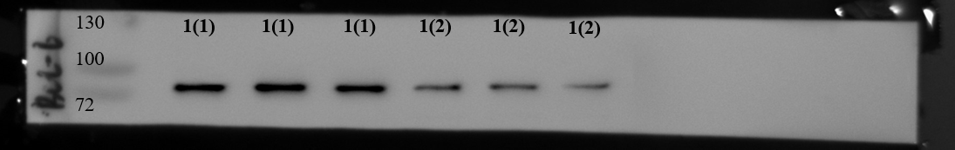
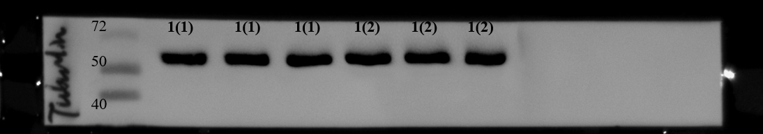
Bcl-6

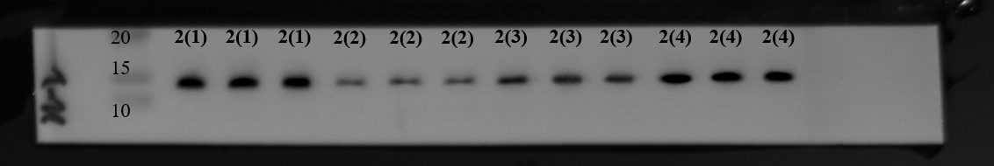
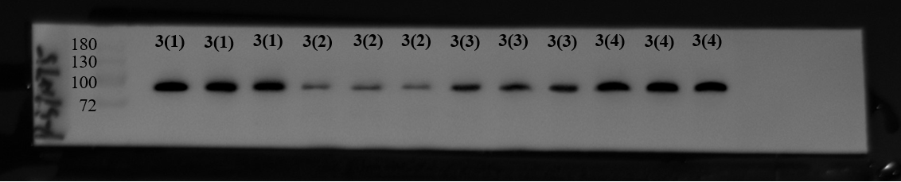
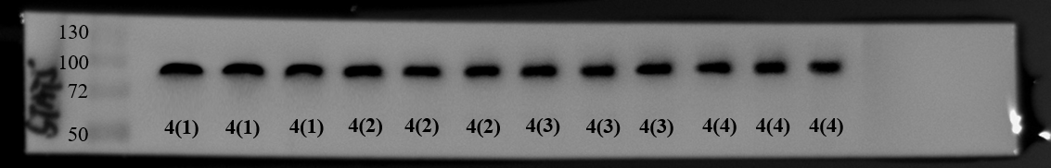
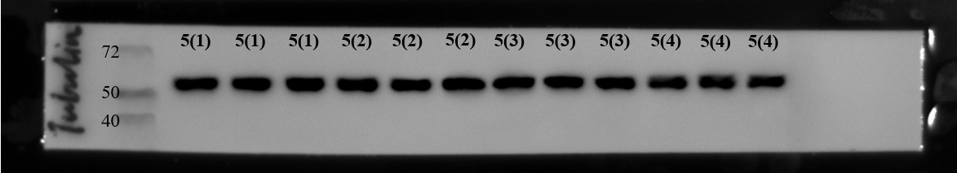
IL-2, p-STAT5 and STAT5

All western blot analysis of Fizz1 were re-performed as follows:

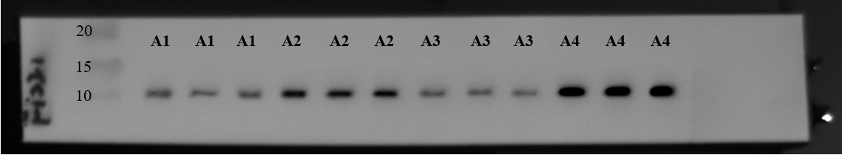
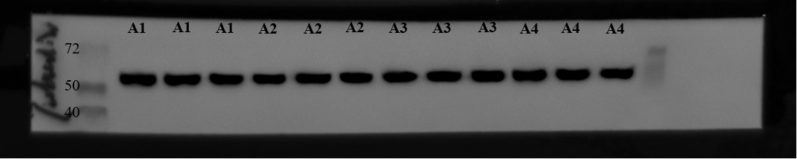
Control HPH Control+AT T_{FH} HPH+AT T_{FH}

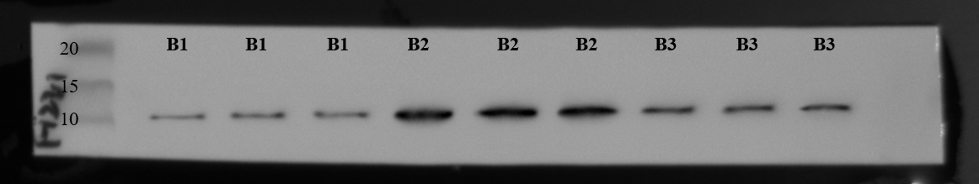
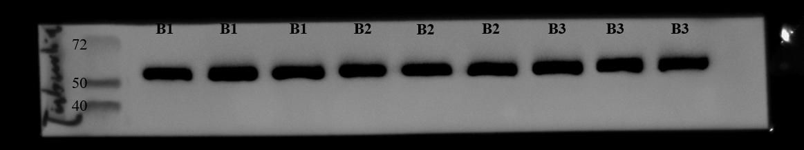
Control HPH HPH+Bcl-6i

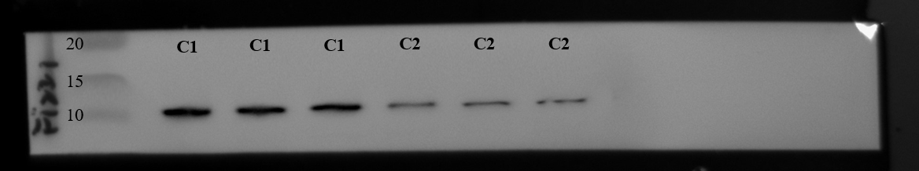
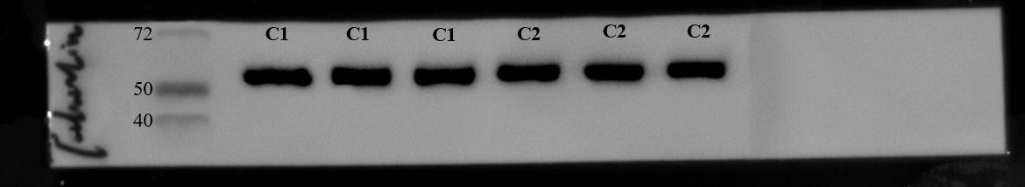
WT HPH IL-21 KO HPH

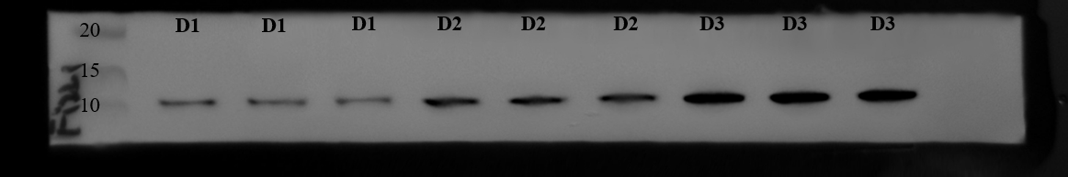
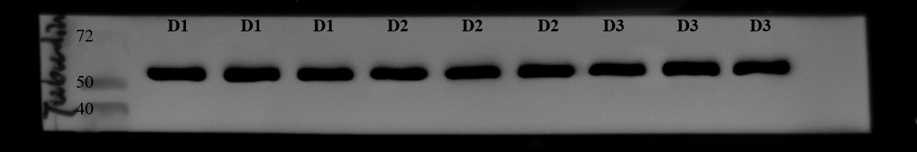
Hypoxia Hypoxia+IL-21（50ng/ml） Hypoxia+IL-21（100ng/ml）

