Table S1. The HWE test of the SNPs in gene
SNP | Major/minor  alleleª | Controls:genotype |  |  |  |  | MAF | Gene
SNP | Major/minor  alleleª | 11^{b} | 12^{b} | 22^{b} | $$x^{2}$$ | P-value | MAF | Gene
rs1130864 | G/A | 428 | 40 | 0 | 0.933 | 0.334 | 0.057 | CRP
rs1205 | T/C | 191 | 207 | 70 | 1.266 | 0.260 | 0.389 | CRP
rs1341665 | A/G | 211 | 192 | 65 | 3.877 | 0.049 | 0.355 | CRP
rs1800947 | C/G | 423 | 45 | 0 | 1.194 | 0.275 | 0.042 | CRP
rs2808630 | T/C | 343 | 114 | 11 | 0.174 | 0.677 | 0.144 | CRP
rs4806606 | A/G | 348 | 114 | 6 | 0.969 | 0.325 | 0.154 | FCAR
rs4806608 | A/G | 355 | 104 | 9 | 0.183 | 0.669 | 0.144 | FCAR
rs62123424 | C/T | 196 | 213 | 59 | 0.009 | 0.924 | 0.332 | FCAR
rs7259090 | G/A | 365 | 100 | 3 | 1.910 | 0.167 | 0.118 | FCAR
rs8112766 | A/G | 191 | 210 | 67 | 0.567 | 0.451 | 0.353 | FCAR
rs11084376 | C/G | 236 | 185 | 47 | 1.433 | 0.231 | 0.284 | FCAR
rs16986050 | A/G | 464 | 3 | 0 | 0.005 | 0.944 | 0.007 | FCAR
rs1865096 | G/A | 257 | 168 | 43 | 3.983 | 0.046 | 0.280 | FCAR
rs1865097 | G/A | 204 | 203 | 52 | 0.871 | 0.351 | 0.350 | FCAR
rs2304225 | C/G | 352 | 108 | 8 | 0.007 | 0.932 | 0.134 | FCAR
rs438228 | A/C | 141 | 272 | 55 | 19.289 | 0.000 | 0.308 | FCGR2A
rs4656308 | T/C | 338 | 120 | 10 | 1.535 | 0.215 | 0.159 | FCGR2A
rs4656309 | C/T | 110 | 249 | 109 | 1.923 | 0.165 | 0.481 | FCGR2A
rs4657040 | T/C | 334 | 126 | 8 | 0.991 | 0.320 | 0.111 | FCGR2A
rs1801274 | A/G | 197 | 219 | 52 | 0.582 | 0.445 | 0.344 | FCGR2A
rs2165088 | G/A | 336 | 123 | 9 | 0.343 | 0.558 | 0.150 | FCGR2A
rs56159502 | G/A | 343 | 105 | 20 | 9.586 | 0.002 | 0.108 | FCGR2B
rs844 | G/A | 240 | 191 | 37 | 0.014 | 0.907 | 0.240 | FCGR2B
rs16827592 | T/G | 310 | 141 | 16 | 0.000 | 0.995 | 0.193 | FCGR2B
rs1771576 | A/C | 172 | 248 | 47 | 9.692 | 0.002 | 0.376 | FCGR2B
a: Reference to 1000 Genomes;
11^{b}: wide type homozygote, 12^{b}: heterozygote, 22^{b}: variant homozygote.

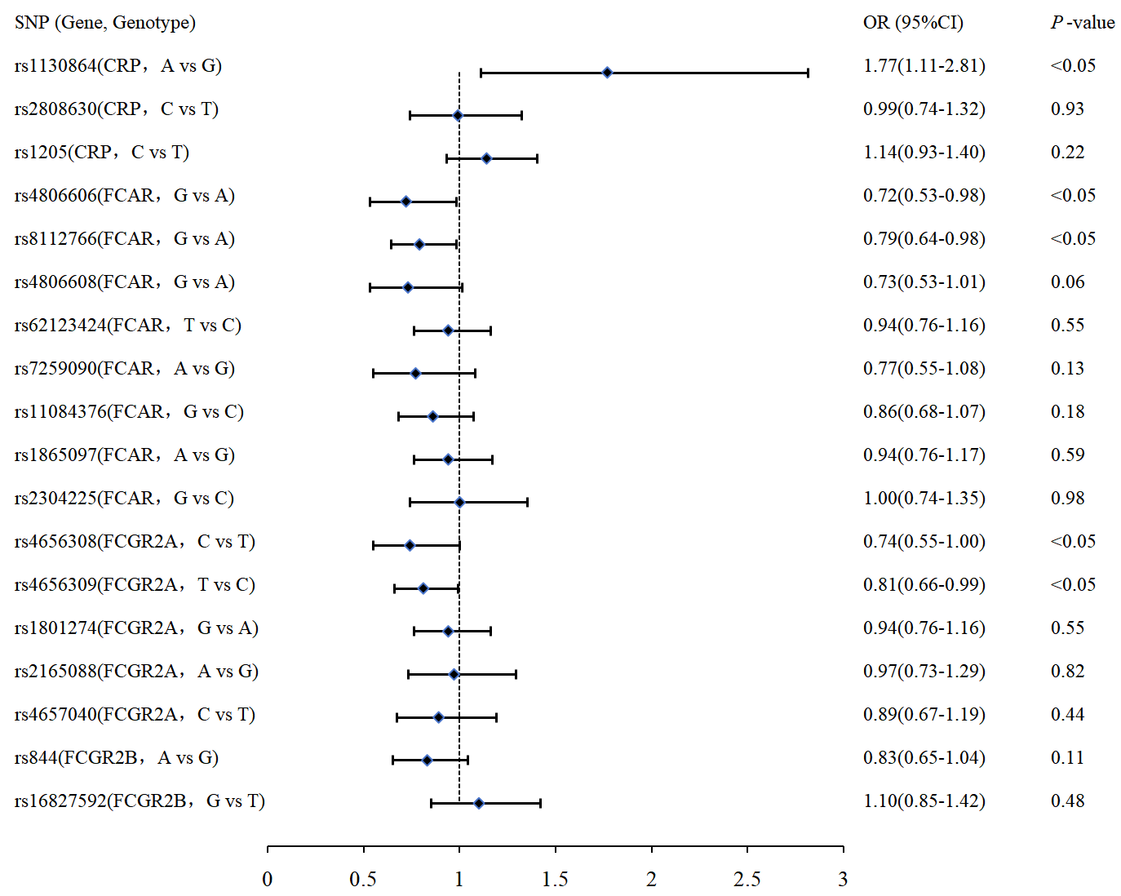
Figure S1 Allele frequencies in COPD and control subjects for SNPs
(Adjusted for age, Income, BMI, Education, History of RD, History of CVD, Smoking, Indoor fuel use, History of CHD/CHF, Straw burning outdoor.)

Table S2. The dominant models in COPD and control subjects for SNPs
SNP (Gene) | Genotype | Control n (%) | Case n (%) | OR (95%CI) | P-value | AIC | BIC
rs1130864 | G/G | 391 (92.0) | 352 (87.1) | Ref | 0.02 | 1077.5 | 1153.0
(CRP) | G/A+A/A | 34 (8.0) | 52 (12.9) | 1.75 (1.07-2.84) | 0.02 | 1077.5 | 1153.0
rs2808630 | T/T | 316 (74.3) | 299 (74.0) | Ref | 0.71 | 1082.5 | 1158
(CRP) | C/T+C/C | 109 (25.6) | 105 (26.0) | 1.06 (0.76-1.48) | 0.71 | 1082.5 | 1158
rs1205 | T/T | 178 (41.9) | 153 (37.9) | Ref | 0.10 | 1079.9 | 1155.4
(CRP) | C/T+C/C | 247 (58.1) | 251 (62.1) | 1.28 (0.95-1.73) | 0.10 | 1079.9 | 1155.4
rs4806606 | A/A | 311 (73.2) | 316 (78.2) | Ref | 0.06 | 1079 | 1154.6
(FCAR) | A/G+G/G | 114 (26.8) | 88 (21.8) | 0.72 (0.51-1.01) | 0.06 | 1079 | 1154.6
rs8112766 | A/A | 174 (40.9) | 192 (47.5) | Ref | 0.09 | 1079.7 | 1155.2
(FCAR) | A/G+G/G | 251 (59.1) | 212 (52.5) | 0.77 (0.58-1.04) | 0.09 | 1079.7 | 1155.2
rs4806608 | A/A | 318 (74.8) | 322 (79.7) | Ref | 0.12 | 1080.3 | 1155.8
(FCAR) | A/G+G/G | 107 (25.2) | 82 (20.3) | 0.76 (0.54-1.08) | 0.12 | 1080.3 | 1155.8
rs62123424 | C/C | 177 (41.6) | 164 (40.6) | Ref | 0.70 | 1082.5 | 1158
(FCAR) | T/C+T/T | 248 (58.4) | 240 (59.4) | 1.06 (0.79-1.42) | 0.70 | 1082.5 | 1158
rs7259090 | G/G | 330 (77.7) | 331 (81.9) | Ref | 0.20 | 1081 | 1156.5
(FCAR) | A/G+A/A | 95 (22.4) | 73 (18.1) | 0.79 (0.54-1.14) | 0.20 | 1081 | 1156.5
rs11084376 | CC | 217 (51.1) | 220 (54.5) | Ref | 0.30 | 1081.5 | 1157.1
(FCAR) | CG+GG | 208 (48.9) | 184 (45.5) | 0.86 (0.64-1.15) | 0.30 | 1081.5 | 1157.1
rs1865097 | G/G | 185 (43.5) | 171 (42.3) | Ref | 0.67 | 1082.4 | 1157.9
(FCAR) | A/G+A/A | 240 (56.5) | 233 (57.7) | 1.07 (0.80-1.43) | 0.67 | 1082.4 | 1157.9
rs2304225 | C/C | 323 (76.0) | 300 (74.3) | Ref | 0.63 | 1082.4 | 1157.9
(FCAR) | C/G+G/G | 102 (24.0) | 104 (25.7) | 1.09 (0.78-1.52) | 0.63 | 1082.4 | 1157.9
rs4656308 | C/C | 323 (76.0) | 300 (74.3) | Ref | 0.63 | 1082.4 | 1157.9
(FCGR2A ) | C/G+G/G | 102 (24.0) | 104 (25.7) | 1.09 (0.78-1.52) | 0.63 | 1082.4 | 1157.9
rs4656309 | C/C | 101 (23.8) | 113 (28.0) | Ref | 0.13 | 1080.3 | 1155.8
(FCGR2A ) | T/C+T/T | 324 (76.2) | 291 (72.0) | 0.77 (0.55-1.08) | 0.13 | 1080.3 | 1155.8
rs1801274 | A/A | 176 (41.4) | 177 (43.8) | Ref | 0.45 | 1082 | 1157.6
(FCGR2A ) | A/G+G/G | 249 (58.6) | 227 (56.2) | 0.89 (0.67-1.20) | 0.45 | 1082 | 1157.6
rs2165088 | G/G | 304 (71.5) | 289 (71.5) | Ref | 0.90 | 1082.6 | 1158.1
(FCGR2A ) | G/A+A/A | 121 (28.5) | 115 (28.5) | 1.02 (0.74-1.41) | 0.90 | 1082.6 | 1158.1
rs4657040 | T/T | 300 (70.6) | 293 (72.5) | Ref | 0.40 | 1081.9 | 1157.4
(FCGR2A ) | T/C+C/C | 125 (29.4) | 111 (27.5) | 0.87 (0.63-1.20) | 0.40 | 1081.9 | 1157.4
rs844 | G/G | 221 (52.0) | 229 (56.7) | Ref | 0.23 | 1081.2 | 1156.7
(FCGR2B ) | A/G+A/A | 204 (48.0) | 175 (43.3) | 0.84 (0.63-1.12) | 0.23 | 1081.2 | 1156.7
rs16827592 | T/T | 280 (66.0) | 248 (61.7) | Ref | 0.25 | 1076.5 | 1152.0
(FCGR2B ) | T/G+G/G | 144 (34.0) | 154 (38.3) | 1.20 (0.88-1.62) | 0.25 | 1076.5 | 1152.0
Notes: Adjusted for age, Income, BMI, Education, History of RD, History of CVD, Smoking, Indoor fuel use, History of CHD/CHF, Straw burning outdoor.
Table S3. The codominant models in COPD and control subjects for SNPs
SNP (Gene) | Genotype | Control n (%) | Case n (%) | OR (95%CI) | P-value | AIC | BIC
rs1130864  (CRP) | G/G | 391 (92.0) | 352 (87.1) | Ref | 0.01 | 1075.2 | 1155.5
rs1130864  (CRP) | G/A | 34 (8.0) | 49 (12.1) | 1.61 (0.98-2.63) | 0.01 | 1075.2 | 1155.5
rs1130864  (CRP) | A/A | 0 (0.0) | 3 (0.7) | NA (0.00-NA) | 0.01 | 1075.2 | 1155.5
rs2808630  (CRP) | T/T | 316 (74.3) | 299 (74.0) | Ref | 0.90 | 1084.4 | 1164.6
rs2808630  (CRP) | C/T | 98 (23.1%) | 97 (24.0) | 1.08 (0.77-1.52) | 0.90 | 1084.4 | 1164.6
rs2808630  (CRP) | C/C | 11 (2.6) | 8 (2.0%) | 0.93 (0.35-2.47) | 0.90 | 1084.4 | 1164.6
rs1205  (CRP) | T/T | 178 (41.9) | 153 (37.9) | Ref | 0.24 | 1081.7 | 1162.0
rs1205  (CRP) | C/T | 181 (42.6) | 177 (43.8) | 1.25 (0.91-1.73) | 0.24 | 1081.7 | 1162.0
rs1205  (CRP) | C/C | 66 (15.5) | 74 (18.3) | 1.37 (0.90-2.10) | 0.24 | 1081.7 | 1162.0
rs4806606  (FCAR) | A/A | 311 (73.2) | 316 (78.2) | Ref | 0.16 | 1080.9 | 1161.1
rs4806606  (FCAR) | A/G | 109 (25.6) | 84 (20.8) | 0.73 (0.51-1.03) | 0.16 | 1080.9 | 1161.1
rs4806606  (FCAR) | G/G | 5 (1.2) | 4 (1.0) | 0.54 (0.11-2.55) | 0.16 | 1080.9 | 1161.1
rs8112766  (FCAR) | A/A | 174 (40.9) | 192 (47.5) | Ref | 0.18 | 1081.1 | 1161.4
rs8112766  (FCAR) | A/G | 192 (45.2) | 167 (41.3) | 0.81 (0.59-1.10) | 0.18 | 1081.1 | 1161.4
rs8112766  (FCAR) | G/G | 59 (13.9) | 45 (11.1) | 0.68 (0.43-1.08) | 0.18 | 1081.1 | 1161.4
rs4806608  (FCAR) | A/A | 318 (74.8) | 322 (79.7) | Ref | 0.12 | 1080.4 | 1160.6
rs4806608  (FCAR) | A/G | 98 (23.1) | 78 (19.3) | 0.80 (0.56-1.15) | 0.12 | 1080.4 | 1160.6
rs4806608  (FCAR) | G/G | 9 (2.1) | 4 (1.0) | 0.32 (0.08-1.24) | 0.12 | 1080.4 | 1160.6
rs62123424  (FCAR) | C/C | 177 (41.6) | 164 (40.6) | Ref | 0.47 | 1083.1 | 1163.4
rs62123424  (FCAR) | T/C | 194 (45.6) | 193 (47.8) | 1.12 (0.82-1.53) | 0.47 | 1083.1 | 1163.4
rs62123424  (FCAR) | T/T | 54 (12.7) | 47 (11.6) | 0.85 (0.53-1.37) | 0.47 | 1083.1 | 1163.4
rs7259090  (FCAR) | G/G | 330 (77.7) | 331 (81.9) | Ref | 0.37 | 1082.6 | 1162.9
rs7259090  (FCAR) | A/G | 92 (21.6) | 70 (17.3) | 0.80 (0.55-1.16) | 0.37 | 1082.6 | 1162.9
rs7259090  (FCAR) | A/A | 3 (0.7) | 3 (0.7) | 0.45 (0.07-3.03) | 0.37 | 1082.6 | 1162.9
rs11084376  (FCAR) | CC | 217 (51.1) | 220 (54.5) | Ref | 0.51 | 1083.3 | 1163.5
rs11084376  (FCAR) | CG | 169 (39.8) | 152 (37.6) | 0.88 (0.65-1.20) | 0.51 | 1083.3 | 1163.5
rs11084376  (FCAR) | GG | 39 (9.2) | 32 (7.9) | 0.76 (0.44-1.30) | 0.51 | 1083.3 | 1163.5
rs1865097  (FCAR) | G/G | 185 (43.5) | 171 (42.3) | Ref | 0.47 | 1083.1 | 1163.4
rs1865097  (FCAR) | A/G | 185 (43.5) | 184 (45.5) | 1.13 (0.83-1.54) | 0.47 | 1083.1 | 1163.4
rs1865097  (FCAR) | A/A | 55 (12.9) | 49 (12.1) | 0.86 (0.54-1.38) | 0.47 | 1083.1 | 1163.4
rs2304225  (FCAR) | C/C | 323 (76) | 300 (74.3) | Ref | 0.67 | 1083.8 | 1164.1
rs2304225  (FCAR) | C/G | 94 (22.1) | 99 (24.5) | 1.12 (0.79-1.58) | 0.67 | 1083.8 | 1164.1
rs2304225  (FCAR) | G/G | 8 (1.9) | 5 (1.2) | 0.71 (0.22-2.30) | 0.67 | 1083.8 | 1164.1
rs4656308  (FCGR2A) | T/T | 310 (72.9) | 311 (77.0) | Ref | 0.17 | 1081 | 1161.3
rs4656308  (FCGR2A) | C/T | 105 (24.7) | 85 (21.0) | 0.72 (0.50-1.02) | 0.17 | 1081 | 1161.3
rs4656308  (FCGR2A) | C/C | 10 (2.4) | 8 (2.0) | 0.78 (0.27-2.22) | 0.17 | 1081 | 1161.3
rs4656309  (FCGR2A) | C/C | 101 (23.8) | 113 (28) | Ref | 0.26 | 1081.9 | 1162.1
rs4656309  (FCGR2A) | T/C | 222 (52.2) | 205 (50.7) | 0.80 (0.56-1.13) | 0.26 | 1081.9 | 1162.1
rs4656309  (FCGR2A) | T/T | 102 (24) | 86 (21.3) | 0.71 (0.47-1.08) | 0.26 | 1081.9 | 1162.1
rs1801274  (FCGR2A) | A/A | 176 (41.4) | 177 (43.8) | Ref | 0.56 | 1083.4 | 1163.7
rs1801274  (FCGR2A) | A/G | 200 (47.1) | 180 (44.5) | 0.86 (0.63-1.17) | 0.56 | 1083.4 | 1163.7
rs1801274  (FCGR2A) | G/G | 49 (11.5) | 47 (11.6) | 1.04 (0.64-1.67) | 0.56 | 1083.4 | 1163.7
rs2165088  (FCGR2A) | G/G | 304 (71.5) | 289 (71.5) | Ref | 0.85 | 1084.3 | 1164.5
rs2165088  (FCGR2A) | G/A | 113 (26.6) | 109 (27) | 1.04 (0.75-1.44) | 0.85 | 1084.3 | 1164.5
rs2165088  (FCGR2A) | A/A | 8 (1.9) | 6 (1.5) | 0.74 (0.23-2.40) | 0.85 | 1084.3 | 1164.5
rs4657040  (FCGR2A) | T/T | 300 (70.6) | 293 (72.5) | Ref | 0.56 | 1083.5 | 1163.7
rs4657040  (FCGR2A) | T/C | 118 (27.8) | 101 (25.0) | 0.85 (0.61-1.18) | 0.56 | 1083.5 | 1163.7
rs4657040  (FCGR2A) | C/C | 7 (1.6) | 10 (2.5) | 1.24 (0.43-3.59) | 0.56 | 1083.5 | 1163.7
rs844  (FCGR2B) | G/G | 221 (52.0) | 229 (56.7) | Ref | 0.31 | 1082.3 | 1162.5
rs844  (FCGR2B) | A/G | 174 (40.9) | 155 (38.4) | 0.87 (0.64-1.18) | 0.31 | 1082.3 | 1162.5
rs844  (FCGR2B) | A/A | 30 (7.1) | 20 (5) | 0.63 (0.33-1.21) | 0.31 | 1082.3 | 1162.5
rs16827592  (FCGR2B) | T/T | 280 (66) | 248 (61.7) | Ref | 0.49 | 1078.5 | 1158.6
rs16827592  (FCGR2B) | T/G | 128 (30.2) | 138 (34.3) | 1.21 (0.88-1.66) | 0.49 | 1078.5 | 1158.6
rs16827592  (FCGR2B) | G/G | 16 (3.8) | 16 (4.0) | 1.09 (0.51-2.34) | 0.49 | 1078.5 | 1158.6
Notes: Adjusted for age, Income, BMI, Education, History of RD, History of CVD, Smoking, Indoor fuel use, History of CHD/CHF, Straw burning outdoor.
Table S4. The recessive models in COPD and control subjects for SNPs
SNP (Gene) | Genotype | Control n (%) | Case n (%) | OR (95%CI) | P-value | AIC | BIC
rs1130864 | G/G+G/A | 425 (100.0) | 401 (99.3) | Ref | 0.02 | 1076.8 | 1152.3
(CRP) | A/A | 0 (0.0) | 3 (0.7) | NA (0.00-NA) | 0.02 | 1076.8 | 1152.3
rs2808630 | T/T+C/T | 414 (97.4) | 396 (98.0) | Ref | 0.85 | 1082.6 | 1158.1
(CRP) | C/C | 11 (2.6) | 8 (2.0) | 0.91 (0.34-2.42) | 0.85 | 1082.6 | 1158.1
rs1205 | T/T+C/T | 359 (84.5) | 330 (81.7) | Ref | 0.32 | 1081.6 | 1157.1
(CRP) | C/C | 66 (15.5) | 74 (18.3) | 1.22 (0.83-1.80) | 0.32 | 1081.6 | 1157.1
rs4806606 | A/A+A/G | 420 (98.8) | 400 (99.0) | Ref | 0.48 | 1082.1 | 1157.6
(FCAR) | G/G | 5 (1.2) | 4 (1.0) | 0.58 (0.12-2.73) | 0.48 | 1082.1 | 1157.6
rs8112766 | A/A+A/G | 366 (86.1) | 359 (88.9) | Ref | 0.21 | 1081 | 1156.5
(FCAR) | G/G | 59 (13.9) | 45 (11.1) | 0.75 (0.49-1.17) | 0.21 | 1081 | 1156.5
rs4806608 | A/A+A/G | 416 (97.9) | 400 (99.0) | Ref | 0.10 | 1079.8 | 1155.3
(FCAR) | G/G | 9 (2.1) | 4 (1.0) | 0.33 (0.09-1.30) | 0.10 | 1079.8 | 1155.3
rs62123424 | C/C+T/C | 371 (87.3) | 357 (88.4) | Ref | 0.32 | 1081.6 | 1157.2
(FCAR) | T/T | 54 (12.7) | 47 (11.6) | 0.80 (0.51-1.25) | 0.32 | 1081.6 | 1157.2
rs7259090 | G/G+A/G | 422 (99.3) | 401 (99.3) | Ref | 0.44 | 1082 | 1157.5
(FCAR) | A/A | 3 (0.7) | 3 (0.7) | 0.47 (0.07-3.17) | 0.44 | 1082 | 1157.5
rs11084376 | CC+CG | 386 (90.8) | 372 (92.1) | Ref | 0.40 | 1081.9 | 1157.4
(FCAR) | GG | 39 (9.2) | 32 (7.9) | 0.80 (0.48-1.35) | 0.40 | 1081.9 | 1157.4
rs1865097 | G/G+A/G | 370 (87.1) | 355 (87.9) | Ref | 0.35 | 1081.7 | 1157.2
(FCAR) | A/A | 55 (12.9) | 49 (12.1) | 0.81 (0.52-1.26) | 0.35 | 1081.7 | 1157.2
rs2304225 | C/C+C/G | 417 (98.1) | 399 (98.8) | Ref | 0.53 | 1082.2 | 1157.7
(FCAR) | G/G | 8 (1.9) | 5 (1.2) | 0.69 (0.21-2.23) | 0.53 | 1082.2 | 1157.7
rs4656308 | T/T+C/T | 415 (97.7) | 396 (98.0) | Ref | 0.75 | 1082.5 | 1158.0
(FCGR2A ) | C/C | 10 (2.4) | 8 (2.0) | 0.84 (0.30-2.39) | 0.75 | 1082.5 | 1158.0
rs4656309 | C/C+T/C | 323 (76.0) | 318 (78.7) | Ref | 0.28 | 1081.5 | 1157.0
(FCGR2A ) | T/T | 102 (24.0) | 86 (21.3) | 0.83 (0.58-1.17) | 0.28 | 1081.5 | 1157.0
rs1801274 | A/A+A/G | 376 (88.5) | 357 (88.4) | Ref | 0.62 | 1082.4 | 1157.9
(FCGR2A ) | G/G | 49 (11.5) | 47 (11.6) | 1.12 (0.72-1.76) | 0.62 | 1082.4 | 1157.9
rs2165088 | G/G+G/A | 417 (98.1) | 398 (98.5) | Ref | 0.61 | 1082.3 | 1157.9
(FCGR2A ) | A/A | 8 (1.9) | 6 (1.5) | 0.74 (0.23-2.37) | 0.61 | 1082.3 | 1157.9
rs4657040 | T/T+T/C | 418 (98.3) | 394 (97.5) | Ref | 0.63 | 1082.4 | 1157.9
(FCGR2A ) | C/C | 7 (1.6) | 10 (2.5) | 1.29 (0.45-3.73) | 0.63 | 1082.4 | 1157.9
rs844 | G/G+A/G | 395 (92.9) | 384 (95.0) | Ref | 0.21 | 1081.1 | 1156.6
(FCGR2B ) | A/A | 30 (7.1) | 20 (5.0) | 0.67 (0.36-1.27) | 0.21 | 1081.1 | 1156.6
rs16827592 | T/T+T/G | 408 (96.2) | 386 (96.0) | Ref | 0.95 | 1077.9 | 1153.3
(FCGR2B ) | G/G | 16 (3.8) | 16 (4.0) | 1.02 (0.48-2.19) | 0.95 | 1077.9 | 1153.3
Notes: Adjusted for age, Income, BMI, Education, History of RD, History of CVD, Smoking, Indoor fuel use, History of CHD/CHF, Straw burning outdoor.
Table S5. The overdominant models in COPD and control subjects for SNPs
SNP (Gene) | Genotype | Control n (%) | Case n (%) | OR (95%CI) | P-value | AIC | BIC
rs1130864 | G/G+A/A | 391 (92.0) | 355 (87.9) | Ref | 0.07 | 1079.2 | 1154.8
(CRP) | G/A | 34 (8.0) | 49 (12.1) | 1.58 (0.97-2.60) | 0.07 | 1079.2 | 1154.8
rs2808630 | T/T+C/C | 327 (76.9%) | 307 (76.0) | Ref | 0.66 | 1082.4 | 1157.9
(CRP) | C/T | 98 (23.1%) | 97 (24.0) | 1.08 (0.77-1.52) | 0.66 | 1082.4 | 1157.9
rs1205 | T/T+C/C | 244 (57.4) | 227 (56.2) | Ref | 0.39 | 1081.9 | 1157.4
(CRP) | C/T | 181 (42.6) | 177 (43.8) | 1.14 (0.85-1.53) | 0.39 | 1081.9 | 1157.4
rs4806606 | A/A+G/G | 316 (74.3) | 320 (79.2) | Ref | 0.08 | 1079.5 | 1155.1
(FCAR) | A/G | 109 (25.6) | 84 (20.8) | 0.73 (0.52-1.04) | 0.08 | 1079.5 | 1155.1
rs8112766 | A/A+G/G | 233 (54.8) | 237 (58.7) | Ref | 0.38 | 1081.9 | 1157.4
(FCAR) | A/G | 192 (45.2) | 167 (41.3) | 0.88 (0.66-1.18) | 0.38 | 1081.9 | 1157.4
rs4806608 | A/A+G/G | 327 (76.9) | 326 (80.7) | Ref | 0.28 | 1081.4 | 1157.0
(FCAR) | A/G | 98 (23.1) | 78 (19.3) | 0.82 (0.57-1.17) | 0.28 | 1081.4 | 1157.0
rs62123424 | C/C+T/T | 231 (54.4) | 211 (52.2) | Ref | 0.31 | 1081.6 | 1157.1
(FCAR) | T/C | 194 (45.6) | 193 (47.8) | 1.16 (0.87-1.56) | 0.31 | 1081.6 | 1157.1
rs7259090 | G/G+A/A | 333 (78.3) | 334 (82.7) | Ref | 0.25 | 1081.3 | 1156.8
(FCAR) | A/G | 92 (21.6) | 70 (17.3) | 0.81 (0.56-1.17) | 0.25 | 1081.3 | 1156.8
rs11084376 | CC+GG | 256 (60.2) | 252 (62.4) | Ref | 0.57 | 1082.3 | 1157.8
(FCAR) | CG | 169 (39.8) | 152 (37.6) | 0.92 (0.68-1.23) | 0.57 | 1082.3 | 1157.8
rs1865097 | G/G+A/A | 240 (56.5) | 220 (54.5) | Ref | 0.29 | 1081.5 | 1157
(FCAR) | A/G | 185 (43.5) | 184 (45.5) | 1.17 (0.87-1.57) | 0.29 | 1081.5 | 1157
rs2304225 | C/C+G/G | 331 (77.9) | 305 (75.5) | Ref | 0.49 | 1082.1 | 1157.7
(FCAR) | C/G | 94 (22.1) | 99 (24.5) | 1.13 (0.80-1.59) | 0.49 | 1082.1 | 1157.7
rs4656308 | T/T+C/C | 320 (75.3) | 319 (79.0) | Ref | 0.07 | 1079.3 | 1154.8
(FCGR2A ) | C/T | 105 (24.7) | 85 (21.0) | 0.72 (0.51-1.02) | 0.07 | 1079.3 | 1154.8
rs4656309 | C/C+T/T | 203 (47.8) | 199 (49.3) | Ref | 0.66 | 1082.4 | 1157.9
(FCGR2A ) | T/C | 222 (52.2) | 205 (50.7) | 0.94 (0.70-1.25) | 0.66 | 1082.4 | 1157.9
rs1801274 | A/A+G/G | 225 (52.9) | 224 (55.5) | Ref | 0.28 | 1081.5 | 1157
(FCGR2A ) | A/G | 200 (47.1) | 180 (44.5) | 0.85 (0.64-1.14) | 0.28 | 1081.5 | 1157
rs2165088 | G/G+A/A | 312 (73.4) | 295 (73.0) | Ref | 0.78 | 1082.5 | 1158.1
(FCGR2A ) | G/A | 113 (26.6) | 109 (27.0) | 1.05 (0.76-1.45) | 0.78 | 1082.5 | 1158.1
rs4657040 | T/T+C/C | 307 (72.2) | 303 (75.0) | Ref | 0.32 | 1081.6 | 1157.1
(FCGR2A ) | T/C | 118 (27.8) | 101 (25.0) | 0.84 (0.61-1.18) | 0.32 | 1081.6 | 1157.1
rs844 | G/G+A/A | 251 (59.1) | 249 (61.6) | Ref | 0.54 | 1082.2 | 1157.8
(FCGR2B ) | A/G | 174 (40.9) | 155 (38.4) | 0.91 (0.68-1.23) | 0.54 | 1082.2 | 1157.8
rs16827592 | T/T+G/G | 296 (69.8) | 264 (65.7) | Ref | 0.24 | 1076.5 | 1152.0
(FCGR2B ) | T/G | 128 (30.2) | 138 (34.3) | 1.20 (0.88-1.64) | 0.24 | 1076.5 | 1152.0
Notes: Adjusted for age, Income, BMI, Education, History of RD, History of CVD, Smoking, Indoor fuel use, History of CHD/CHF, Straw burning outdoor.

Table S6. The log-additive models in COPD and control subjects for SNPs
SNP | Minor vs major allele  alleleª | OR (95%CI) | P-value | AIC | BIC
rs1130864 (CRP) | A vs G | 1.82 (1.14-2.89) | 0.01 | 1076.1 | 1151.6
rs1205 (CRP) | C vs T | 1.19 (0.97-1.45) | 0.10 | 1079.9 | 1155.4
rs2808630 (CRP) | C vs T | 1.04 (0.78-1.39) | 0.79 | 1082.5 | 1158.1
rs4806606 (FCAR) | G vs A | 0.73 (0.53-1.01) | 0.05* | 1078.9 | 1154.4
rs4806608 (FCAR) | G vs A | 0.74 (0.54-1.02) | 0.07 | 1079.3 | 1154.8
rs62123424 (FCAR) | T vs C | 0.98 (0.79-1.22) | 0.85 | 1082.6 | 1158.1
rs7259090 (FCAR) | A vs G | 0.78 (0.55-1.11) | 0.17 | 1080.7 | 1156.2
rs8112766 (FCAR) | G vs A | 0.82 (0.66-1.01) | 0.06 | 1079.2 | 1154.7
rs11084376 (FCAR) | G vs C | 0.88 (0.70-1.10) | 0.25 | 1081.3 | 1156.8
rs1865097 (FCAR) | A vs G | 0.98 (0.80-1.22) | 0.89 | 1082.6 | 1158.1
rs2304225 (FCAR) | G vs C | 1.04 (0.77-1.41) | 0.78 | 1082.5 | 1158.1
rs4656308 (FCGR2A) | C vs T | 0.76 (0.56-1.03) | 0.08 | 1079.5 | 1155.0
rs4656309 (FCGR2A) | T vs C | 0.84 (0.68-1.04) | 0.11 | 1080 | 1155.5
rs4657040 (FCGR2A) | C vs T | 0.91 (0.68-1.22) | 0.53 | 1082.2 | 1157.7
rs1801274 (FCGR2A) | G vs A | 0.97 (0.78-1.20) | 0.75 | 1082.5 | 1158
rs2165088 (FCGR2A) | A vs G | 1.00 (0.74-1.34) | 0.99 | 1082.6 | 1158.1
rs844 (FCGR2B) | A vs G | 0.84 (0.66-1.06) | 0.14 | 1080.5 | 1156.0
rs16827592 (FCGR2B) | G vs T | 1.14 (0.88-1.48) | 0.31 | 1076.8 | 1152.3
Notes: Adjusted for age, Income, BMI, Education, History of RD, History of CVD, Smoking, Indoor fuel use, History of CHD/CHF, Straw burning outdoor.
*P>0.05.

Table S7. The relationship between CRP haplotypes and COPD
Linkage SNPs | Haplotype | Control (%) | Case (%) | OR (95%CI) | P-value
rs2808630-rs1205 | TT | 62.93 | 59.15 | Ref | -
rs2808630-rs1205 | CT | 22.54 | 26.58 | 1.25 (0.98-1.60) | 0.07
rs2808630-rs1205 | CC | 14.53 | 14.27 | 1.11 (0.82-151) | 0.49
rs2304225-rs11084376-rs8112766 | CCA | 63.16 | 67.90 | Ref | -
rs2304225-rs11084376-rs8112766 | CGG | 16.33 | 13.54 | 0.75 (0.56-1.02) | 0.06
rs2304225-rs11084376-rs8112766 | GGG | 13.21 | 13.43 | 0.97 (0.71-1.32) | 0.83
rs2304225-rs11084376-rs8112766 | CCG | 7.30 | 5.13 | 0.67 (0.43-1.04) | 0.08
rs1865097-rs62123424 | GC | 64.41 | 63.90 | Ref | -
rs1865097-rs62123424 | AT | 34.30 | 35.01 | 0.98 (0.79-1.22) | 0.89
rs1865097-rs62123424 | GT | 1.29 | 1.09 | 0.77 (0.29-1.97) | 0.59
rs4656308-rs4656309-rs2165088 | TCG | 42.19 | 42.20 | Ref | -
rs4656308-rs4656309-rs2165088 | TTG | 27.78 | 28.54 | 0.96 (0.75-1.22) | 0.72
rs4656308-rs4656309-rs2165088 | CTG | 14.96 | 13.83 | 0.74 (0.54-1.02) | 0.07
rs4656308-rs4656309-rs2165088 | TCA | 7.91 | 9.04 | 1.11 (0.76-1.63) | 0.60
rs4656308-rs4656309-rs2165088 | TTA | 7.16 | 5.99 | 0.75 (0.49-1.16) | 0.20
Notes: Adjusted for age, Income, BMI, Education, History of RD, History of CVD, History of CHD/CHF, Smoking, Indoor fuel use, Straw burning outdoor.

Table S8. GMDR analysis for gene SNP-gene SNP interaction models on COPD
Model | Training Bal.Acc | Testing Bal.Acc | Sign Test (P) | CV Consistency
rs844 | 0.5350 | 0.4846 | 5 (0.6230) | 6/10
rs1205-rs8112766 | 0.5547 | 0.4746 |  | 3/10
rs1205-rs8112766-rs844 | 0.5844 | 0.5147 | 7 (0.1719) | 6/10
Notes: Adjusted for age, Income, BMI, Education, History of RD, History of CHD/CHF, History of CVD, Smoking, Indoor fuel use, Straw burning outdoor.

Table S9. GMDR analysis for haplotype-haplotype interaction models on COPD
Model | Training Bal.Acc | Testing Bal.Acc | Sign Test (P) | CV Consistency
rs2808630-rs1205 | 0.5247 | 0.5008 | 4 (0.8281) | 5/10
rs2808630-rs1205-  rs2304225-rs11084376-rs8112766 | 0.5281 | 0.5192 | 7 (0.1719) | 9/10
rs2808630-rs1205-  rs2304225-rs11084376-rs8112766-  rs1865097-rs62123424 | 0.5315 | 0.4978 | 4 (0.8281) | 5/10
Notes: Adjusted for age, Income, BMI, Education, History of RD, History of CHD/CHF, History of CVD, Smoking, Indoor fuel use, Straw burning outdoor.

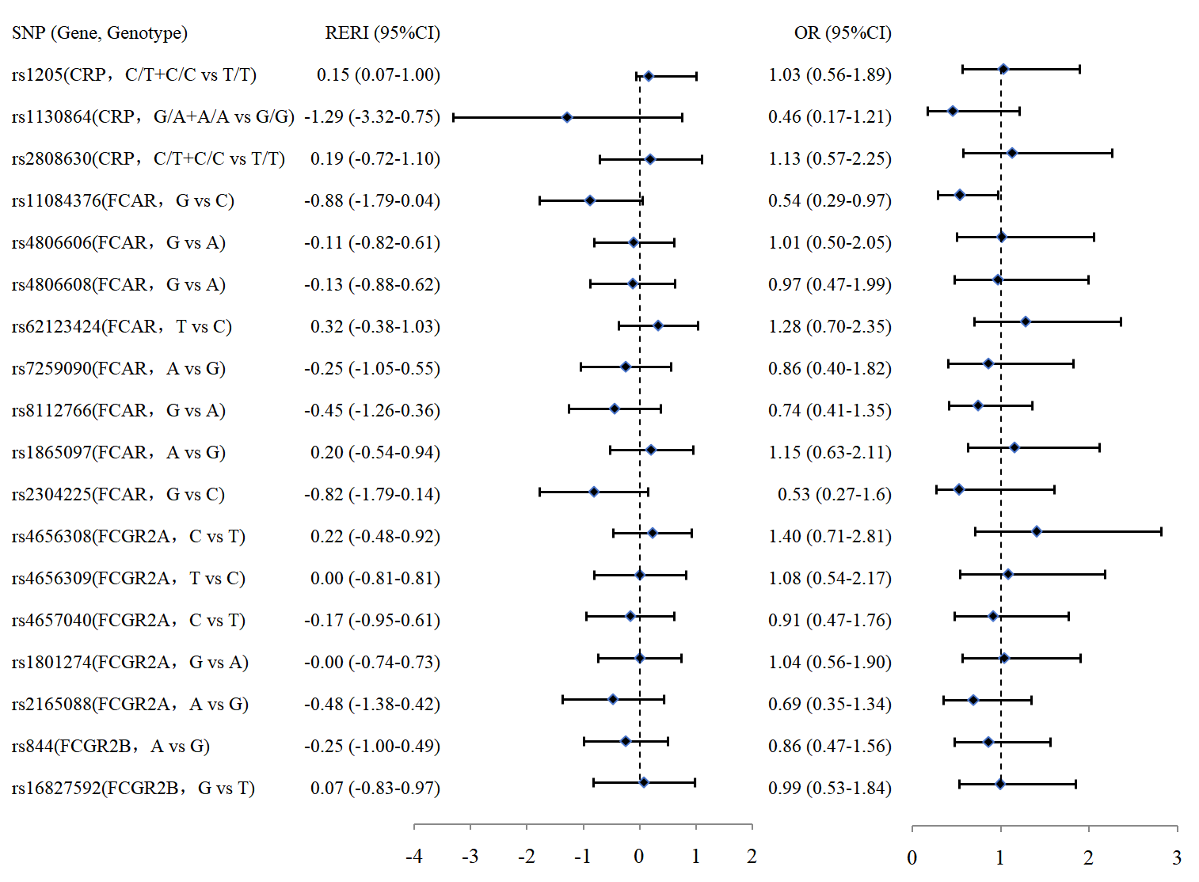Figure S2 Interaction between smoking exposure and SNPs on COPD
(The smoking exposure is classified into Smoking index>200 vs Smoking index≤200; Adjusted for Age, Education, Income, BMI, History of RD, History of CHD/CHF, History of CVD, Indoor fuel use, Straw burning outdoor; OR-value for Multiplication interaction.)

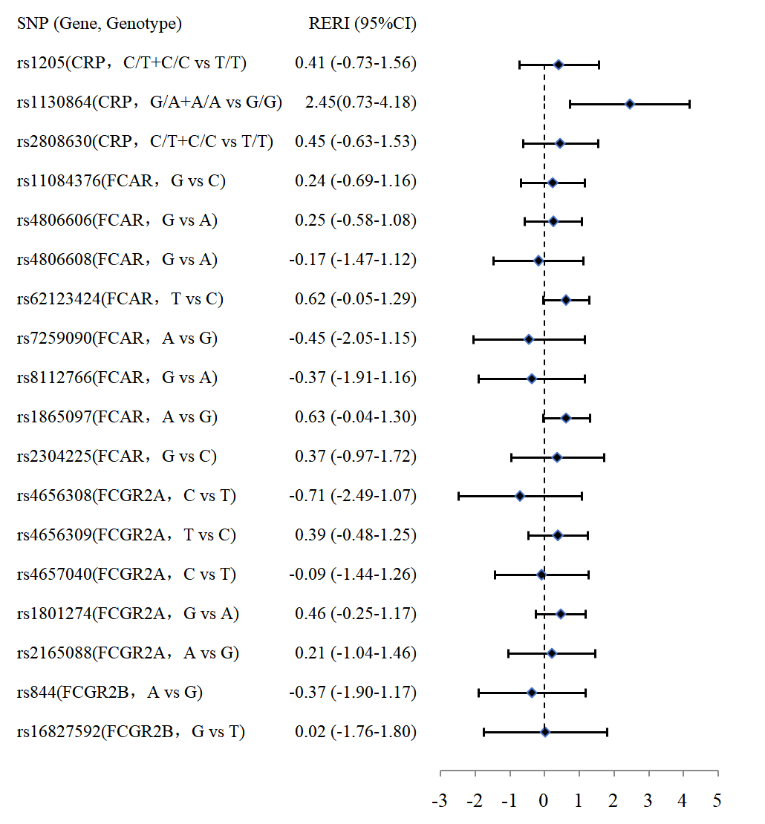
Figure S3 Interaction between smoking exposure and SNPs on COPD
(The indoor fuel use exposure is classified into Coal/Wood/Straw vs No fuel/Natural gas/Electricity ; Adjusted for Age, Education, Income, BMI, History of RD, History of CHD/CHF, History of CVD, Smoking, Straw burning outdoor.)

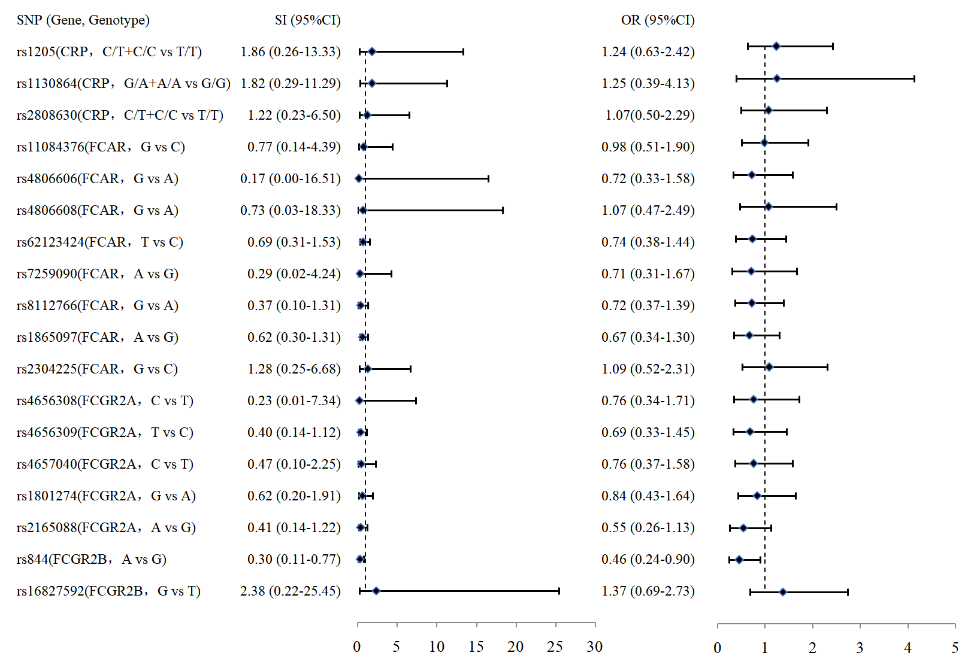
Figure S4 Interaction between Straw burning outdoor exposure and SNPs on COPD
(The straw burning outdoor exposure is classified into Straw burning outdoor vs No Straw burning outdoor ; Adjusted for Age, Education, Income, BMI, History of RD, History of CHD/CHF, History of CVD, Indoor fuel use, Smoking; OR-value for Multiplication interaction.)

