Supplemental Materials
Supplementary Figures.
Supplementary Table 1
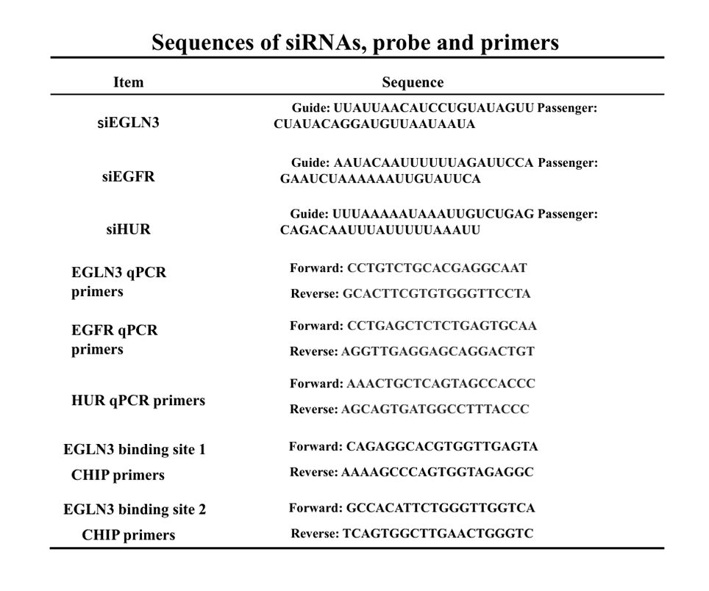
Supplementary Figure 1 Overexpression of EGLN3 promotes endothelial cell proliferation and migration. (A) Verification of the efficiency of EGLN3 overexpression. (B) Cell proliferation curves for various treatment groups. (C) Assessment of cell proliferation ability across different treatment groups, with red indicating the number of proliferating cells. Bar 100μm. (D) Measurement of cell migration distance among treatment groups at 0 and 12 hours. Bar 200μm. (E) Comparison of the number of cell migrations between different treatment groups. Bar 50μm. *P < 0.05, **P < 0.01, ***P < 0.001
Supplementary Figure 2 Overexpression of EGLN3 promotes the activation of PI3K/AKT and MEK/ERK signaling pathways. (A) Activation of the PI3K/AKT signaling pathway across various treatment groups. (B) Activation of the MEK/ERK signaling pathway across different treatment groups. *P < 0.05, **P < 0.01, ***P < 0.001
Supplementary Figure 3 EGLN3 regulates endothelial cell proliferation and migration through the PI3K/AKT and MER/ERK signaling pathways. (A) Cell proliferation curves between different treatment groups. (B) Cell migration numbers between different treatment groups. Bar 50μm. *P < 0.05, **P < 0.01, ***P < 0.001
Supplementary Figure 4 Potential mechanisms by which EGLN3 affects EGFR expression. (A) This panel depicts the protein expression levels of EGFR and the associated downstream signaling pathways across various treatment groups. (B) This panel similarly presents the protein expression of EGFR along with the downstream signaling pathways among different treatment groups. *P < 0.05, **P < 0.01, ***P < 0.001
Supplementary Figure 5 HUR binds to EGFR mRNA to regulate its stability. (A) Following the application of various antibodies for mRNA pull-down, PCR was employed to assess the levels of EGFR mRNA. (B) This panel displays the variations in EGFR mRNA stability across different treatment groups. *P < 0.05, **P < 0.01, ***P < 0.001
Supplementary Figure 6 EGLN3 regulates downstream signaling through HUR. (A) Verification of HUR knockout. (B) Cell proliferation curves under various treatment conditions. (C) Quantification of cell migration following different treatment conditions. Bar 50μm. (D) Activation of downstream signaling pathways in response to various treatment conditions. *P < 0.05, **P < 0.01, ***P < 0.001
Supplementary Figure 7 JUN regulates cell proliferation and migration through EGLN3. (A) Cell proliferation curves are presented under various treatment conditions. (B) The number of cells migrating is shown under different treatment conditions. Bar 50μm. *P < 0.05, **P < 0.01, ***P < 0.001

