Additional file 2
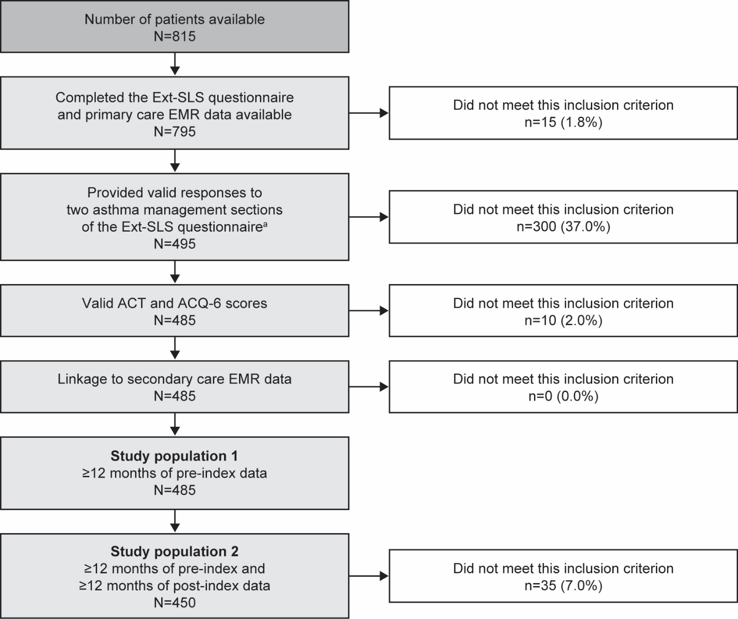
Figure S2. Patient attrition

Patient numbers were rounded to the nearest 5 and values <8 were suppressed to comply with HES analysis guidance [1]; ªNumber of extra inhalations taken during a moderate asthma exacerbation and number of moderate asthma exacerbations in the previous year.
ACQ-6, Asthma Control Questionnaire 6-item; ACT, Asthma Control Test; EMR, electronic medical record; Ext-SLS, Extended Salford Lung Study; HES, Hospital Episode Statistics.

References
1. NHS Digital. Hospital Episode Statistics (HES). https://digital.nhs.uk/data-and-information/data-tools-and-services/data-services/hospital-episode-statistics. Accessed: 07 July 2023.

