s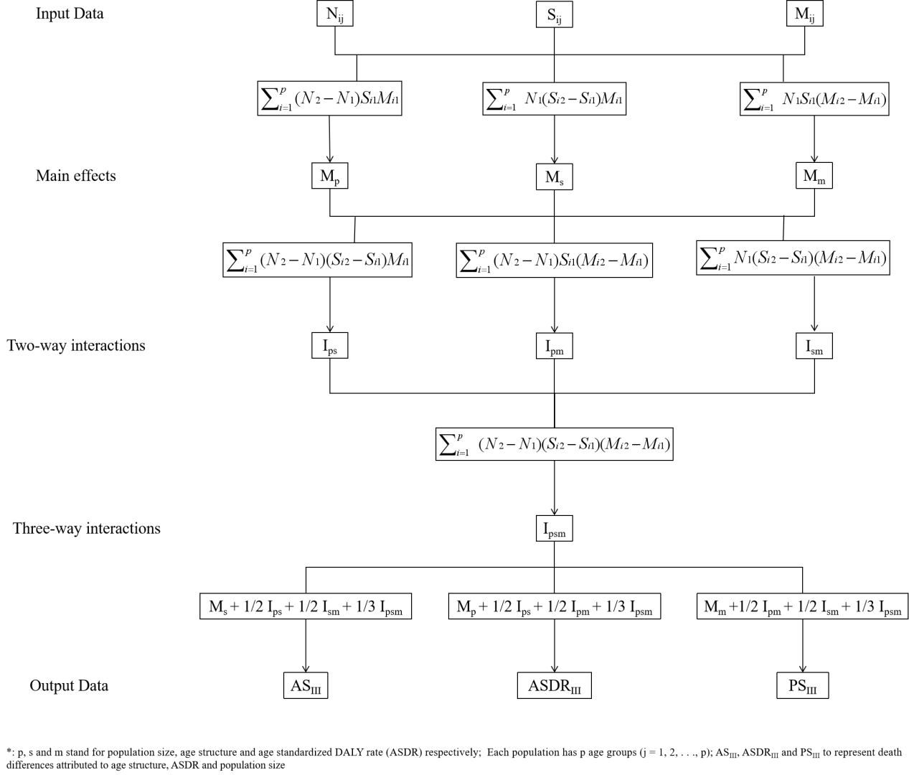
Figure S1. A flowchart of the decomposition analysis methodology
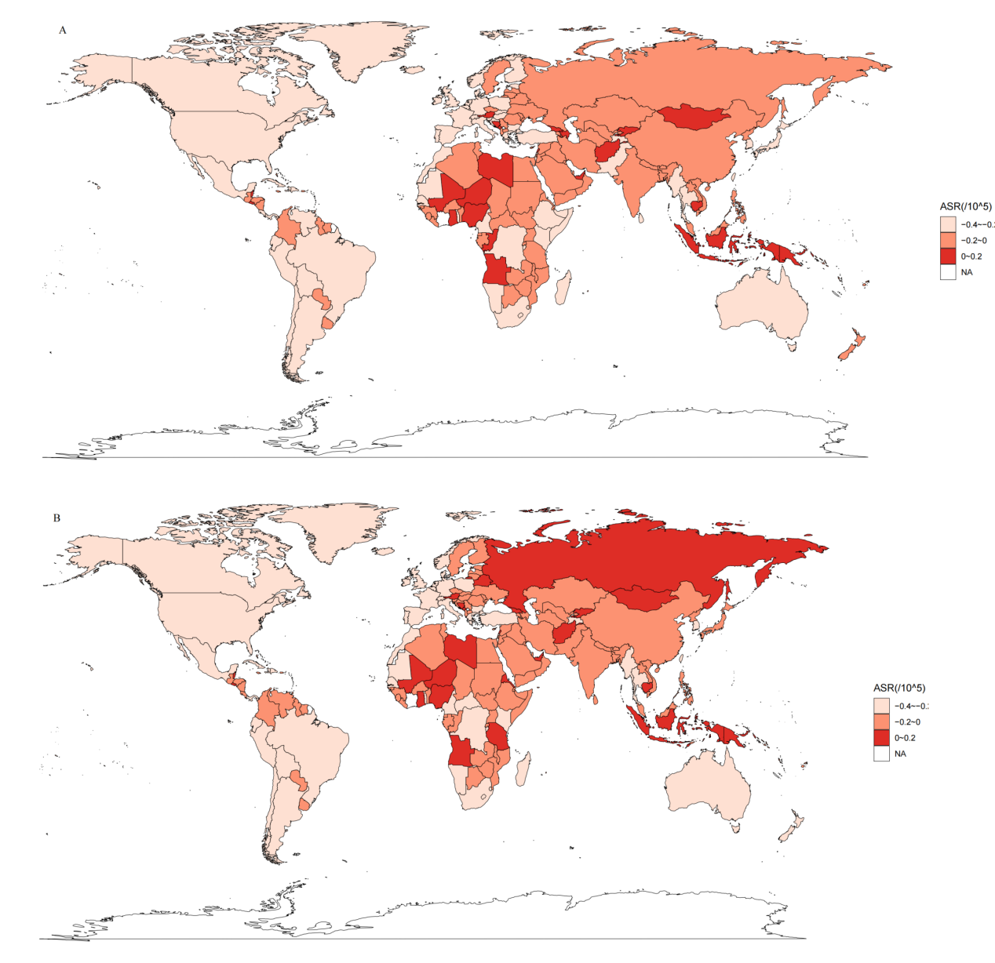
Figure S2. Secular trends in second hand smoke exposure for females (A) and males (B) from 1990 to 2021

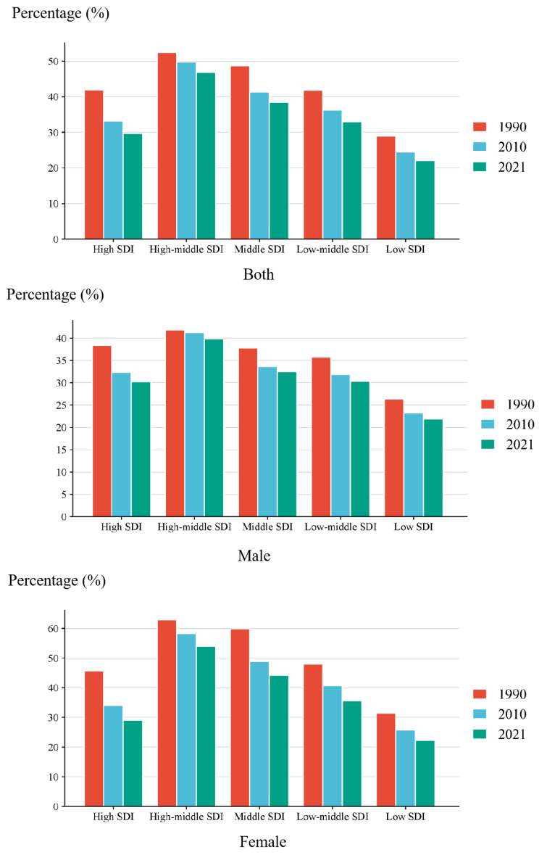

Figure S3. Age-standardized summary exposure values of second hand smoke by SDI in 1990, 2010 and 2021 for males, females and both sexes

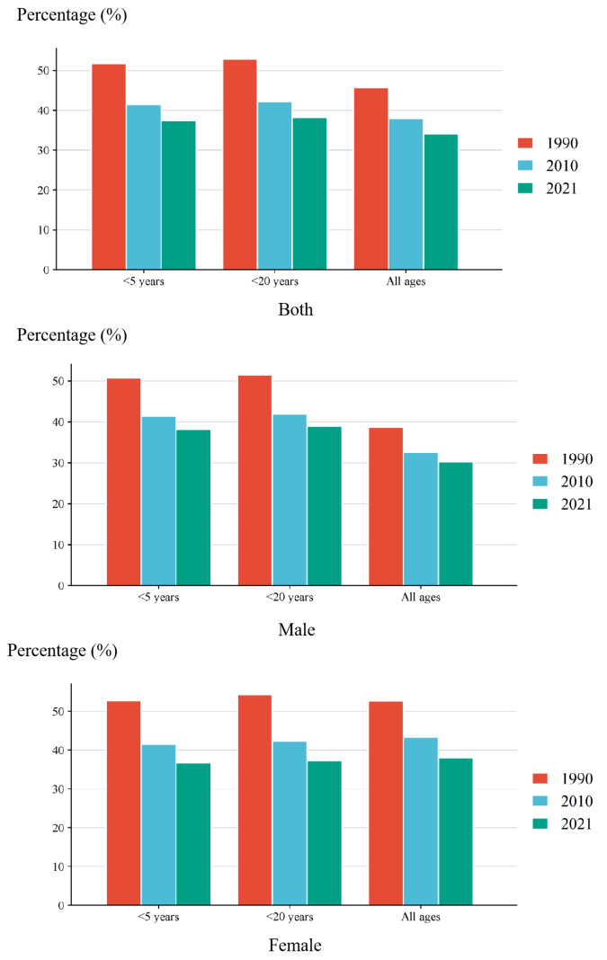
Figure S4. Age-standardized summary exposure values of second hand smoke by age groups in 1990, 2010 and 2021 for males, females and both sexes

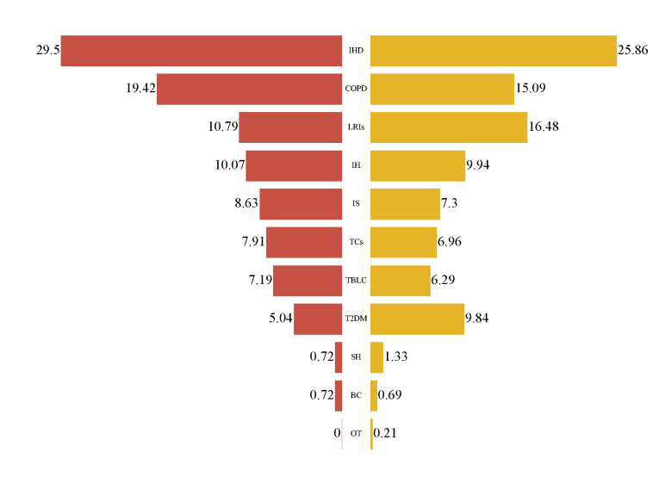

Figure S5. The proportion of the number of death (left) and DALY (Right) of leading causes attributable to second hand smoke

