Supplement Figures
Figure S1. Reproducibility and coefficient of variation cumulative curves of quantity control samples in the discovery cohort (n = 93).
- Reproducibility of quantity control samples in T3 and amide column with positive and negative mode. B. Cumulative coefficient of variation curves of quantity control samples in T3 and amide column with positive and negative mode.
(Abbreviation: QC: quality control; AN: amide column with positive mode; AP: amide column with negative mode; TN: T3 column with negative mode; TP: T3 column with positive mode; NDB: non-durable clinical benefit; DCB: durable clinical benefit. *** p < 0.001, **** p < 0.0001.)
Figure S2. PCA and OPLS-DA analysis of metabolites in the T3 and amide column with positive and negative mode in the discovery cohort (n = 93).
A-D. PCA analysis of metabolites in the T3 and amide column with positive and negative mode. E-H. OPLS-DA and permutations test analysis of metabolites in the T3 and amide column with positive and negative modes.
(Abbreviation: PCA: principal component analysis; OPLS-DA: Orthogonal partial least squares discriminant analysis; QC: quality control; NDB: non-durable clinical benefit; DCB: durable clinical benefit.)
Figure S3. Reproducibility and coefficient of variation cumulative curves of quantity control samples in the validation cohort (n = 40).
- Reproducibility of quantity control samples in T3 and amide column with positive and negative mode. B. Cumulative coefficient of variation curves of quantity control samples in T3 and amide column with positive and negative mode.
(Abbreviation: QC: quality control; AN: amide column with positive mode; AP: amide column with negative mode; TN: T3 column with negative mode; TP: T3 column with positive mode; NDB: non-durable clinical benefit; DCB: durable clinical benefit. *** p < 0.001, **** p < 0.0001.)
Figure S4. PCA and OPLS-DA analysis of metabolitesin T3 and amide column with positive and negative mode in the validation cohort (n = 40).
- D. PCA analysis of metabolites in T3 and amide column with positive and negative mode. E-H. OPLS-DA and permutations test analysis of metabolites in T3 and amide column with positive and negative mode in the discovery cohort.
(Abbreviation: PCA: principal component analysis; OPLS-DA: Orthogonal partial least squares discriminant analysis; QC: quality control.)
Figure S5. Correlation between L-leucine, cholesterol, and lymphocyte subsets in the discovery (n = 43) and validation (n = 29) cohorts.
A. Correlation analysis between L-leucine metabolite, and various lymphocyte subsets, including the absolute lymphocyte count, and the percentages and counts of CD3⁺ T (total T) cells, CD3⁺CD4⁺ T (Th) cells, CD3⁺CD8⁺ T (Ts) cells, CD3⁻CD16⁺CD56⁺ (NK) cells, and CD3⁻CD19⁺ (B) cells in the discovery cohort. B-C. Detailed correlations between L-leucine and the absolute lymphocyte count, CD3⁺ T (total T) cells, and CD3⁺CD4⁺ T (Th) cells in both the discovery and validation cohorts.
(Abbreviation: ALC: absolute lymphocyte count; R: correlation coefficient. * p < 0.05, ** p < 0.01, *** p < 0.001, **** p < 0.0001. Mann-Whitney test was performed between groups.)

Figure S6. Distinct patterns of BCAA metabolism-related in NSCLC.
A. Univariate Cox regression analysis of 27 BCAA metabolism regulators for OS in GSE41271. B. Consensus clustering matrix for k = 4 in GSE42127. C. Principal component analysis of the four clusters. D. Heatmap depicting 27 prognosis-related BCAA metabolism regulators across the four clusters.
(Abbreviation: BCAA: branched chain amino acid; NSCLC: non-small cell lung cancer; PC: principal component.)
Figure S7. Identification of prognostic BCAA signatures.
A. Univariate Cox regression analysis of 27 BCAA metabolism regulators for OS in GSE42127. B-D. Lasso Cox regression analysis for OS based on the 27 prognosis-related BCAA metabolism regulators in GSE41271. E. Univariate Cox regression analysis of five prognosis-related BCAA metabolism regulators for OS in GSE37745. F-G. Protein-protein interaction networks and functional enrichment analysis of five BCAA-related proteins and genes.
(Abbreviation: BCAA: branched chain amino acid; OS: overall survival.)
Figure S8. Performance of the five BCAA gene-based risk score in predicting OS in three GEO datasets (GSE41271, GSE42127, and GSE37745) and in predicting survival in immunotherapy cohorts.
A-C. Scatterplots, heatmaps, Kaplan-Meier curves, time-dependent ROC curves for OS, and difference of CD8⁺ T cells infiltration between high-risk score and low-risk score groups in three cohorts. D-E. Kaplan-Meier curves and time-dependent ROC curves for PFS based on five BCAA genes in NSCLC immunotherapy cohort (GSE126044 and GSE135222). F. Difference in tumor-infiltrating immune cells between high-risk score and low-risk score groups. G-H. Heatmap of KEGG and Hallmark pathway functional enrichment analysis between high-risk score and low-risk score groups. I. Comparison of valine leucine and isoleucine degradation and cholesterol biosynthesis pathway scores. J-K. Kaplan-Meier curves and time-dependent ROC curves for OS based on five BCAA genes in melanoma immunotherapy cohort (GSE100797). L. Correlation between OS risk score and cholesterol biosynthesis pathway score.
(Abbreviation: BCAA: branched chain amino acid; OS: overall survival; GEO: Gene Expression Omnibus; ROC: receiver operating curve; PFS: progression free survival; NSCLC: non-small cell lung cancer; KEGG: Kyoto Encyclopedia of Genes and Genomes enrichment. * p < 0.05, ** p < 0.01, ns: not significant. Mann-Whitney test was performed between groups.)
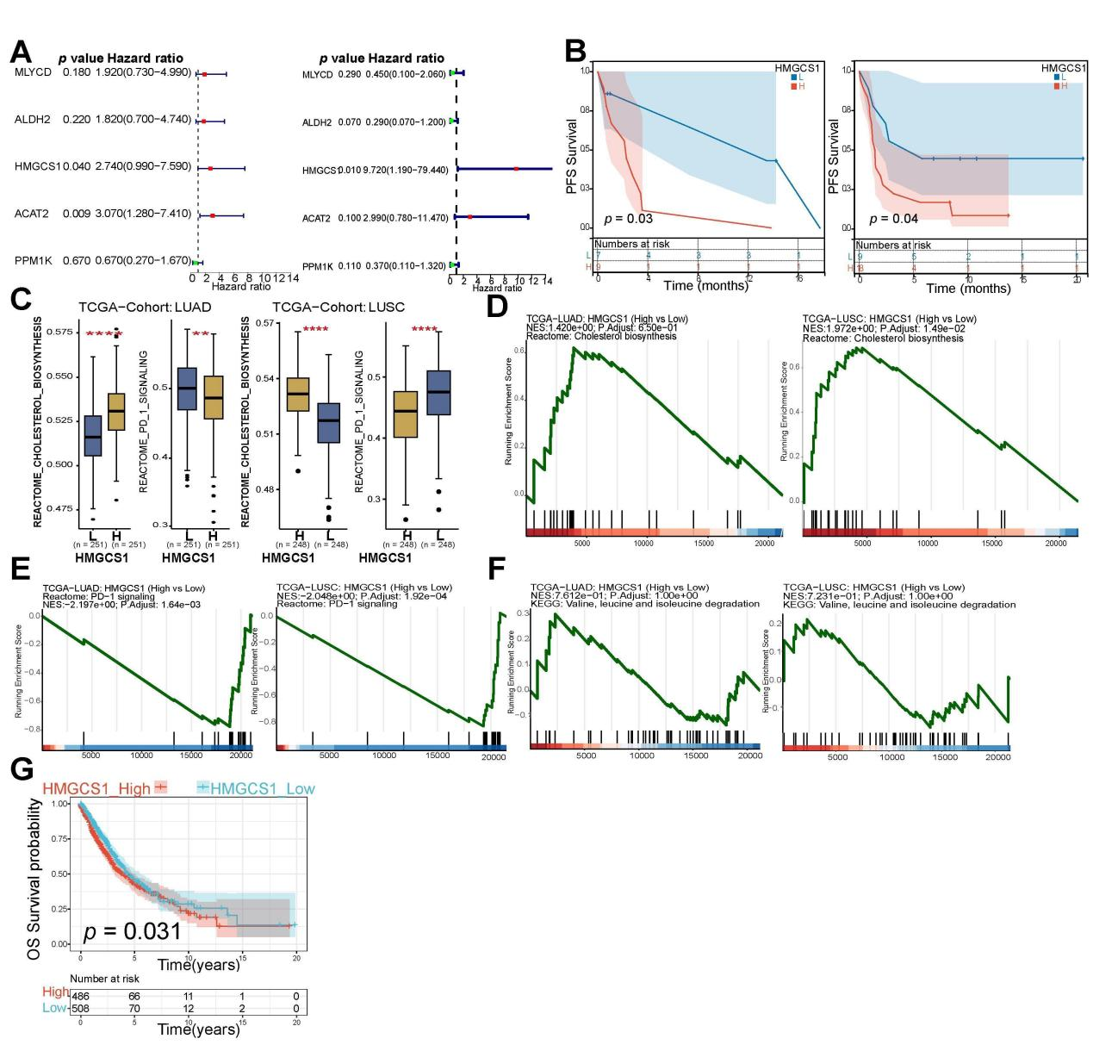
Figure S9. Survival and functional enrichment analysis of HMGCS1 in immunotherapy and TCGA NSCLC cohorts.
A. Univariate Cox regression analysis of five BCAA metabolism regulators for OS in GSE126044 and GSE135222. B. Survival analysis of HMGCS1 expression for PFS in GSE126044 and GSE135222. C. Comparison of cholesterol biosynthesis and PD-1 singnaling pathways between HMGCS1 high and low groups in LUAD and LUSC. D-F. ssGSEA analysis of cholesterol biosynthesis, PD-1 singnaling, and valine leucine and isoleucine degradation pathways between HMGCS1 high and low expression groups in LUAD and LUSC. G. Kaplan-Meier curves for OS based on HMGCS1 in TCGA cohort.
(Abbreviation: TCGA: The Cancer Genome Atlas; NSCLC: non-small cell lung cancer; PFS: progression free survival; LUAD: lung adenocarcinoma; LUSC: lung squamous cell carcinoma. ** p < 0.01,**** p < 0.0001.)
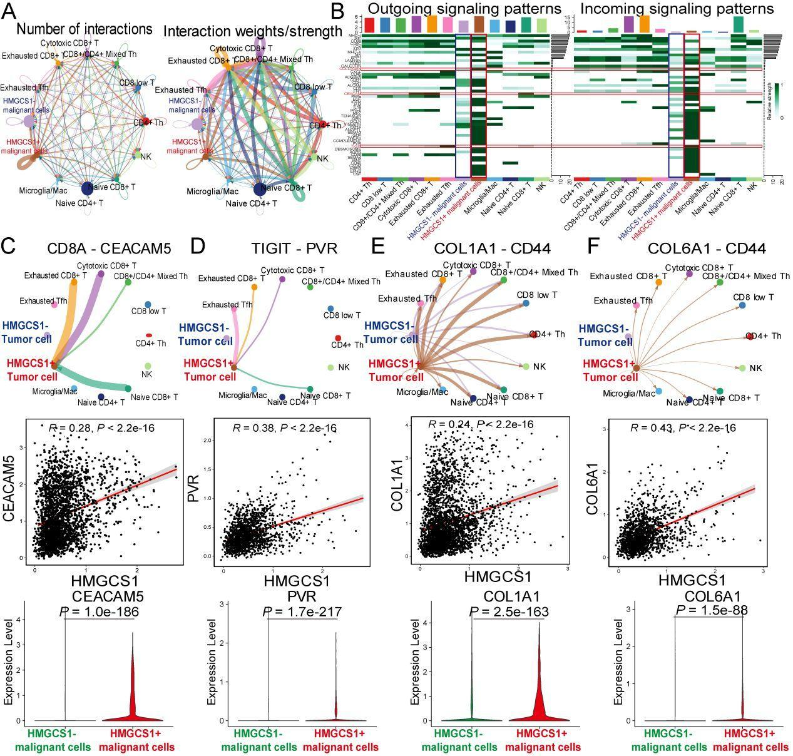
Figure S10. Cell-Cell communications between HMGCS1⁺ and HMGCS1⁻ malignant cells and immune cells in single-cell RNA sequencing (n = 21).
- B. Circular plots and heatmap depicting the cell-cell communication network for both incoming and outgoing signaling analysis. C-F. Circular plots illustrating the quantity or intensity of interactions among various cell groups within the CD8A-CEACAM5, TIGIT-PVR, COL1A1-CD44, and COL6A1-CD44 networks, alongside comparison of CEACAM5, PVR, COL1A1, and COL6A1 expression between HMGCS1⁺ malignant cells and HMGCS1⁻ malignant cells.

