HNRNPH1 promotes autophagy to inhibit the development of lung adenocarcinoma via the HSP90AB1/MAP1LC3B axis
Running title: Effects and mechanisms of HNRNPH1 on lung adenocarcinoma
Materials and methods
Real-time quantitative Polymerase Chain Reaction (RT-qPCR)
Total RNA in cells was extracted by utilizing TRIzol® Reagent (15596-026, Invitrogen, USA) and then transcribed into complementary DNA (cDNA) using an mRNA reverse transcription kit (CW2569, CWBIO, China). Afterward, RT-qPCR was performed using UltraSYBR Mixture (CW2601, CWBIO, China). The RT-qPCR protocol was as follows: 95℃ for 10 min, 95℃ for 15 s, and 60℃ for 30 s, with 40 cycles. Detailed primer information is displayed in Table S1. Finally, the 2^{−ΔΔCt} method was applied to calculate the relative gene levels normalized to β-actin [1].
RNA Immunoprecipitation-quantitative Polymerase Chain Reaction (RIP-qPCR)
After transfection with oe-HNRNPH1 or si-HNRNPH1, cells were lysed using RIP Lysis Buffer (RIP-12RXN, Sigma-Aldrich, USA) to release HNRNPH1 protein and its bound RNA. The lysate was then incubated with HNRNPH1 antibody (14774-1-AP, Proteintech, USA) to form antibody-HNRNPH1-RNA complexes. Protein A/G magnetic beads were added to capture the complexes. After washing to remove unbound RNA and proteins, the RNA was purified using the TRIzol® Reagent kit. Finally, the presence of HSP90AB1 mRNA was detected using the aforementioned RT-qPCR technique. The primer information of HSP90AB1 mRNA is displayed in Table S1.
Western blot
Firstly, total protein was extracted by using RIPA lysis buffer (AWB0136, Abiowell, China) followed by concentration analysis by using a BCA protein quantification kit (AWB0104, Abiowell, China). Then, proteins were transferred to nitrocellulose (NC) membranes after the separation of 10% SDS-PAGE. The membranes were immersed in 5% skim milk powder and blocked for 1.5 h, and then incubated with corresponding antibodies at 4℃ overnight. The secondary antibody was then added to membranes and incubated for another 1.5 h. The membranes were mixed with Super ECL Plus detection reagent (AWB0005, Abiowell, China) for chemiluminescence imaging. The protein expression was calculated using Quantity One 4.6.6 (Bio-Rad Inc., USA) with β-actin as an internal reference. The specific information on antibodies is displayed in Table S2. Full uncropped images are showed in Figure S1.
Cell counting kit-8 (CCK-8) assay
A549 and NCI-H358 cells were digested with trypsin (AWC0238, Abiowell, China) and then subjected to cell counting. A549 and NCI-H358 cells were inoculated (5×10³ cells/well) into a 24-well plate and incubated overnight at 37℃. After adhesion, cells were grouped and treated accordingly for 48 h. Afterward, a fresh FBS-free medium containing 10% CCK-8 reagent (NU679, DOJINDO, Japan) was added to cells for an additional incubation for 4 h in a humidified incubator at 37°C with 5% CO₂. At last, the optical density (OD) value at 450 nm was read by a microplate reader (MB-530, HEALES, China).
Colony formation assay
After digestion and counting, A549 and NCI-H358 cells (2×10² cells/well) were seeded in a 6-well plate and incubated for 2 weeks at 37°C with 5% CO₂, with fresh medium replaced every 3 days. After the medium was removed, the cells were washed with phosphate-buffered saline (PBS) twice, and 1 mL of 4% paraformaldehyde (N1012, NCM Biotech, China) was added to each well to fix the cells for 15 min. Subsequently, 1 mL of 1% crystal violet (G1062, Solarbio, China) was added and stained for 30 min. Finally, the colonies were photographed and counted.
Transwell chamber assay
For cell migration analysis, 500 μL of medium containing 10% FBS was put in the lower chamber (3428, Corning, USA) while 2×10⁵ cells/well A549 and NCI-H358 cells were seeded in the upper chamber. Following 48 h of incubation at 37°C, the upper chamber was rinsed with PBS, and the cells were fixed in 4% paraformaldehyde for 20 min. The porous membrane was then stained with 0.1% crystal violet for 5 min, washed with PBS, and mounted on a glass slide. For evaluating cell invasion, 100 μL of pre-chilled matrigel (354262, BD, USA) was added to the upper chamber and allowed to solidify at 37°C for 30 min before proceeding with the same protocol as that for cell migration. The migrated and invaded cells were visualized and quantified using an inverted light microscope (DSZ2000X, CNMICRO, China).
Co-immunoprecipitation (Co-IP)
A549 and NCI-H358 cells were washed with pre-chilled PBS, and 300 μL of IP lysis buffer was added to them, followed by incubation on ice for 30 min. Subsequently, the cell lysates were centrifuged at 4°C, 12000 rpm for 15 min. Antibodies against HSP90AB1 or IgG were added to the supernatant and rotated at 4°C overnight. The lysates incubated with antibodies were added to pre-treated Protein A/G agarose beads, and shaken slowly at 4°C for 2 h to allow coupling of the antibodies with the beads. The mixture was then centrifuged at 4°C, 3000 rpm for 3 min to obtain the precipitate. Afterward, 30 μL of IP lysis buffer was added to the precipitate, followed by 10 μL of 5×loading buffer, mixed well, and boiled for 5 min. At last, magnetic selection was carried out to collect the supernatant for Western blot analysis.
Immunofluorescence (IF) staining
Cell slides were fixed with 4% paraformaldehyde and washed three times with PBS. Subsequently, the slides were treated with 0.3% Triton X-100 at 37℃ for 30 min to enhance cell permeability. Then, the slides were blocked with 5% BSA at 37℃ for 60 min followed by incubation with antibodies of HSP90AB1 and MAP1LC3B overnight at 4℃. Then, the slides were incubated with 50-100 μL of CoraLite594-conjugated Goat Anti-Rabbit IgG (SA00013-4, Proteintech, USA) at 37℃ for 90 min. Nuclear staining was carried out using 4’,6-diamidino-2-phenylindole (DAPI, AWI0331a, Abiowell, China) for 10 min at 37℃. At last, the slides were observed under a fluorescence microscope after glycerin sealing.
Immunohistochemical (IHC) staining
The tumor tissues were fixed with 4% paraformaldehyde, then cut into 4 μm slices after paraffin embedding, and baked at 60℃ for 12 h. After being dewaxed in xylene, dehydrated in gradient ethanol, heated for antigen retrieval in 0.01 M sodium citrate solution, and inactivated endogenous enzymes in 1% periodic acid, the tissue sections were incubated with primary antibodies of Ki67 (1: 400, 28074-1-AP, Proteintech, USA) and incubated overnight at 4℃. Afterward, the tissue sections were incubated with 100 μL of HRP-goat anti-rabbit IgG (AWS0005, Abiowell, China) for 30 min at 37℃. After being treated with 3,3'-diaminobenzidine (DAB), tissue sections were re-stained with hematoxylin (AWI0001a, Abiowell, China). The tissue sections were returned to blue in PBS, dehydrated in gradient ethanol, immersed in xylene, sealed with neutral gum, and then observed under a microscope.
Supplementary Tables
Table S1. Sequences of the primers.
Gene name | Forward (5’-3’) | Reverse (5’-3’) | Product length (bp)
H-β-actin | ACCCTGAAGTACCCCATCGAG | AGCACAGCCTGGATAGCAAC | 224
H-HSP90AB1 | TGGGTATCGGAAAGCAAGC | TGCACTTCCTCAGGCATCTAA | 90
H-MAP1LC3B | TTCAGGTTCACAAAACCCGC | TCTCACACAGCCCGTTTACC | 163
H-HNRNPH1 | CAGTTCAGCGACCACGTTTG | CACCACGAATCCCTCTCCAC | 86
Table S2. The information on antibodies.
Protein name | Cat. No | Dilution rate | Company
HSP90AB1 | 11405-1-AP | 1: 5000 | Proteintech, USA
MAP1LC3B | 14600-1-AP | 1: 2000 | Proteintech, USA
SQSTM1 | AWA10515 | 1: 3000 | Abiowell, China
HNRNPH1 | 14774-1-AP | 1:3000 | Proteintech, USA
β-actin | AWA80002 | 1: 5000 | Abiowell, China
HRP goat anti-mouse IgG | SA00001-1 | 1: 5000 | Proteintech, USA
HRP goat anti-rabbit IgG | SA00001-2 | 1: 6000 | Proteintech, USA

Supplementary Figure
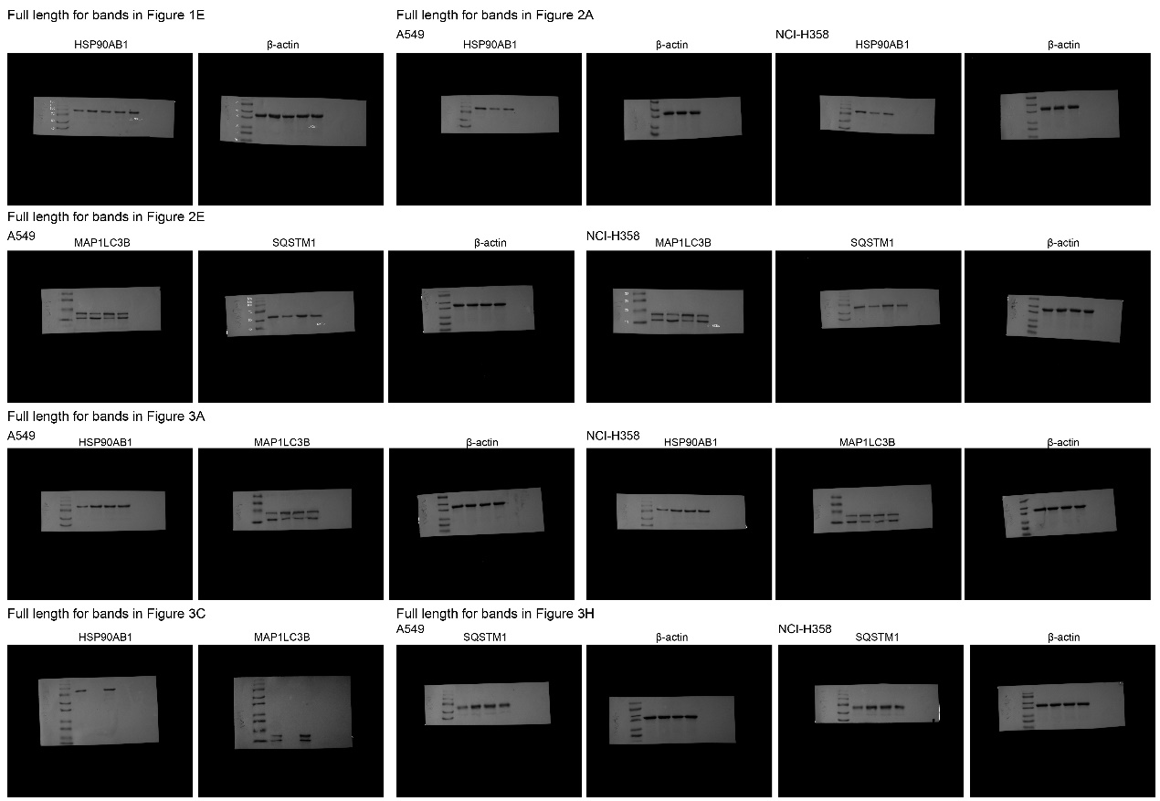
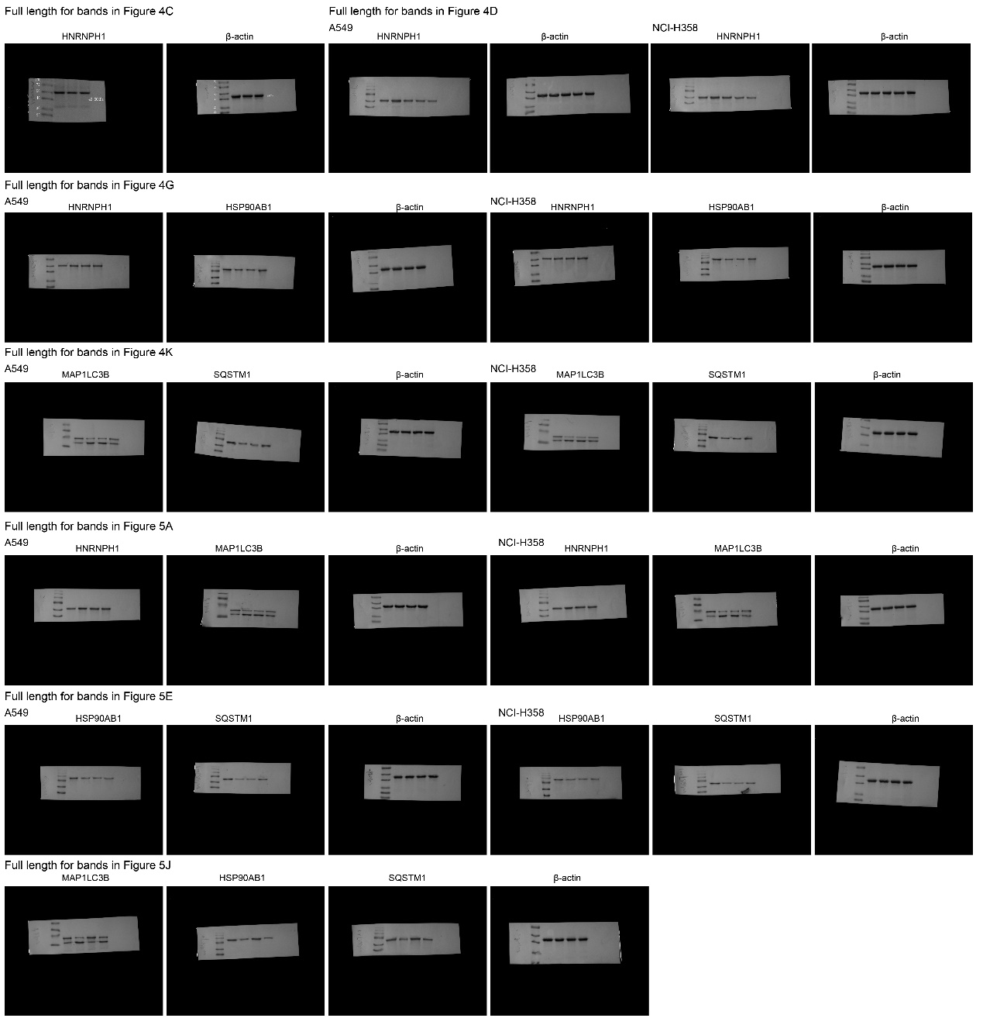
Figure S1. Full uncropped Blots images.

References
1. Livak KJ, Schmittgen TD: Analysis of relative gene expression data using real-time quantitative PCR and the 2(-Delta Delta C(T)) Method. Methods 2001, 25:402-408.

