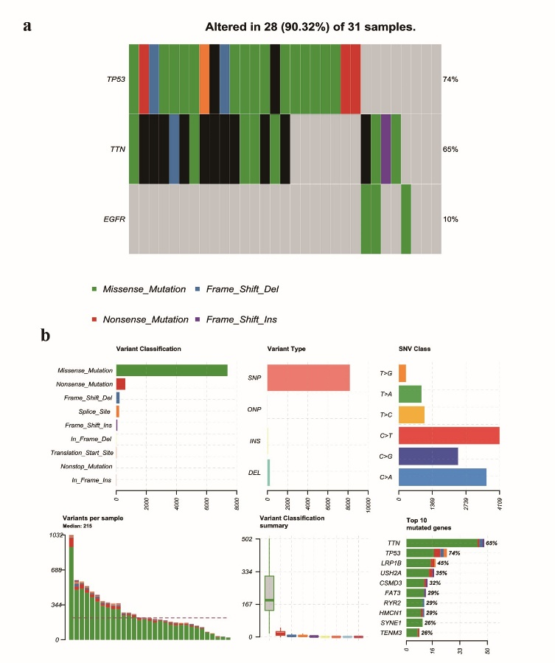

Fig. S3. Mutation files of the CPTAC-NSCLC cohort.

