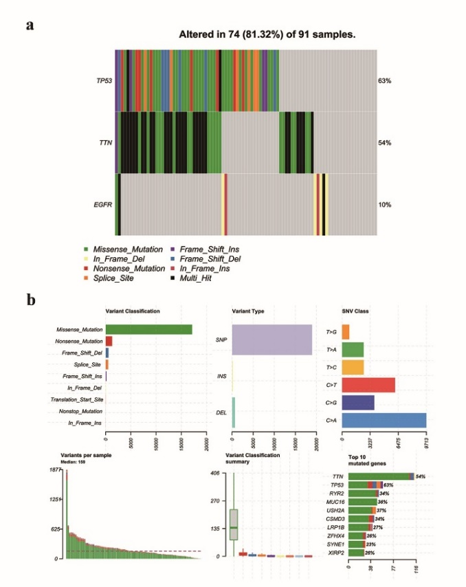

Fig. S4. Mutation files of the TCGA-NSCLC cohort.

