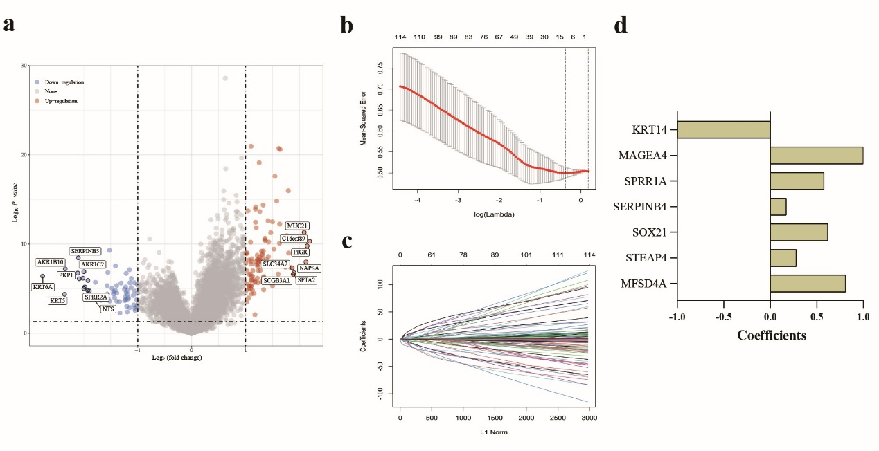

Fig. S6. LASSO regression for the genomic features. (a) the volcano map of EGFR-related DEGs (b, c) LASSO method for screening features; (d) Coefficients of seven selected features.

