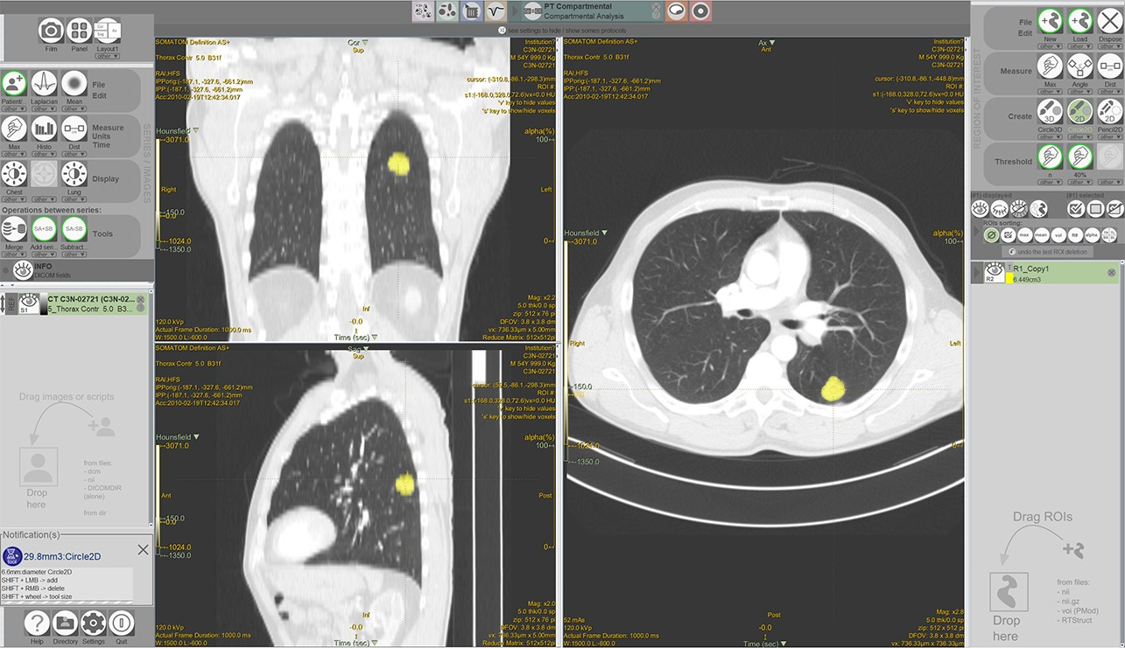

Fig. S1. The snapshot of the LIFEx software.

