Additional file 4 for

IGF1R deficiency mitigates acute lung injury by promoting anti-inflammatory transcriptional profiles

Alfredo Urtubia¹, Sergio Piñeiro-Hermida², Elvira Alfaro-Arnedo¹, Judith Beni-Ledesma¹, Marta Canalejo¹, María de Toro³, José G. Pichel^{1,4,}* and Icíar P. López¹
¹Lung Cancer and Respiratory Diseases Unit, Center for Biomedical Research of La Rioja (CIBIR), Fundación Rioja Salud, Logroño, Spain
²Telomeres and Tumor Microenvironment Unit, Fundación Rioja Salud (CIBIR), Logroño, Spain
³Genomics and Bioinformatics Core Facility, Center for Biomedical Research of La Rioja (CIBIR), Fundación Rioja Salud, Logroño, Spain
⁴Spanish Biomedical Research Networking Centre – Respiratory Diseases (CIBERES), ISCIII; Madrid, Spain
* Correspondence should be addressed to J.G.P. (jgpichel@riojasalud.es)

Western blot full original images
Original blot images of Fig. 6B-C

Original blot images of Fig. 6B
p21 in mouse lungs, Fig. 6B – Chemiluminescence signal (red boxes indicate the parts of the image shown in the figure)

p21 in mouse lungs, Fig. 6B – Merged: Chemiluminescence + Color (MW ladder):

p21: ~23 kDa
15 kDa
20 kDa
25 kDa
Igf1r^{fl/fl}
SAL
2
Igf1r^{fl/fl}
SAL
1
Igf1r^{fl/fl}
SAL
3
Igf1r^{fl/fl}
SAL
4
Igf1r^{fl/fl}
SAL
5
CreERT2
SAL
1
CreERT2
SAL
2
CreERT2
SAL
3
CreERT2
SAL
4
CreERT2
SAL
5
Igf1r^{fl/fl}
SAL
1
Igf1r^{fl/fl}
BLM
1
Igf1r^{fl/fl}
BLM
2
Igf1r^{fl/fl}
BLM
3
Igf1r^{fl/fl}
BLM
4
Igf1r^{fl/fl}
BLM
5
CreERT2
BLM
1
CreERT2
BLM
2
CreERT2
BLM
3
CreERT2
BLM
4
CreERT2
BLM
4
CreERT2
BLM
3
CreERT2
BLM
2
CreERT2
BLM
1
Igf1r^{fl/fl}
BLM
5
Igf1r^{fl/fl}
BLM
2
Igf1r^{fl/fl}
BLM
1
Igf1r^{fl/fl}
SAL
1
Igf1r^{fl/fl}
BLM
4
Igf1r^{fl/fl}
BLM
3
CreERT2
SAL
5
CreERT2
SAL
4
CreERT2
SAL
3
CreERT2
SAL
2
CreERT2
SAL
1
Igf1r^{fl/fl}
SAL
5
Igf1r^{fl/fl}
SAL
4
Igf1r^{fl/fl}
SAL
3
Igf1r^{fl/fl}
SAL
2
Igf1r^{fl/fl}
SAL
1
Total protein in mouse lungs, Fig. 6B – Fluorescence signal (red boxes indicate the parts of the image shown in the figure)
CreERT2
BLM
4
CreERT2
BLM
1
Igf1r^{fl/fl}
BLM
2
Igf1r^{fl/fl}
SAL
1
Igf1r^{fl/fl}
BLM
1
Igf1r^{fl/fl}
BLM
5
Igf1r^{fl/fl}
BLM
4
CreERT2
BLM
3
CreERT2
BLM
2
Igf1r^{fl/fl}
BLM
3
CreERT2
SAL
5
CreERT2
SAL
1
Igf1r^{fl/fl}
SAL
5
Igf1r^{fl/fl}
SAL
2
Igf1r^{fl/fl}
SAL
1
Igf1r^{fl/fl}
SAL
3
Igf1r^{fl/fl}
SAL
4
CreERT2
SAL
2
CreERT2
SAL
3
CreERT2
SAL
4

Original blot images of Fig. 6I-J
p21 in MEFs, Fig. 6I – Chemiluminescence signal (red box indicates the part of the image shown in the figure)

Igf1r ^{-/-}
BLM
3
Igf1r ^{fl/fl}
BLM
3
Igf1r ^{-/-}
NT
3
Igf1r ^{fl/fl}
NT
3
Igf1r ^{fl/fl}
BLM
1
Igf1r ^{-/-}
NT
1
Igf1r ^{-/-}
BLM
1
Igf1r ^{fl/fl}
NT
1
Igf1r ^{-/-}
BLM
2
Igf1r ^{fl/fl}
BLM
2
Igf1r ^{-/-}
NT
2
Igf1r ^{fl/fl}
NT
2
Igf1r ^{fl/fl}
BLM
1
Igf1r ^{-/-}
NT
1
Igf1r ^{-/-}
BLM
1
Igf1r ^{fl/fl}
NT
1

p21 in MEFs, Fig. 6I – Merged: Chemiluminescence + Color (MW ladder):

p21: ~18 kDa
Igf1r ^{fl/fl}
NT
1
Igf1r ^{-/-}
BLM
1
Igf1r ^{-/-}
NT
1
Igf1r ^{fl/fl}
BLM
1
Igf1r ^{fl/fl}
NT
2
Igf1r ^{-/-}
NT
2
Igf1r ^{fl/fl}
BLM
2
Igf1r ^{fl/fl}
NT
1
Igf1r ^{-/-}
BLM
1
Igf1r ^{-/-}
NT
1
Igf1r ^{fl/fl}
BLM
1
Igf1r ^{fl/fl}
NT
3
Igf1r ^{-/-}
NT
3
Igf1r ^{fl/fl}
BLM
3
Igf1r ^{-/-}
BLM
3
Igf1r ^{-/-}
BLM
2
150 kDa
100 kDa
75 kDa
50 kDa
37 kDa
15 kDa
20 kDa
25 kDa
Total protein in MEFs, Fig. 6I – Fluorescence signal (red box indicates the part of the image shown in the figure)
Igf1r ^{fl/fl}
NT
3
Igf1r ^{-/-}
BLM
1
Igf1r ^{fl/fl}
BLM
1
Igf1r ^{-/-}
NT
1
Igf1r ^{fl/fl}
NT
1
Igf1r ^{-/-}
BLM
2
Igf1r ^{fl/fl}
BLM
2
Igf1r ^{-/-}
NT
2
Igf1r ^{fl/fl}
NT
2
Igf1r ^{-/-}
BLM
1
Igf1r ^{-/-}
NT
1
Igf1r ^{-/-}
BLM
3
Igf1r ^{fl/fl}
BLM
3
Igf1r ^{-/-}
NT
3
Igf1r ^{fl/fl}
BLM
1
Igf1r ^{fl/fl}
NT
1
Original blot images of Fig. 8B-C
TOM20 in MEFs, Fig. 8B – Chemiluminescence signal (red box indicates the part of the image shown in the figure)
Igf1r ^{fl/fl}
NT
1
Igf1r ^{-/-}
BLM
1
Igf1r ^{-/-}
NT
1
Igf1r ^{fl/fl}
BLM
1
Igf1r ^{-/-}
NT
2
Igf1r ^{-/-}
BLM
2
Igf1r ^{fl/fl}
BLM
2
Igf1r ^{fl/fl}
NT
2

TOM20 in MEFs, Fig. 8B – Merged: Chemiluminescence + Color (MW ladder)
10 kDa
15 kDa
150 kDa
75 kDa
100 kDa
37 kDa
50 kDa
25 kDa
20 kDa

TOM20: ~16 kDa
Igf1r ^{fl/fl}
NT
1
Igf1r ^{-/-}
BLM
1
Igf1r ^{-/-}
NT
1
Igf1r ^{fl/fl}
BLM
1
Igf1r ^{fl/fl}
NT
2
Igf1r ^{-/-}
NT
2
Igf1r ^{fl/fl}
BLM
2
Igf1r ^{-/-}
BLM
2

Total protein, Fig. 8B – Fluorescence signal (red box indicates the part of the image shown in the figure)
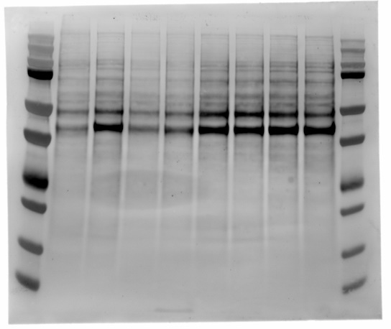
Igf1r ^{-/-}
BLM
2
Igf1r ^{fl/fl}
BLM
2
Igf1r ^{-/-}
NT
2
Igf1r ^{fl/fl}
NT
2
Igf1r ^{fl/fl}
BLM
1
Igf1r ^{-/-}
NT
1
Igf1r ^{-/-}
BLM
1
Igf1r ^{fl/fl}
NT
1
Original blot images of Fig. S2A
IGF1Rβ in lungs of E16 embryos, lung fibroblasts and MEFs, Fig S2A – Chemiluminescence signal (red boxes indicate the parts of the image shown in the figure)

Igf1r^{fl/fl} adult lung fibroblasts-1
Igf1r^{fl/fl} adult lung fibroblasts-2
CreERT2 lung fibroblasts-1
CreERT2 lung fibroblasts-2
Igf1r^{fl/fl} MEFs-1
Igf1r^{fl/fl} MEFs-2
Igf1r^{-/-} MEFs-1

Igf1r^{-/-} MEFs-2

Igf1r^{fl/fl} E16 lung

IGF1Rβ, Fig. S2A – Merged: Chemiluminescence + Color (MW ladder)
250 kDa
25 kDa
20 kDa
15 kDa
37 kDa
50 kDa
75 kDa
100 kDa
150 kDa
IGF1Rβ: ~95 kDa
prepro-IGF1R: ~200 kDa
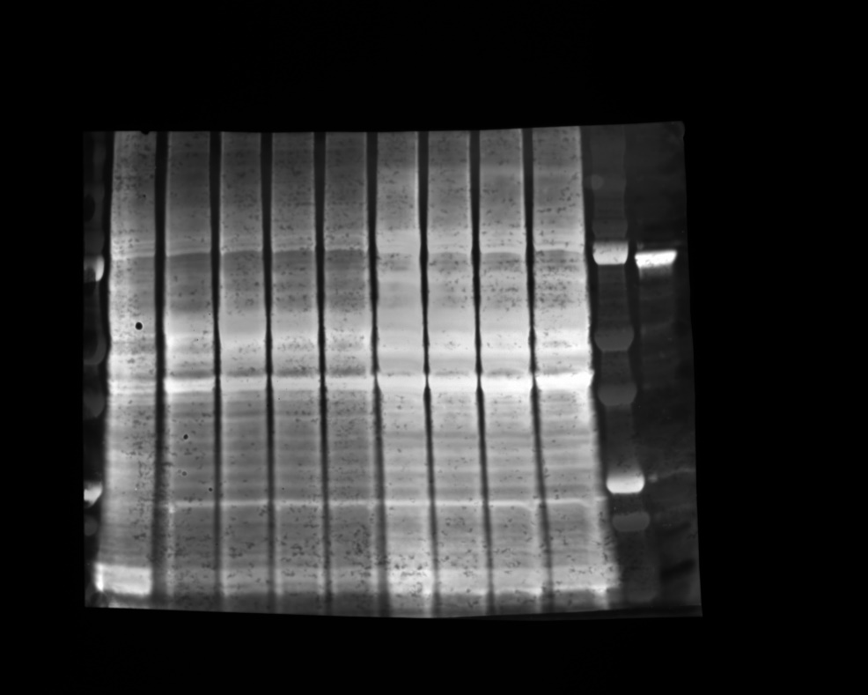
Total protein, Fig. S2A – Fluorescence signal (red boxes indicate the parts of the image shown in the figure)
Igf1r^{fl/fl} adult lung fibroblasts-1
Igf1r^{fl/fl} adult lung fibroblasts-2
CreERT2 lung fibroblasts-1
CreERT2 lung fibroblasts-2
Igf1r^{fl/fl} MEFs-1
Igf1r^{fl/fl} MEFs-2
Igf1r^{-/-} MEFs-1

Igf1r^{-/-} MEFs-2

Igf1r^{fl/fl} E16 lung

Original blot images of Fig. S9

ACSS1. Fig. S9A – Chemiluminescence signal (red box indicates the part of the image shown in the figure)

CreERT2
BLM
2
CreERT2
BLM
4
Igf1r^{fl/fl}
BLM
1
Igf1r^{fl/fl}
BLM
3
Igf1r^{fl/fl}
BLM
2
CreERT2
BLM
3
CreERT2
BLM
1
Igf1r^{fl/fl}
BLM
5
Igf1r^{fl/fl}
BLM
4
Igf1r^{fl/fl}
SAL
1
CreERT2
SAL
5
CreERT2
SAL
4
CreERT2
SAL
3
CreERT2
SAL
2
CreERT2
SAL
1
Igf1r^{fl/fl}
SAL
5
Igf1r^{fl/fl}
SAL
4
Igf1r^{fl/fl}
SAL
3
Igf1r^{fl/fl}
SAL
2
Igf1r^{fl/fl}
SAL
1

ACSS1, Fig. S9A – Merged: Chemiluminescence + Color (MW ladder)

CreERT2
BLM
4
CreERT2
BLM
3
CreERT2
BLM
2
CreERT2
BLM
1
Igf1r^{fl/fl}
BLM
5
Igf1r^{fl/fl}
BLM
4
Igf1r^{fl/fl}
BLM
3
Igf1r^{fl/fl}
BLM
2
Igf1r^{fl/fl}
BLM
1
Igf1r^{fl/fl}
SAL
1
CreERT2
SAL
5
CreERT2
SAL
4
CreERT2
SAL
3
CreERT2
SAL
2
CreERT2
SAL
1
Igf1r^{fl/fl}
SAL
5
Igf1r^{fl/fl}
SAL
4
Igf1r^{fl/fl}
SAL
3
Igf1r^{fl/fl}
SAL
2
Igf1r^{fl/fl}
SAL
1
250 kDa
150 kDa
100 kDa
75 kDa
ACSS1: ~ 60 – 70 kDa
50 kDa

PDK2. Fig. S9C – Chemiluminescence signal (red box indicates the part of the image shown in the figure)
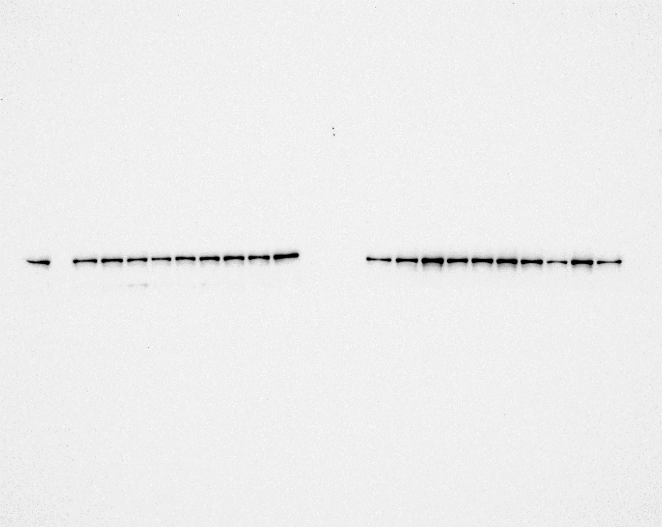
º
Igf1r^{fl/fl}
SAL
1
Igf1r^{fl/fl}
SAL
2
Igf1r^{fl/fl}
SAL
3
Igf1r^{fl/fl}
SAL
4
Igf1r^{fl/fl}
SAL
5
CreERT2
SAL
1
CreERT2
SAL
2
CreERT2
SAL
3
CreERT2
SAL
4
CreERT2
SAL
5
Igf1r^{fl/fl}
SAL
1
Igf1r^{fl/fl}
BLM
1
Igf1r^{fl/fl}
BLM
2
Igf1r^{fl/fl}
BLM
3
Igf1r^{fl/fl}
BLM
4
Igf1r^{fl/fl}
BLM
5
CreERT2
BLM
1
CreERT2
BLM
2
CreERT2
BLM
3
CreERT2
BLM
4

PDK2 – Merged: Chemiluminescence + Color (MW ladder) *From a previous test of the antibody

50 kDa
37 kDa
PDK2: ~ 46 kDa

25 kDa
20 kDa

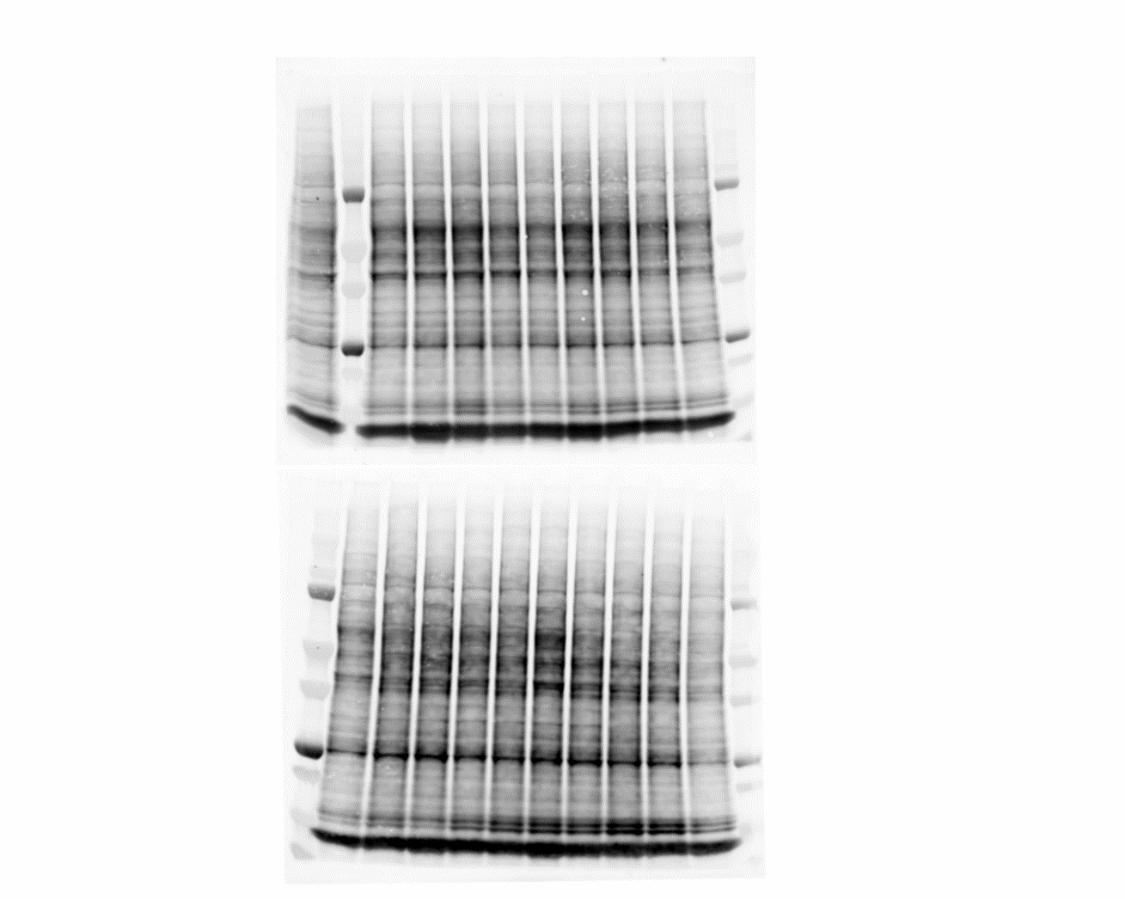
Total protein. Fig. S9A, C– Fluorescence signal (red box indicates the part of the image shown in the figure)
CreERT2
SAL
5
CreERT2
SAL
4
CreERT2
SAL
3
CreERT2
SAL
2
CreERT2
SAL
1
Igf1r^{fl/fl}
SAL
4
Igf1r^{fl/fl}
SAL
5
Igf1r^{fl/fl}
SAL
2
Igf1r^{fl/fl}
SAL
1
Igf1r^{fl/fl}
SAL
3

CreERT2
BLM
3
Igf1r^{fl/fl}
BLM
1
CreERT2
BLM
4
CreERT2
BLM
2
CreERT2
BLM
1
Igf1r^{fl/fl}
BLM
5
Igf1r^{fl/fl}
SAL
1
Igf1r^{fl/fl}
BLM
2
Igf1r^{fl/fl}
BLM
4
Igf1r^{fl/fl}
BLM
3

PDHA, Fig. S9E – RDye 800 fluorescence signal (red box indicates the part of the image shown in the figure)
Igf1r^{fl/fl}
BLM
2
Igf1r^{fl/fl}
BLM
3
Igf1r^{fl/fl}
BLM
4
Igf1r^{fl/fl}
BLM
5
CreERT2
BLM
1
CreERT2
BLM
2
CreERT2
BLM
3
CreERT2
BLM
4
Igf1r^{fl/fl}
BLM
1
Igf1r^{fl/fl}
SAL
1
CreERT2
SAL
2
CreERT2
SAL
1
CreERT2
SAL
5
Igf1r^{fl/fl}
SAL
5
Igf1r^{fl/fl}
SAL
4
Igf1r^{fl/fl}
SAL
1
Igf1r^{fl/fl}
SAL
2
Igf1r^{fl/fl}
SAL
3
CreERT2
SAL
3
CreERT2
SAL
4

pPDHA, Fig. S9E – RDye 680 fluorescence signal (red box indicates the part of the image shown in the figure)
Igf1r^{fl/fl}
SAL
1
Igf1r^{fl/fl}
SAL
2
Igf1r^{fl/fl}
SAL
3
Igf1r^{fl/fl}
SAL
4
Igf1r^{fl/fl}
SAL
5
CreERT2
SAL
1
CreERT2
SAL
2
CreERT2
SAL
3
CreERT2
SAL
4
CreERT2
SAL
5
Igf1r^{fl/fl}
SAL
1
Igf1r^{fl/fl}
BLM
1
Igf1r^{fl/fl}
BLM
2
Igf1r^{fl/fl}
BLM
3
Igf1r^{fl/fl}
BLM
4
Igf1r^{fl/fl}
BLM
5
CreERT2
BLM
1
CreERT2
BLM
2
CreERT2
BLM
3
CreERT2
BLM
4

Merged, Fig S9E: PDHA + pPDHA + Color (MW Marker)
150 kDa
CreERT2
BLM
4
CreERT2
BLM
3
CreERT2
BLM
2
CreERT2
BLM
1
Igf1r^{fl/fl}
BLM
5
Igf1r^{fl/fl}
BLM
4
Igf1r^{fl/fl}
BLM
3
Igf1r^{fl/fl}
BLM
2
Igf1r^{fl/fl}
BLM
1
Igf1r^{fl/fl}
SAL
1
CreERT2
SAL
5
CreERT2
SAL
4
CreERT2
SAL
3
CreERT2
SAL
2
CreERT2
SAL
1
Igf1r^{fl/fl}
SAL
5
Igf1r^{fl/fl}
SAL
4
Igf1r^{fl/fl}
SAL
3
Igf1r^{fl/fl}
SAL
2
Igf1r^{fl/fl}
SAL
1
100 kDa
75 kDa
50 kDa
Mouse igG ~ 50 kDa
PDHA & pPDHA: ~ 40 kDa
37 kDa
25 kDa

Total protein. Fig. S9E– Fluorescence signal (red box indicates the parts of the image shown in the figure)
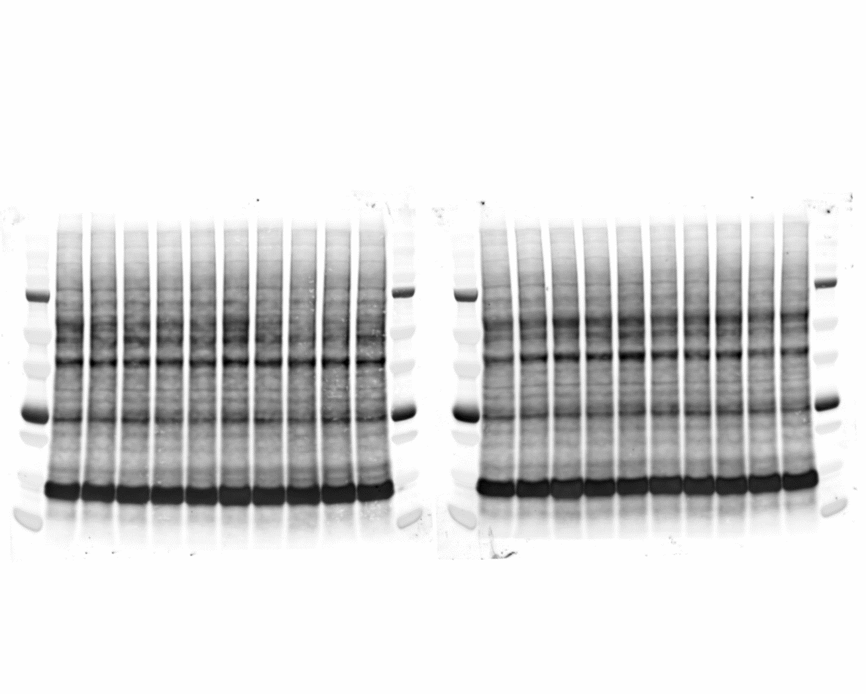

Igf1r^{fl/fl}
BLM
5
CreERT2
SAL
3
CreERT2
SAL
2
CreERT2
SAL
1
Igf1r^{fl/fl}
SAL
5
Igf1r^{fl/fl}
SAL
4
Igf1r^{fl/fl}
SAL
3
Igf1r^{fl/fl}
SAL
1
CreERT2
SAL
5
CreERT2
BLM
4
CreERT2
BLM
3
CreERT2
BLM
2
CreERT2
BLM
1
Igf1r^{fl/fl}
BLM
4
Igf1r^{fl/fl}
BLM
3
Igf1r^{fl/fl}
BLM
2
Igf1r^{fl/fl}
BLM
1
Igf1r^{fl/fl}
SAL
1
CreERT2
SAL
4
Igf1r^{fl/fl}
SAL
2

