Aging-Related Signature Stratifies LUAD Prognosis and Uncovers Senescence-Induced Chemoresistance via NF-κB/RELA Activation

Supplemental Figures

sFigure 1: Identification of aging-related signature genes.
- Upper: Venn diagram of 6523 differentially expressed genes (DEGs; Tumor vs. Normal) and 500 aging-related genes (ARG), revealing 82 overlapping candidates. Lower: Venn diagram of 5538 prognostic genes (COX) and 500 prognostic genes (ARGs), revealing 132 overlapping candidates.
- KEGG enrichment analysis of PPI-derived cluster 1 and 2 candidates obtained from protein–protein interaction network analysis.
- 3 representative immunohistochemical staining of each group (Tumor vs. Normal) for five signature proteins (H2AX, IGFBP1, TFAP2A, TNFRSF11A and TNFRSF13C), as retrieved from the Human Protein Atlas.
sFigure 2: Validation the aging-related signature model with GEO cohort.
(A) The box plots showing the 6 genes’ different expression levels between samples from alive (n = 182) and dead (n = 33) patients.
(B) Distribution of individual risk scores with the median indicated.
(C) Scatter plot shows the distribution of patients with their risk scores and the color showing the survival status. A vertical dashed line at the median separates the low-risk (left) and high-risk (right) groups. The proportions of alive vs. dead differ between groups (χ² test, p = 0.0002).
(D) Kaplan-Meier curves for patients in the high- and low-risk groups split by the median risk score.
(E) Time-dependent ROC curves for 1-, 3- and 5- year overall survival in the GEO cohort.
(F) Box plots showing expression of RELA and RFXAP and LDB1 in high and low risk groups.

sFigure 3: Quantitative analysis of Figure 6D co-localization situation and Chip-seq analysis for the downstream targets of RELA.
- Sector graph quantifying overlap between senescent cells and those with NF-κB pathway activation as defined by gene-set activity scores.
- Heatmap and metagene plots showing RELA ChIP–seq signal enrichment around gene promoter region. Signal was normalized and aggregated across peaks.
- Genome browser snapshots of RELA ChIP-seq signal at the BIRC3 and BBC3 transcription loci.

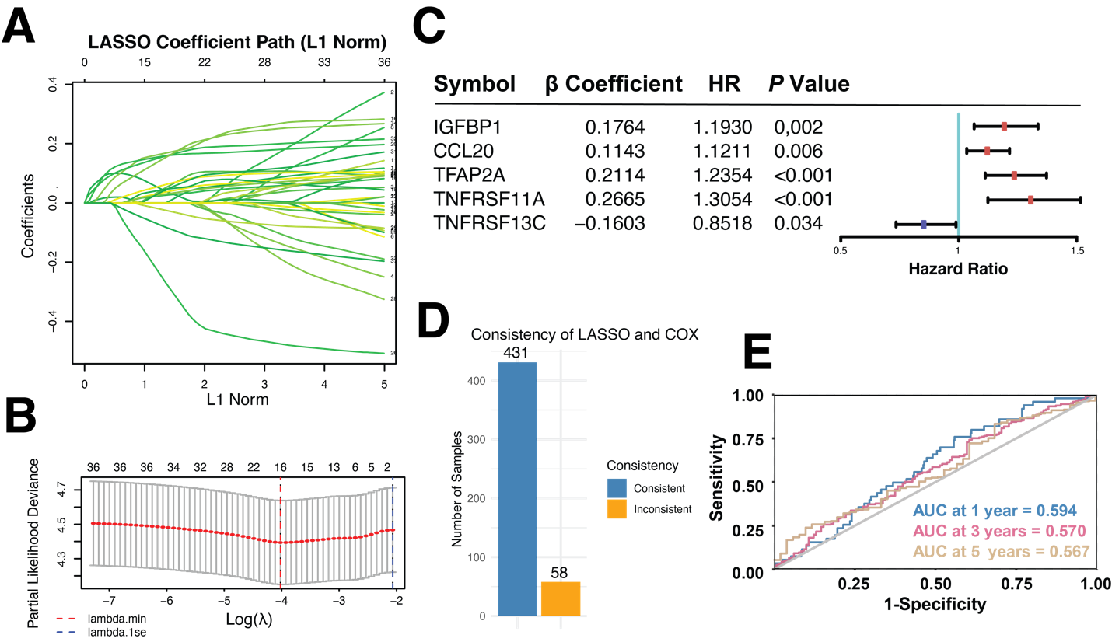
sFigure 4: LASSO regression of 37 candidates and predictive performance comparison with Cox regression.
(A) LASSO coefficient plot showing 37 genes regression coefficients variation curve.
(B) LASSO partial likelihood deviance plot showing that change in mean squared error (MSE) with respect to Log(λ), and we chose the value of λ when the MSE was minimum.
(C) Forest plot showing β coefficients, hazard ratios (HR) with 95% confidence intervals, and P values. IGFBP1, CCL20, TFAP2A and TNFRSF11A are associated with increased risk (HR > 1, red), while TNFRSF13C is protective (HR < 1, blue).
(D) Bar plot showing the consistency of risk classification on 489 cases using LASSO and Cox regression.
(E) Time-dependent ROC curves demonstrating the prognostic performance of the LASSO signature at 1, 3, and 5 years.

