Additional file 1

Section S1: Methods
Sample preparation
Plasma samples were randomized based on patient ID to mitigate plate-wise batch effects. Liquid handling was performed on the Agilent Bravo platform in 96-well format. Of each sample, 1uL was reduced and alkylated with 24 uL 10mM Tris(2-chloroethyl) phosphate, 40 mM Chloroacetamide, 100 mM Tris/HCl (pH 8.5) at 95 °C for 10 min. Samples were cooled on ice for 5 mins before proteins were digested with 7.5 uL Trypsin (0.5 ug/uL, Sigma #T6567) and 7.5 uL LysC (0.5 ug/uL, Wako Chemicals #129-02541) at 37°C for 4 hours. Samples were acidified with 60 uL 0.2% Trifluoroacetic acid before loading 1 uL onto Evotip disposable C18 trap columns (Evosep, #EV2011 Evotip Pure) according to the manufacturer’s recommendations.
To boost peptide identification during downstream data processing, we generated a deep experimental spectral library consisting of three fractionated sample pools: one from plasma samples of both patients with IPF and controls that was depleted of the seven most abundant proteins (albumin, immunoglobulin A, immunoglobulin G, transferrin, haptoglobin, antitrypsin, fibrinogen) before digestion, and two from digested peptides from samples of either patients with IPF or controls. To this end, 1uL plasma from 100 randomly selected samples (from patients with IPF and controls) were pooled and depleted of the top seven most abundant proteins using an affinity spin cartridge (Agilent, #5188-6408). Proteins were reduced, alkylated and digested as described above. Digested peptides were fractionated in technical duplicates into 24 fractions each by high-pH C18 reversed phase nanoflow UHPLC (Easy-nLC 1200, Thermo Scientific) using a 30 cm in-house packed column (Composite Metal Service Ltd., #TSP075375) containing ReproSil-Pur 120 C18-AQ 1.9 µm resin (Dr. Maisch GmbH, #r119.aq). Peptides were separated using a binary buffer system with Buffer A (pH 10 with ~5 mM ammonium formate) and Buffer B (80% Acetonitrile (AcN), pH 10 with ~ 5 mM ammonium formate) in a 120 min non-linear gradient: 2-6% Buffer B for 1 min, 6-32% for 102 min, 32-55% for 9 min, 55-95% for 2 min and 95% for 5 min. The eluate was concatenated into 24 fractions in 30 second intervals. Peptide concentrations were determined by nanodrop and 500 ng of each fraction was loaded onto Evotips. Two additional experimental spectral libraries were created from pools of peptides taken from digested samples, each containing exclusively IPF or exclusively control samples. The peptide pools were fractionated and loaded onto Evotips as described above. The use of an experimental spectral library boosted total coverage and sample-wise depth. The average depth increased from 384.8 in library-free mode to 409.1 using the experimental spectral library, and the number of protein groups identified increased from 434 to 568 (Figure S1).
Liquid chromatography coupled to tandem mass spectrometry (LC-MS/MS)
Peptides were analyzed by LC coupled to tandem mass spectrometry (MS/MS) for identification and quantification. LC was performed on an Evosep One (Evosep, #EV-1000) using a standardized 44-minute, non-linear gradient (“30 SPD”) [1] and peptides were separated using a 15 cm in-house packed C18-reversed phase column (Composite Metal Service Ltd., #TSP075375) containing ReproSil-Pur 120 C18-AQ 1.9 µm resin (Dr. Maisch GmbH, #r119.aq). Column oven (Sonation GmbH) temperature was set to 60°C and monitored using SprayQC (Scheltema and Mann, 2012). Eluting peptides were analyzed using an Exploris Orbitrap 480 mass spectrometer (Thermo Scientific) coupled to the LC with a nanoelectronspray ion online source. Two samples (one IPF, one control) were excluded due to quality control issues.
All experimental spectral library samples were acquired in data-dependent (DDA), positive ion mode using a survey scan at a resolution of 120000 ranging from 350 to 1400 m/z at a normalized AGC target of 300%. The maximum injection time was set to 45 ms. The top 15 highest intensity precursor ions with 2-5 charges were isolated for higher-energy collisional dissociation (HCD) using 1.2 m/z wide isolation windows and 27% HCD collision energy. The resulting fragment ion spectra were acquired at a resolution of 15000 ranging from 350 to 1000 m/z at a normalized AGC target of 1000%. Maximum injection time was set to 22 ms. Dynamic exclusion of previously fragmented ions was set to 30 s to reduce redundant peak picking.
Cohort samples were acquired in data-independent (DIA), positive ion mode. Survey scan settings were identical to those described for DDA above. Precursor ions were isolated for HCD using 22 evenly spaced, 13.7 m/z wide windows between 361-1033 m/z with a window overlap of 1 m/z. Orbitrap resolution, HCD collision energy, AGC target and maximum injection time were identical to DDA settings described above.
LC-MS/MS data analysis
Peptide identification and spectral matching from DDA MS raw files of the experimental spectral library samples were performed with the computational proteomics platform MaxQuant [2] version 1.6.14, using standard settings. Protein inference was performed using the UniProt database reference proteome (Uniprot, UP000005640_9606 and UP000005640_9606_additional). Digestion mode was set to specific for Trypsin/P, the minimum peptide length was set to 7 and a maximum of two missed cleavages were allowed. Cysteine carbamidomethylation was specified as a fixed modification, while methionine oxidation and acetylation of the N-terminus were set as variable modifications. False discovery rates (FDR) on both peptide and protein level were kept at 1%. An experimental spectral library was generated from the MaxQuant output files and the corresponding MS raw files using Spectronaut (Biognosis) version 14.
Protein identification and quantification from DIA MS raw files of the cohort samples were also performed with Spectronaut. Spectral matching and peptide identification were performed in library mode using the deep experimental spectral library. BGS factory settings were used and label-free quantification was performed with QUANT 2.0. The results were log₂ transformed and missing values were imputed sample-wise by downshift imputation from a normal distribution whose standard deviation was 0.3 times the standard deviation of the log₂ protein group intensity distribution, and whose mean was 1.8 standard deviations below the mean of protein group intensities. Batch correction was performed with the empirical Bayes method in Python using pyComBat after grouping samples by plate number. Principal component analysis (PCA) after batch correction showed good clustering of the reference samples (Figure S2).
Figure S1. Increase in proteome coverage by using an experimental spectral library, tested on a subset of the full cohort (Plate 1). Histograms of sample depths of cohort files processed in (A) Spectronaut direct (= library-free) mode or in (B) Spectronaut library mode with a deep experimental spectral library.
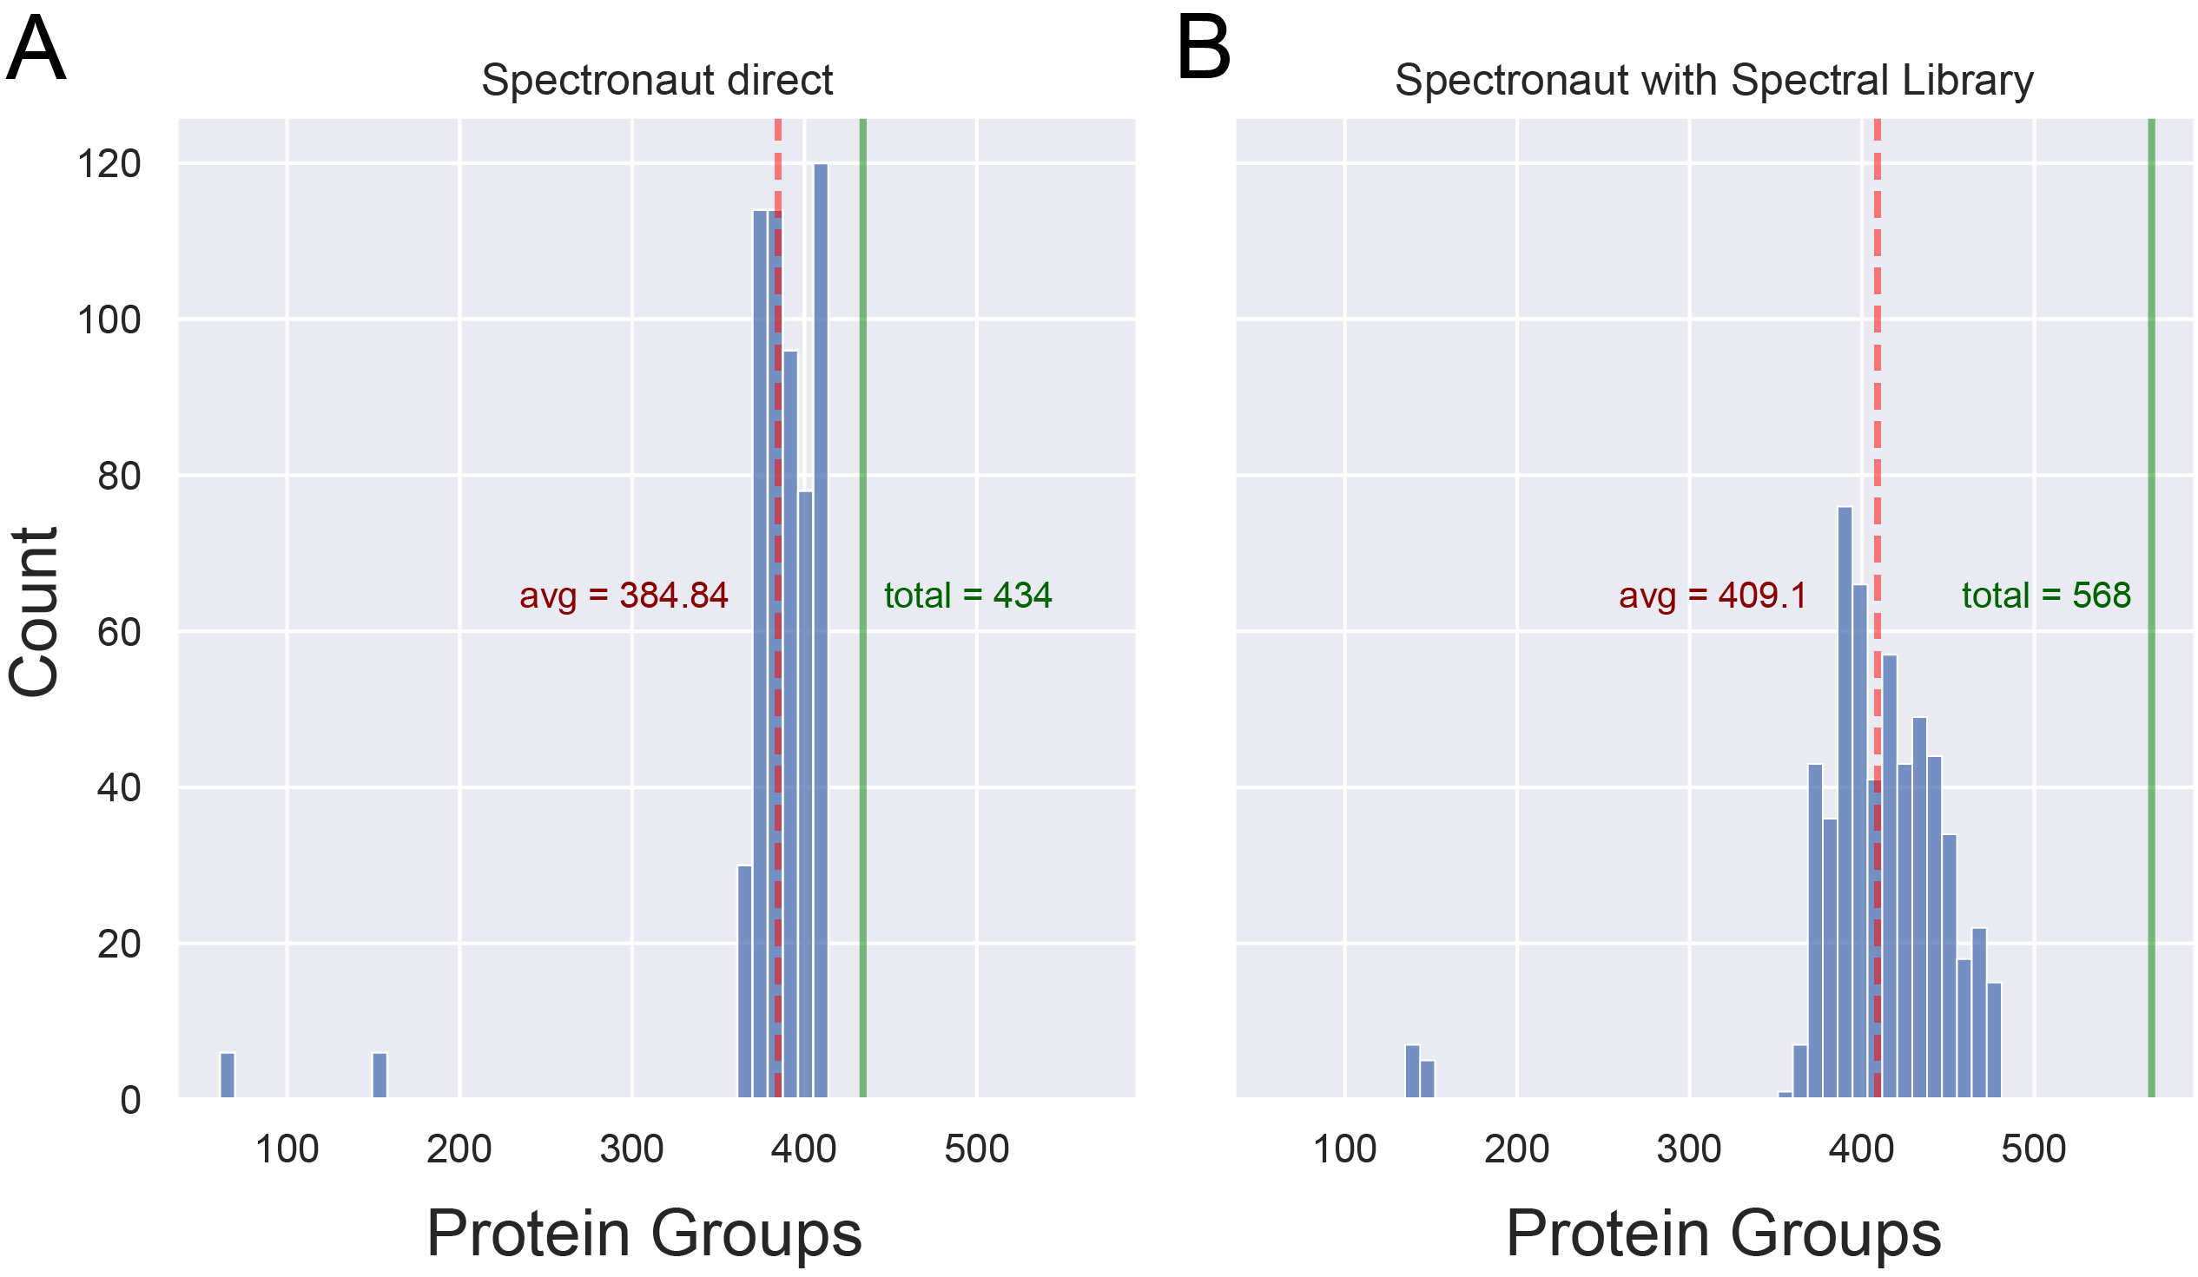
Figure S2. Principal component analysis (PCA) plot of samples after batch correction.

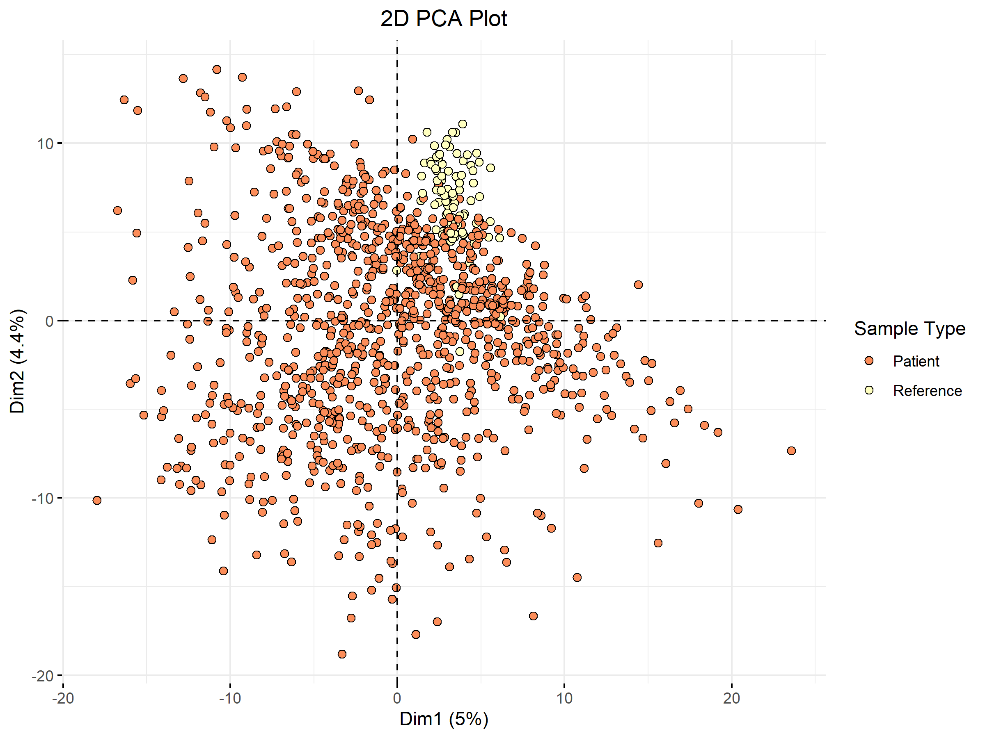

References
- Bache N, Geyer PE, Bekker-Jensen DB, et al. A novel LC system embeds analytes in pre-formed gradients for rapid, ultra-robust proteomics. Mol Cell Proteomics 2018;17:2284–2296.
- Cox J, Mann M. MaxQuant enables high peptide identification rates, individualized p.p.b.-range mass accuracies and proteome-wide protein quantification. Nat Biotechnol 2008;26:1367–1372.

Additional File 2

Table S1. Proteins statistically or clinically significantly associated with FVC % predicted at enrollment (FDR-corrected p-value ≤0.05 or > 5-unit difference in the disease severity measure per unit difference in log₂ protein abundance i.e., twice the protein concentration) at enrollment in unadjusted or adjusted analyses.
 |  | Unadjusted |  |  | Adjusted for Antifibrotic Treatment Use at Enrollment
Uniprot | Gene | Difference* | P-value | FDR-  Corrected P-value | Difference* | P-value | FDR-  Corrected P-value
P02768 | ALB | 24.6019 | 0.001 | 0.095 | 24.7415 | 0.001 | 0.097
P01008 | SERPINC1 | 22.2012 | 0.001 | 0.077 | 23.0346 | 0.001 | 0.068
P02647 | APOA1 | 20.0646 | 0.000 | 0.007 | 20.5655 | 0.000 | 0.005
P08697 | SERPINF2 | 18.3307 | 0.011 | 0.160 | 18.8274 | 0.009 | 0.161
P10909-6 | CLU | 17.2143 | 0.037 | 0.287 | 17.9611 | 0.031 | 0.264
P19827 | ITIH1 | 17.1312 | 0.006 | 0.147 | 17.8169 | 0.004 | 0.128
P01042 | KNG1 | 15.1038 | 0.035 | 0.274 | 15.0417 | 0.036 | 0.282
D6RF35;P02774;P02774-3 | GC | 14.9189 | 0.046 | 0.312 | 14.9863 | 0.046 | 0.313
A0A182DWH7;P49908 | SELENOP | 12.9808 | 0.013 | 0.169 | 13.0305 | 0.014 | 0.175
P08185 | SERPINA6 | 12.4878 | 0.111 | 0.434 | 12.4171 | 0.114 | 0.441
P02652;V9GYM3 | APOA2 | 12.2734 | 0.002 | 0.099 | 12.4296 | 0.002 | 0.097
P06396 | GSN | 11.5485 | 0.017 | 0.188 | 11.4388 | 0.019 | 0.203
A0A087WSY5;Q96IY4 | CPB2 | 11.4626 | 0.012 | 0.169 | 11.6169 | 0.012 | 0.170
P02787 | TF | 11.3194 | 0.074 | 0.375 | 11.1496 | 0.080 | 0.395
O95445 | APOM | 11.1782 | 0.005 | 0.147 | 11.5704 | 0.004 | 0.128
P80108 | GPLD1 | 10.7526 | 0.001 | 0.077 | 11.8440 | 0.001 | 0.058
O75882;O75882-2;O75882-3 | ATRN | 10.5536 | 0.236 | 0.596 | 10.5291 | 0.239 | 0.599
P04180 | LCAT | 10.3923 | 0.007 | 0.159 | 10.4970 | 0.007 | 0.161
Q14520;Q14520-2 | HABP2 | 10.2146 | 0.017 | 0.188 | 10.5016 | 0.015 | 0.181
P19823 | ITIH2 | 10.0359 | 0.070 | 0.364 | 10.3294 | 0.064 | 0.361
P29622 | SERPINA4 | 9.7460 | 0.013 | 0.169 | 9.7282 | 0.014 | 0.175
A0A0S2Z4L3;A0A3B3ISJ1;P07225 | PROS1 | 9.7174 | 0.116 | 0.439 | 9.9007 | 0.111 | 0.439
P05160 | F13B | 8.9700 | 0.051 | 0.324 | 8.9678 | 0.052 | 0.323
P25311 | AZGP1 | 8.9137 | 0.005 | 0.147 | 8.9005 | 0.006 | 0.150
P02753;Q5VY30 | RBP4 | 8.7653 | 0.001 | 0.071 | 8.9075 | 0.001 | 0.063
P04196 | HRG | 8.5487 | 0.004 | 0.132 | 8.7574 | 0.003 | 0.128
P00488 | F13A1 | 8.4580 | 0.010 | 0.159 | 8.3939 | 0.011 | 0.166
P00747 | PLG | 8.4507 | 0.189 | 0.542 | 8.8985 | 0.170 | 0.526
K7ERI9;P02654 | APOC1 | 8.3515 | 0.005 | 0.139 | 8.5920 | 0.004 | 0.128
P06276 | BCHE | 8.1465 | 0.028 | 0.248 | 8.3361 | 0.028 | 0.253
P20851;P20851-2 | C4BPB | 8.0394 | 0.054 | 0.328 | 8.0663 | 0.054 | 0.326
P00740 | F9 | 7.9278 | 0.066 | 0.358 | 8.2298 | 0.059 | 0.346
P06727 | APOA4 | 7.6856 | 0.001 | 0.071 | 7.9813 | 0.000 | 0.058
P02760 | AMBP | 7.6788 | 0.056 | 0.329 | 7.5703 | 0.061 | 0.354
H0YAC1;P03952 | KLKB1 | 7.5399 | 0.139 | 0.474 | 7.6613 | 0.135 | 0.471
P05543 | SERPINA7 | 7.5279 | 0.065 | 0.358 | 7.7153 | 0.060 | 0.352
P04217-2 | A1BG | 7.1985 | 0.061 | 0.349 | 7.9569 | 0.044 | 0.312
P04004 | VTN | 7.0988 | 0.048 | 0.313 | 7.3555 | 0.042 | 0.312
P02749 | APOH | 7.0051 | 0.014 | 0.173 | 7.1108 | 0.013 | 0.173
P27169 | PON1 | 6.9416 | 0.008 | 0.159 | 7.1007 | 0.007 | 0.161
A0A0C4DFP6;Q9NQ79;Q9NQ79-2;Q9NQ79-3 | CRTAC1 | 6.6659 | 0.002 | 0.107 | 6.7932 | 0.002 | 0.097
P05546 | SERPIND1 | 6.6284 | 0.095 | 0.415 | 7.0426 | 0.080 | 0.395
P04217 | A1BG | 6.6282 | 0.212 | 0.566 | 7.4326 | 0.173 | 0.526
P05155;P05155-3 | SERPING1 | 6.4510 | 0.065 | 0.358 | 6.4780 | 0.064 | 0.361
A0A087WT59;P02766 | TTR | 6.4155 | 0.082 | 0.389 | 6.5412 | 0.079 | 0.395
P55058 | PLTP | 6.3131 | 0.095 | 0.415 | 6.3634 | 0.095 | 0.419
B0YIW2;P02656 | APOC3 | 6.2599 | 0.001 | 0.085 | 6.4780 | 0.001 | 0.073
P02765 | AHSG | 6.0975 | 0.082 | 0.389 | 6.1061 | 0.082 | 0.395
P15169 | CPN1 | 6.0862 | 0.247 | 0.610 | 6.4272 | 0.225 | 0.583
P02745 | C1QA | 6.0642 | 0.170 | 0.511 | 5.9884 | 0.177 | 0.526
P00734 | F2 | 6.0588 | 0.284 | 0.650 | 6.1109 | 0.285 | 0.649
P00450 | CP | 6.0277 | 0.171 | 0.511 | 5.9356 | 0.180 | 0.526
P36955 | SERPINF1 | 5.7555 | 0.140 | 0.476 | 5.7765 | 0.141 | 0.485
G3V2W1;Q9UK55 | SERPINA10 | 5.7551 | 0.053 | 0.327 | 5.9205 | 0.050 | 0.320
P02790 | HPX | 5.5929 | 0.176 | 0.518 | 5.4889 | 0.188 | 0.540
P00748 | F12 | 5.4967 | 0.025 | 0.233 | 5.6966 | 0.021 | 0.214
P04003 | C4BPA | 5.4375 | 0.166 | 0.511 | 5.5772 | 0.159 | 0.503
P08571 | CD14 | 5.3799 | 0.171 | 0.511 | 5.3864 | 0.176 | 0.526
C9JF17;P05090 | APOD | 5.3709 | 0.024 | 0.233 | 5.3479 | 0.025 | 0.242
Q13790 | APOF | 5.2670 | 0.052 | 0.324 | 5.3670 | 0.050 | 0.320
P06681 | C2 | 5.2505 | 0.208 | 0.566 | 5.3440 | 0.202 | 0.560
O15195;O15195-2 | VILL | 5.1526 | 0.179 | 0.522 | 5.0493 | 0.195 | 0.551
P04114 | APOB | 5.1302 | 0.199 | 0.561 | 5.4100 | 0.182 | 0.527
P01019 | AGT | 5.1268 | 0.101 | 0.427 | 5.1099 | 0.103 | 0.433
K7ER74 | APOC4-APOC2 | 4.9482 | 0.014 | 0.177 | 5.0629 | 0.013 | 0.175
F8VZY9;P05783 | KRT18 | -5.0857 | 0.004 | 0.132 | -5.1498 | 0.004 | 0.128
A0A075B6K5 | IGLV3-9 | -5.3185 | 0.000 | 0.067 | -5.3067 | 0.000 | 0.058
A0A0G2JRQ6 |  | -5.3751 | 0.008 | 0.159 | -5.3647 | 0.009 | 0.161
A0A5H1ZRQ7;A0M8Q6 | IGLC7 | -5.5766 | 0.008 | 0.159 | -5.7245 | 0.007 | 0.161
P23142 | FBLN1 | -5.9738 | 0.074 | 0.375 | -5.8861 | 0.082 | 0.395
A0A2Q2TTZ9 | IGKV1D-33 | -6.2065 | 0.012 | 0.169 | -6.1757 | 0.013 | 0.173
B1AHL2 | FBLN1 | -6.2297 | 0.091 | 0.403 | -6.3456 | 0.086 | 0.400
P01624 | IGKV3-15 | -6.4155 | 0.007 | 0.159 | -6.3935 | 0.008 | 0.161
P06312 | IGKV4-1 | -7.0295 | 0.016 | 0.188 | -6.9676 | 0.018 | 0.200
P0DOY2 | IGLC2 | -7.1438 | 0.017 | 0.188 | -7.2298 | 0.016 | 0.185
P01023 | A2M | -7.6422 | 0.013 | 0.169 | -8.0579 | 0.009 | 0.161
P01834 | IGKC | -9.2155 | 0.015 | 0.178 | -9.2723 | 0.015 | 0.181
P01857 | IGHG1 | -9.7755 | 0.010 | 0.159 | -9.7781 | 0.010 | 0.166

*Difference in disease severity per unit higher log₂ concentration of protein.

Table S2. Proteins statistically or clinically significantly associated with DLCO % predicted at enrollment (FDR-corrected p-value ≤0.05 or > 5-unit difference in the disease severity measure per unit difference in log₂ protein abundance i.e., twice the protein concentration) at enrollment in unadjusted or adjusted analyses.

 |  | Unadjusted |  |  | Adjusted for Antifibrotic Treatment Use at Enrollment |  |  | Adjusted for Antifibrotic Treatment Use and Smoking Status at Enrollment
Uniprot | Gene | Difference* | P-value | FDR-  Corrected P-value | Difference* | P-value | FDR-  Corrected P-value | Difference* | P-value | FDR-  Corrected P-value
P02768 | ALB | 23.8059 | 0.000 | 0.019 | 23.8280 | 0.000 | 0.019 | 25.1498 | 0.000 | 0.008
P01042 | KNG1 | 14.8273 | 0.013 | 0.180 | 14.7114 | 0.013 | 0.183 | 15.2161 | 0.009 | 0.150
P02787 | TF | 14.1550 | 0.007 | 0.136 | 13.7320 | 0.009 | 0.155 | 15.7460 | 0.003 | 0.063
O15195;O15195-2 | VILL | 12.7642 | 0.000 | 0.007 | 12.7440 | 0.000 | 0.008 | 13.0930 | 0.000 | 0.005
P05543 | SERPINA7 | 12.2890 | 0.000 | 0.019 | 12.5533 | 0.000 | 0.019 | 11.8694 | 0.000 | 0.023
A0A0S2Z4L3;A0A3B3ISJ1;P07225 | PROS1 | 11.9445 | 0.020 | 0.243 | 12.4929 | 0.015 | 0.198 | 11.5139 | 0.024 | 0.262
P06276 | BCHE | 11.9349 | 0.000 | 0.011 | 12.3782 | 0.000 | 0.008 | 11.7184 | 0.000 | 0.014
P08697 | SERPINF2 | 11.7766 | 0.049 | 0.400 | 12.8462 | 0.033 | 0.320 | 13.8385 | 0.020 | 0.248
A0A182DWH7;P49908 | SELENOP | 11.5319 | 0.008 | 0.143 | 11.6773 | 0.008 | 0.140 | 12.3207 | 0.004 | 0.091
P06396 | GSN | 11.2095 | 0.006 | 0.118 | 10.9256 | 0.007 | 0.131 | 10.7570 | 0.007 | 0.121
P43652 | AFM | 10.5496 | 0.000 | 0.021 | 10.8335 | 0.000 | 0.019 | 10.5328 | 0.000 | 0.021
P02765 | AHSG | 9.9973 | 0.001 | 0.028 | 9.9183 | 0.001 | 0.028 | 9.9460 | 0.000 | 0.024
P19823 | ITIH2 | 9.9557 | 0.031 | 0.307 | 10.5954 | 0.022 | 0.246 | 10.1692 | 0.026 | 0.278
P29622 | SERPINA4 | 9.2689 | 0.005 | 0.105 | 9.2502 | 0.005 | 0.097 | 9.3952 | 0.004 | 0.079
E9PHK0;P05452 | CLEC3B | 8.9424 | 0.001 | 0.034 | 8.9320 | 0.001 | 0.032 | 8.5714 | 0.001 | 0.035
P19827 | ITIH1 | 8.8240 | 0.089 | 0.473 | 9.9401 | 0.057 | 0.432 | 10.1995 | 0.047 | 0.381
P08185 | SERPINA6 | 8.5188 | 0.193 | 0.648 | 8.3518 | 0.202 | 0.648 | 8.9519 | 0.165 | 0.589
P01024 | C3 | 8.4599 | 0.076 | 0.464 | 8.8236 | 0.064 | 0.438 | 8.7583 | 0.062 | 0.418
P08603 | CFH | 8.4284 | 0.040 | 0.359 | 8.5255 | 0.038 | 0.346 | 8.1050 | 0.045 | 0.376
P04196 | HRG | 8.3050 | 0.001 | 0.031 | 8.6725 | 0.000 | 0.020 | 8.2933 | 0.001 | 0.025
P02749 | APOH | 8.2810 | 0.000 | 0.024 | 8.5598 | 0.000 | 0.020 | 8.0700 | 0.001 | 0.024
P01008 | SERPINC1 | 8.1877 | 0.146 | 0.574 | 8.5859 | 0.136 | 0.558 | 10.7913 | 0.058 | 0.412
P10909-6 | CLU | 8.1422 | 0.237 | 0.695 | 9.6629 | 0.163 | 0.581 | 10.6698 | 0.118 | 0.521
P04004 | VTN | 8.0467 | 0.007 | 0.133 | 8.5771 | 0.004 | 0.090 | 8.6302 | 0.003 | 0.078
P05160 | F13B | 7.7725 | 0.043 | 0.365 | 7.8430 | 0.041 | 0.369 | 7.8665 | 0.037 | 0.332
P80108 | GPLD1 | 6.9358 | 0.010 | 0.158 | 7.7061 | 0.007 | 0.131 | 7.8244 | 0.005 | 0.104
O75882;O75882-2;O75882-3 | ATRN | 6.6704 | 0.370 | 0.792 | 6.4245 | 0.387 | 0.789 | 6.5359 | 0.372 | 0.790
Q14520;Q14520-2 | HABP2 | 6.5289 | 0.068 | 0.453 | 7.0710 | 0.049 | 0.401 | 7.2042 | 0.042 | 0.356
P07360 | C8G | 6.4909 | 0.181 | 0.640 | 6.2865 | 0.195 | 0.634 | 6.0904 | 0.202 | 0.620
P00734 | F2 | 6.3417 | 0.179 | 0.637 | 6.6714 | 0.160 | 0.578 | 5.4544 | 0.245 | 0.679
Q6EMK4 | VASN | 6.3115 | 0.085 | 0.468 | 5.7088 | 0.122 | 0.549 | 5.5120 | 0.130 | 0.538
P02753;Q5VY30 | RBP4 | 6.3103 | 0.003 | 0.085 | 6.4035 | 0.003 | 0.085 | 6.7796 | 0.002 | 0.045
A0A087X1L8;K4DIA0;O75144;O75144-2;O75144-3 | ICOSLG | 6.3051 | 0.003 | 0.083 | 6.5051 | 0.002 | 0.065 | 6.6880 | 0.001 | 0.044
P36955 | SERPINF1 | 6.1724 | 0.058 | 0.431 | 6.0037 | 0.066 | 0.438 | 6.7407 | 0.036 | 0.332
P00488 | F13A1 | 6.1164 | 0.026 | 0.277 | 5.9483 | 0.031 | 0.304 | 6.6353 | 0.015 | 0.201
P02647 | APOA1 | 6.1049 | 0.110 | 0.516 | 6.8708 | 0.074 | 0.455 | 6.2155 | 0.101 | 0.489
P00747 | PLG | 5.9536 | 0.268 | 0.728 | 6.9788 | 0.196 | 0.634 | 7.7341 | 0.146 | 0.552
A0A087WT59;P02766 | TTR | 5.7844 | 0.061 | 0.439 | 6.1599 | 0.047 | 0.387 | 6.7831 | 0.026 | 0.283
P07358 | C8B | 5.7705 | 0.161 | 0.600 | 5.2411 | 0.205 | 0.649 | 5.2489 | 0.197 | 0.619
P06727 | APOA4 | 5.7446 | 0.002 | 0.065 | 6.2890 | 0.001 | 0.032 | 7.0269 | 0.000 | 0.014
P13473;P13473-2;P13473-3 | LAMP2 | 5.4117 | 0.098 | 0.504 | 5.6035 | 0.087 | 0.489 | 6.0293 | 0.061 | 0.418
D6RF35;P02774;P02774-3 | GC | 5.3952 | 0.389 | 0.805 | 5.6069 | 0.371 | 0.789 | 5.2533 | 0.394 | 0.797
P02652;V9GYM3 | APOA2 | 5.2742 | 0.108 | 0.516 | 5.4022 | 0.100 | 0.504 | 5.8132 | 0.072 | 0.444
P05546 | SERPIND1 | 5.2323 | 0.115 | 0.527 | 6.0962 | 0.068 | 0.449 | 6.5926 | 0.045 | 0.376
Q96PD5 | PGLYRP2 | 5.1557 | 0.159 | 0.598 | 5.5686 | 0.128 | 0.549 | 5.2865 | 0.143 | 0.552
Q9Y5Y7 | LYVE1 | 5.0752 | 0.004 | 0.096 | 5.2262 | 0.003 | 0.082 | 4.8514 | 0.005 | 0.104
P06681 | C2 | 4.9999 | 0.151 | 0.578 | 5.1200 | 0.141 | 0.558 | 4.7182 | 0.169 | 0.596
Q04756 | HGFAC | 4.7696 | 0.071 | 0.453 | 4.5856 | 0.083 | 0.477 | 5.2730 | 0.043 | 0.365
Q96KN2 | CNDP1 | 4.6448 | 0.003 | 0.074 | 4.6977 | 0.002 | 0.065 | 4.7967 | 0.002 | 0.045
A0A5K1VW67;F8VY04 | AK2 | 3.9676 | 0.005 | 0.115 | 4.1463 | 0.004 | 0.087 | 4.8160 | 0.001 | 0.025
P23381;P23381-2 | WARS1 | 2.8613 | 0.001 | 0.042 | 2.9300 | 0.001 | 0.032 | 2.9174 | 0.001 | 0.028
F5H8B0;P08709;P08709-2 | F7 | 2.4697 | 0.001 | 0.044 | 2.5365 | 0.001 | 0.034 | 2.6742 | 0.000 | 0.023
P0DJI9 | SAA2 | -1.5538 | 0.000 | 0.002 | -1.5429 | 0.000 | 0.002 | -1.5500 | 0.000 | 0.001
P02741 | CRP | -1.6522 | 0.000 | 0.019 | -1.6261 | 0.000 | 0.020 | -1.5689 | 0.000 | 0.023
Q8TDL5 | BPIFB1 | -1.8456 | 0.001 | 0.042 | -1.7646 | 0.002 | 0.065 | -1.8742 | 0.001 | 0.032
P05109 | S100A8 | -2.2975 | 0.001 | 0.039 | -2.3028 | 0.001 | 0.034 | -2.1712 | 0.002 | 0.045
O75368 | SH3BGRL | -2.6147 | 0.001 | 0.039 | -2.6700 | 0.001 | 0.032 | -2.6816 | 0.001 | 0.025
P0DJI8 | SAA1 | -3.4776 | 0.000 | 0.000 | -3.5125 | 0.000 | 0.000 | -3.5483 | 0.000 | 0.000
Q96QR1 | SCGB3A1 | -3.4980 | 0.000 | 0.000 | -3.4829 | 0.000 | 0.000 | -3.5459 | 0.000 | 0.000
A0A075B6K5 | IGLV3-9 | -4.4075 | 0.000 | 0.019 | -4.3816 | 0.000 | 0.020 | -4.4709 | 0.000 | 0.014
P06702 | S100A9 | -4.4684 | 0.000 | 0.000 | -4.4744 | 0.000 | 0.000 | -4.4086 | 0.000 | 0.000
P07988 | SFTPB | -5.2222 | 0.000 | 0.004 | -5.1335 | 0.000 | 0.006 | -5.0265 | 0.000 | 0.006
P01857 | IGHG1 | -5.2906 | 0.096 | 0.498 | -5.3290 | 0.094 | 0.501 | -5.9678 | 0.057 | 0.406
P06331 | IGHV4-34 | -5.3142 | 0.008 | 0.143 | -5.0497 | 0.012 | 0.180 | -4.9050 | 0.014 | 0.192
P02763 | ORM1 | -5.8656 | 0.004 | 0.096 | -5.7460 | 0.005 | 0.099 | -5.5034 | 0.006 | 0.116
P10643 | C7 | -7.8830 | 0.008 | 0.143 | -8.6124 | 0.004 | 0.090 | -8.5206 | 0.004 | 0.085
P02748 | C9 | -8.2917 | 0.006 | 0.124 | -8.1562 | 0.007 | 0.131 | -7.7997 | 0.009 | 0.148
P19652 | ORM2 | -8.5243 | 0.007 | 0.131 | -8.2848 | 0.009 | 0.148 | -8.0582 | 0.009 | 0.150
P01011 | SERPINA3 | -9.5827 | 0.001 | 0.044 | -9.6620 | 0.001 | 0.040 | -9.1624 | 0.002 | 0.051
P23142 | FBLN1 | -10.098 | 0.000 | 0.019 | -9.9379 | 0.000 | 0.020 | -9.7338 | 0.000 | 0.023
B1AHL2 | FBLN1 | -10.470 | 0.001 | 0.028 | -10.771 | 0.000 | 0.020 | -9.8883 | 0.001 | 0.035
*Difference in disease severity per unit higher log₂ concentration of protein.

Figure S3. Differences in protein abundance between controls and patients with IPF in subsets by antifibrotic treatment status at enrollment compared with the overall cohort of patients with IPF.

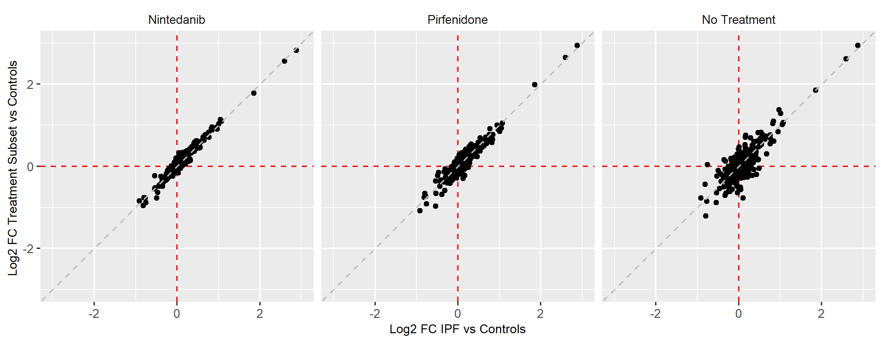

Figure S4. Comparisons of protein abundance between subsets of patients with IPF based on antifibrotic treatment status at enrollment. A) Nintedanib versus no treatment, B) pirfenidone versus no treatment, and C) nintedanib versus pirfenidone.

A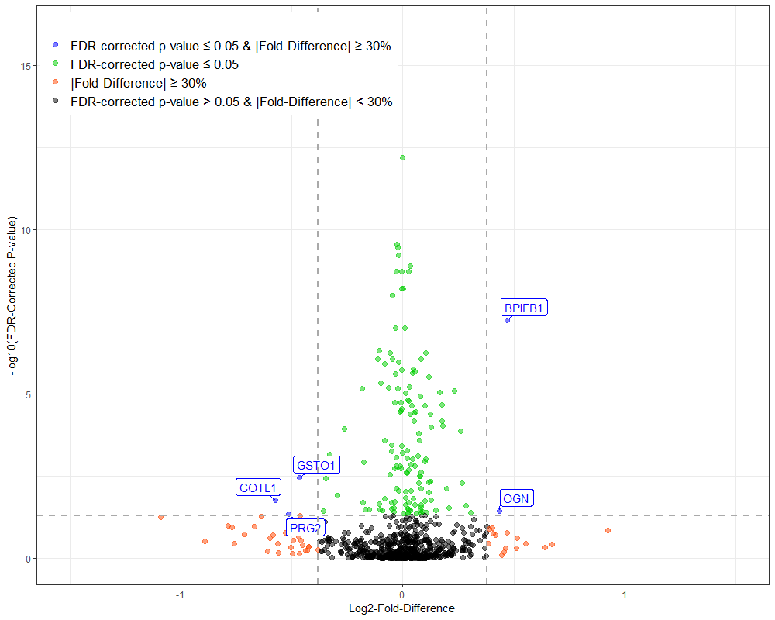

B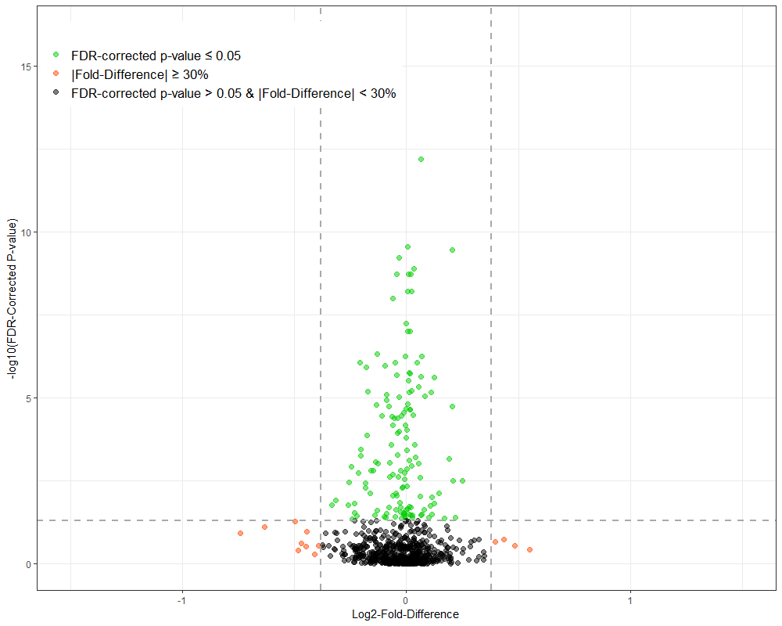

C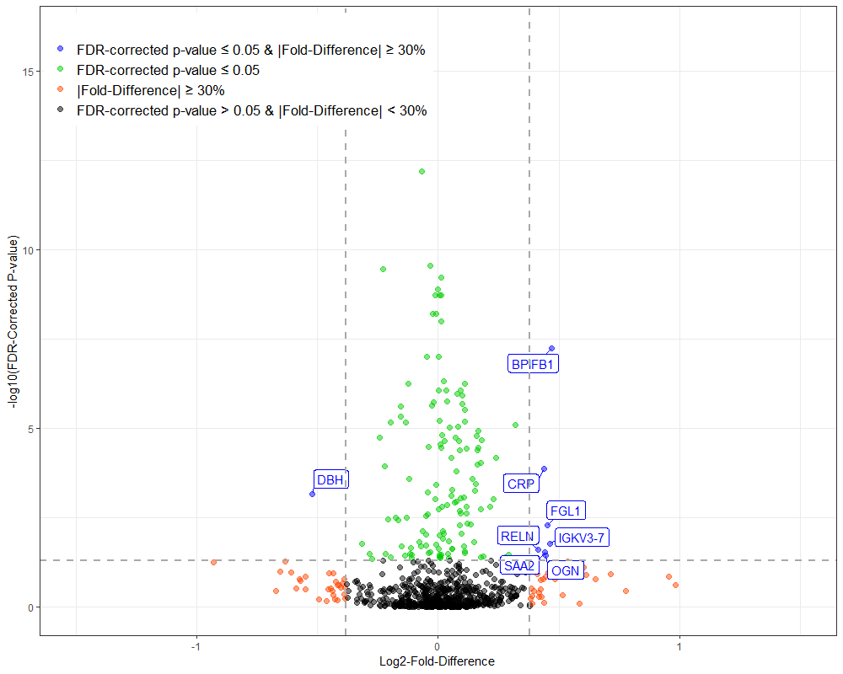

Figure S5. Associations between proteins and decline in FVC % predicted ≥10%, death, or lung transplant in patients with IPF in A) analyses unadjusted for clinical covariates and B) analyses adjusted for clinical covariates at enrollment.

A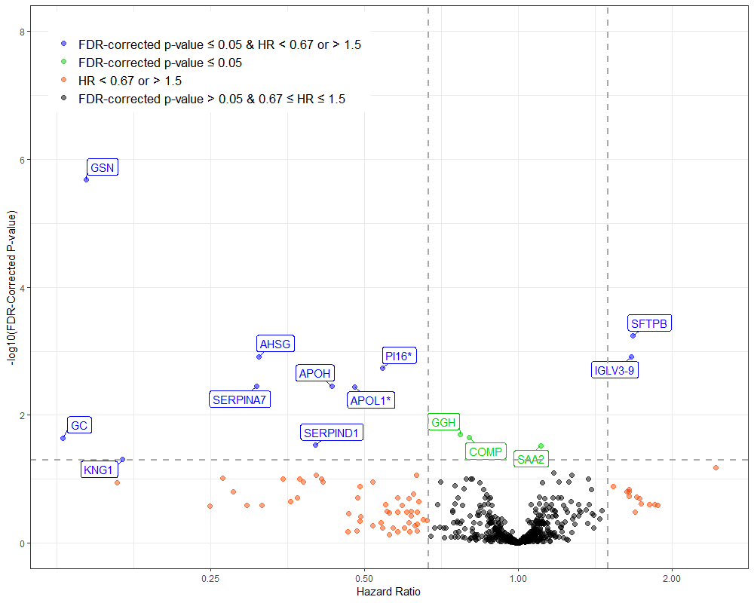

B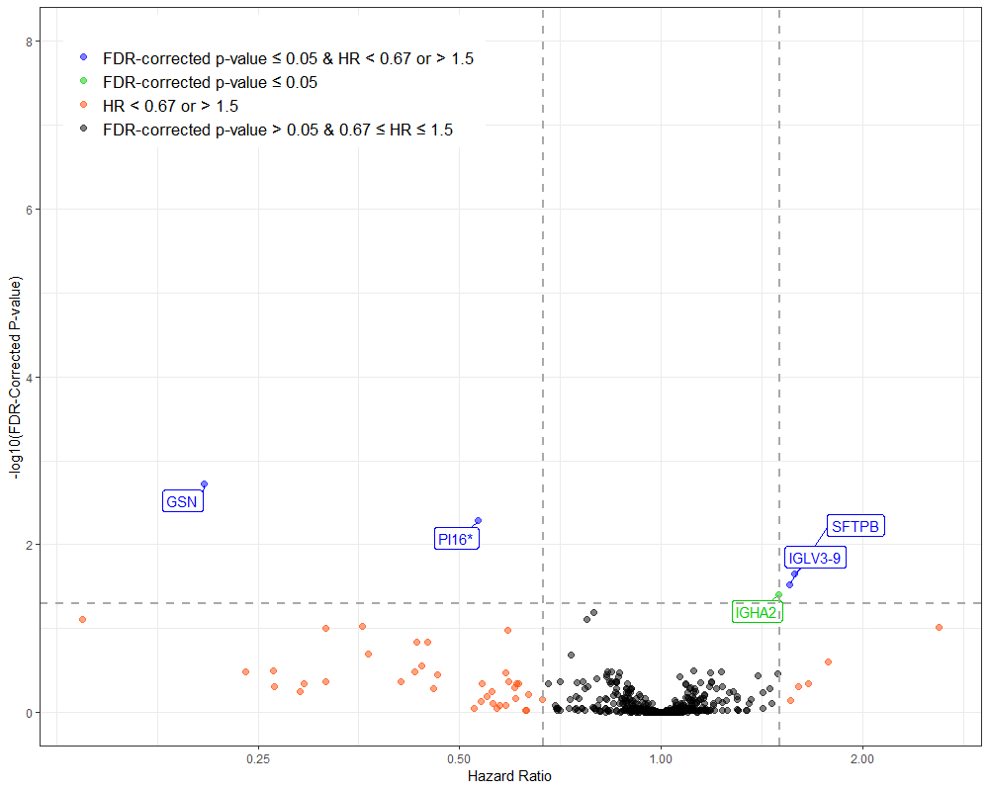

Figure S6. Model calibration (observed vs predicted event rates) at 6 months, 1 year, and 2 years for the composite of respiratory death and lung transplant in the training and test sets for models considering A) proteins only, B) proteins and clinical factors, and C) clinical factors only in patients with IPF.

A B C
