Supplementary Information (SI)
A 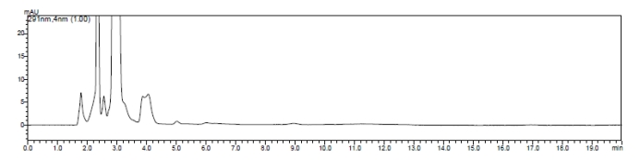
B 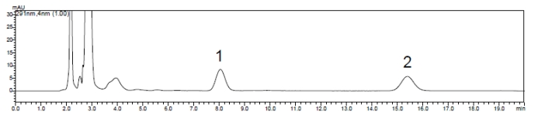
C 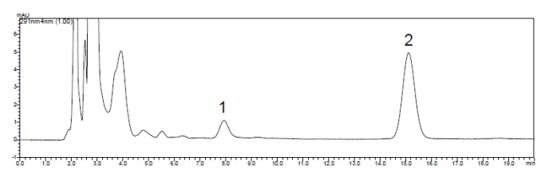
D 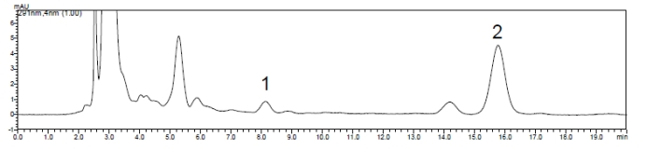
E 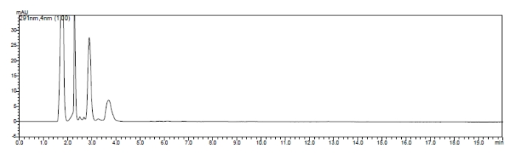
F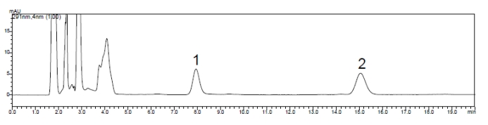
G 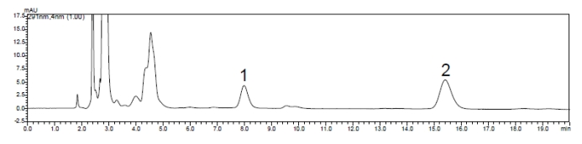
H 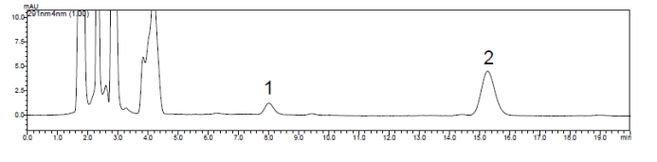
Supplementary Fig. 1 Representative chromatograms of blank plasma and lung tissue homogenates from mice plus the DMY control or internal standard. (Peak 1 is the DMY peak, and peak 2 is the dihydroquercetin peak.) (A) Blank mouse lung tissue homogenates; (B) blank lung tissues of mice spiked with the DMY reference and internal standard; (C) lung tissue samples collected from mice after the administration of nebulized DMY; (D) lung tissue samples collected from mice after the oral administration of DMY; (E) blank plasma from mice; (F) blank plasma from mice spiked with the DMY reference and internal standard; (G) plasma samples collected from mice after the nebulized administration of DMY; (H) plasma sample collected from mice after the intragastric administration of DMY.

Table S1. Concentrations of DMY in plasma and tissues at different sampling time points

Time (min) | Plasma (Mean±SD) |  | Lung (Mean±SD) |  | Liver (Mean±SD) |  | Kidney (Mean±SD) |  | Heart (Mean±SD)
Time (min) | Oral administration | Nebulization administration | Oral administration | Nebulization administration | Oral administration | Nebulization administration | Oral administration | Nebulization administration | Oral administration | Nebulization administration
5 | 206.38±66.7 | 7875.89±438.31 | 98.43±33.66 | 1418.41±272.82 | 235.29±76.49 | 184.69±79.08 | 413.61±67.48 | 259.46±38.66 | 60.8±29.69 | 61.62±41.34
10 | 458.65±303.96 | 1286.05±359.14 | 195.78±74.75 | 646.27±160.73 | 430.63±90.04 | 796.44±147.37 | 602.27±85.2 | 575.2±61.59 | 188.94±38.94 | 88.87±27.09
20 | 509.88±182.02 | 1120.58±494.99 | 262.15±58.17 | 457.55±131.76 | 563.44±73.91 | 905.18±213.94 | 652.35±160.59 | 812.84±184.92 | 345.42±90.61 | 215.65±103.63
30 | 2457.74±174.43 | 936.17±456.49 | 591.87±85.95 | 295.16±81.85 | 770.2±126.18 | 1427.89±53.25 | 827.48±141.27 | 654.89±152.85 | 534.35±61.69 | 834.52±181.59
45 | 964.69±61.14 | 400±110.73 | 276.52±99.84 | 413.52±89.95 | 349.39±79.71 | 589.69±157.17 | 568.68±118.09 | 508.66±117.21 | 233.1±56.67 | 240.46±131.82
60 | 271.93±86.48 | 716.31±190.84 | 192.56±64.33 | 199.55±135.46 | 347.02±33.84 | 554.24±176.29 | 425.45±104.66 | 366.14±4.67 | 169.57±29.68 | 231.01±126.24
90 | 338.03±200.93 | 277.12±111.11 | 217.8±36.57 | 128.45±18.53 | 389.32±35.68 | 506.16±114.12 | 437.46±111.99 | 468.77±95.65 | 132.23±16.58 | 203.79±56.78
120 | 232.43±103.46 | 452.49±20.06 | 145.58±60.29 | 62.86±28.56 | 365.43±29.21 | 326.49±111.37 | 368.68±50.61 | 362.84±102.66 | 70.61±18.89 | 179.01±44.96
150 | 209.56±82.39 | 374.1±116.92 | 43.06±19.85 | 63.64±36.46 | 315.15±54.77 | 373.8±56.3 | 235.43±88.3 | 435.6±38.1 | 83.06±15.78 | 51.98±27.66

