Supplemental figure 5

A | B |  | C
D
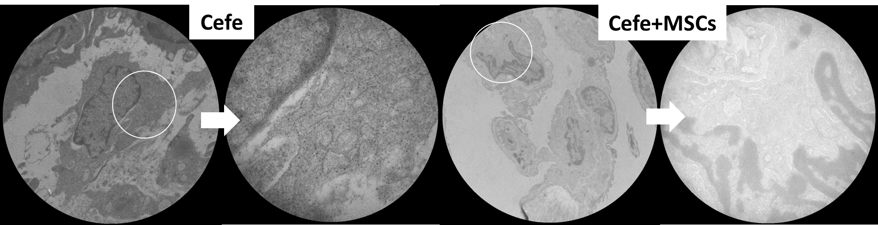
E |  | F | G

