SUPPLEMENTARY INFORMATION

TITLE: Longitudinal change of lung microbiome in chronic obstructive pulmonary disease: a prospective cohort study

Authors:
†Sung Woo Moon, †Minhong Kim, Eun Young Kim, Chaeeun Kang, Ju Hye Shin, Kangjin Kim, Sungho Won, ‡Hana Yi*, ‡Ji Ye Jung*

†Sung Woo Moon and Min Hong Kim are equal contributors as first author.
‡Hana Yi and Ji Ye Jung are equal contributors as corresponding author.

Table S1. Summary of key taxa present in >50% of samples, with prevalence and mean relative abundance
Genus | Prevalence percentage (%) | Mean relative abundance (%)
Streptococcus | 100 | 21.6
Prevotella | 100 | 16.4
Veillonella | 100 | 8.15
Neisseria | 100 | 7
Haemophilus | 100 | 6.96
Rothia | 100 | 5.72
Porphyromonas | 100 | 3.66
Fusobacterium | 100 | 3.45
Leptotrichia | 100 | 3.11
Actinomyces | 100 | 2.59
Gemella | 100 | 1.65
Granulicatella | 100 | 1.54
Alloprevotella | 100 | 1.32
Campylobacter | 100 | 1.15
Atopobium | 100 | 0.855
Capnocytophaga | 99.2 | 0.997
Oribacterium | 99.2 | 0.641
Selenomonas | 99.2 | 0.586
Bulleidia | 99.2 | 0.28
Lachnoanaerobaculum | 97.7 | 0.448
Treponema | 96.9 | 0.626
Parvimonas | 96.9 | 0.547
Bergeyella | 96.9 | 0.147
Tannerella | 96.9 | 0.142
Saccharimonas | 96.1 | 1.01
Megasphaera | 96.1 | 0.494
Lautropia | 95.3 | 0.655
Corynebacterium | 94.6 | 0.183
Dialister | 89.9 | 0.0989
Catonella | 89.9 | 0.0952
Peptostreptococcus | 89.1 | 0.388
PAC000661_g | 87.6 | 0.259
Moryella | 87.6 | 0.2
Eubacterium_g10 | 86.8 | 0.0815
Gallibacter | 84.5 | 0.0932
Mycoplasma_g4 | 82.9 | 0.0827
Fretibacterium | 81.4 | 0.079
Lachnospiraceae_G | 80.6 | 0.233
Bifidobacterium | 80.6 | 0.223
Lactobacillus | 79.8 | 0.635
Nanosyncoccus | 77.5 | 0.138
Cardiobacterium | 76.7 | 0.0554
Kingella | 75.2 | 0.0647
Aggregatibacter | 74.4 | 0.155
Filifactor | 74.4 | 0.145
Aminicella | 72.9 | 0.0546
Paludibacter | 72.1 | 0.0502
Phocaeicola | 71.3 | 0.0376
Pasteurellaceae_G | 70.5 | 0.713
Slackia | 69 | 0.034
Olsenella | 66.7 | 0.0701
Neisseriaceae_G | 63.6 | 0.0334
Pseudomonas | 62 | 0.0496
Butyrivibrio | 59.7 | 0.0596
Cyanobacteria | 59.7 | 0.0472
PAC001141_g | 57.4 | 0.0936
Bacteroides | 56.6 | 0.767
PAC002801_g | 54.3 | 0.0268
PAC001354_g | 54.3 | 0.0154
PYXF_g | 52.7 | 0.121

Table S2. Convergence rate, intraclass correlation coefficients (ICC), and random-effect variance estimates for negative binomial mixed models without time interaction terms.
Clinical Variable | Convergence Rate | ICC | Random-effect Variance | ICC 95% CI | RE Variance 95% CI
ICS use | 1 | 0.181 | 1.479 | 0.144 - 0.222 | 1.013 - 2.001
Smoking status | 1 | 0.160 | 1.322 | 0.125 - 0.204 | 0.834 - 1.913
FEV₁ category | 1 | 0.153 | 1.040 | 0.122 - 0.189 | 0.716 - 1.040
Abbreviations: ICC, intraclass correlation coefficient; RE, random effect; CI, confidence interval; ICS, inhaled corticosteroid; FEV₁, forced expiratory volume in 1 s, % predicted.

Table S3. Convergence rate, intraclass correlation coefficients (ICC), and random-effect variance estimates for negative binomial mixed models that included time interaction terms.
Clinical Variable | Convergence Rate | ICC | Random-effect Variance | ICC 95% CI | RE Variance 95% CI
ICS use | 1 | 0.187 | 1.540 | 0.148 - 0.232 | 1.080 - 2.101
Smoking status | 1 | 0.168 | 1.412 | 0.131 - 0.212 | 0.911 - 2.018
FEV1 category | 1 | 0.155 | 1.124 | 0.124 - 0.189 | 0.798 - 1.535
Abbreviations: ICC, intraclass correlation coefficient; RE, random effect; CI, confidence interval; ICS, inhaled corticosteroid; FEV₁, forced expiratory volume in 1 s, % predicted.

Table S4. Post-hoc power estimates for significant genera in NBMMs with and without time interaction
Model Type | Clinical Variable | Genus | Power
NBMM without time interaction | ICS use | Veillonella | 0.79
NBMM without time interaction | ICS use | Catonella | 0.604
NBMM without time interaction | ICS use | Saccharimonas | 0.502
NBMM without time interaction | Smoking | Actinomyces | 0.628
NBMM without time interaction | Smoking | Bulleidia | 0.782
NBMM without time interaction | Smoking | Lautropia | 0.342
NBMM without time interaction | FEV₁ | Alloprevotella | 0.784
NBMM with time interaction | ICS use | Megasphaera | 0.52
NBMM with time interaction | ICS use | Alloprevotella | 0.468
NBMM with time interaction | Smoking | Butyrivibrio | 0.11
NBMM with time interaction | Smoking | Pseudomonas | 0.28
NBMM with time interaction | FEV₁ | Bacteroides | 0.866
NBMM with time interaction | FEV₁ | Atopobium | 0.556
NBMM with time interaction | FEV₁ | Gemella | 0.508
NBMM with time interaction | FEV₁ | Kingella | 0.168
NBMM with time interaction | FEV₁ | Tannerella | 0.634
Abbreviations: NBMM, negative binomial mixed model; ICC, intraclass correlation coefficient; RE, random effect; CI, confidence interval; ICS, inhaled corticosteroid; FEV₁, forced expiratory volume in 1 s, % predicted

Figure S1. Seasonal effects on airway microbiome composition.
(A) PCoA based on Bray–Curtis dissimilarity comparing spring–summer versus autumn–winter, (B) PCoA comparing summer–autumn versus winter–spring, (C) PCoA comparing the four individual meteorological seasons (spring, summer, autumn, winter).
Across all grouping strategies, PERMANOVA (adonis2) showed no significant differences in beta diversity (P > 0.05 for all models),
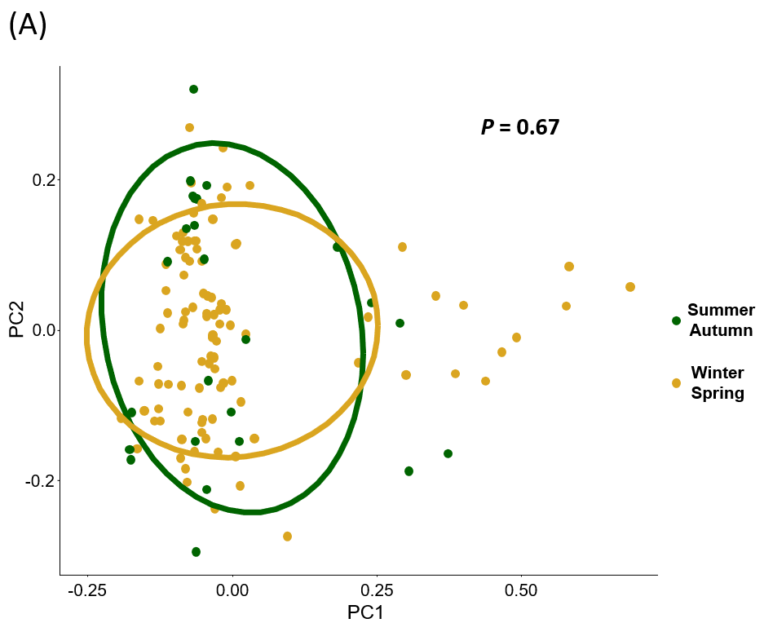
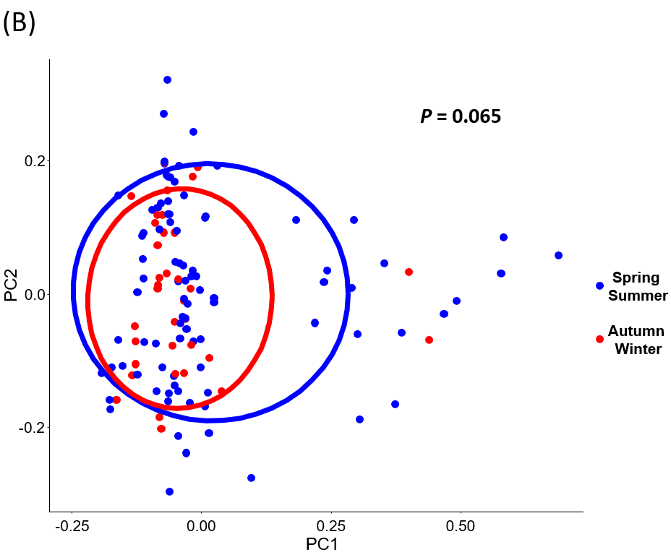
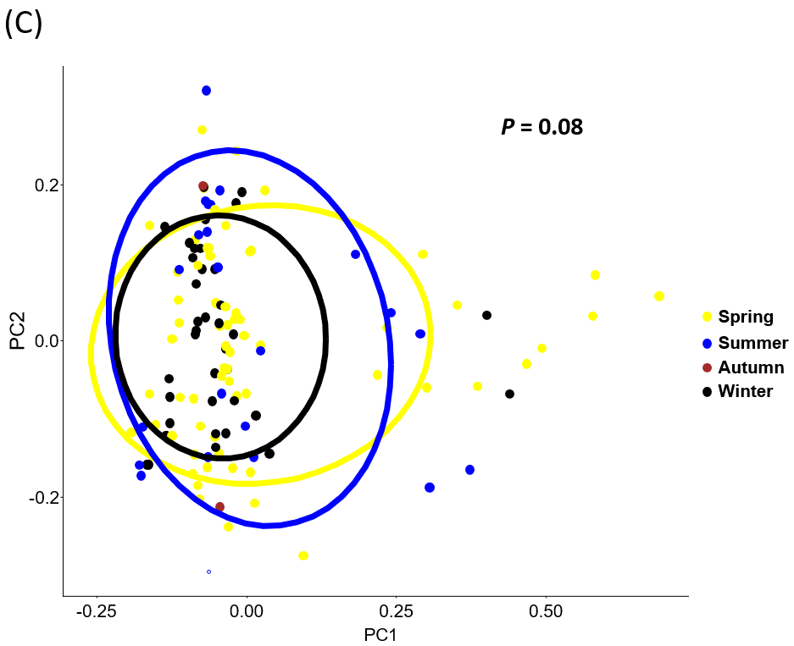
Figure S2. Taxonomic profiles of negative controls
Negative controls included two extraction blanks, one PCR blank, and one barcoding blank, all processed in parallel with clinical samples. Only low-abundance reagent-associated contaminant genera were detected, and sequencing depth in negative controls was markedly lower than in clinical samples, supporting that background contamination was minimal.
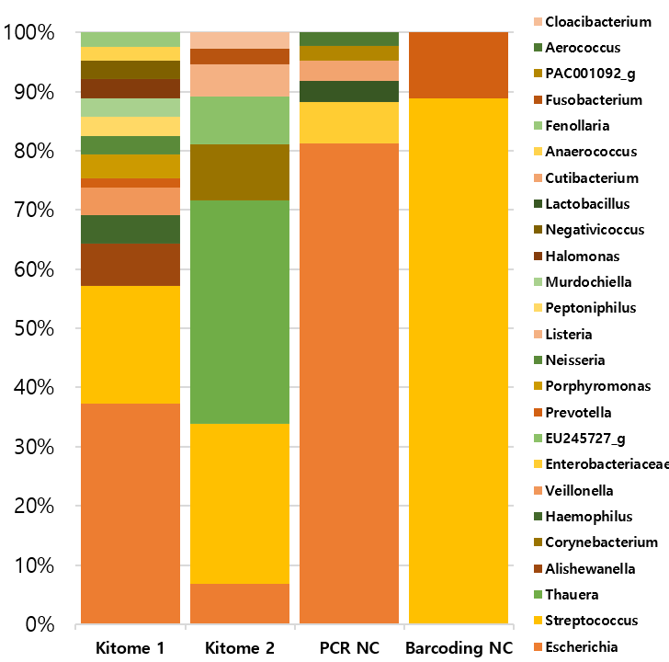

Figure S3. Microbial diversity and composition at baseline in patients with COPD vs. healthy controls.
(A-B) Bar plots showing genus-level relative abundance in individual samples and each group. (C) Principal coordinates analysis (PCoA) of Bray-Curtis dissimilarity. (D) Differentially abundant low-abundance genera identified using MaAsLin2 with adjustment for age and smoking status.
