Identification and validation of cilia-associated molecular candidates deregulated in severe asthma
Maëva A. Devilliers, Lynda Saber Cherif, Audrey Brisebarre, Ruby Chouquet, Ludivine Bralet, Julien Ancel, Alexandre Vivien, Emilie Luczka-Majérus, Arnaud Bonnomet, Nathalie Lalun, Camille Taillé, Xavier Dubernard, Jean-Claude Mérol, Christophe Ruaux, Myriam Polette, Gaëtan Deslée, Jeanne-Marie Perotin, Valérian Dormoy

Supplementary material

Supplementary figures:
Figure S1: Multi-subject single-cell (MuSiC) deconvolution
Figure S2: Validation of the immunofluorescence candidate detection
Figure S3: Airway remodelling is enhanced upon IL-13 treatment at ALI-14
Figure S4: PHLDB2 abundance is altered upon IL-13 treatment at ALI-14
Figure S5: Airway remodelling is enhanced upon IL-13 treatment at ALI-28

Supplementary tables:
Table S1: List of primary antibodies used for FFPE immunostainings
Table S2: Clinical characteristics of the patients included for FFPE immunostainings on airway epithelial cells cultured in ALI-culture
Supplementary figures
Figure S1. Multi-subject single-cell (MuSiC) deconvolution. (a) Barplots showing estimated cell-type proportions in three bulk RNA-seq datasets from HC (top panels) and SA (bottom panels) patients. Each bar represents a bulk sample, and colors indicate the relative proportion of each cell type. (b) Barplots showing estimated airway epithelial cell proportions in bulk RNA-seq datasets from HC (top panel) and SA (bottom panel) patients. Each bar represents a bulk sample, and colors indicate the relative proportion of each cell type.
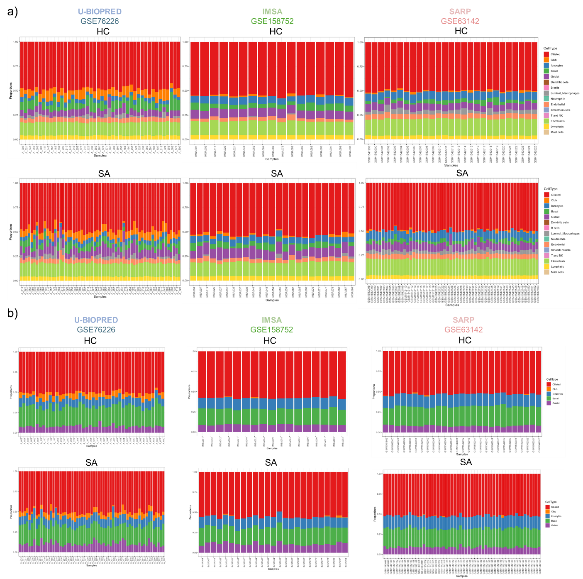
Figure S2: Validation of the immunofluorescence candidate detection. (a) Representative micrographs showing bronchial biospies immunostained with the indicated primary antibodies (red, right panel) or without primary antibodies as a negative control (left panel). DAPI (blue) marks nuclei. (b) Representative micrographs showing IAL cultures immunostained with the indicated primary antibodies (red, right panel) or without primary antibodies as a negative control (left panel). DAPI (blue) marks nuclei. The absence of signal in the negative control confirms the specificity of the primary antibodies used.
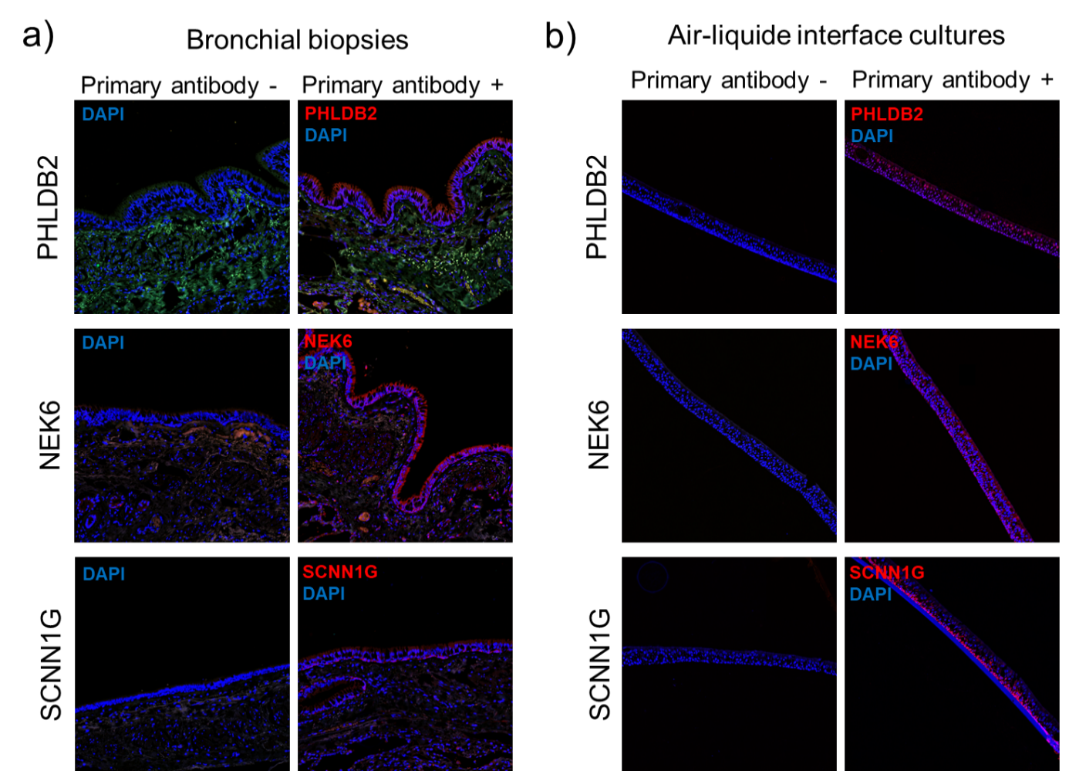

Figure S3: Airway remodelling is enhanced upon IL-13 treatment at ALI-14. (a) Representative micrographs showing epithelia of non-asthmatic (NA) and asthmatic (A) ALI cultures, treated or not with IL-13 for 14 days, and immunostained for epithelial remodelling features MUC5AC/MUC5B (top panel), ARL13B/p63 (middle panel) and cell nuclei (DAPI, blue). Magnification corresponding to the selected area is shown. (b) Dot plots with mean ± SEM representing MUC5AC expression, epithelial height, proportion of basal cells and ciliated surface, and TEER of NA (n=6, black) and A (n=6, red) cultures treated or not with IL-13 for 14 days. *p<0.05; **p<0.01; CTL vs IL-13.
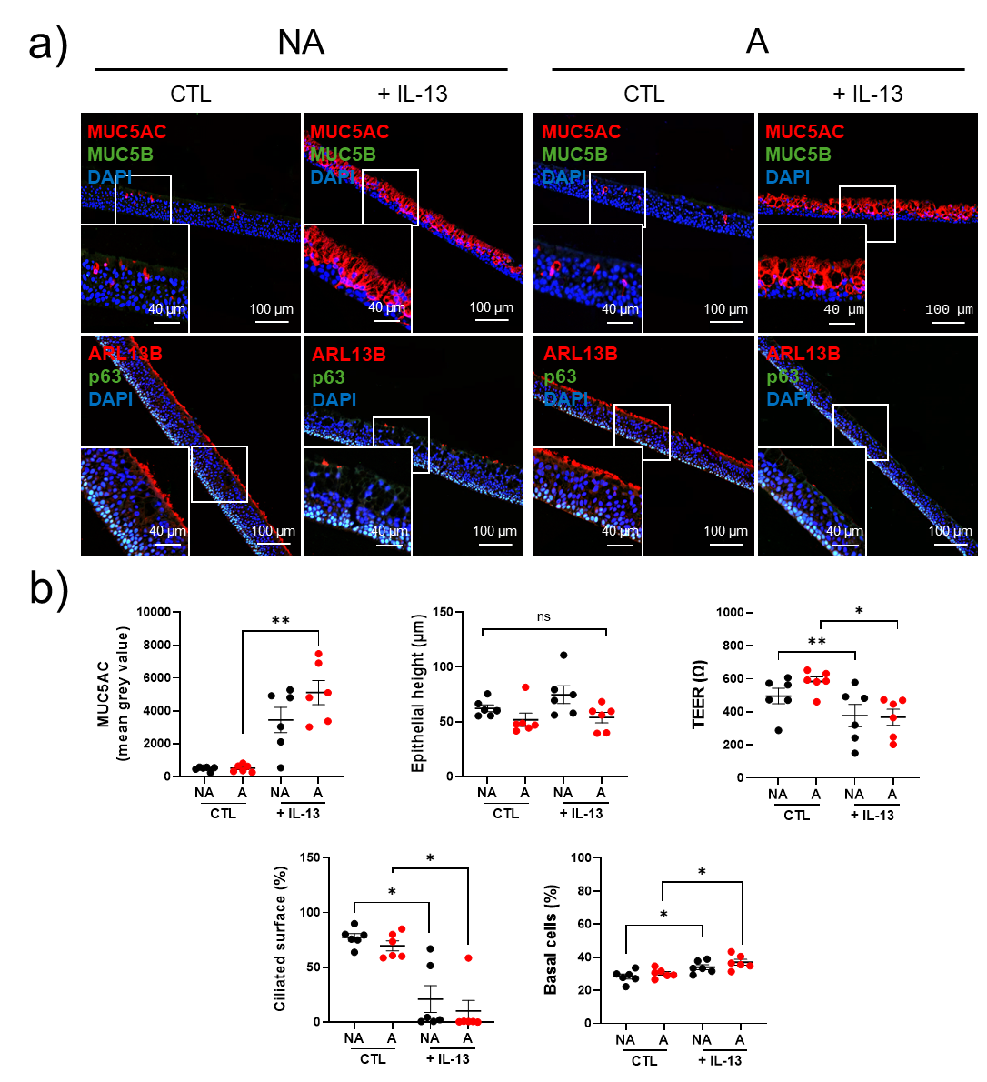
Figure S4: PHLDB2 abundance is altered upon IL-13 treatment at ALI-14. (a) Representative micrographs showing epithelia of non-asthmatic (NA) and asthmatic (A) ALI cultures, treated or not with IL-13 for 14 days, and immunostained for PHLDB2 (top panel, red), NEK6 (middle panel, red), SCNN1G (bottom panel, red), acetylated tubulin (Acetub, green) and cell nuclei (DAPI, blue). Magnification corresponding to the selected area is shown. (b) Dot plots with mean ± SEM representing PHLDB2 (top panel), NEK6 (middle panel), SCNN1G (bottom panel) expression of NA (n=6, black) and A (n=6, red) cultures treated or not with IL-13 for 14 days. *p<0.05; **p<0.01. (c) Before-after plots showing relative evolution of PHLDB2 (top panel), NEK6 (middle panel) and SCNN1G (bottom panel) expression of NA (n=6, black) cultures after IL-13 stimulation for 14 days. (d) Before-after plots showing relative evolution of PHLDB2 (top panel), NEK6 (middle panel) and SCNN1G (bottom panel) expression of A (n=5, red) cultures after IL-13 stimulation for 14 days in ALI-culture. *p<0.05.
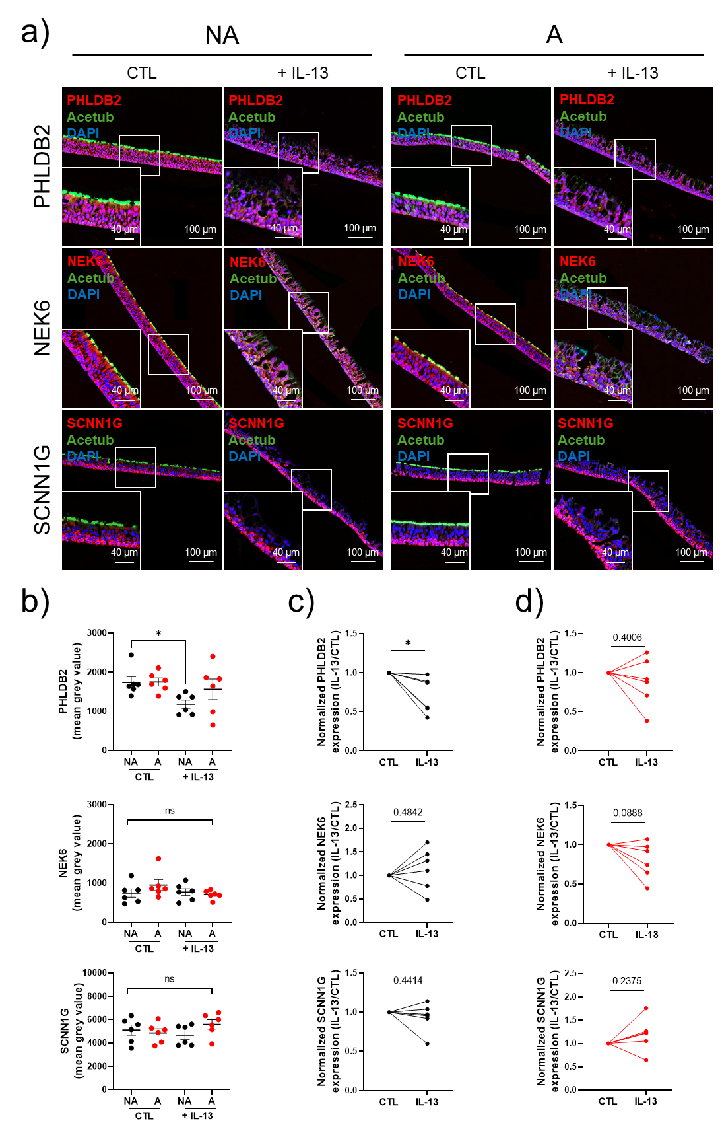
Figure S5: Airway remodelling is enhanced upon IL-13 treatment at ALI-28. (a) Representative micrographs showing epithelia of non-asthmatic (NA) and asthmatic (A) cultures, treated or not with IL-13 for 28 days, and immunostained for epithelial remodelling features MUC5AC/MUC5B (top panel), ARL13B/p63 (middle panel) and cell nuclei (DAPI, blue). Magnification corresponding to the selected area is shown. (b) Dot plots with mean ± SEM representing MUC5AC expression, epithelial height, proportion of basal cells and ciliated surface, and TEER of NA (n=6, black) and A (n=5, red) cultures treated or not with IL-13 for 28 days. *p<0.05; **p<0.01; CTL vs IL-13.
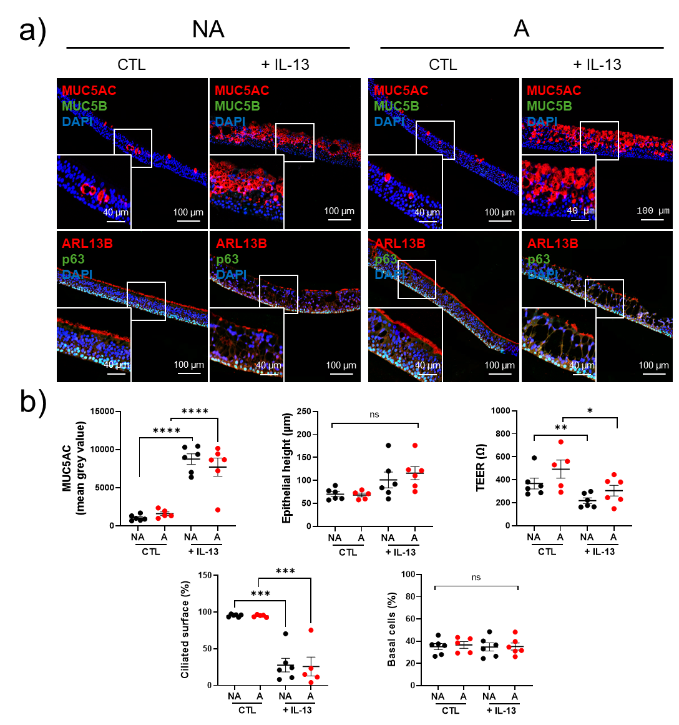

Supplementary tables
Table S1: List of primary antibodies used for FFPE immunostainings.
Antibodies | Species | References | Companies | Concentrations | RRID
Acetylated tubulin | Mouse | T6793 | Sigma-Aldrich | IF – 1:1000 | AB_477585
Arl13b | Rabbit | 17711-1-AP | Proteintech | IF – 1:100 | AB_2060867
CC10 | Rabbit | 10490-1-AP | Proteintech | IF – 1:100 | AB_2183285
Muc5ac | Mouse | MAB2011 | Millipore | IF – 1:100 | AB_2146983
Muc5b | Rabbit | E-AB-15988 | Elabscience | IF – 1:200 | AB_3107123
NEK6 | Rabbit | HPA056828 | Sigma-Aldrich | IF – 1:100 | AB_2683250
P63 | Goat | AF1916 | R&D Systems | IF – 1:100 | AB_2207174
PHLDB2 | Rabbit | NBP2-38238 | Novus Biologicals | IF – 1:100 | AB_3297699
SCNN1G | Rabbit | 13943-1-AP | Proteintech | IF – 1:500 | AB_2184510

Table S2: Clinical characteristics of the patients included for FFPE immunostainings on airway epithelial cells cultured in ALI-culture.
Clusters | A | NA | p value
n | 6 | 6
Demography and clinical characteristics
Age at inclusion (yrs) | 64.2 ± 11.4 | 53.4 ± 13.3 | 0.099
Sex -F/M | 1/5 | 2/4 | >0.999
BMIª (kg/m²) | 26.82 ± 8.2 | 26.6 ± 7.2 | 0.964
ACT^{b} score | 22.5 [18-25] | ND
SNOT22^{c} score | 38.0 [29-56] | 47.3 [2-90] | 0.523
Smoking history
Never smokers | 6 (100) | 4 (66.7) | 0.455
Current smokers | 0 (0) | 2 (33.3) | 0.455
Pack-years | ND | 14.0 [10-18]
ª BMI: Body mass index; ^{b} ACT: Asthma control test; ^{c} SNOT22: Sino-Nasal Outcome Test 22. ND: Not determined.

