Quantitative computed tomography body composition analysis for risk stratification in bronchiectasis

Umberto Semenzato¹*#, Virginia Santello¹#, Giulia Fichera²¶, Daniele Previtero¹¶, Chiara Contin³, Andrea Rastelli⁴, Rossella Valvason⁵, Marta Zuffellato⁶, Anna Ferrari⁷, Alessandro Micelli², Chiara Giraudo², Andrea Sattin⁷, Anna Maria Cattelan⁷, Paolo Spagnolo¹, Mariaenrica Tinè¹

1 Respiratory Medicine, Department of Cardiac, Thoracic, Vascular Sciences and Public Health, Padova University Hospital - Padua (Italy),
2 Unit of Advanced Clinical and Translational Imaging, Department of Cardiac, Thoracic, Vascular Sciences and Public Health, Padova University, Padova, Italy
3 Respiratory Disease Unit, Ospedale dell'Angelo, Mestre, Venice, Italy.
4 Department of Pneumology, Cittadella Hospital (PD), ULSS6 Euganea, Cittadella, Italy.
5 Pulmonology Unit, Dolo-Mirano Hospital, AULSS3 Serenissima, Venice, Italy.
6 Pulmonology Unit, San Bassiano Hospital, Bassano Del Grappa, Italy
7 Infectious and Tropical Diseases Unit, Padova University Hospital - Padua (Italy)
* corresponding author
#Umberto Semenzato and Virginia Santello contributed equally to this work.
¶Giulia Fichera and Daniele Previtero contributed equally and shared second authorship.

Correspondence to: Umberto Semenzato, Respiratory Medicine, Department of Cardiac, Thoracic, Vascular Sciences and Public Health, Padova University Hospital - 35128 Via Giustiniani 2, Padua (Italy). Email: umberto.semenzato@aopd.veneto.it

Supplementary

Supplementary Results

Vertebral Muscle Index (VMI) was not significantly correlated with clinical or functional parameters, including age, smoking exposure, exacerbation rate, bronchiectasis severity scores (BSI, FACED, E-FACED, BACI), or lung function. A significant correlation was observed only with BMI (r = 0.274, p = 0.005).
Moreover, there was no correlation between VMI and HU muscle (r = 0.101; p = 0.291).
The BMI was similar among MSp with and without NTM (21.98 [19.99-25.24] vs 22.52 [20.14-24.99]; p = 0.788).

Supplementary Figures
Figure S1. The aetiology of bronchiectasis in the study population.
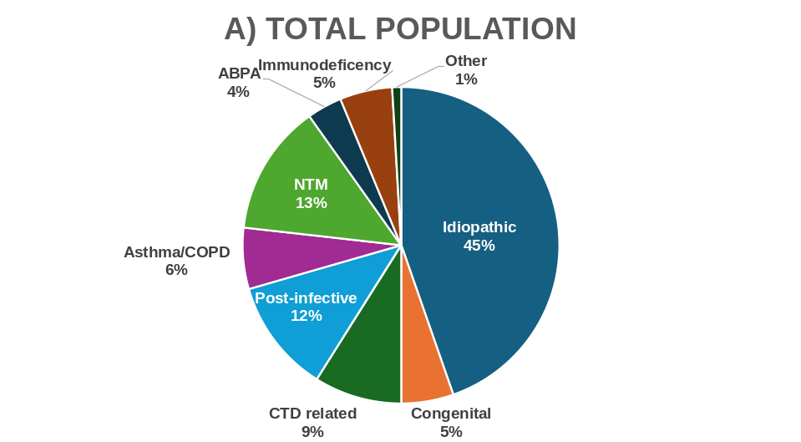
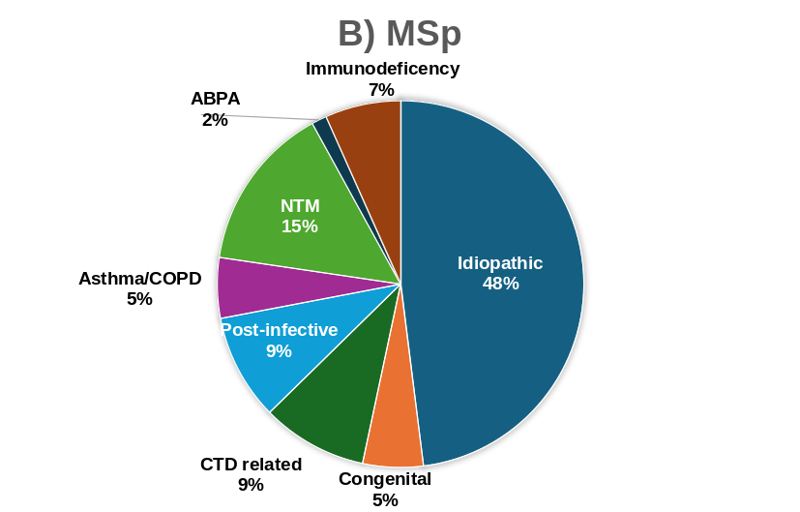
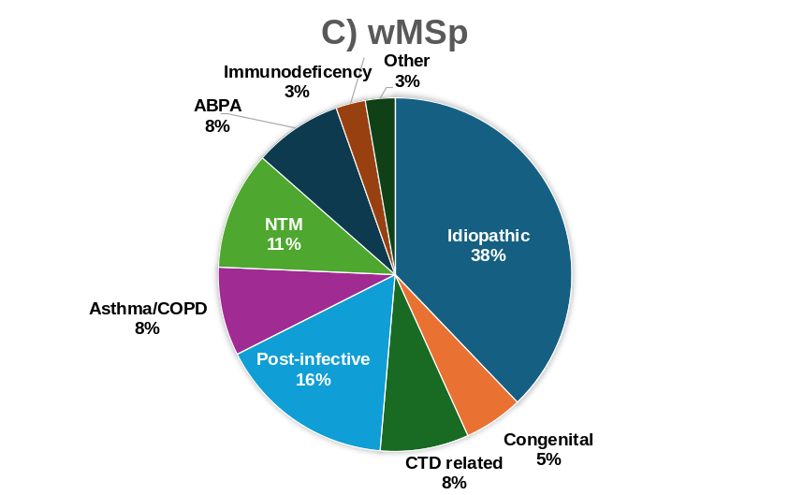
Abbreviations: MSp = patients with myosteatosis; wMSp = patients without myosteatosis; ABPA = allergic broncho-pulmonary aspergillosis; COPD = chronic obstructive pulmonary disease; CTD = connective tissue disease; NTM = nontuberculous mycobacteria.

Figure S2. Association between FEV₁ and muscle density.

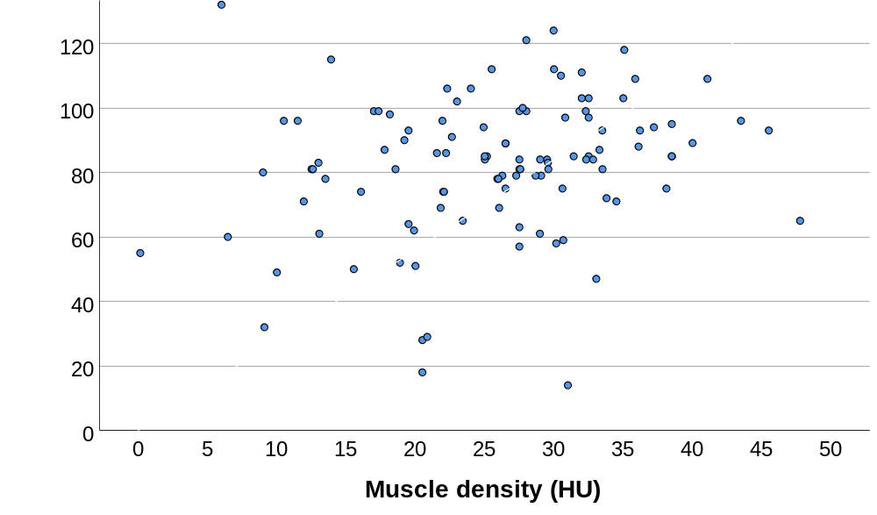
Scatter plot showing the association between FEV₁ (% predicted) and muscle density. Spearman’s rank correlation coefficient r = 0.23; p = 0.016
Abbreviations: FEV₁= Forced Expiratory Volume in 1 second; HU = Hounsfield Units

Figure S3. Association between Bronchiectasis Severity Index and muscle density.

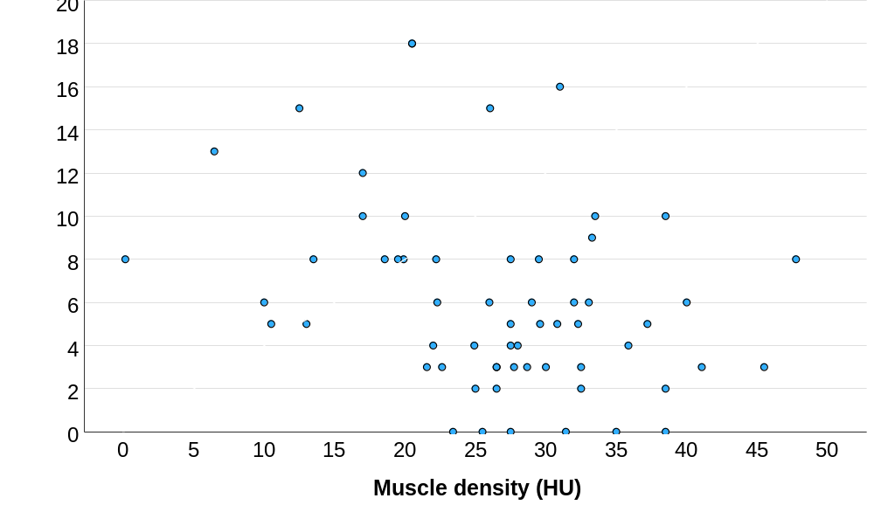
Scatter plot showing the association between Bronchiectasis Severity Index (BSI) and muscle density. Spearman’s rank correlation coefficient r = −0.32; p = 0.012
Abbreviations: BSI = Bronchiectasis Severity Index, HU = Hounsfield Units

