Supplemental information
Quantitative label-free multiphoton imaging of collagen features predicts disease severity and progression in idiopathic pulmonary fibrosis
Wei Liu, Yu Sun, Ling Zhao, Shu Wang, Guowu Zhou, Shiyao Wang, Sheng Xie, Jing Geng, bingbing Xie, Aimin Wang, Huaping Dai
This file includes:
Supplementary methods
1. Figure S1
2. Figure S2
3. Table S1
4. Table S2

Supplementary methods
1.1 Selection of biopsy sites
In our study, the indication and site selection for TBLC were determined based on the 2018 and 2022 IPF diagnostic guidelines and multidisciplinary discussion (MDD). TBLC was primarily performed in patients with indeterminate UIP pattern on HRCT, for whom histopathological confirmation was considered necessary after MDD. In addition, a small proportion of patients with probable UIP pattern underwent biopsy when the MDD panel considered that imaging findings alone were insufficient to establish a confident diagnosis of IPF.
For biopsy site selection, HRCT images were carefully reviewed before the procedure. The biopsy region was preferentially chosen from areas demonstrating relatively prominent fibrotic changes on HRCT, while avoiding end-stage honeycombing regions whenever possible, in order to maximize diagnostic yield while maintaining procedural safety.
1.2 Sampling strategy
The number of TBLC specimens obtained from each patient followed standardized procedural principles. In general, 3-5 specimens were obtained per patient.
Biopsy samples were usually obtained from different lobes on the same side. When lesions were relatively confined to a single lobe, samples were taken from different subsegmental locations within that lobe. The final number of specimens obtained was also adjusted according to intra-procedural conditions, including specimen quality, bleeding risk, and overall patient safety.
1.3 Collagen feature extraction
To comprehensively characterize collagen architecture, a total of 175 quantitative features were extracted (Table S1). These features were classified into four categories: (1) morphological features; (2) first-order statistical (FOS) features; (3) second-order statistical (SOS) features derived from the gray-level co-occurrence matrix (GLCM); and (4) Gabor wavelet transform features.
(1) Morphological features
A total of 36 morphological features were extracted to characterize the geometric and structural properties of individual collagen fibers and the overall fiber network. These features included fiber-level descriptors, such as fiber number, length, width, eccentricity, solidity, perimeter, tortuosity, and straightness, together with their corresponding local heterogeneity measures, quantified as within-region variance. Network-level parameters were used to assess collective fiber organization, including the collagen area ratio, elastin-to-collagen ratio, fiber colocalization index, dual-channel correlation and difference, fiber independence index, and tissue consistency. Orientation-related features were derived using fast Fourier transform (FFT) analysis and included the orientation index, anisotropy index, local orientation heterogeneity, orientation dispersion, and orientation entropy. Structural complexity and connectivity were quantified by fractal dimension, network complexity calculated using the box-counting method, crosslink count, spacing, density, and the crosslink-to-length ratio. In addition, pore geometry features were extracted to characterize inter-fiber spaces, including the mean, minimum, and maximum pore area, as well as the small-pore ratio.
(2) First-order statistics
Six first-order statistical features were calculated from the histogram of SHG pixel intensities, including the mean, standard deviation, variance, skewness, kurtosis, and entropy. These features describe the overall intensity distribution of the image.
(3) Second-order statistics — GLCM-based features
Contrast, correlation, energy, and homogeneity were calculated using five displacements of pixels at 1, 2, 3, 4, and 5 and four directions at 0, 45, 90, and 135 degrees^{[1]}. The mean value of each descriptor across all displacement-direction combinations was calculated to generate four additional features, and the inverse difference moment (IDM) was included as a measure of local texture homogeneity.
(4) Gabor wavelet transform features
The 48 Gabor wavelet features were derived from 24 filter settings defined by 4 scales (λ = 4, 8, 16, and 32 pixels) and 6 orientations (θ = 0°, 30°, 60°, 90°, 120°, and 150°) , with 2 summary statistics (mean and variance of the magnitude of the convolution response) extracted for each setting^{[2]}. Gabor wavelet features were used to characterize texture patterns across different spatial scales and orientations. Because features were extracted separately for fixed orientations, they were orientation-sensitive rather than strictly rotation-invariant.
1.4 Feature selection using random forest and XGBoost
Feature importance ranking was subsequently performed using an ensemble strategy integrating Random Forest (RF) and XGBoost. For RF, feature importance was estimated using 500 trees and ranked by mean decrease in accuracy. For XGBoost, feature importance was estimated using a learning rate of 0.1, a maximum tree depth of 6, and 100 boosting rounds, and ranked according to gain. The top 15 features identified by each method were then compared, and the intersection of the two sets was retained as the final candidate discriminative feature set for subsequent exploratory analyses.
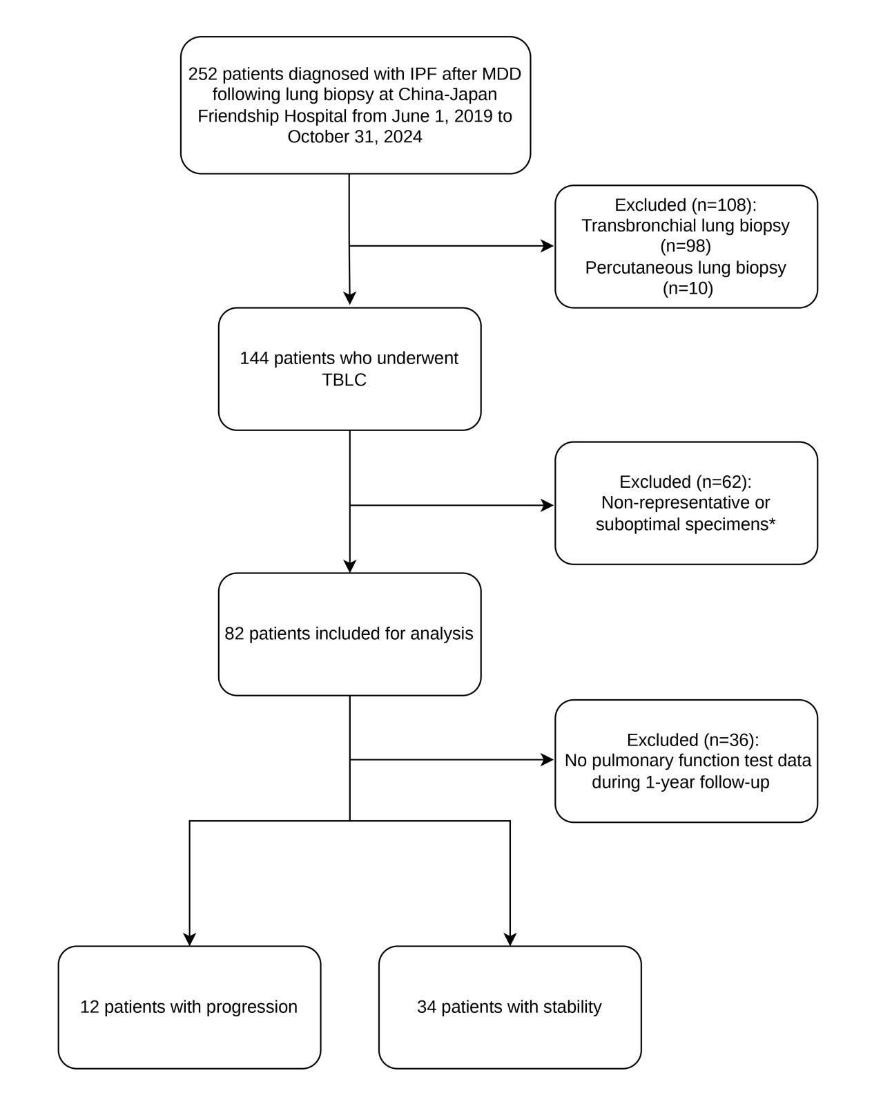
Figure S1. The flowchart of inclusion and exclusion criteria of IPF patients who underwent TBLC.
*Non-representative or suboptimal specimens were defined as specimens meeting any of the following criteria: specimen volume too small for adequate evaluation, similar to that typically obtained by conventional transbronchial forceps biopsy; predominance of bronchial mucosal tissue with insufficient lesional lung parenchyma for evaluation; or exclusively normal lung tissue with insufficient lesional components.
Abbreviations: IPF, idiopathic pulmonary fibrosis; TBLC, transbronchial lung cryobiopsy; MDD, multidisciplinary discussion.

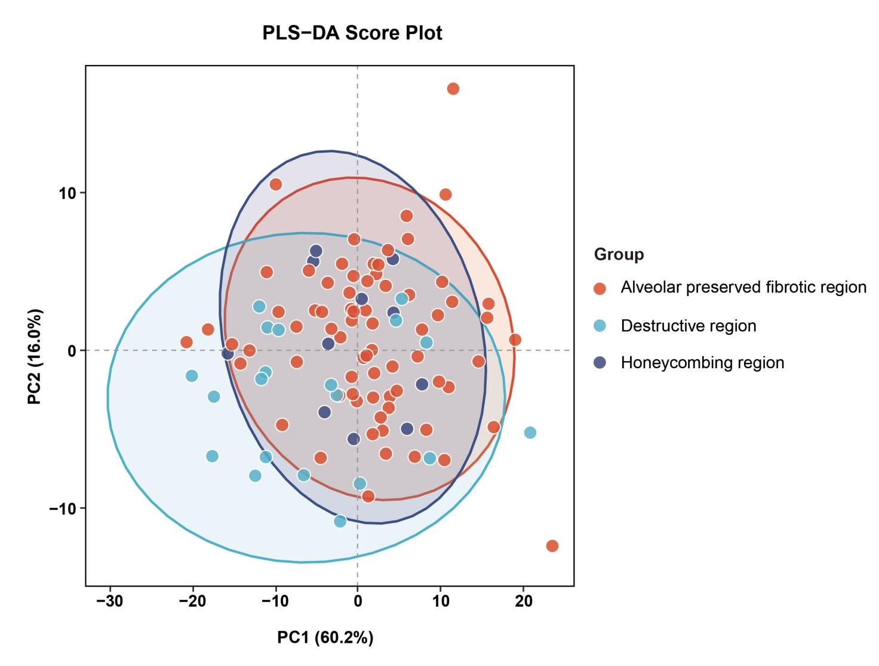
Figure S2. PLS-DA score plot of collagen features in alveolar preserved fibrotic region (red), destructive region (light blue), and honeycombing region (dark blue). Ellipses indicate the 95% confidence regions for each group. The first two components explained 76.2% of the total variance in collagen features but only 10.1% of the between-group variance, indicating substantial overlap and limited separation among the three pathological patterns.

Table S1. The 175 collagen parameters with the corresponding description.
No. | Features | Description
- Morphological features
1 | Collagen Area Ratio (CAR) | The percentage of collagen area in relation to the region of interest area.
2 | Elastin collagen ratio | The percentage of elastin area in relation to collagen area.
3 | The coefficient of variation in elastic collagen ratio | The coefficient of variation (CV) of the ratio between elastin and collagen content across the pathological regions
4 | Collagen fiber number | The total number of individual collagen fibers in ROI.
5 | Collagen fiber length | The mean length of each fiber is defined as the sum of distances between neighboring vertices.
6 | Collagen fiber width | The mean width of the identified collagen fibers is defined as the average distance between the vertices in the list to their nearest background pixel.
7 | Collagen fiber eccentricity | The elongation of the fibres, with values approaching 1 representing greater elongation and values close to 0 indicating a more circular shape.
8 | Local eccentricity heterogeneity | The variations in collagen fiber eccentricity within ROIs.
9 | Collagen fiber solidity | The density of the fiber network, with values closer to 1 indicating a denser structure.
10 | Local solidity heterogeneity | The variations in collagen fiber solidity within ROIs.
11 | Collagen fiber perimeter | the total length of the boundary contour of an individual segmented collagen fiber.
12 | Local perimeter heterogeneity | The variations in collagen fiber length within ROIs.
13 | Collagen fiber tortuosity | The ratio of the actual path length of the collagen fiber to the straight-line distance between its two endpoints.
14 | Local tortuosity heterogeneity | The variations in collagen fiber tortuosity within ROIs.
15 | Collagen fiber straightness | The ratio of the straight-line distance between its two endpointsthe to the actual path length of the fiber.
16 | Fiber colocalization index | The spatial co-occurrence of collagen and elastin, reflecting their interaction in the tissue.
17 | Dual channel correlation | The pixel-wise linear relationship of signal intensities between the SHG and TPEF.
18 | Dual channel difference | The average intensity disparity between the SHG and TPEF channels within the ROIs.
19 | Dual channel difference variability | The standard deviation of the intensity differences between the two channels across the ROIs.
20 | Collagen fiber independent index | The proportion of fibers that exist as distinct, non-aggregated entities relative to the total collagen network.
21 | Collagen tissue consistency | The spatial homogeneity and textural regularity of the collagen distribution across the ROIs.
Orientation
22 | Orientation index | The degree of isotropy of collagen fibres in images using Fast Fourier transformation (FFT) .  Orientation Index (OI) = 1 − (short axis / long axis).
23 | Local orientation heterogeneity | The variations in orientation index within ROIs.
24 | Anisotropy Index | The degree of directional preference of the fiber network, with values closer to 1 indicating strong orientation and values closer to 0 indicating randomness.
25 | Orientation dispersion | The degree of dispersion in fiber orientations, with higher values indicating more spread in fiber alignment.
26 | Orientation entropy | The randomness of the fiber orientation distribution, a high value indicates isotropic (disordered) alignment.
Structure
27 | Cross-link count | The total number of intersection points of collagen in region of interest
28 | Cross-link sapce | The average distances between neighboring crosslink points.
29 | Cross-link over length | The ratio of the total number of crosslink points to the sum of lengths of all collagen fibers.
30 | Cross-link density | The ratio of the total number of crosslink points to the total area of the ROIS.
Fractal analysis
31 | Collagen fiber fractal dimension | Collagen fiber network complexity is defined as the fractal dimension (FD) of the collagen architecture, typically quantified using the box-counting method. A higher complexity indicates a detailed, multi-scale reticular meshwork, while a lower complexity signifies a simplified, coarse, or homogenized structure.
32 | Collagen fiber network complexity | The composite metric assessing the intricacy of the specified fiber network, often integrating parameters like fractal dimension, connectivity, and branching.
33 | Mean Pore area | The mean area of the void spaces enclosed by the structural fibers within the network，reflecting the density of the network.
34 | Min Pore Area | The smallest area of void spaces within the fiber network, indicating the tightness or density of the network.
35 | Max Pore Area | The largest area of void spaces within the fiber network, reflecting the looseness or porosity of the network.
36 | Small Pore Ratio | The ratio of small void spaces to total void spaces within the fiber network, reflecting the fine structure of the network.
- First-order statistics (FOS)
37 | Mean | The average intensity value.
38 | Standard deviation | The standard deviation of the gray values.
39 | Variance | The standard deviation squared.
40 | Skewness | The degree of symmetry relative to the mean value.
41 | Kurtosis | The flatness of the distribution around the mean.
42 | Entropy | The degree of spatial organization.
- Second-order statistics (SOS, Grey-level co-occurrence matrix-based features, GLCM)
43-126 | Contrast | The consistency in gray levels between neighboring pixels.
43-126 | Correlation | The dependence of gray levels between two pixels separated by a certain distance neighboring pixels.
43-126 | Energy | The uniformity of the distribution of gray levels.
43-126 | Homogeneity | The local uniformity in the image
127 | IDM | The local uniformity of image intensity. High IDM values indicate a texture with low contrast variations and high smoothness, whereas low values suggest a rough, heterogeneous texture.
- Gabor wavelet transform features
128-175 | Mean | Mean of the magnitude of Gabor wavelet transform.
128-175 | Variance | Variance of the magnitude of Gabor wavelet transform.

Table S2. Demographic data of healthy controls.
Variable | Control(n=22)
Male | 8 (36.4%)
Age(years) | 58.2±9.33
BMI(kg·m²) | 24.7±3.47
Smokers | 2 (9.09%)
Spirometry
FVC (L) | 3.38±0.87
FVC (% predicted) | 108±20.5
FEV1 (L) | 2.69±0.73
FEV1(% predicted) | 103±17.3
TLC (L) | 5.40±1.11
TLC (% pred) | 100±12.1
DLCO (mmol/min/kPa) | 8.06±1.84
DLCO(%predicted) | 98.1±15.6
Abbreviations: FVC: forced vital capacity; TLC: total lung capacity; FEV1: forced expiratory volume in 1 s; DLCO: diffusing capacity of the lungs for carbon monoxide.

Supplementary References
- Haralick RM, Shanmugam K, Dinstein I. Textural Features for Image Classification. Studies in Media and Communication. 1973; SMC-3:610-621.
- Daugman JG. Complete discrete 2-D Gabor transforms by neural networks for image analysis and compression. IEEE Transacoustspeech & Signal Process. 1988;36:1169-1179.

