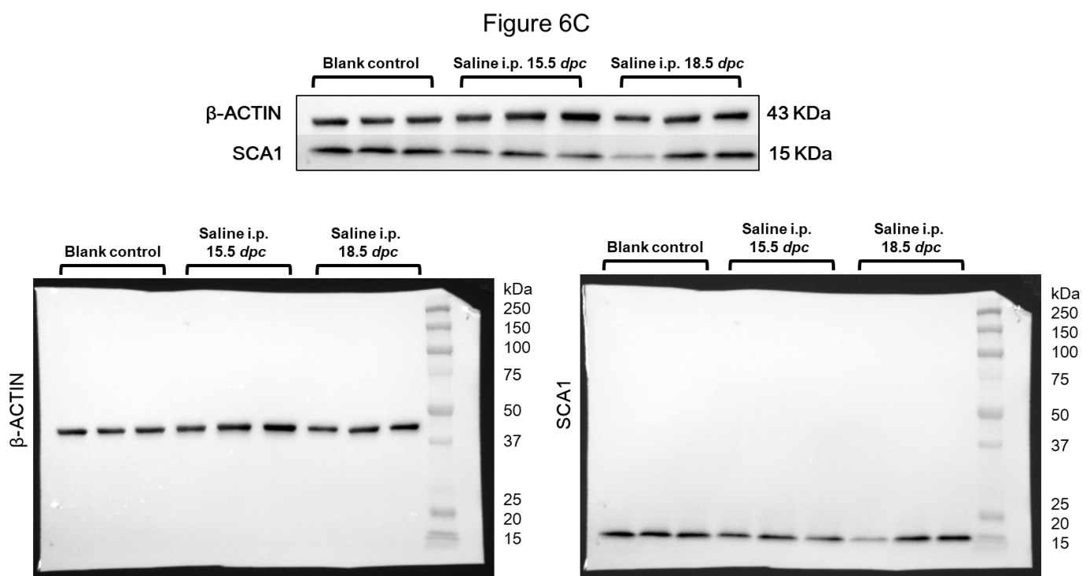
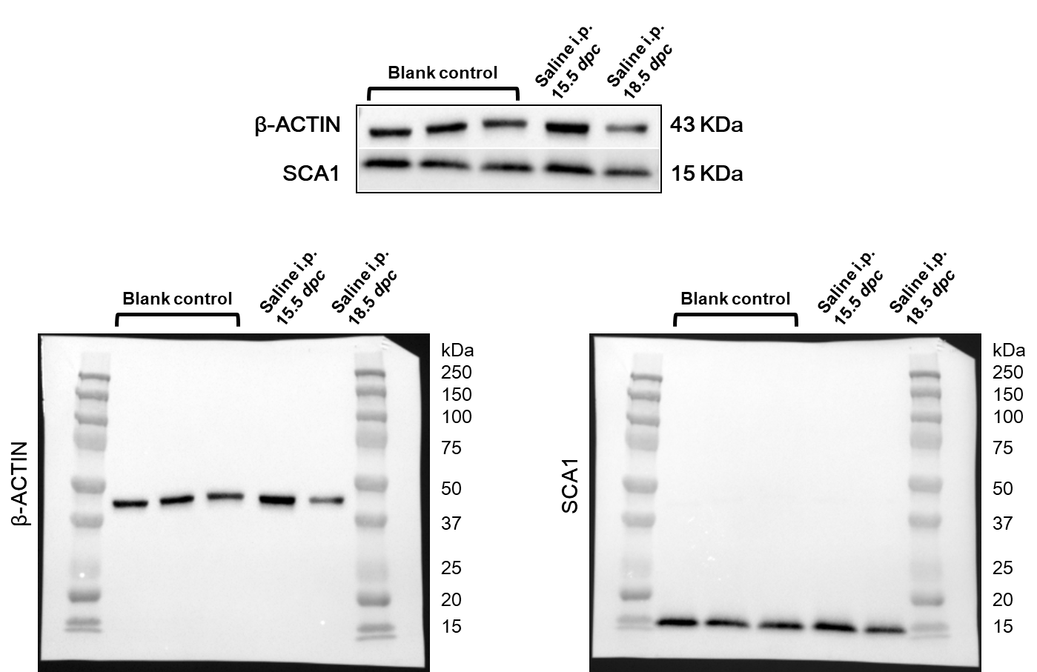
Supplementary file of uncropped gels/blots. dpc: day post coitum, i.p.: intraperitoneal, SCA1: stem cell antigen 1.

