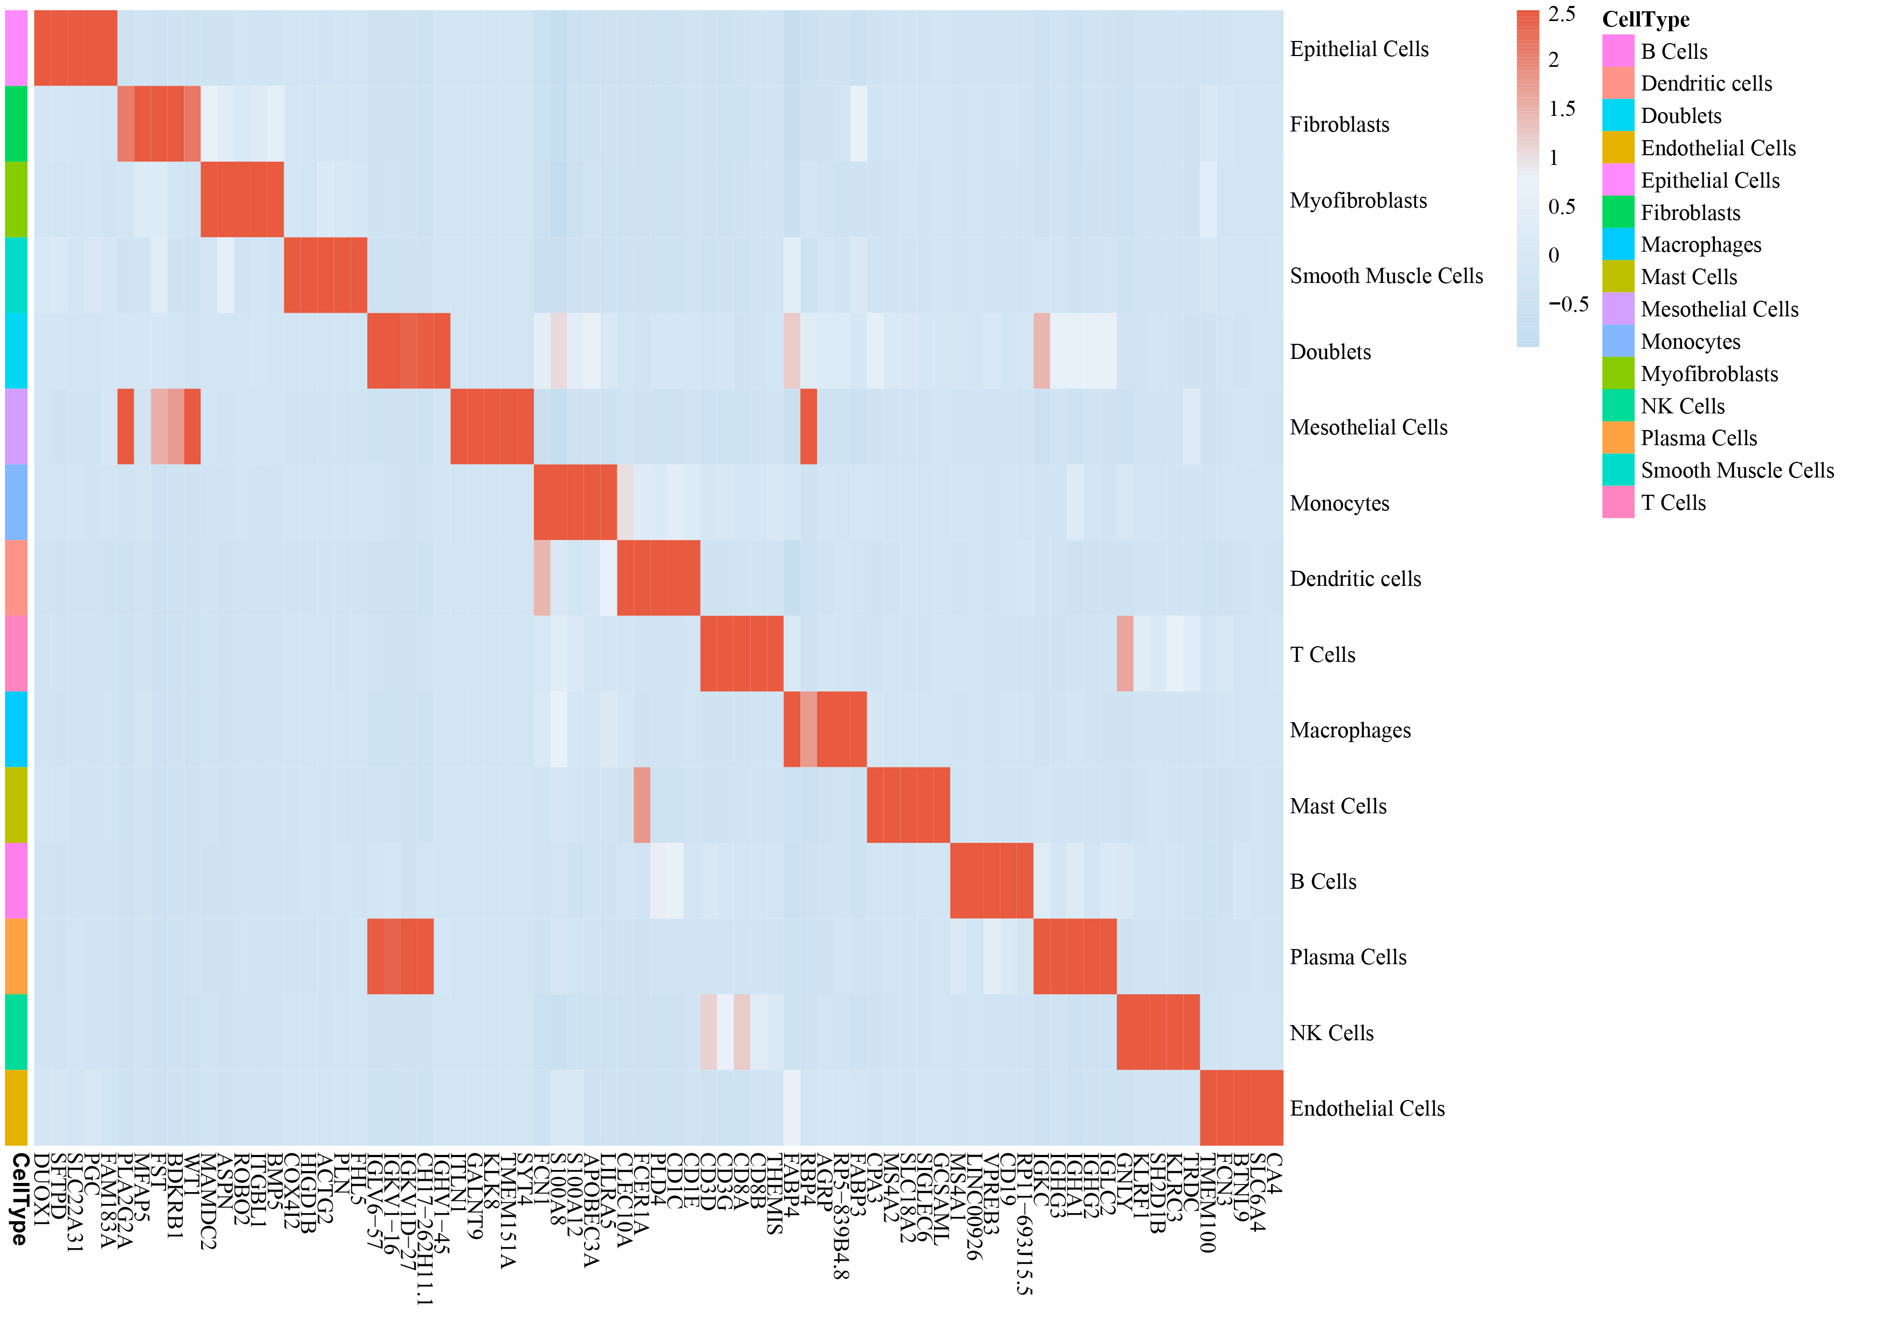
Figure S1 The heatmap of average expression levels of signature genes across different cell subtypes in the lung tissues of the patients with idiopathic pulmonary fibrosis.

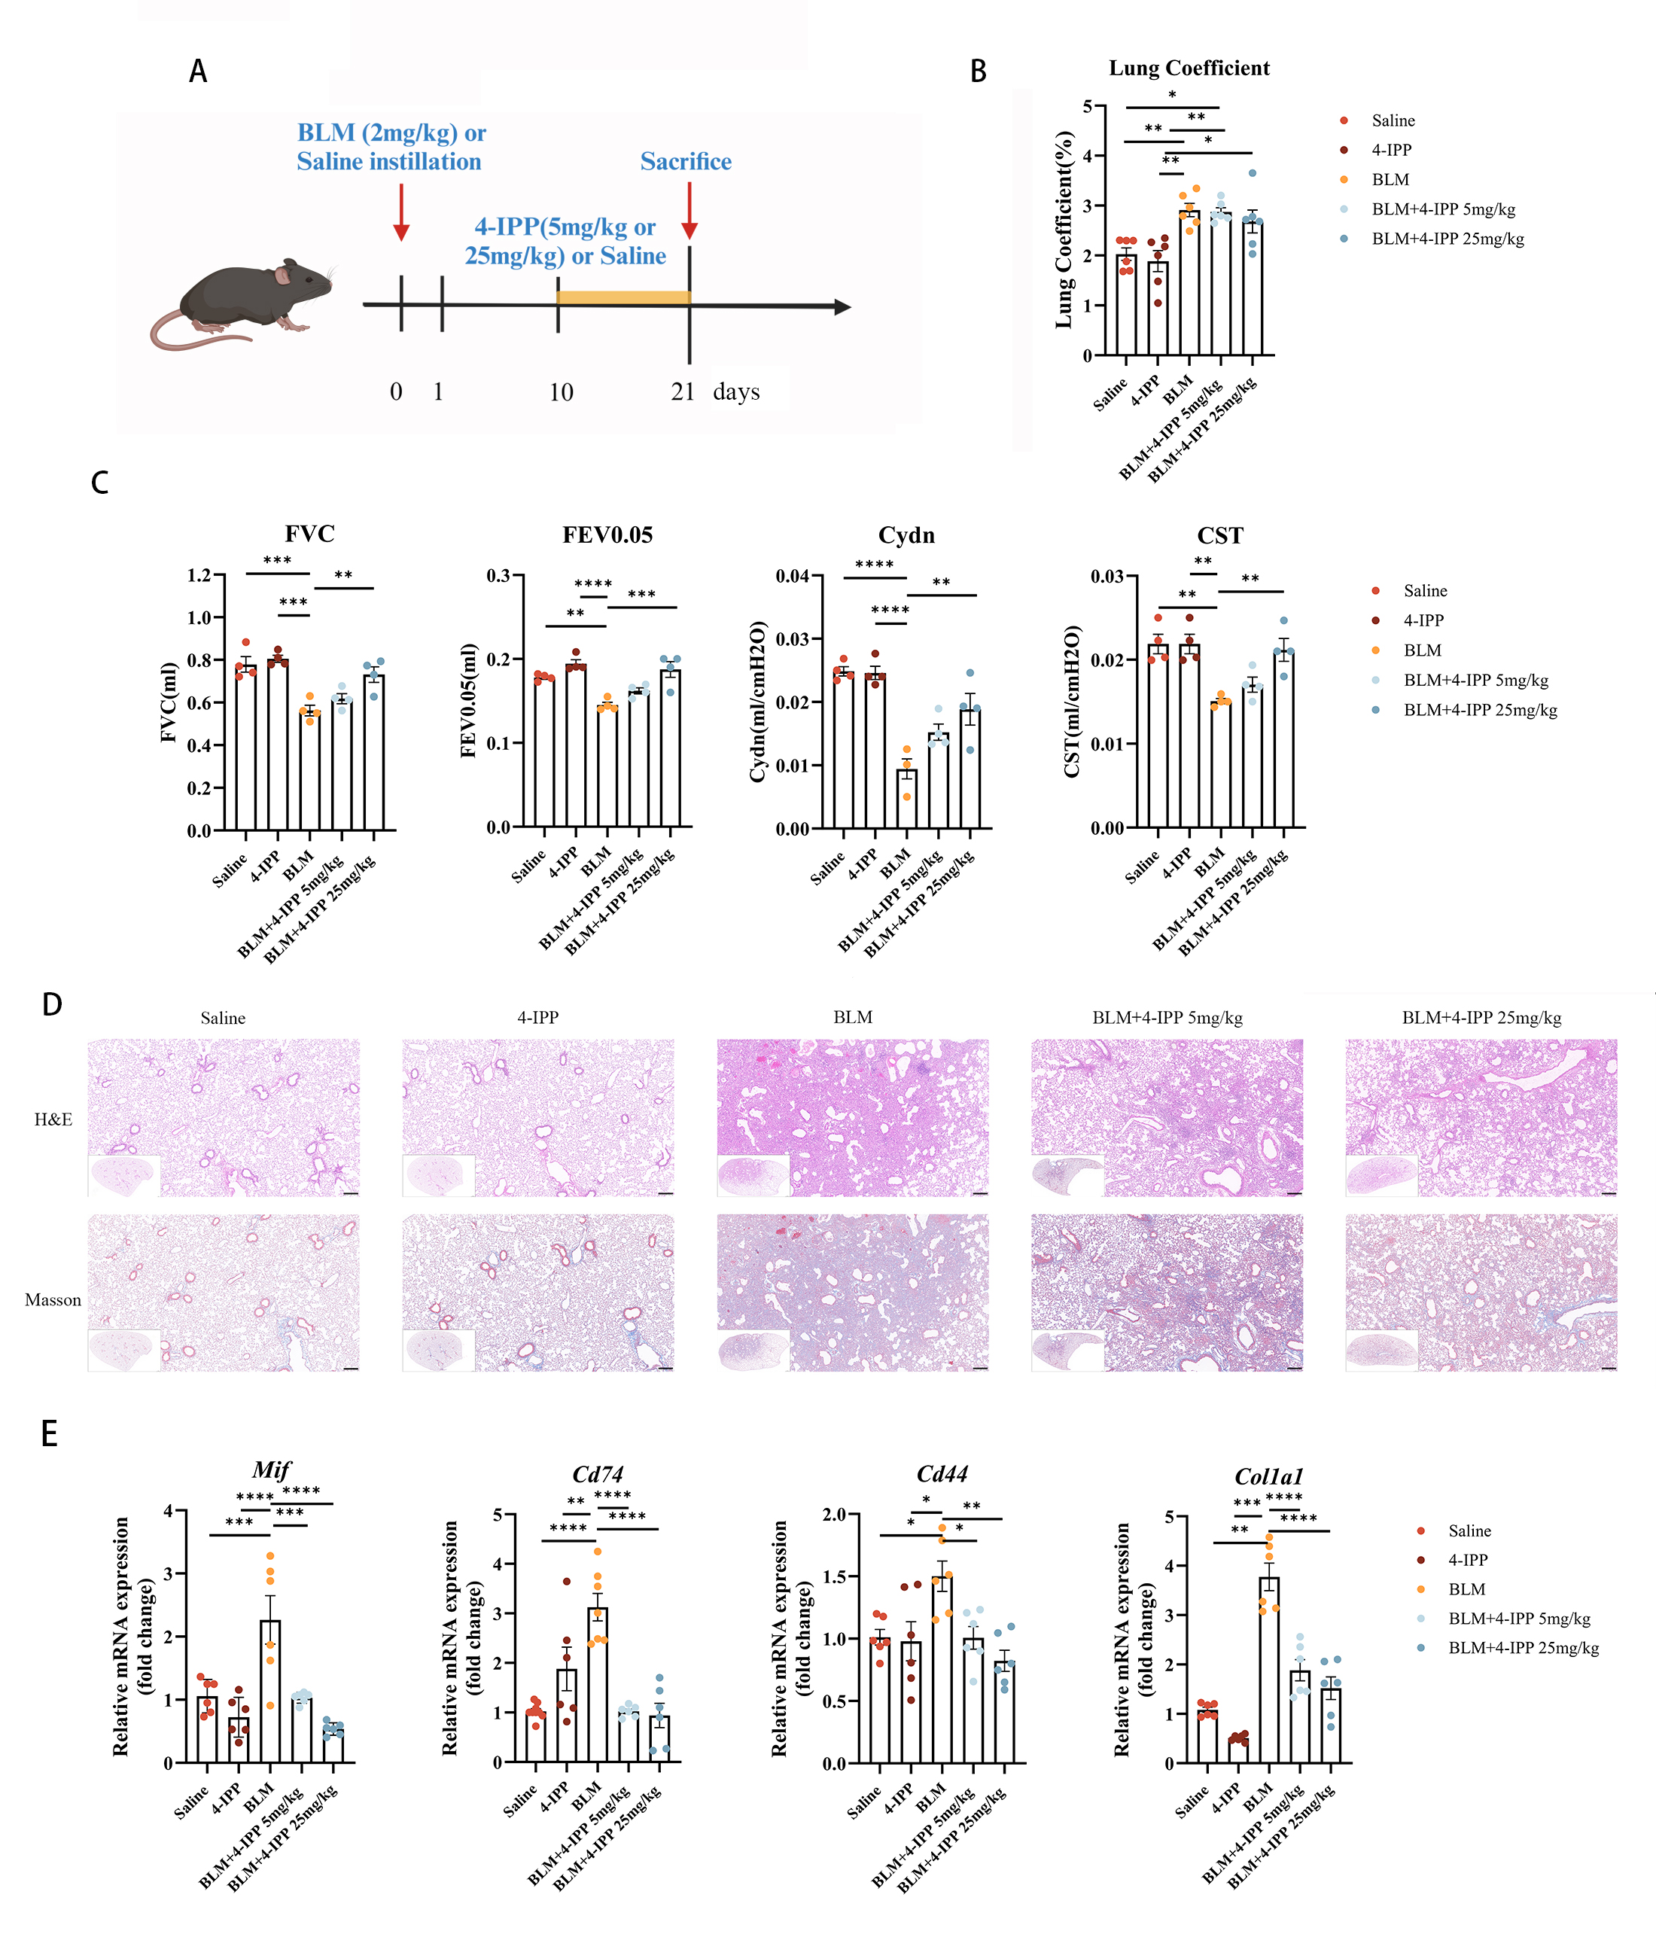
Figure S2 4-IPP alleviates pulmonary fibrosis by inhibiting the MIF/CD74 pathway at the late stage. (A) Schematic illustration of the late therapeutic administration of 4-IPP, initiated 10 days post-modeling, in a therapeutic pulmonary fibrosis mouse model. (B) Lung coefficient in control mice and bleomycin (BLM)-induced pulmonary fibrosis mice treated with 4-IPP in the late therapeutic phase. (C) Pulmonary function parameters, including forced vital capacity (FVC), forced expiratory volume in 0.05 seconds (FEV₀.₀₅), lung dynamic compliance (CST), and dynamic lung compliance (Cydn), were compared between control and BLM-induced PF mice treated with 4-IPP in the late therapeutic phase. (D) Representative histological images of lung tissues stained with hematoxylin and eosin (HE) and Masson’s trichrome from control and BLM-induced pulmoanry fibrosis in mice treated with 4-IPP in the late therapeutic phase. Scale bar: 200 μm. (E) mRNA expression levels of Mif, Cd74, Cd44, and Col1a1 in whole lung lysates from control and BLM-induced PF mice treated with 4-IPP in the late therapeutic phase were analyzed using qRT-PCR. In the 4-IPP control group, mice received 4-IPP alone at a dose of 5 mg/kg. Data are shown as mean ± SEM. Statistical significance: *P < 0.05, **P < 0.01, ***P < 0.001.

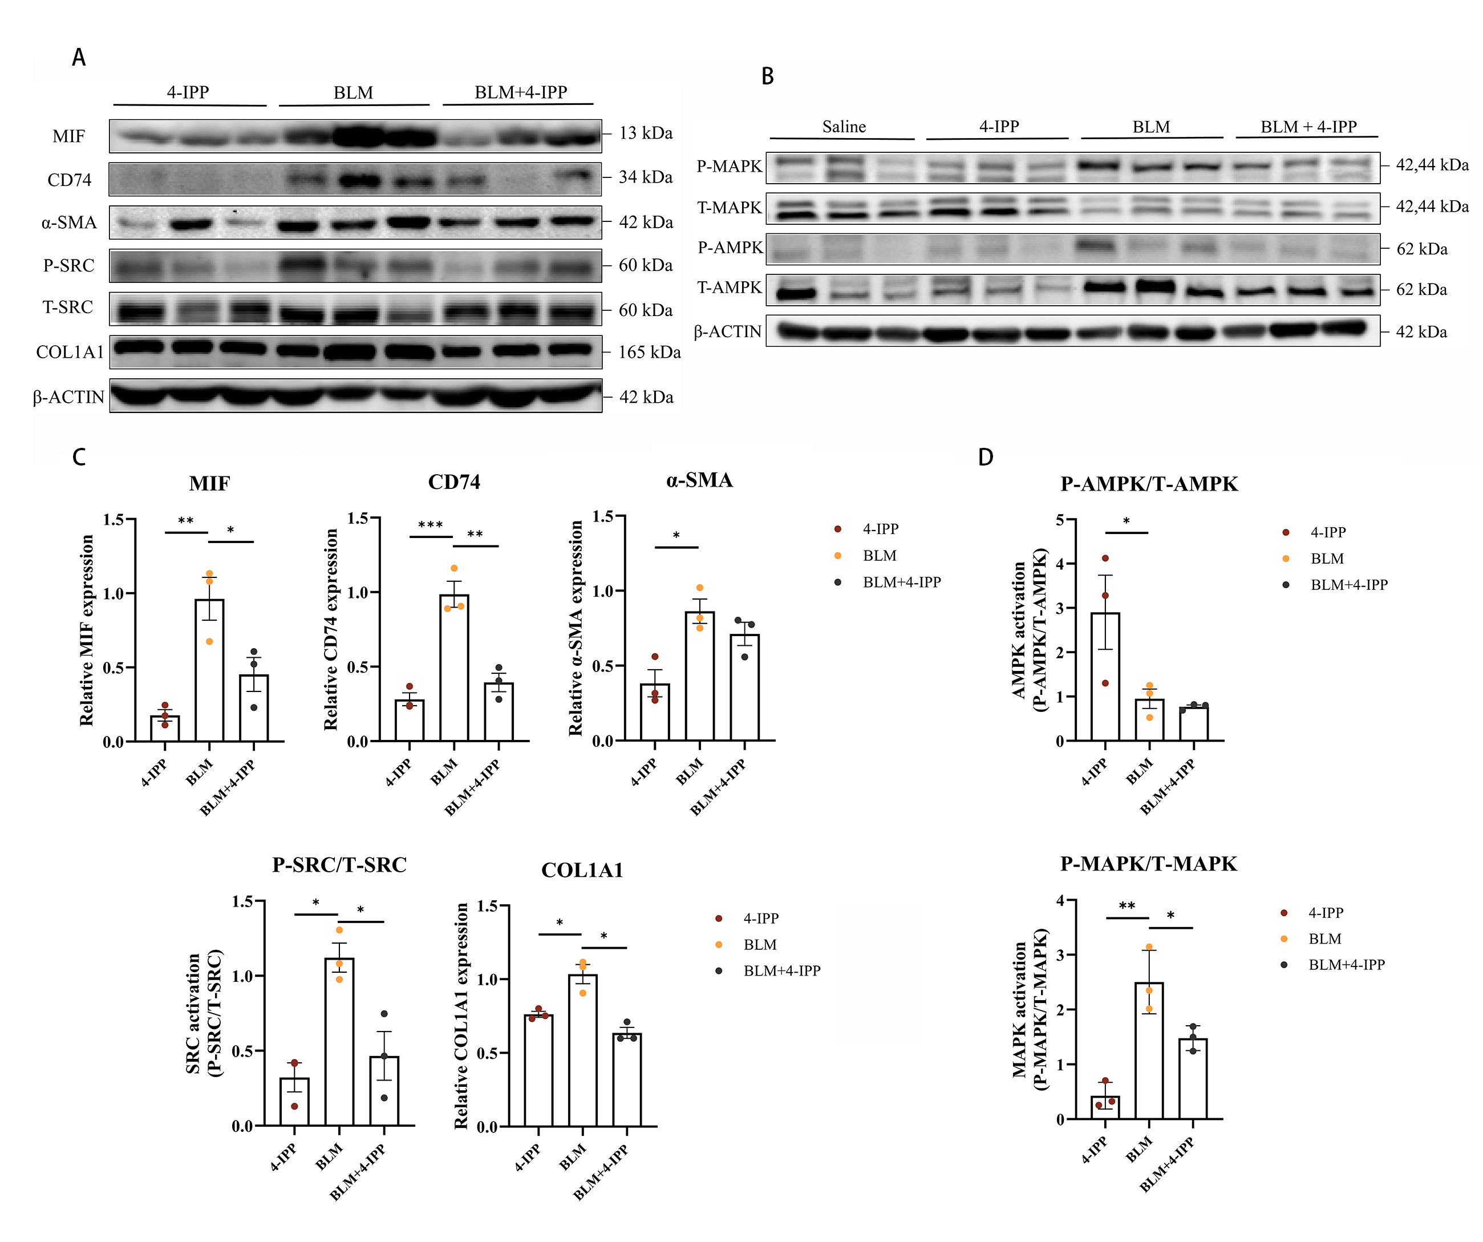
Figure S3 The protein levels of markers in bleomycin (BLM)-induced pulmonary fibrosis mice model treated with MIF inhibitor 4-IPP. (A) Protein levels of MIF, CD74, CXCR4, α-SMA, SRC and COL1A1 in wild-type mice treated with 4-IPP, BLM, or a combination of BLM and 4-IPP. (B) Protein levels of key pathway components, including AMPK, and MAPK, were assessed in wild-type mice treated with 4-IPP, BLM, or a combination of BLM and 4-IPP (C) Quantification of MIF, CD74, CXCR4, α-SMA, SRC and COL1A1 in wild-type mice treated with 4-IPP, BLM, or a combination of BLM and 4-IPP. (D) Quantification of AMPK,MAPK pathway in wild-type mice treated with 4-IPP, BLM, or a combination of BLM and 4-IPP. Data were expressed as means ± SEM. *P < 0.05, **P < 0.01, ***P < 0.001.

