Supplementary figure 1. Expression localization analysis of RS1 in lung cells. (A-C) UMAP visualizations based on the public single-cell transcriptomic dataset (GSE136831), showing the distribution of major lung cell populations. Dot color intensity represents the expression level of the RS1 gene (log-normalized counts).
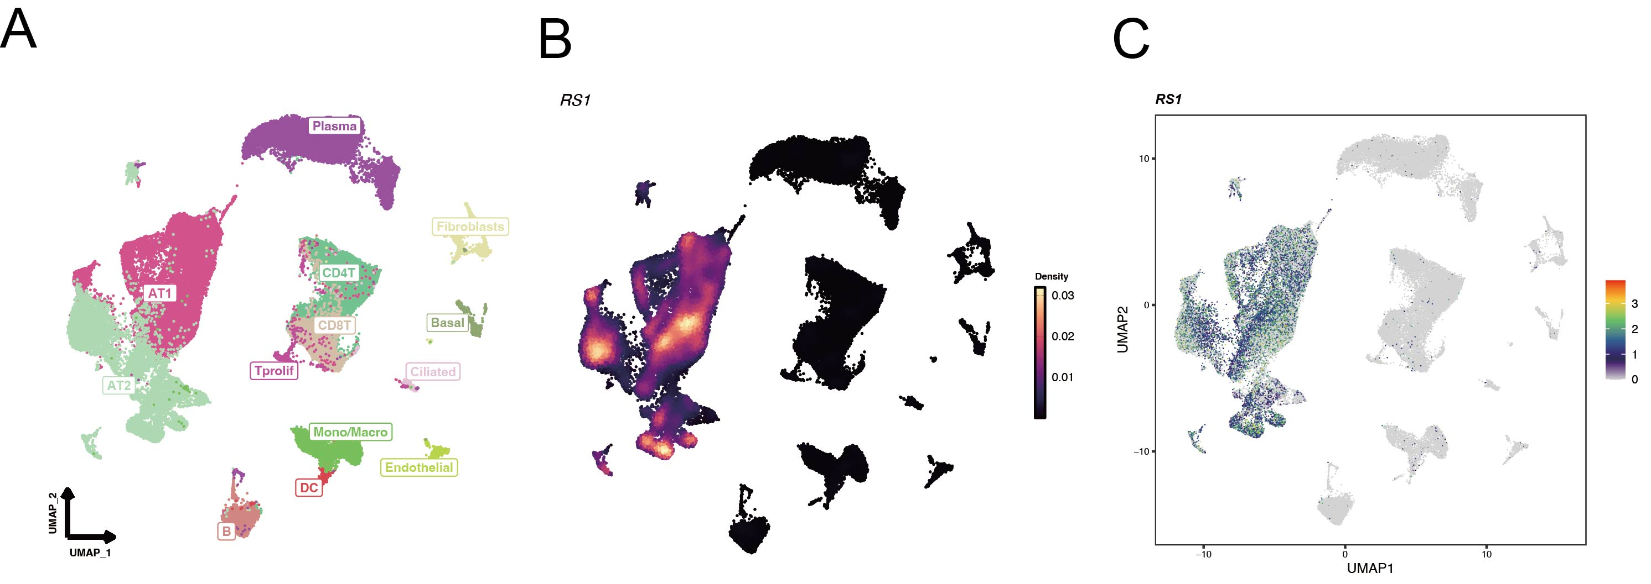

Supplement figure 2. RS1 deficiency in AT2 cells attenuates cigarette smoke-induced inflammatory cell infiltration in the lung. Bronchoalveolar lavage fluid (BALF) was collected from the indicated mouse groups for cell counting and differential analysis. The total cell counts (A), as well as the numbers of macrophages (B), lymphocytes (C), and neutrophils (D), were significantly increased in the BALF of RS1^{fl/fl}+CS mice compared to controls. In contrast, AT2 cell-specific knockout of RS1 (Sftpccre; RS1^{fl/fl}+CS) significantly reduced the total cell, macrophage, and lymphocyte counts, while neutrophil numbers were not significantly altered. Data are presented as mean ± SEM; *P < 0.05, **P < 0.01, ***P < 0.001, ****P < 0.0001 (two-tailed t-test).
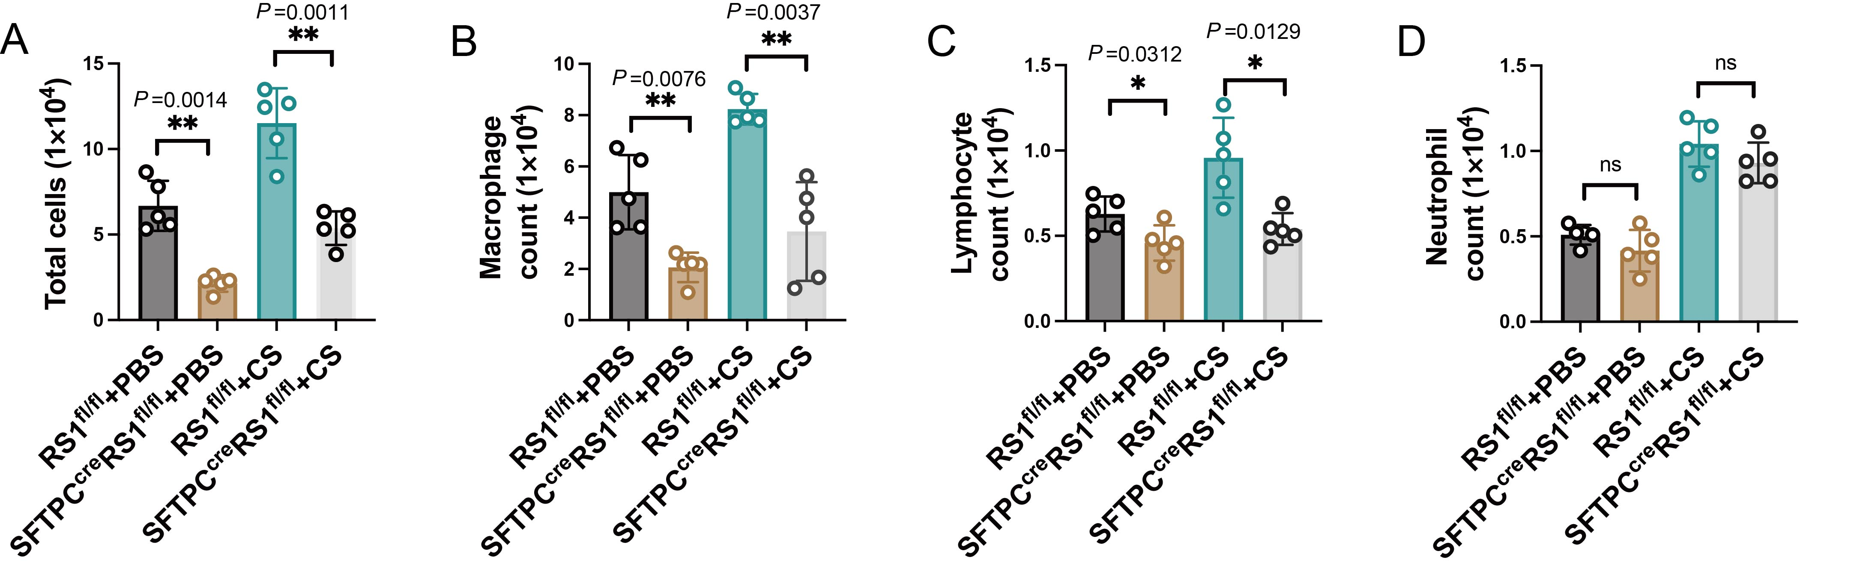

Supplementary figure 3. Negative control. (A) In the negative control group, PBS was used in place of EdU staining, and only DAPI nuclear staining (blue) was visible, Scale bar: 50 μm. (B-D) Negative control staining was performed with PBS substituted for the primary antibody, followed by incubation with the secondary antibody. Only DAPI nuclear staining was visible, confirming the specificity of the immunostaining (Supplementary figure 3B, D, Scale bar: 200 μm; Supplementary figure 3C, Scale bar: 200 μm).
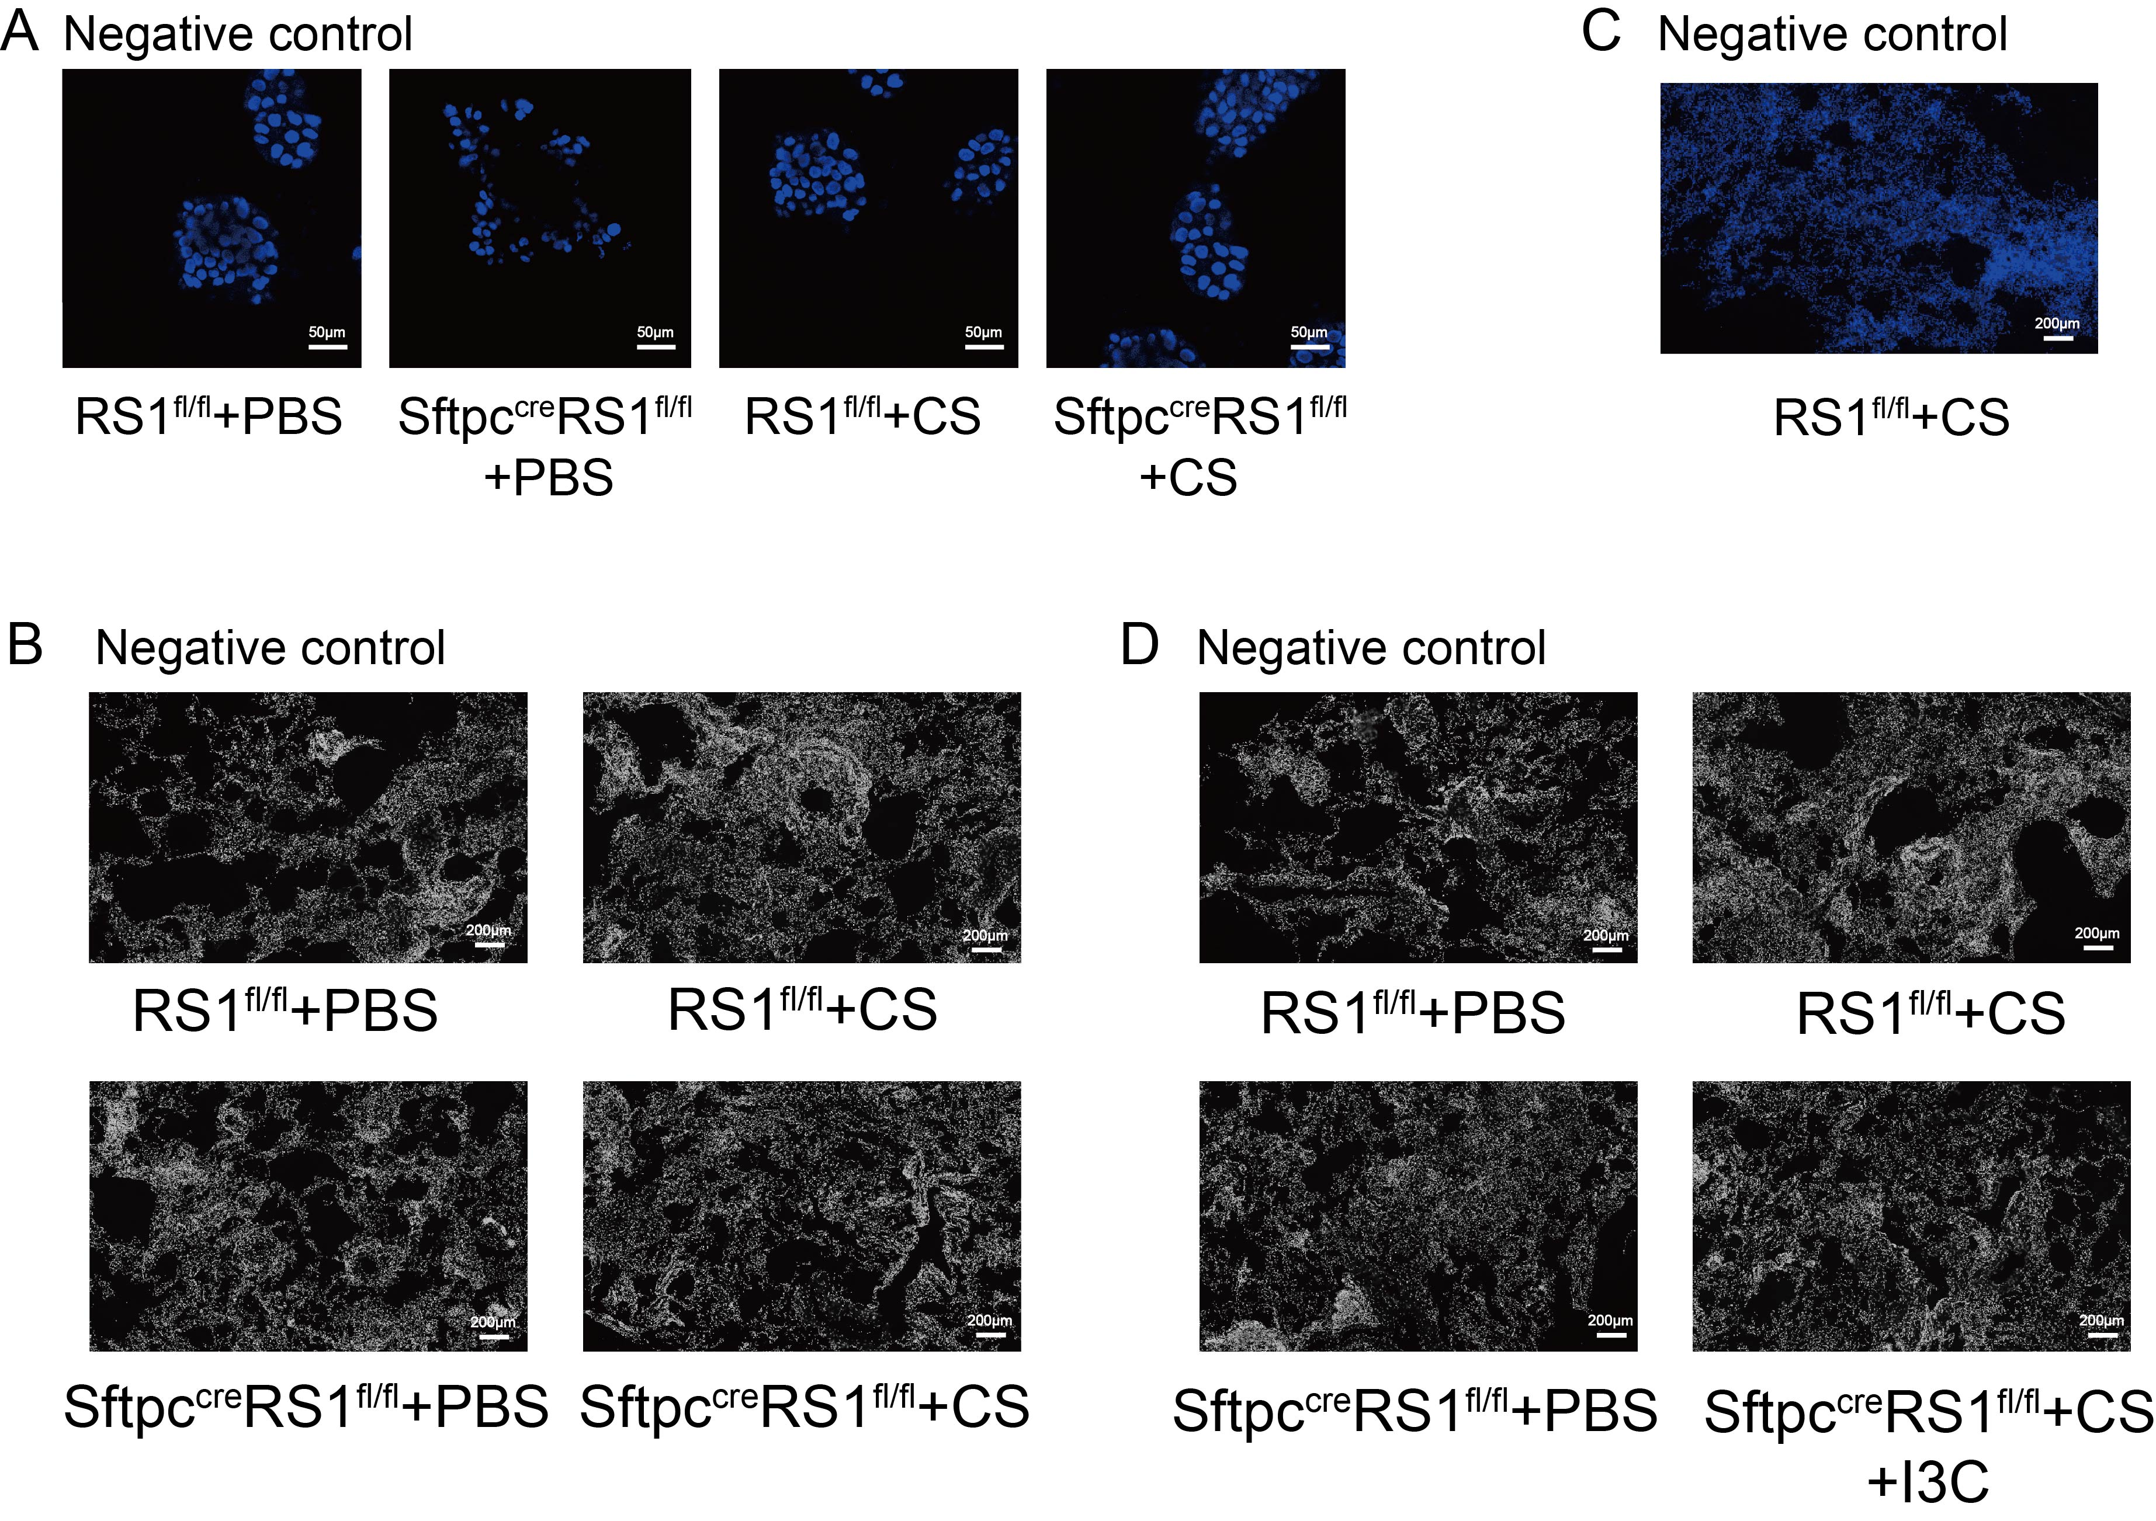

Supplementary figure 4. Gating strategy for pulmonary immune cells and AT2 cells.
