Table S1. Baseline characteristics of patients with IPF
Characteristics | Stable IPF | AE-IPF | P
n | 47 | 27
Age, years | 68.38±8.91 | 68.33±6.76 | 0.980
Male sex, n (%) | 36(76.6) | 24(88.9) | 0.194
Smoking history, n(%) | 23(48.9) | 18(66.7) | 0.140
BMI, Kg/m2 | 23.12(19.46-25.15) | 23.12(20.57-24.61) | 0.823
PO2, mmHg | 85.87±19.67 | 90.32±40.99 | 0.529
Oxygenation index, mmHg | 351.66±77.89 | 269.62±99.13 | P<0.001
Pulmonary function testing
FVC, L | 2.31±0.79(n=27) | 1.99±0.69(n=13) | 0.221
FVC% predicted | 72.00(60.40-85.80)(n=27) | 51.90(45.60-74.35)(n=13) | 0.078
FEV1, L | 2.00±0.57(n=27) | 1.74±0.51(n=13) | 0.178
FEV1% predicted | 79.64±18.79(n=27) | 68.85±17.91(n=13) | 0.092
DLCO, mmol/min/kPa | 2.51(1.84-4.06)(n=21) | 1.62(1.45-2.61)(n=9) | 0.178
DLCO% predicted | 33.40(25.25-53.60)(n=21) | 19.30(18.05-36.65)(n=9) | 0.226
GAP score | 5.00(3.00-6.00)(n=27) | 6.00(5.00-7.00)(n=13) | 0.042
GAP stage |  |  | 0.100
I | 8(29.6) | 2(15.4)
II | 10(37.0) | 2(15.4)
III | 9(33.3) | 9(69.2)
SPP1, ng/mL | 45.44 (34.32-65.91) | 101.76 (87.96-136.77) | P<0.001
CRP, mg/L | 5.55(3.38-19.87) | 13.80(7.00-22.90) | 0.039
Ferritin, ng/mL | - | 181.70(147.10-552.40)(n=8)
Treatment
Glucocorticoid therapy | 15(31.9) | 20(74.1) | 0.166
Intravenous methylprednisolone pulse therapy | 0(0.0) | 1(3.7) | 0.184
Antifibrotic therapy | 35(74.5) | 10(37.0) | 0.001
1-year mortality, n (%) | 10(21.3) | 16(59.3) | P<0.001
Data are presented as mean ± SD, median (IQR), or n (%).
IPF, idiopathic pulmonary fibrosis; AE, acute exacerbation; BMI, body mass index; PO2, partial pressure of oxygen; FVC, forced vital capacity; FEV1, forced expiratory volume in 1 s; DLCO, diffusing capacity of the lung for carbon monoxide; GAP, gender-age-physiology; SPP1, secreted phosphoprotein 1 ; CRP, C-reactive protein.

Table S2. Baseline characteristics of patients with IIM-ILD
Characteristics | Stable IIM-ILD | RP-IIM-ILD | P
n | 54 | 38
Age, years | 57.17±9.67 | 61.13±7.75 | 0.169
Male sex, n (%) | 21(38.9) | 18(47.4) | 0.418
Smoking history, n(%) | 9(16.7) | 5(13.2) | 0.645
BMI, Kg/m2 | 24.84±3.68 | 23.92±2.70 | 0.369
PO2, mmHg | 82.00(70.75-95.00) | 66.00(57.00-121.00) | 0.006
Oxygenation index, mmHg | 365.61±88.70 | 279.31±132.45 | P<0.001
HRCT pattern, n (%)
UIP pattern | 16(29.6) | 4(10.5) | 0.029
NSIP pattern | 33(61.1) | 19(50.0) | 0.290
OP pattern | 5(9.3) | 3(7.9) | 0.819
DAD pattern | 0(0.0) | 12(31.6) | P<0.001
Pulmonary function testing
FVC, L | 2.23±0.75(n=38) | 1.76±0.41(n=8) | 0.094
FVC% predicted | 74.86±23.59(n=38) | 59.74±10.17(n=8) | 0.084
FEV1, L | 1.84±0.57(n=38) | 1.53±0.39(n=8) | 0.153
FEV1% predicted | 74.15±22.25(n=38) | 63.18±10.28(n=8) | 0.182
DLCO, mmol/min/kPa | 4.30±1.60(n=36) | 2.88±0.36(n=5) | 0.057
DLCO% predicted | 54.94±19.70(n=36) | 37.46±8.11(n=5) | 0.059
GAP score | 3.00(1.00-3.25)(n=38) | 4.00(3.25-5.00)(n=8) | 0.009
GAP stage |  |  | 0.018
I | 29(76.3) | 2(25.0)
II | 8(21.1) | 5(62.5)
III | 1(2.6) | 1(12.5)
SPP1, ng/mL | 31.86 (25.30-44.22) | 103.34(75.20-139.27) | P<0.001
CRP, mg/L | 4.65(3.00-8.48) | 19.30(3.20-49.20) | P<0.001
Ferritin, ng/mL | 143.60(61.50-539.60)(n=11) | 1303.10(958.15-1650.00)(n=16) | P<0.001
Autoantibody positivity, n (%)
Anti-MDA5 | 10(33.3)(n=30) | 16(69.6)(n=23) | 0.009
Anti-Ro52 | 12(40.0)(n=30) | 5(21.7)(n=23) | 0.158
Anti-Jo-1 | 3(10.0)(n=30) | 2(8.7)(n=23) | 0.872
Anti-EJ | 2(6.7)(n=30) | 0(0.0)(n=23) | 0.207
Anti-PL-7 | 4(13.3)(n=30) | 0(0.0)(n=23) | 0.069
Anti-PL-12 | 1(3.3)(n=30) | 0(0.0)(n=23) | 0.377
Anti-SRP | 2(6.7)(n=30) | 0(0.0)(n=23) | 0.207
Anti-TIF1γ | 4(13.3)(n=30) | 0(0.0)(n=23) | 0.069
Anti-Mi-2β | 4(13.3)(n=30) | 0(0.0)(n=23) | 0.069
Anti-PM-Scl75 | 1(3.3)(n=30) | 0(0.0)(n=23) | 0.377
Anti-OJ | 1(3.3)(n=30) | 0(0.0)(n=23) | 0.377
Anti-SAE1 | 1(3.3)(n=30) | 0(0.0)(n=23) | 0.377
Anti-NXP2 | 2(6.7)(n=30) | 1(4.3)(n=23) | 0.717
Treatment, n (%)
Glucocorticoid therapy | 52(96.3) | 38(100.0) | 0.230
Intravenous methylprednisolone pulse therapy | 0(0.0) | 8(21.1) | P<0.001
Antifibrotic therapy | 5(9.3) | 2(5.3) | 0.477
Tacrolimus | 20(37.0) | 18(47.4) | 0.322
Cyclosporine | 10(18.5) | 3(7.9) | 0.150
Tofacitinib | 4(7.4) | 8(21.1) | 0.056
Cyclophosphamide | 5(9.3) | 14(36.8) | 0.001
Hydroxychloroquine | 2(3.7) | 0(0.0) | 0.230
Tripterygium glycosides | 2(3.7) | 0(0.0) | 0.230
Mycophenolate mofetil | 4(7.4) | 2(5.3) | 0.682
1-year mortality, n (%) | 6(11.1) | 29(76.3) | P<0.001
Data are presented as mean ± SD, median (IQR), or n (%).
IIM-ILD, idiopathic inflammatory myopathy-associated interstitial lung disease; RP, rapidly progressive; BMI, body mass index; PO2, partial pressure of oxygen; FVC, forced vital capacity; FEV1, forced expiratory volume in 1 s; DLCO, diffusing capacity of the lung for carbon monoxide; GAP, gender-age-physiology; SPP1, secreted phosphoprotein 1; CRP, C-reactive protein; MDA5, melanoma differentiation-associated protein 5; HRCT, high-resolution computed tomography; UIP, usual interstitial pneumonia; NSIP, nonspecific interstitial pneumonia; OP, organizing pneumonia; DAD, diffuse alveolar damage.

Table S3.The relationship between baseline serum SPP1 level and lung function as well as GAP score
 | FVC% |  | FEV1% |  | DLCO% |  | GAP score
 | r | P | r | P | r | P | r | P
ILD | -0.107 | 0.325 | -0.101 | 0.353 | -0.249 | 0.036 | 0.206 | 0.056
IPF | -0.119 | 0.464 | -0.091 | 0.578 | -0.045 | 0.812 | 0.121 | 0.456
IIM-ILD | -0.160 | 0.289 | -0.140 | 0.352 | -0.276 | 0.081 | 0.138 | 0.361
SPP1, Secreted phosphoprotein 1; GAP, gender-age-physiology; ILD, interstitial lung disease; IPF, idiopathic pulmonary fibrosis; IIM, idiopathic inflammatory myopathy; FVC, forced vital capacity; FEV1, forced expiratory volume in 1s；DLCO, diffusing capacity of the lung for carbon monoxide.
Table S4. Survival analysis for 1-year mortality in the IPF subgroup
 | Univariable |  | Multivariable
 | HR (95% CI) | p-value | HR (95% CI) | p-value
Age | 0.991(0.947-1.037) | 0.685 | 0.996(0.943-1.053) | 0.899
Male | 2.105(0.632-7.012) | 0.226 | 1.038(0.264-4.078) | 0.957
Oxygenation index | 0.991(0.987-0.995) | P<0.001 | 0.995(0.991-1.000) | 0.048
SPP1 | 1.018(1.009-1.027) | P<0.001 | 1.015(1.003-1.027) | 0.012
CRP | 1.028(1.012-1.044) | P<0.001 | 1.023(1.005-1.040) | 0.011
IPF, idiopathic pulmonary fibrosis; CRP, C-reactive protein; SPP1, secreted phosphoprotein 1; HR, hazard ratio; CI, confidence interval.

Table S5. Survival analysis for 1-year mortality in the IIM-ILD subgroup
 | Univariable |  | Multivariable
 | HR (95% CI) | p-value | HR (95% CI) | p-value
Age | 1.048(1.005-1.091) | 0.027 | 1.044(1.005-1.085) | 0.025
Male | 2.252(1.075-4.718) | 0.031 | 3.079(1.327-7.145) | 0.009
Oxygenation index | 0.989(0.984-0.993) | P<0.001 | 0.991(0.985-0.996) | P<0.001
SPP1 | 1.008(1.005-1.012) | P<0.001 | 1.007(1.001-1.012) | 0.022
CRP | 1.012(1.003-1.022) | 0.013 | 0.995(0.981-1.009) | 0.467
IIM-ILD, idiopathic inflammatory myopathy-associated interstitial lung disease; CRP, C-reactive protein; SPP1, secreted phosphoprotein 1; HR, hazard ratio; CI, confidence interval.

Figure S1. Study flow chart.
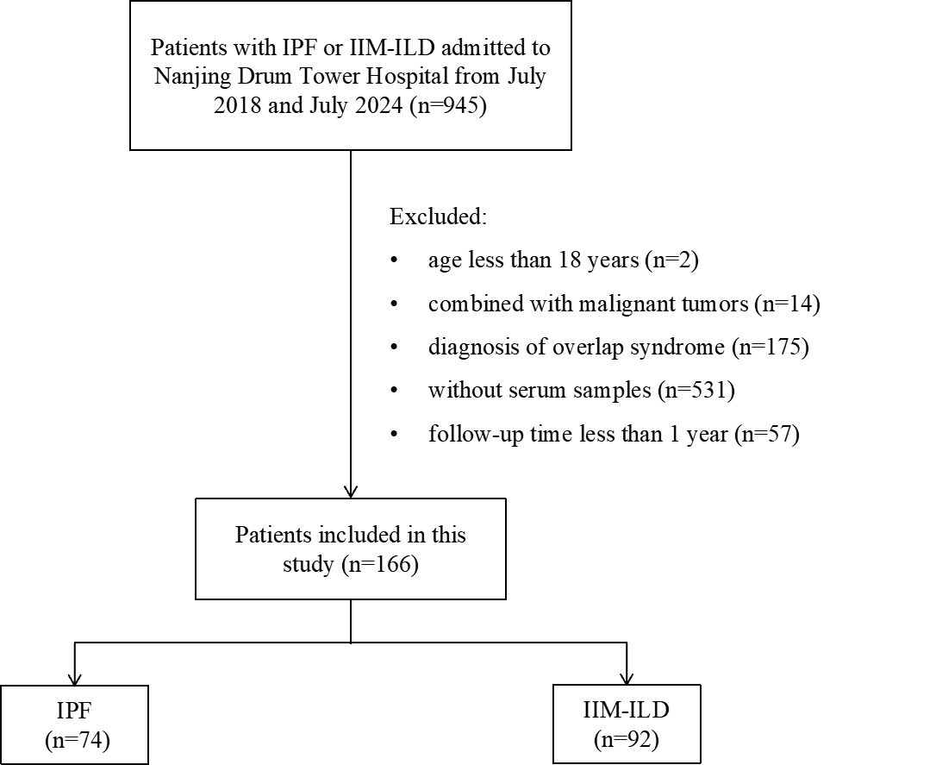
IPF, idiopathic pulmonary fibrosis; IIM, idiopathic inflammatory myopathy; ILD, interstitial lung disease

Figure S2. External validation of SPP1 expression using the public GSE122960 scRNA-seq dataset.

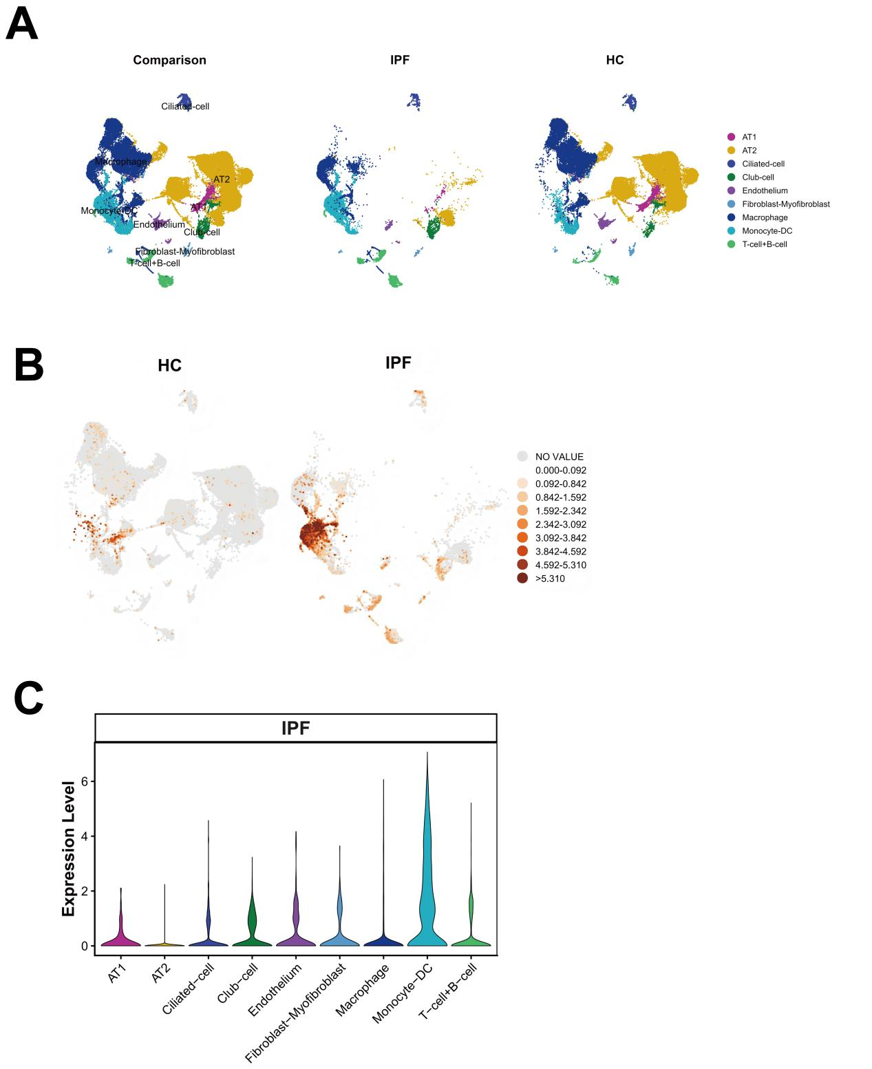
(A) UMAP visualization of major lung cell populations in the GSE122960 dataset, including 8 control donor subjects and 4 patients with IPF. Cells were annotated into major cell types according to canonical marker genes, including AT1 cells, AT2 cells, ciliated cells, club cells, endothelial cells, fibroblasts/myofibroblasts, macrophages, monocytes/dendritic cells, and T/B lymphocytes. UMAP plots are shown for the combined dataset, IPF samples, and control donor samples.
(B) Feature plot showing that SPP1 expression is increased in IPF lung tissue and is predominantly localized to macrophage-lineage and monocyte/dendritic cell populations
(C) Violin plots showing SPP1 expression across annotated cell types in IPF and control donor lungs. SPP1 expression was increased mainly in macrophage-lineage and monocyte/dendritic cell populations in IPF lungs, supporting enrichment of SPP1-associated myeloid populations in IPF.
SPP1, Secreted phosphoprotein 1; scRNA-seq, Single-cell RNA sequencing; UMAP, Uniform Manifold Approximation and Projection; IPF, idiopathic pulmonary fibrosis; AT1 cells, alveolar type 1 cells; AT2 cells, alveolar type 2 cells; GSE, Gene Expression Omnibus Series.

Figure S3. Correlation between serum SPP1 and ferritin levels. 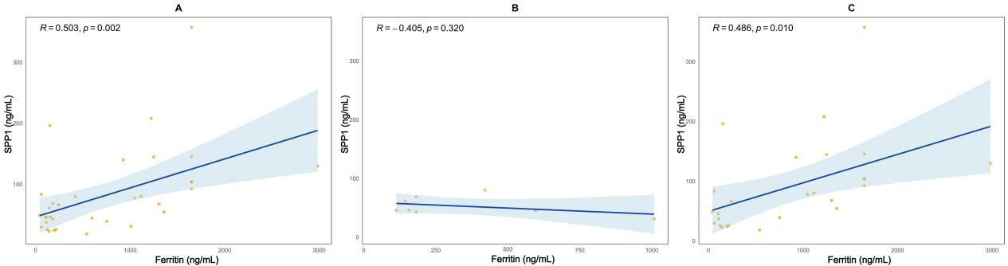
- ILD; (B) IPF; (C) IIM-ILD
SPP1, Secreted phosphoprotein 1; ILD, interstitial lung disease; IPF, idiopathic pulmonary fibrosis; IIM, idiopathic inflammatory myopathy.

