Supplementary material

Additional Tables

Additional Table 1 Serum and DBS AAT concentrations in validation Rounds 1 and 2, per sample
Sample  (Genotype) | 1.1  (ZZ) | 1.2  (MS) | 1.3  (MM) | 1.4  (MZ) | 1.5  (ZZ) | 2.1  (MS) | 2.2  (MZ) | 2.3  (MM) | 2.4  (SZ) | 2.5  (ZZ)
Lab A
Serum AAT,  mg/dL | 17.7 | 111.0 | 132.0 | 121.0 | 16.8 | 146.3 | 72.7 | 160.3 | 56.4 | 26.6
DBS AAT,  mg/dL |  |  |  |  |  | 81.5 | 90.8 | 146.0 | 52.9 | 34.5
Lab B
Serum AAT,  mg/dL | 20.4 | 106.0 | 153.0 | 137.0 | 17.6 | 163.0 | 80.0 | 189.0 | 65.0 | <10.0†
DBS AAT,  mg/dL | † | 104.0 | 119.0 | 114.0 | †
Samples are identified by their sample number, with the genotype additionally identified for reference. Note, in the validation rounds, the DBS analysis was only performed by the laboratory that the tests were sent to
†: Denotes below the lower level for quantification
Abbreviations: AAT: Alpha-1 Antitrypsin; DBS: dried blood spot; dL: decilitre; mg: milligram

Additional Table 2 AAT serum median (IQR) concentrations per laboratory, for each analysis round
AAT serum concentrations (mg/dL)  Median (IQR) | Round 3  (n=5) | Round 4  (n=5) | Round 5  (n=5) | Round 6  (n=6)
Lab A | 88.9  (71.7–111.7) | 87.3  (65.3–136.0) | 66.0  (22.63–67.43) | 98.1  (27.93–139)
Lab B | 102.0  (61.9–107.0) | 88.9  (56.4–129.0) | 71.1  (27.1–81.3) | 99.3  (27.4–128.0)
Lab C | 93.8  (64.6–110.0) | 84.8  (58.5–132.0) | 65.7  (28.1–70.4) | 101.6  (31.7–134.0)
Lab D | 84.0  (76.0–94.0) | 85.0  (59.0–125.0) | 55.0  (15.0–61.0) | 87.5  (17.0–124.0)
Lab E | 94.0  (65.0–102.0) | 93.0  (64.0–128.0) | 61.0  (26.0–65.0) | 84.0  (24.0–121.0)
Lab F | 63.5  (57.0–72.7) | 96.0  (69.0–142.0) | 60.0  (28.0–81.0) | 98.5  (28.0–132.0)
Kruskal-Wallis p-value | 0.65 | 0.98 | 0.69 | 0.90
The median and IQR for each laboratory was used to calculate the Kruskal-Wallis p-value for each round. No p-values were significant, and hence the distribution of serum AAT concentrations were not significantly different by laboratory
Abbreviations: AAT: Alpha-1 Antitrypsin; dL: decilitre; IQR: interquartile range; mg: milligram

Additional Table 3 Serum and DBS AAT concentrations in Rounds 3–6, per sample
Sample  (Genotype) | 3.1  (SZ) | 3.2  (MZ) | 3.3  (MS) | 3.4  (SZ) | 3.5  (MM) |  | 4.1  (MZ) | 4.2  (ZZ) | 4.3  (MS) | 4.4  (MM) | 4.5  (SZ)
Serum AAT, mg/dL
(DBS AAT, mg/dL)
Lab A | 71.7 | 88.9 | 113.0 | 56.2 | 111.7 |  | 87.3 | 22.4 | 149.0 | 136.0 | 65.3
Lab A | (ND) | (ND) | (ND) | (ND) | (ND) |  | (85.4) | (17.7) | (168.7) | (168.8) | (55.6)
Lab B | 61.9 | 102.0 | 107.0 | 57.6 | 113.0 |  | 88.9 | 21.9 | 148.0 | 129.0 | 56.4
Lab B | (74.8) | (100.0) | (106.0) | (66.6) | (127.0) |  | (95.5) | below LOD | (140.0) | (139.0) | (76.5)
Lab C | 64.6 | 93.8 | 112.0 | 56.0 | 110.0 |  | 84.8 | 27.4 | 141.0 | 132.0 | 58.5
Lab C | (2.63)* | (3.37)* | (3.25)* | (1.77)* | (3.05)* |  | ND | ND | ND | ND | ND
Lab D | 76.0 | 84.0 | 94.0 | 51.0 | 99.0 |  | 85.0 | 12.0 | 143.0 | 125.0 | 59.0
Lab D | ND | ND | ND | ND | ND |  | ND | ND | ND | ND | ND
Lab E | 65.0 | 94.0 | 102.0 | 58.0 | 109.0 |  | 93.0 | 24.0 | 141.0 | 128.0 | 64.0
Lab E | (64.0) | (100.0) | (99.0) | (49.0) | (100.0) |  | (69.0) | (19.0) | (119.0) | (111.0) | (55.0.)
Lab F | 39.4 | 63.5 | 72.7 | 57.0 | 95.2 |  | 96.0 | 29.0 | 157.0 | 142.0 | 69.0
Lab F | ND | ND | ND | ND | ND |  | ND | ND | ND | ND | ND
Sample  (Genotype) | 5.1  (ZZ) | 5.2  (SZ) | 5.3  (SZ) | 5.4  (ZZ) | 5.5  (MMp) |  | 6.1  (MM) | 6.2  (MF) | 6.3  (ZZ) | 6.4  (MS) | 6.5  (ZMh) | 6.6  (SMw)
Serum AAT, mg/dL
(DBS AAT, mg/dL)
Lab A | 18.3 | 67.4 | 69.1 | 22.6 | 66.0 |  | 139.0 | 122.3 | 27.9 | 171.3 | 22.2 | 73.8
Lab A | (25.8) | (82.3) | (41.2) | (22.5) | (71.6) |  | (129.0) | (125.4) | (25.8) | (145.8) | (6.6) | (76.4)
Lab B | 21.6 | 71.1 | 87.1 | 27.1 | 81.3 |  | 128.0 | 125.0 | 27.4 | 177.0 | 20.2 | 73.5
Lab B | (<0.078) | (78.2) | (80.0) | (<0.078) | (90.0) |  | (134.0) | (113.0) | (<10.00) | (134.0) | (<10.00) | (61.9)
Lab C | 19.1 | 65.7 | 74.0 | 28.1 | 70.4 |  | 134.0 | 130.0 | 31.7 | 182.0 | 25.7 | 73.2
Lab C | (0.48)* | (2.07)* | (2.74)* | (0.75)* | (2.13)* |  | (25.6)* | (18.6)* | (4.95)* | (21.9)* | (3.20)* | (7.65)*
Lab D | 10.0 | 55.0 | 68.0 | 15.0 | 61.0 |  | 124.0 | 111.0 | 17.0 | 153.0 | 9.0 | 64.0
Lab D | ND | ND | ND | ND | ND |  | ND | ND | ND | ND | ND | ND
Lab E | 23.0 | 61.0 | 74.0 | 26.0 | 65.0 |  | 121.0 | 103.0 | 24.0 | 156.0 | 17.0 | 65.0
Lab E | (8.0) | (62.0) | (73.0) | (16.0) | (71.0) |  | (108.0) | (95.0) | (12.0) | (134.0) | (7.0) | (63.0)
Lab F | 21.0 | 60.0 | 84.0 | 28.0 | 81.0 |  | 132.0 | 126.0 | 28.0 | 167.0 | 21.0 | 71.0
Lab F | ND | ND | ND | ND | ND |  | ND | ND | ND | ND | ND | ND
Serum AAT concentrations (bold) and DBS AAT concentrations (in parentheses), are tabulated for Labs A–F. Note, not all labs reported DBS concentrations
Altogether, DBS measurements underestimated serum AAT concentrations in 34/53 (64%) paired samples and overestimated in 19/53 (36%) paired samples. For differences that were >20 mg/dL, DBS measurements underestimated serum AAT concentrations in 6/8 (75%) paired samples and overestimated in 2/8 (25%) paired samples. For differences that were <20 mg/dL, DBS measurements underestimated serum AAT concentrations in 28/45 (62%) paired samples and overestimated in 17/45 (38%) paired samples
*: Lab C reported DBS concentrations as values of absorbance, rather than converting them to concentrations
Abbreviations: AAT: Alpha-1 Antitrypsin; DBS: dried blood spot; dL: decilitre; LOD: limit of detection; Mh: M_{Heerlen}; mg: milligram; Mp: M_{Procida}; Mw: M_{Wurzburg}; ND: not determined

Additional Table 4 Serum CRP concentration in Rounds 3–6, per sample
Sample  (Genotype) | 3.1  (SZ) | 3.2  (MZ) |  |  | 3.3  (MS) |  |  | 3.4  (SZ) |  |  | 3.5  (MM) |  |  | 4.1  (MZ) |  |  | 4.2  (ZZ) |  |  | 4.3  (MS) |  |  | 4.4  (MM) |  |  | 4.5  (SZ)
Serum CRP, mg/dL
Lab A | 0.12 | 0.97 |  |  | 0.14 |  |  | 0.08 |  |  | 0.05 |  |  | 0.04 |  |  | 0.14 |  |  | 0.09 |  |  | 0.04 |  |  | 0.02
Lab B |  |  |  |  |  |  |  |  |  |  |  |  |  | 0.00 |  |  | 0.11 |  |  | 0.12 |  |  |  |  |  | 0.00
Lab C | 0.14 | 0.96 |  |  | 0.16 |  |  | 0.09 |  |  | 0.06 |  |  | 0.07 |  |  | 0.15 |  |  | 0.12 |  |  | 0.06 |  |  | 0.03
Lab E | 0.00 | 0.09 |  |  | 0.00 |  |  | 0.00 |  |  | 0.00 |  |  | 0.00 |  |  | 0.00 |  |  | 0.00 |  |  | 0.00 |  |  | 0.00
Lab F
Sample  (Genotype) | 5.1  (ZZ) |  | 5.2  (SZ) |  |  | 5.3  (SZ) |  |  | 5.4  (ZZ) |  |  | 5.5  (MMp) |  |  | 6.1  (MM) |  |  | 6.2  (MF) |  |  | 6.3  (ZZ) |  |  | 6.4  (MS) |  |  | 6.5  (ZMh) |  |  | 6.6  (SMw)
Serum CRP, mg/dL
Lab A | 0.03 |  | 0.26 |  |  | 0.03 |  |  | 0.41 |  |  | 0.13 |  |  | 0.02 |  |  | 0.19 |  |  | 0.09 |  |  | 0.20 |  |  | 0.97 |  |  | 0.09
Lab B |  |  |  |  |  |  |  |  |  |  |  |  |  |  | 0.02 |  |  | 0.21 |  |  | 0.10 |  |  | 0.25 |  |  | 1.00 |  |  | 0.10
Lab C | 0.06 |  | 0.10 |  |  | 0.06 |  |  | 0.42 |  |  | 0.18 |  |  | 0.03 |  |  | 0.20 |  |  | 0.12 |  |  | 0.22 |  |  | 0.84 |  |  | 0.14
Lab E | <0.313 |  | <0.313 |  |  | <0.313 |  |  | 0.32 |  |  | <0.313
Lab F | 0.04 |  | 0.09 |  |  | 0.05 |  |  | 0.42 |  |  | 0.17 |  |  | 0.04 |  |  | 0.21 |  |  | 0.11 |  |  | 0.22 |  |  | 1.03 |  |  | 0.13
Serum CRP concentrations are tabulated for Labs A–F. Note, not all labs reported CRP concentrations for each round
Abbreviations: CRP: C-reactive protein; dL: decilitre; Mh: M_{Heerlen}; mg: milligram; Mp: M_{Procida}; Mw: M_{Wurzburg}

Additional Table 5 Sequencing performed for Rounds 5 and 6
 | 5.1  (ZZ) | 5.2  (SZ) | 5.3  (SZ) | 5.4  (ZZ) | 5.5  (MMp) | 6.1  (MM) | 6.2  (MF) | 6.3  (ZZ) | 6.4  (MS) | 6.5  (ZMh) | 6.6  (SMw)
Lab A |  |  |  |  | MMp |  |  |  |  |  | SMw
Lab B |  |  |  |  | MMp |  | MF |  |  | ZMh | SMw
Lab C | ZZ | SZ | SZ | ZZ | MMp | MM | MM | ZZ |  | ZMh
Lab D
Lab E |  |  |  |  | MMp |  | MF |  |  | ZMh | SMw
Lab F | ZZ | SZ | SZ | ZZ | MMp | MM | MF | ZZ | MS | ZMh | SMw
Lab G | ZZ |  | SZ |  | MM | MM | MF |  |  | ZMh | SMw
Samples are identified by their sample number, with the genotype additionally identified for reference
Abbreviations: Mh: M_{Heerlen}; Mp: M_{Procida}; Mw: M_{Wurzburg}

Additional Table 6 Examples of differences in nomenclature used for reporting the results of genotyping and sequencing analyses
Historic nomenclature | HGVS nomenclature for SERPINA1 molecular variants and the genotype† | Examples of nomenclature used in assessment reports
Historic nomenclature |  | Genotyping (simple or multiplex) | Sequencing
PI*MM  (no S or Z variant detected) | NM_000295.5:c.863A>T p.(Glu288Val) and  NM_000295.5:c.1096G>A p.(Glu366Lys) not detected  NM_000295.5:c.[863=;1096=];[863=;1096=]  or  homozygous for NM_000295.5(SERPINA1):c.-4-10_*10=  (meaning no pathogenic molecular variant was detected in this region of the gene - exons 2-5 + splice junctions) | MM or M/M  M2/M2  M1ValM1Val  non S/non S; non Z/non Z  no S / no S-no Z / no Z  PI Z:c.1096G>A not detected; PI S:c.863A>T not detected  no mutation | M/M  M2/M2  M1/M1
PI*MZ | heterozygous for NM_000295.5:c.1096G>A p.(Glu366Lys)  NM_000295.5:c.[1096G>A];[1096=]  ClinVar Variation ID: 17967 | Heterozygous for Z  MZ (not S, Z heterozygote)  PI Z:c.1096G>A heterozygous  PI Z:c.1096G>A detected, PI S:c.863A>T not detected  M1AlaZ
PI*ZZ | homozygous for NM_000295.5:c.1096G>A p.(Glu366Lys)  NM_000295.5:c.[1096G>A];[1096G>A]  ClinVar Variation ID: 17967 | ZZ or Z/Z  Homozygous for Z  PI Z:c.1096G>A detected homozygous | ZZ or Z/Z
PI*MS | heterozygous for NM_000295.5:c.863A>T p.(Glu288Val)  NM_000295.5:c.[863A>T];[863=]  ClinVar Variation ID: 17969 | MS or M/S  M1S  S hetorozygote, not Z  Heterozygous for S  S / no S-no Z / no Z  PI Z:c.1096G>A not detected, PI S:c.863A>T detected  M1ValS | M/S
PI*SZ | heterozygous for NM_000295.5:c.863A>T p.(Glu288Val)  heterozygous for NM_000295.5:c.1096G>A p.(Glu366Lys)  NM_000295.5:c.[863A>T];[1096G>A]  ClinVar Variation ID: 17969  ClinVar Variation ID: 17967 | SZ or S/Z  S heterozygote, Z heterozygote  PI Z:c.1096G>A detected, PI S:c.863A>T detected | SZ or S/Z
PI*MF | heterozygous for NM_000295.5:c.739C>T p.(Arg247Cys)  NM_000295.5:c.[739C>T];[739=]  ClinVar Variation ID: 17961 | MF  M1F  F heterozygote  no S / no S-no Z / no Z  PI Z:c.1096G>A not detected, PI S:c.863A>T not detected | M/F  M1/F  PI*FM
PI*M_{Heerlen}Z (PI*MhZ) | heterozygous for NM_000295.5:c.1096G>A p.(Glu366Lys)  heterozygous for NM_000295.5:c.1178C>T p.(Pro393Leu)  NM_000295.5:c.[1096G>A];[1178C>T]  ClinVar Variation ID: 17967  ClinVar Variation ID: 17965 | MheerlenZ  Z heterozygote - Mheerlen heterozygote  ZM-Heerlen  PI Z:c.1096G>A detected heterozygous, PI S:c.863A>T not detected  Heterozygous for Z  no S / no S - Z / no Z | Mheerlen/Z  PI*MHeerlenZ
PI*MM_{Procida}(PI*MMp) | heterozygous for NM_000295.5:c.194T>C (p.Leu65Pro)  NM_000295.5:c.[194T>C];[194=]  ClinVar Variation ID: 17971 | M/Mprocida  non S/non S, non Z/non Z  MM  PI Z:c.1096G>A not detected, PI S:c.863A>T not detected | M/Mprocida  M1/Mprocida  M1/Mprocida (c.122T>C p.Leu41Pro heterozygous)  MMprocida (c.194T>C p.Leu65Pro heterozygous)
PI*M_{Wurzbürg}S (PI*MwS) | heterozygous for NM_000295.5:c.863A>T p.(Glu288Val)  heterozygous for NM_000295.5:c.1177C>T (p.Pro393Ser)  NM_000295.5:c.[863A>T];[1177C>T]  ClinVar Variation ID: 17969  ClinVar Variation ID: 289135 | MwurzbürgS  S / no S-no Z / no Z  Heterozygous for S  S heterozygote  PI Z:c.1096G>A not detected, PI S:c.863A>T detected hetreozygous  MS  M1ValS | MwurzbürgS or Mwurzbürg/S  PI*MwurzbürgS
†: The genotype descriptions assume that two different variants occur on different alleles (in trans), which was confirmed by segregation analysis in the families
Abbreviations: HGVS: Human Genome Variation Society

Additional Figures

Additional Fig. 1 Tests per laboratory between 2013 and 2021
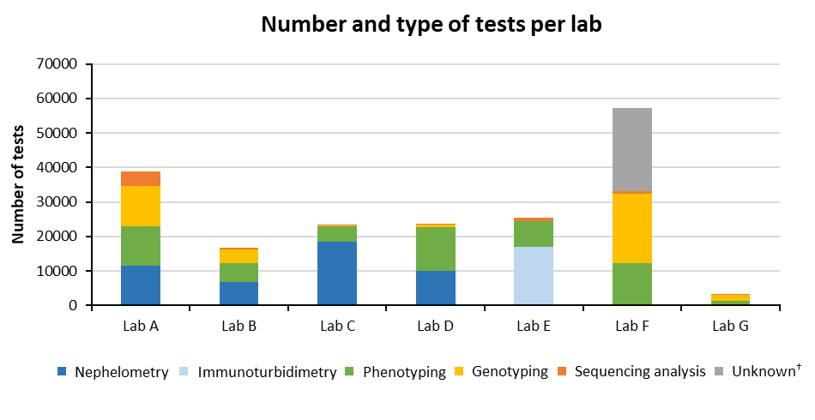
Different colours denote the different tests performed by each laboratory
†: Outsourced; exact method used unknown

Additional Fig. 2 Serum AAT concentrations in Rounds 3–6, per sample
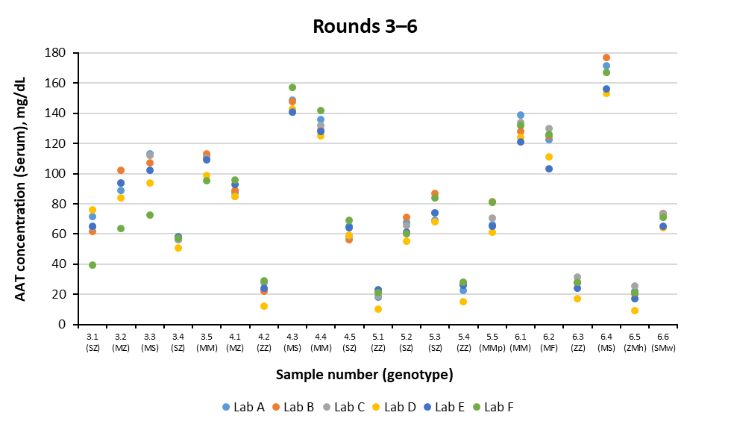
Samples are identified by their sample number, with the genotype additionally identified for reference. Different colours denote different laboratories. Reported mean serum concentration ranges (5% –95%) for genotypes with the PI*S and Pi*Z variants, in a Swiss Cohort are: PI*SS, 0.73–1.06 g/L; PI*SZ, 0.49–0.66 g/L; PI*MS, 0.88–1.37 g/L; PI*MZ, 0.66–1.00 g/L with the mean concentration for PI*ZZ, 0.32 g/L.[12] Note, the commercial median concentration for PI*ZZ is <0.29 g/L [33]
Abbreviations: AAT: Alpha-1 Antitrypsin; dL: decilitre; Mh: M_{Heerlen}; mg: milligram; Mp: M_{Procida}; Mw: M_{Wurzburg}

Additional Fig. 3 Genotypes identified from combined phenotyping, genotyping and sequencing analyses, Rounds 3–6
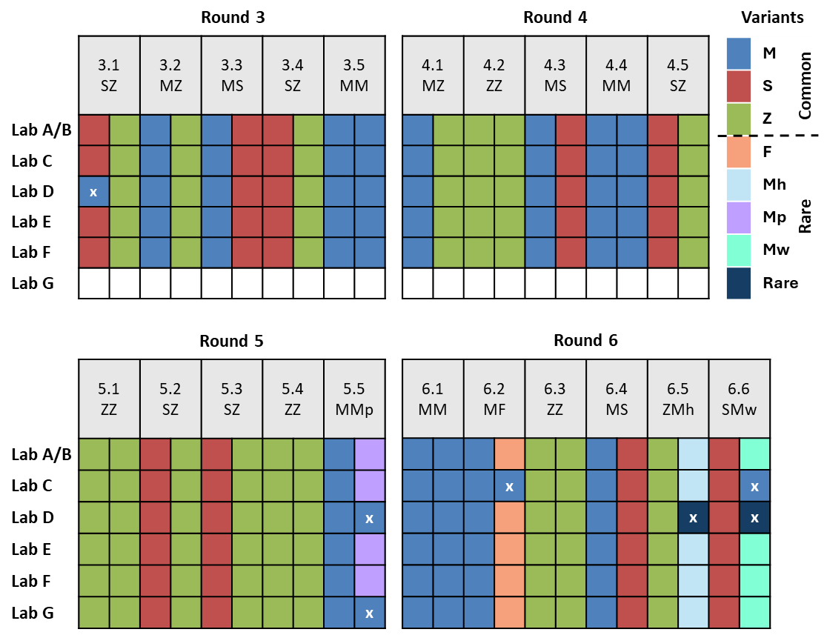
AAT variant genotypes are identified by combining the outputs of the phenotyping (Fig. 3), and molecular genotyping and sequencing methods (Fig. 4). For each sample, the genotypes for Lab A and Lab B, combined, are shown in the top row, with the other laboratories underneath. Results from each laboratory are colour coded by variant type. Where there are no results, and cells are left blank, this indicates that the laboratory did not take part in these rounds. Crosses denote where variants were identified incorrectly, or incompletely
Abbreviations: Mh: M_{Heerlen}; Mp: M_{Procida}; Mw: M_{Wurzburg}

