ONLINE SUPPLEMENT APPENDIX
Aspartame and Asthma: Immunomodulatory Effects on Airway Inflammation

Supplemental Figures
Figure S1. Flow chart of study population selection in the Taiwan Puberty Longitudinal Study. Children with an allergic onset were first identified, followed by exclusion of participants without a confirmed diagnosis of allergic disease. Among children diagnosed with asthma, those lacking aspartame intake records were further excluded. The final analytical sample comprised children with asthma and available aspartame intake data who were included in subsequent analyses.
Figure S2. Experimental design of the house dust mite (HDM)–induced asthma model with aspartame exposure in mice. Male BALB/c mice were randomly assigned to five experimental groups: Control (n = 15), HDM (n = 15), HDM + aspartame 15 mg/kg (n = 10), HDM + aspartame 30 mg/kg (n = 15), and HDM + aspartame 60 mg/kg (n = 17). Aspartame was administered via oral gavage throughout the experimental period. Allergic asthma was induced by intranasal HDM sensitization, consisting of 25 μL administered once weekly for three consecutive weeks, followed by 50 μL administered four times during the later phase of the protocol. Stool samples were collected during the intervention period, and blood samples were obtained prior to sacrifice. At the end of week 10, mice were sacrificed, and bronchoalveolar lavage fluid (BALF), blood, and lung tissues were collected for downstream immunological, histological, and microbiome analyses.
Figure S3. Effects of aspartame exposure on body weight and fasting blood glucose in an HDM-induced asthma mouse model. (A) Longitudinal body weight changes from week 0 to week 10 in male BALB/c mice assigned to the Control (n = 15), HDM (n = 15), HDM + aspartame 15 mg/kg (n = 12), HDM + aspartame 30 mg/kg (n = 15), and HDM + aspartame 60 mg/kg (n = 17) groups. (B) Fasting blood glucose levels were measured at the end of the experimental period. Data are presented as mean ± SD, with individual data points indicating biological replicates. Statistical comparisons among groups were performed using one-way ANOVA followed by appropriate post hoc multiple-comparison tests. Sample sizes for fasting blood glucose analysis were Control (n = 10), HDM (n = 11), HDM + aspartame 15 mg/kg (n = 12), HDM + aspartame 30 mg/kg (n = 11), and HDM + aspartame 60 mg/kg (n = 12).
Figure S4. Effects of aspartame exposure on airway inflammatory cell profiles in bronchoalveolar lavage fluid (BALF) from HDM-induced asthmatic mice. BALF inflammatory cells were analyzed in male BALB/c mice from the Control, HDM, HDM + aspartame 15 mg/kg, HDM + aspartame 30 mg/kg, and HDM + aspartame 60 mg/kg groups. (A) Total white blood cell counts (Control n = 5; HDM n = 9; HDM + aspartame 15 mg/kg n = 10; HDM + aspartame 30 mg/kg n = 9; HDM + aspartame 60 mg/kg n = 10). Differential leukocyte proportions included (B) neutrophils (Control n = 5; HDM n = 7; HDM + aspartame 15 mg/kg n = 7; HDM + aspartame 30 mg/kg n = 5; HDM + aspartame 60 mg/kg n = 10), (C) lymphocytes (Control n = 6; HDM n = 7; HDM + aspartame 15 mg/kg n = 7; HDM + aspartame 30 mg/kg n = 5; HDM + aspartame 60 mg/kg n = 9), (D) monocytes (Control n = 6; HDM n = 7; HDM + aspartame 15 mg/kg n = 7; HDM + aspartame 30 mg/kg n = 5; HDM + aspartame 60 mg/kg n = 10), and (E) eosinophils (Control n = 1; HDM n = 2; HDM + aspartame 15 mg/kg n = 3; HDM + aspartame 30 mg/kg n = 2; HDM + aspartame 60 mg/kg n = 3). Data are presented as mean ± SD, with individual data points representing biological replicates. Statistical comparisons were performed using one-way analysis of variance (ANOVA) followed by appropriate post hoc multiple-comparison tests. Differences in sample size among panels reflect the availability of analyzable samples following a technical malfunction of the hematology analyzer during differential cell analysis, which resulted in the loss of several samples.

Figure S5. Effects of aspartame exposure on methacholine-induced airway hyperresponsiveness in an HDM-induced asthma mouse model. Airway mechanics were assessed in male BALB/c mice from the Control, HDM, HDM + aspartame 15 mg/kg, HDM + aspartame 30 mg/kg, and HDM + aspartame 60 mg/kg groups following increasing doses of methacholine (0–25 mg/mL). (A) Maximum respiratory system resistance (Max Rrs), (B) maximum respiratory system elastance (Max Ers), and (C) airway resistance (Max Rn) were measured to evaluate airway responsiveness. Tissue-level mechanical properties were further assessed by (D) tissue damping (G) and (E) tissue elastance (H). Data are presented as mean values at each methacholine dose. Sample sizes for each parameter were as follows: (A) Max Rrs—Control (n = 7), HDM (n = 11), HDM + aspartame 15 mg/kg (n = 5), HDM + aspartame 30 mg/kg (n = 9), HDM + aspartame 60 mg/kg (n = 12); (B) Max Ers—Control (n = 8), HDM (n = 10), HDM + aspartame 15 mg/kg (n = 5), HDM + aspartame 30 mg/kg (n = 9), HDM + aspartame 60 mg/kg (n = 9); (C) Max Rn—Control (n = 4), HDM (n = 6), HDM + aspartame 15 mg/kg (n = 5), HDM + aspartame 30 mg/kg (n = 6), HDM + aspartame 60 mg/kg (n = 3); (D) tissue damping (G)—Control (n = 6), HDM (n = 4), HDM + aspartame 15 mg/kg (n = 5), HDM + aspartame 30 mg/kg (n = 7), HDM + aspartame 60 mg/kg (n = 5); and (E) tissue elastance (H)—Control (n = 3), HDM (n = 6), HDM + aspartame 15 mg/kg (n = 6), HDM + aspartame 30 mg/kg (n = 6), HDM + aspartame 60 mg/kg (n = 5).
Figure S6. Effects of aspartame exposure on pulmonary expression of sweet taste receptors and immune-related genes in an HDM-induced asthma mouse model. Relative mRNA expression levels of sweet taste receptor subunits and inflammatory cytokines were quantified in lung tissue from male BALB/c mice in the Control, HDM, HDM + aspartame 15 mg/kg, HDM + aspartame 30 mg/kg, and HDM + aspartame 60 mg/kg groups. Panels depict expression of (A) Tas1r2, (B) Tas1r3, (C) Tgf-β, (D) Tnf-α, (E) Il-2, (F) Il-4, (G) Il-5, and (H) Il-10. Gene expression was measured by quantitative real-time PCR and normalized to an internal reference gene. Data are presented as mean ± SD, with individual data points representing biological replicates. Statistical comparisons among groups were performed using one-way ANOVA followed by appropriate post hoc multiple-comparison tests. Sample sizes for each panel were as follows: (A) Tas1r2—Control (n = 5), HDM (n = 6), HDM + aspartame 15 mg/kg (n = 6), HDM + aspartame 30 mg/kg (n = 6), HDM + aspartame 60 mg/kg (n = 6); (B) Tas1r3—Control (n = 6), HDM (n = 5), HDM + aspartame 15 mg/kg (n = 6), HDM + aspartame 30 mg/kg (n = 6), HDM + aspartame 60 mg/kg (n = 6); (C) Tgf-β—all groups n = 6; (D) Tnf-α—Control (n = 4), HDM (n = 4), HDM + aspartame 15 mg/kg (n = 5), HDM + aspartame 30 mg/kg (n = 5), HDM + aspartame 60 mg/kg (n = 5); (E) Il-2—all groups n = 6; (F) Il-4—all groups n = 6; (G) Il-5—Control (n = 6), HDM (n = 5), HDM + aspartame 15 mg/kg (n = 6), HDM + aspartame 30 mg/kg (n = 6), HDM + aspartame 60 mg/kg (n = 6); and (H) Il-10—Control (n = 6), HDM (n = 6), HDM + aspartame 15 mg/kg (n = 6), HDM + aspartame 30 mg/kg (n = 5), HDM + aspartame 60 mg/kg (n = 6).
Figure S7. Pulmonary mRNA expression of immune-related mediators in an HDM-induced asthma mouse model with aspartame exposure. Relative mRNA expression levels of cytokines and immune-associated genes were quantified in lung tissue from male BALB/c mice in the Control, HDM, HDM + aspartame 15 mg/kg, HDM + aspartame 30 mg/kg, and HDM + aspartame 60 mg/kg groups. Panels depict expression of (A) Ifn-γ, (B) Il-1β, (C) Il1rl1, (D) Il-13, (E) Il-17a, (F) Il-22, (G) Il-33, and (H) Mcp1. Gene expression was measured by quantitative real-time PCR and normalized to an internal reference gene. Data are presented as mean ± SD, with individual data points representing biological replicates. Statistical comparisons among groups were performed using one-way ANOVA followed by appropriate post hoc multiple-comparison tests; statistical significance is indicated as P < 0.05 and ****P < 0.0001. Sample sizes for each panel were as follows: (A) Ifn-γ—Control (n = 6), HDM (n = 6), HDM + aspartame 15 mg/kg (n = 6), HDM + aspartame 30 mg/kg (n = 5), HDM + aspartame 60 mg/kg (n = 6); (B) Il-1β—all groups n = 6; (C) Il1rl1—all groups n = 6; (D) Il-13—Control (n = 6), HDM (n = 5), HDM + aspartame 15 mg/kg (n = 6), HDM + aspartame 30 mg/kg (n = 5), HDM + aspartame 60 mg/kg (n = 6); (E) Il-17a—all groups n = 6; (F) Il-22—Control (n = 6), HDM (n = 5), HDM + aspartame 15 mg/kg (n = 6), HDM + aspartame 30 mg/kg (n = 6), HDM + aspartame 60 mg/kg (n = 6); (G) Il-33—all groups n = 6; and (H) Mcp1—Control (n = 6), HDM (n = 5), HDM + aspartame 15 mg/kg (n = 6), HDM + aspartame 30 mg/kg (n = 4), HDM + aspartame 60 mg/kg (n = 3).
Figure S8. Pulmonary mRNA expression of chemokines, matrix metalloproteinases, and mucin-related genes in an HDM-induced asthma mouse model with aspartame exposure. Relative mRNA expression levels were quantified in lung tissue from male BALB/c mice in the Control, HDM, HDM + aspartame 15 mg/kg, HDM + aspartame 30 mg/kg, and HDM + aspartame 60 mg/kg groups. Panels depict expression of chemokines (A) Cxcl1, (B) Cxcl5, and (C) Cxcl8; matrix metalloproteinases (D) Mmp8, (E) Mmp9, and (F) Mmp12; and mucin-associated genes (G) Muc5ac and (H) Muc5b. Gene expression was measured by quantitative real-time PCR and normalized to an internal reference gene. Data are presented as mean ± SD with individual data points representing biological replicates. Statistical comparisons among groups were performed using one-way ANOVA followed by appropriate post hoc multiple-comparison tests; P < 0.05 indicated statistical significance. Sample sizes for each panel were as follows: (A) Cxcl1—Control (n = 5), HDM (n = 6), HDM + aspartame 15 mg/kg (n = 6), HDM + aspartame 30 mg/kg (n = 5), HDM + aspartame 60 mg/kg (n = 6); (B) Cxcl5—all groups n = 6; (C) Cxcl8—Control (n = 4), HDM (n = 4), HDM + aspartame 15 mg/kg (n = 5), HDM + aspartame 30 mg/kg (n = 5), HDM + aspartame 60 mg/kg (n = 5); (D) Mmp8—Control (n = 6), HDM (n = 4), HDM + aspartame 15 mg/kg (n = 3), HDM + aspartame 30 mg/kg (n = 5), HDM + aspartame 60 mg/kg (n = 3); (E) Mmp9—Control (n = 6), HDM (n = 4), HDM + aspartame 15 mg/kg (n = 3), HDM + aspartame 30 mg/kg (n = 5), HDM + aspartame 60 mg/kg (n = 3); (F) Mmp12—all groups n = 6; (G) Muc5ac—Control (n = 6), HDM (n = 6), HDM + aspartame 15 mg/kg (n = 6), HDM + aspartame 30 mg/kg (n = 5), HDM + aspartame 60 mg/kg (n = 6); and (H) Muc5b—Control (n = 6), HDM (n = 6), HDM + aspartame 15 mg/kg (n = 6), HDM + aspartame 30 mg/kg (n = 5), HDM + aspartame 60 mg/kg (n = 6).
Figure S9. Pulmonary mRNA expression of selected asthma- and sensory-related genes in an HDM-induced asthma mouse model with aspartame exposure. Relative mRNA expression levels were quantified in lung tissue from male BALB/c mice in the Control, HDM, HDM + aspartame 15 mg/kg, HDM + aspartame 30 mg/kg, and HDM + aspartame 60 mg/kg groups. Panels depict expression of (A) Dazl, (B) Gnat3, (C) Olig3, (D) Ormdl3, and (E) Rad50. Gene expression was measured by quantitative real-time PCR and normalized to an internal reference gene. Data are presented as mean ± SD with individual data points representing biological replicates. Statistical comparisons among groups were performed using one-way ANOVA followed by appropriate post hoc multiple-comparison tests. Statistical significance is indicated as *P < 0.05 and **P < 0.01. Sample sizes for each panel were as follows: (A) Dazl—Control (n = 6), HDM (n = 5), HDM + aspartame 15 mg/kg (n = 6), HDM + aspartame 30 mg/kg (n = 6), HDM + aspartame 60 mg/kg (n = 6); (B) Gnat3—Control (n = 6), HDM (n = 6), HDM + aspartame 15 mg/kg (n = 6), HDM + aspartame 30 mg/kg (n = 5), HDM + aspartame 60 mg/kg (n = 5); (C) Olig3—Control (n = 5), HDM (n = 6), HDM + aspartame 15 mg/kg (n = 6), HDM + aspartame 30 mg/kg (n = 5), HDM + aspartame 60 mg/kg (n = 6); (D) Ormdl3—all groups n = 6; and (E) Rad50—all groups n = 6.
Figure S10. Differential KEGG Orthology (KO) functional profiles derived from fecal microbiota in mice exposed to HDM and aspartame supplementation. Heatmap visualization of significantly altered KEGG Orthology (KO) functional profiles predicted from mice across experimental comparisons. Rows represent individual KO terms, and columns indicate pairwise group comparisons, including Control versus HDM and HDM with or without aspartame supplementation (15, 30, and 60 mg/kg). Color intensity reflects standardized differences in KO abundance (z-scores), with warmer colors indicating relative enrichment and cooler colors indicating relative depletion. Asterisks denote statistically significant differences (P < 0.05). The accompanying table lists the functional annotations and the associated metabolic pathways for each KO term.
Figure S11. Differential gut microbial taxa derived from fecal samples of mice exposed to HDM and aspartame supplementation identified by volcano plot analysis. Volcano plots illustrate differential abundance analysis of gut microbial taxa with log₂ fold change (x-axis) and −log₁₀ (P value) (y-axis) across experimental comparisons. (A) House dust mite (HDM)–exposed mice versus Control; (B) Control versus HDM + aspartame 15 mg/kg; (C) Control versus HDM + aspartame 60 mg/kg; and (D) Control versus HDM + aspartame 30 mg/kg. Each point represents an individual microbial taxon. Red points indicate significantly decreased taxa, green points indicate significantly increased taxa, and gray points indicate taxa with no significant change. Vertical dashed lines denote the log₂ fold change thresholds, and the horizontal dashed line indicates the statistical significance threshold (P < 0.05). Selected taxa with significant differential abundance are annotated. Statistical analyses were performed using differential abundance testing with multiple-comparison correction.

Figure S12. Toluidine blue staining illustrating mast cell infiltration in the lungs of HDM-induced asthmatic mice treated with aspartame (A-E). Periodic acid–Schiff staining does not exhibit mucus secretion from goblet cells in the lungs of HDM-induced asthmatic mice treated with aspartame (F–J).
Figure S13. Collagen deposition in the lungs of HDM-induced asthmatic mice treated with aspartame. Lung tissues were stained with Masson’s trichrome (blue).
Table S1. Primers for quantitative Reverse Transcription Polymerase Chain Reaction

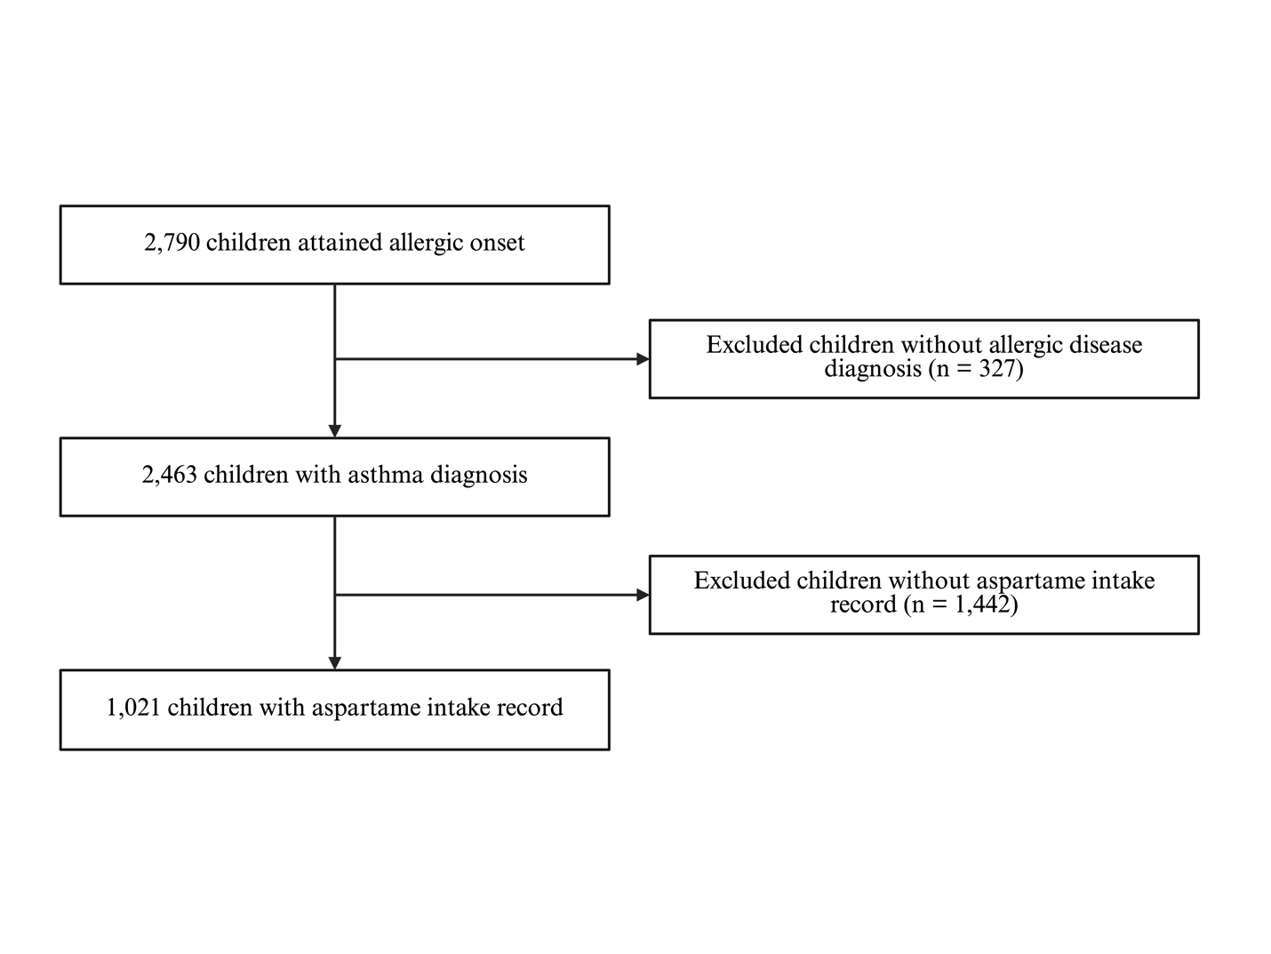Figure S1. Flow chart of study population selection in the Taiwan Puberty Longitudinal Study. Children with an allergic onset were first identified, followed by exclusion of participants without a confirmed diagnosis of allergic disease. Among children diagnosed with asthma, those lacking aspartame intake records were further excluded. The final analytical sample comprised children with asthma and available aspartame intake data who were included in subsequent analyses.

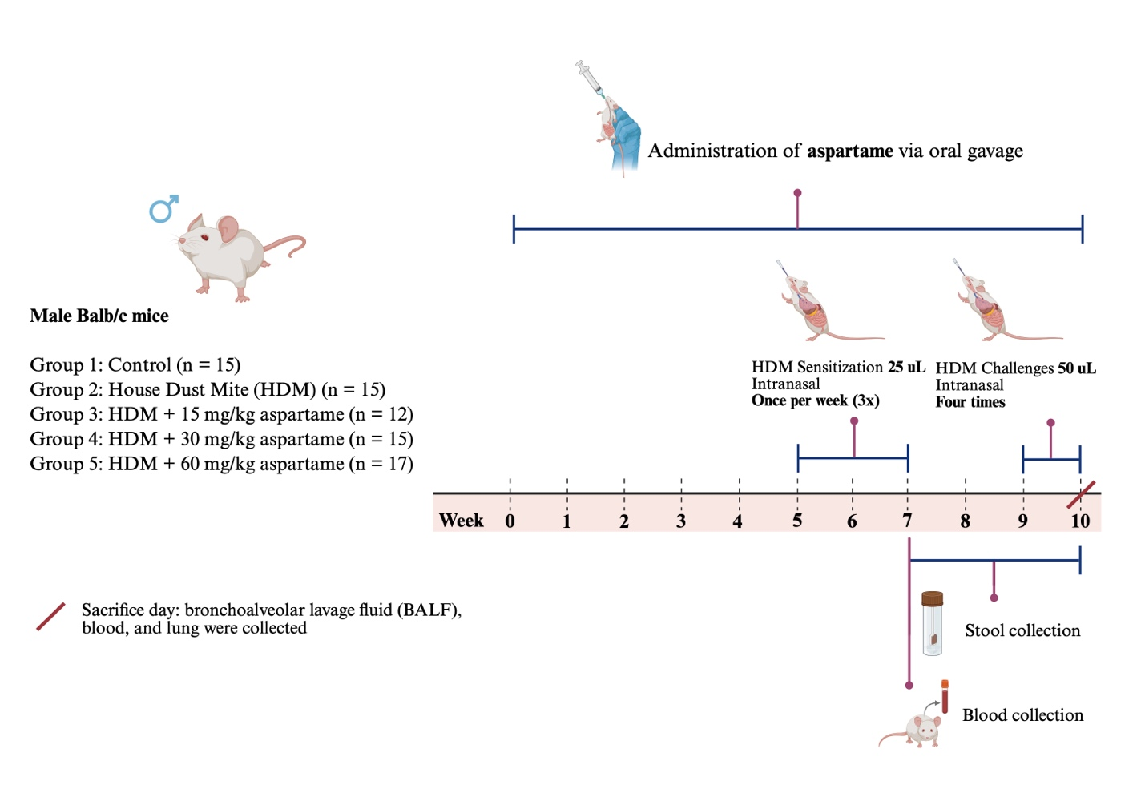
Figure S2. Experimental design of the house dust mite (HDM)–induced asthma model with aspartame exposure in mice. Male BALB/c mice were randomly assigned to five experimental groups: Control (n = 15), HDM (n = 15), HDM + aspartame 15 mg/kg (n = 12), HDM + aspartame 30 mg/kg (n = 15), and HDM + aspartame 60 mg/kg (n = 17). Aspartame was administered via oral gavage throughout the experimental period. Allergic asthma was induced by intranasal HDM sensitization, consisting of 25 μL administered once weekly for three consecutive weeks, followed by 50 μL administered four times during the later phase of the protocol. Stool samples were collected during the intervention period, and blood samples were obtained prior to sacrifice. At the end of week 10, mice were sacrificed, and bronchoalveolar lavage fluid (BALF), blood, and lung tissues were collected for downstream immunological, histological, and microbiome analyses.

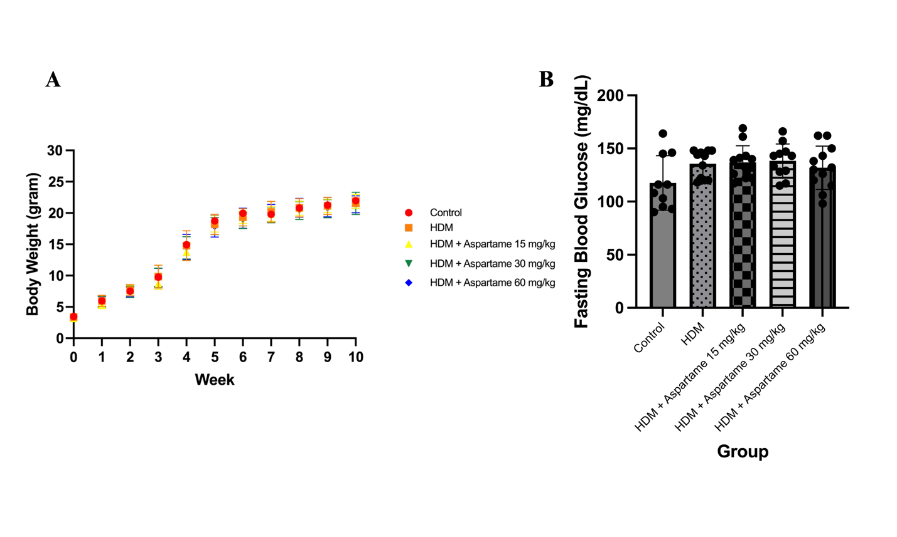
Figure S3. Effects of aspartame exposure on body weight and fasting blood glucose in an HDM-induced asthma mouse model. (A) Longitudinal body weight changes from week 0 to week 10 in male BALB/c mice assigned to the Control (n = 15), HDM (n = 15), HDM + aspartame 15 mg/kg (n = 12), HDM + aspartame 30 mg/kg (n = 15), and HDM + aspartame 60 mg/kg (n = 17) groups. (B) Fasting blood glucose levels were measured at the end of the experimental period. Data are presented as mean ± SD, with individual data points indicating biological replicates. Statistical comparisons among groups were performed using one-way ANOVA followed by appropriate post hoc multiple-comparison tests. Sample sizes for fasting blood glucose analysis were Control (n = 10), HDM (n = 11), HDM + aspartame 15 mg/kg (n = 12), HDM + aspartame 30 mg/kg (n = 11), and HDM + aspartame 60 mg/kg (n = 12).

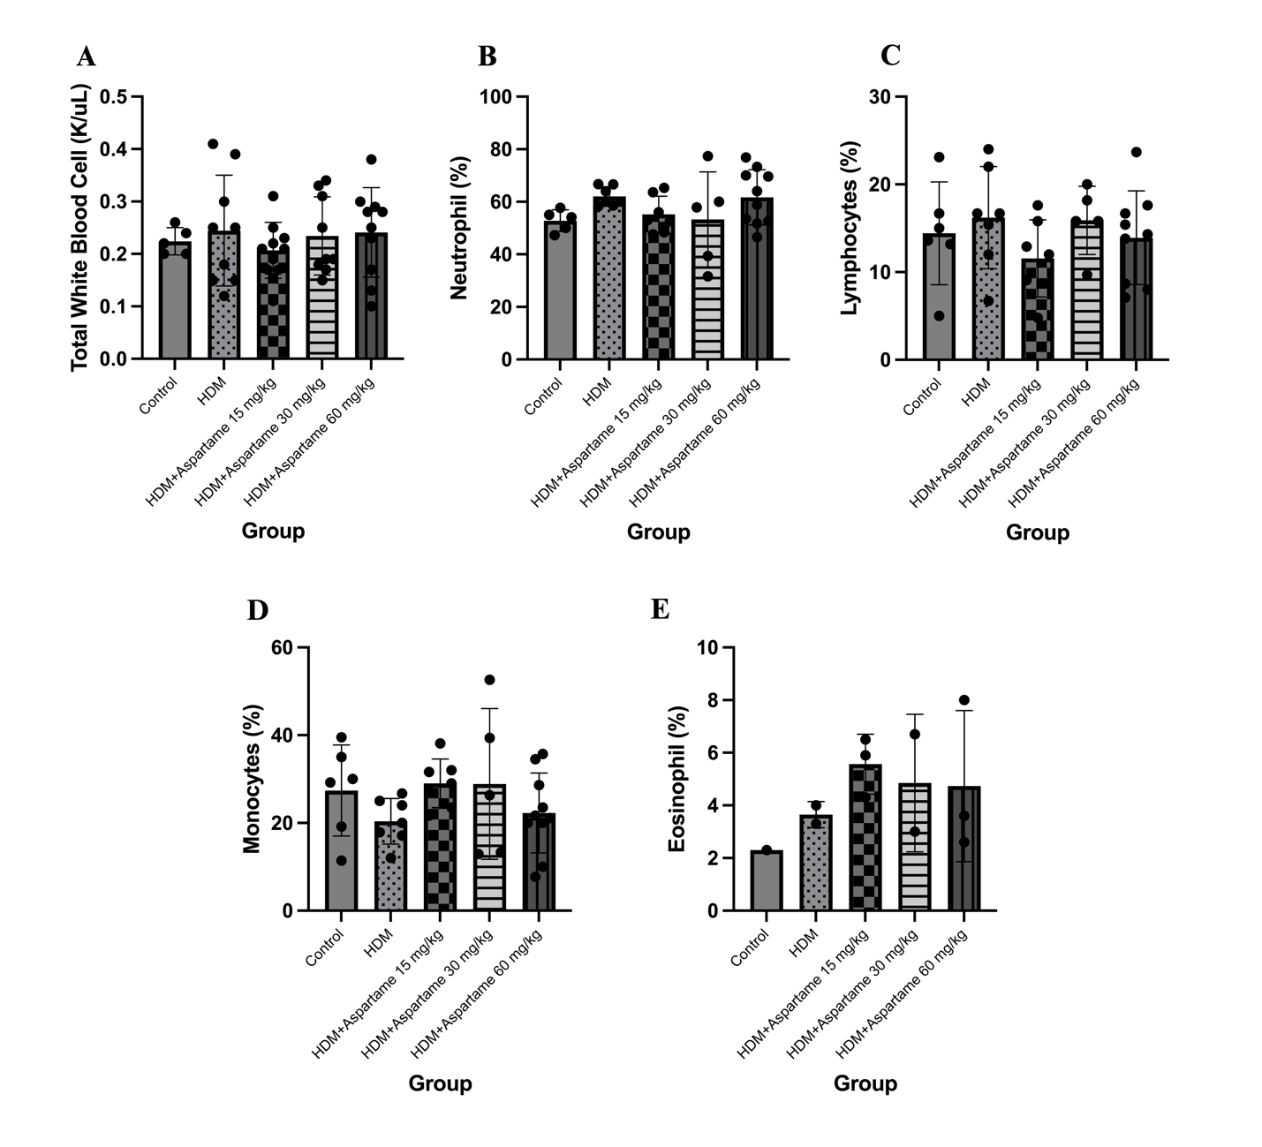
Figure S4. Effects of aspartame exposure on airway inflammatory cell profiles in bronchoalveolar lavage fluid (BALF) from HDM-induced asthmatic mice. BALF inflammatory cells were analyzed in male BALB/c mice from the Control, HDM, HDM + aspartame 15 mg/kg, HDM + aspartame 30 mg/kg, and HDM + aspartame 60 mg/kg groups. (A) Total white blood cell counts (Control n = 5; HDM n = 9; HDM + aspartame 15 mg/kg n = 10; HDM + aspartame 30 mg/kg n = 9; HDM + aspartame 60 mg/kg n = 10). Differential leukocyte proportions included (B) neutrophils (Control n = 5; HDM n = 7; HDM + aspartame 15 mg/kg n = 7; HDM + aspartame 30 mg/kg n = 5; HDM + aspartame 60 mg/kg n = 10), (C) lymphocytes (Control n = 6; HDM n = 7; HDM + aspartame 15 mg/kg n = 7; HDM + aspartame 30 mg/kg n = 5; HDM + aspartame 60 mg/kg n = 9), (D) monocytes (Control n = 6; HDM n = 7; HDM + aspartame 15 mg/kg n = 7; HDM + aspartame 30 mg/kg n = 5; HDM + aspartame 60 mg/kg n = 10), and (E) eosinophils (Control n = 1; HDM n = 2; HDM + aspartame 15 mg/kg n = 3; HDM + aspartame 30 mg/kg n = 2; HDM + aspartame 60 mg/kg n = 3). Data are presented as mean ± SD, with individual data points representing biological replicates. Statistical comparisons were performed using one-way analysis of variance (ANOVA) followed by appropriate post hoc multiple-comparison tests. Differences in sample size among panels reflect the availability of analyzable samples following a technical malfunction of the hematology analyzer during differential cell analysis, which resulted in the loss of several samples.
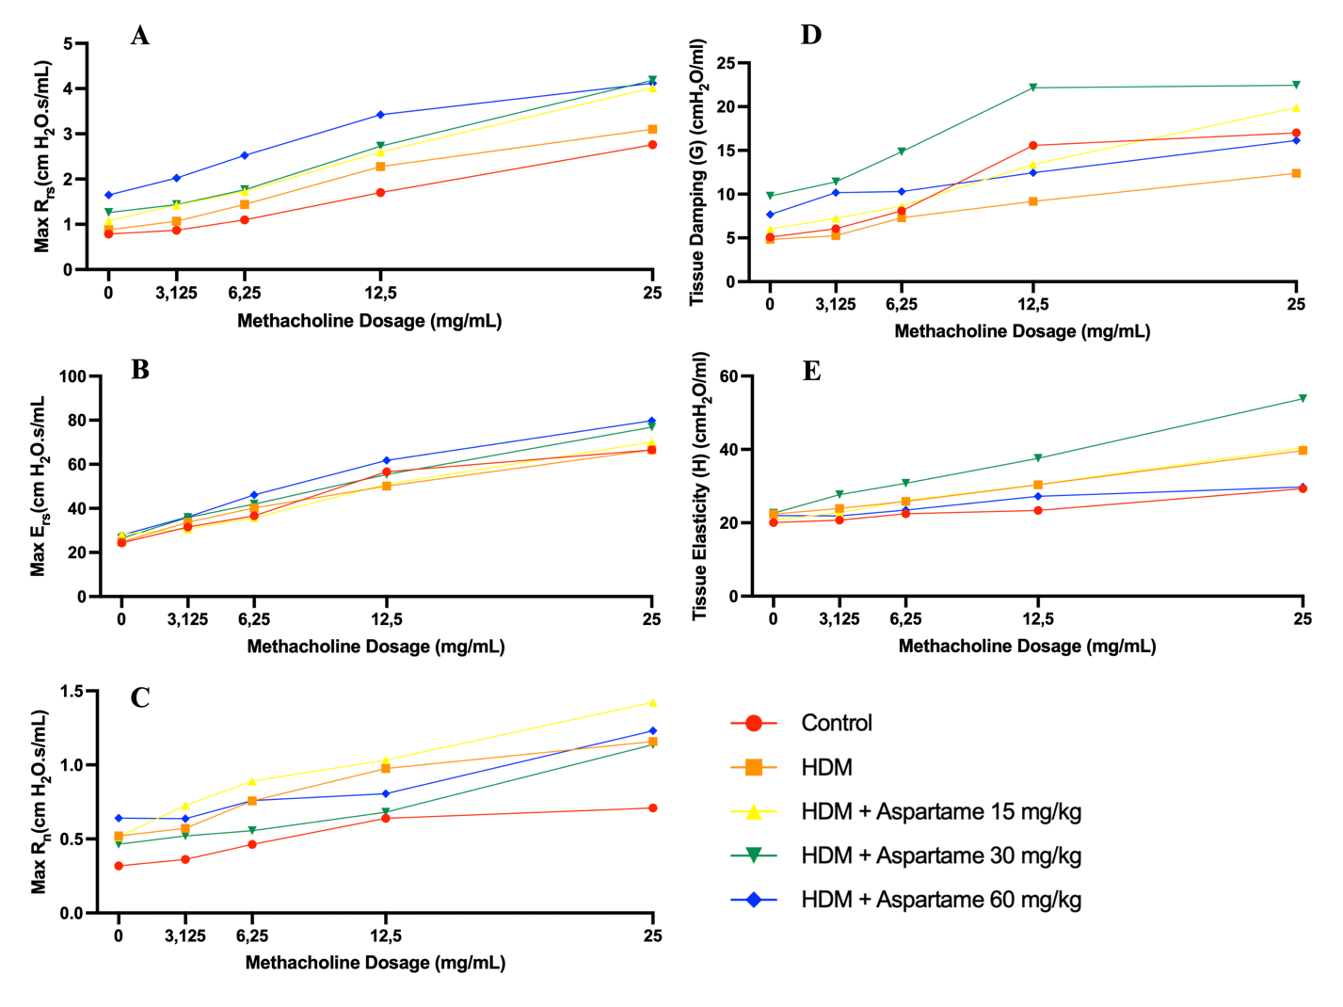
Figure S5. Effects of aspartame exposure on methacholine-induced airway hyperresponsiveness in an HDM-induced asthma mouse model. Airway mechanics were assessed in male BALB/c mice from the Control, HDM, HDM + aspartame 15 mg/kg, HDM + aspartame 30 mg/kg, and HDM + aspartame 60 mg/kg groups following increasing doses of methacholine (0–25 mg/mL). (A) Maximum respiratory system resistance (Max Rrs), (B) maximum respiratory system elastance (Max Ers), and (C) airway resistance (Max Rn) were measured to evaluate airway responsiveness. Tissue-level mechanical properties were further assessed by (D) tissue damping (G) and (E) tissue elastance (H). Data are presented as mean values at each methacholine dose. Sample sizes for each parameter were as follows: (A) Max Rrs—Control (n = 7), HDM (n = 11), HDM + aspartame 15 mg/kg (n = 5), HDM + aspartame 30 mg/kg (n = 9), HDM + aspartame 60 mg/kg (n = 12); (B) Max Ers—Control (n = 8), HDM (n = 10), HDM + aspartame 15 mg/kg (n = 5), HDM + aspartame 30 mg/kg (n = 9), HDM + aspartame 60 mg/kg (n = 9); (C) Max Rn—Control (n = 4), HDM (n = 6), HDM + aspartame 15 mg/kg (n = 5), HDM + aspartame 30 mg/kg (n = 6), HDM + aspartame 60 mg/kg (n = 3); (D) tissue damping (G)—Control (n = 6), HDM (n = 4), HDM + aspartame 15 mg/kg (n = 5), HDM + aspartame 30 mg/kg (n = 7), HDM + aspartame 60 mg/kg (n = 5); and (E) tissue elastance (H)—Control (n = 3), HDM (n = 6), HDM + aspartame 15 mg/kg (n = 6), HDM + aspartame 30 mg/kg (n = 6), HDM + aspartame 60 mg/kg (n = 5).

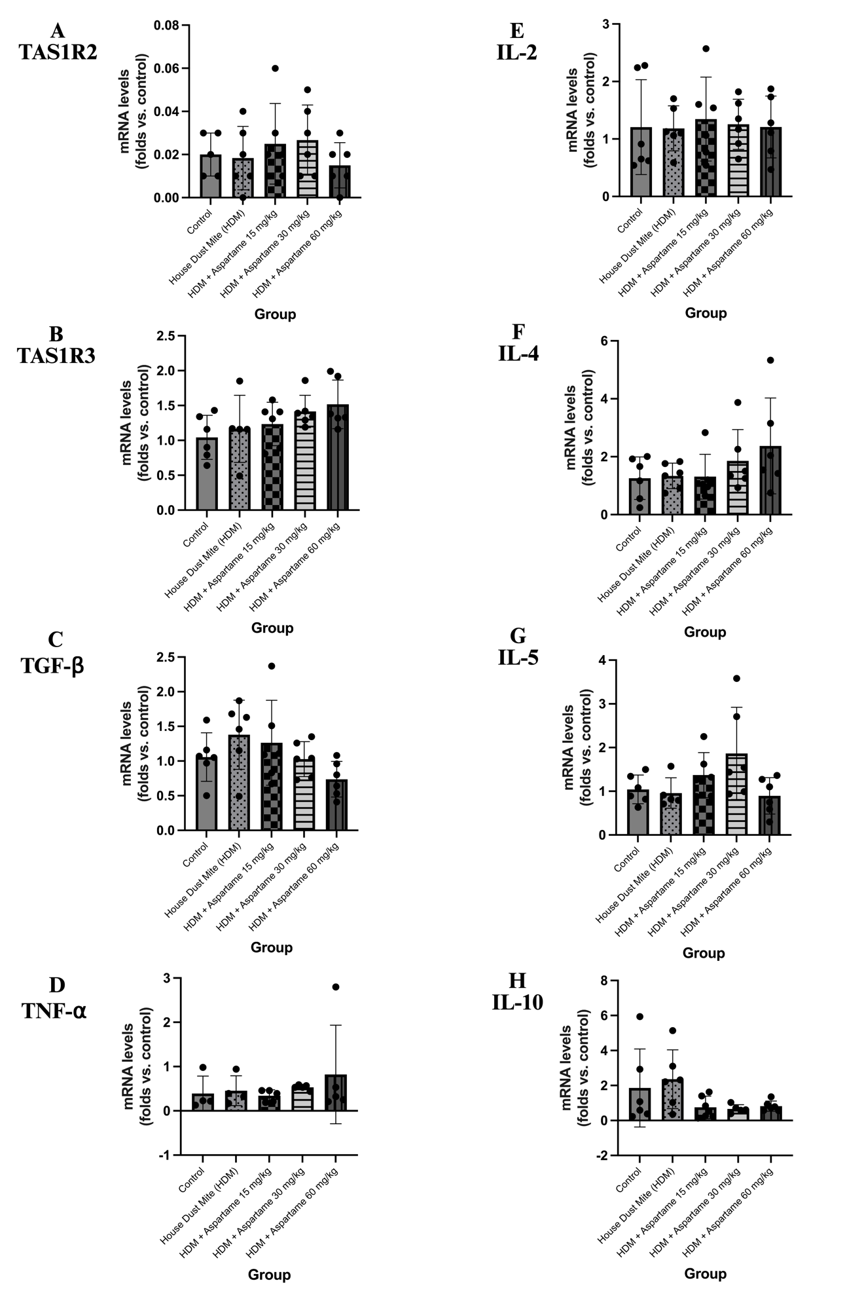
Figure S6. Effects of aspartame exposure on pulmonary expression of sweet taste receptors and immune-related genes in an HDM-induced asthma mouse model. Relative mRNA expression levels of sweet taste receptor subunits and inflammatory cytokines were quantified in lung tissue from male BALB/c mice in the Control, HDM, HDM + aspartame 15 mg/kg, HDM + aspartame 30 mg/kg, and HDM + aspartame 60 mg/kg groups. Panels depict expression of (A) Tas1r2, (B) Tas1r3, (C) Tgf-β, (D) Tnf-α, (E) Il-2, (F) Il-4, (G) Il-5, and (H) Il-10. Gene expression was measured by quantitative real-time PCR and normalized to an internal reference gene. Data are presented as mean ± SD, with individual data points representing biological replicates. Statistical comparisons among groups were performed using one-way ANOVA followed by appropriate post hoc multiple-comparison tests. Sample sizes for each panel were as follows: (A) Tas1r2—Control (n = 5), HDM (n = 6), HDM + aspartame 15 mg/kg (n = 6), HDM + aspartame 30 mg/kg (n = 6), HDM + aspartame 60 mg/kg (n = 6); (B) Tas1r3—Control (n = 6), HDM (n = 5), HDM + aspartame 15 mg/kg (n = 6), HDM + aspartame 30 mg/kg (n = 6), HDM + aspartame 60 mg/kg (n = 6); (C) Tgf-β—all groups n = 6; (D) Tnf-α—Control (n = 4), HDM (n = 4), HDM + aspartame 15 mg/kg (n = 5), HDM + aspartame 30 mg/kg (n = 5), HDM + aspartame 60 mg/kg (n = 5); (E) Il-2—all groups n = 6; (F) Il-4—all groups n = 6; (G) Il-5—Control (n = 6), HDM (n = 5), HDM + aspartame 15 mg/kg (n = 6), HDM + aspartame 30 mg/kg (n = 6), HDM + aspartame 60 mg/kg (n = 6); and (H) Il-10—Control (n = 6), HDM (n = 6), HDM + aspartame 15 mg/kg (n = 6), HDM + aspartame 30 mg/kg (n = 5), HDM + aspartame 60 mg/kg (n = 6).
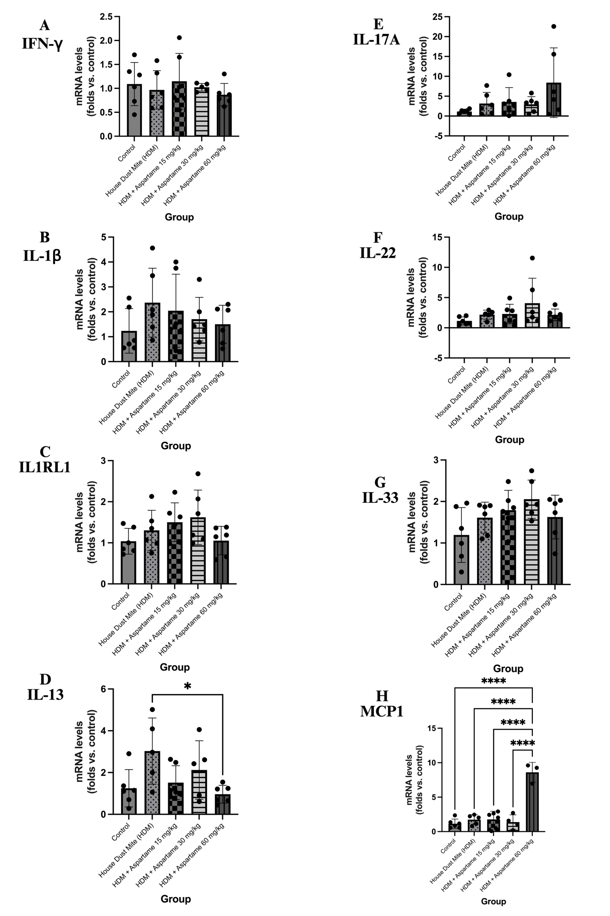
Figure S7. Pulmonary mRNA expression of immune-related mediators in an HDM-induced asthma mouse model with aspartame exposure. Relative mRNA expression levels of cytokines and immune-associated genes were quantified in lung tissue from male BALB/c mice in the Control, HDM, HDM + aspartame 15 mg/kg, HDM + aspartame 30 mg/kg, and HDM + aspartame 60 mg/kg groups. Panels depict expression of (A) Ifn-γ, (B) Il-1β, (C) Il1rl1, (D) Il-13, (E) Il-17a, (F) Il-22, (G) Il-33, and (H) Mcp1. Gene expression was measured by quantitative real-time PCR and normalized to an internal reference gene. Data are presented as mean ± SD, with individual data points representing biological replicates. Statistical comparisons among groups were performed using one-way ANOVA followed by appropriate post hoc multiple-comparison tests; statistical significance is indicated as P < 0.05 and ****P < 0.0001. Sample sizes for each panel were as follows: (A) Ifn-γ—Control (n = 6), HDM (n = 6), HDM + aspartame 15 mg/kg (n = 6), HDM + aspartame 30 mg/kg (n = 5), HDM + aspartame 60 mg/kg (n = 6); (B) Il-1β—all groups n = 6; (C) Il1rl1—all groups n = 6; (D) Il-13—Control (n = 6), HDM (n = 5), HDM + aspartame 15 mg/kg (n = 6), HDM + aspartame 30 mg/kg (n = 5), HDM + aspartame 60 mg/kg (n = 6); (E) Il-17a—all groups n = 6; (F) Il-22—Control (n = 6), HDM (n = 5), HDM + aspartame 15 mg/kg (n = 6), HDM + aspartame 30 mg/kg (n = 6), HDM + aspartame 60 mg/kg (n = 6); (G) Il-33—all groups n = 6; and (H) Mcp1—Control (n = 6), HDM (n = 5), HDM + aspartame 15 mg/kg (n = 6), HDM + aspartame 30 mg/kg (n = 4), HDM + aspartame 60 mg/kg (n = 3).
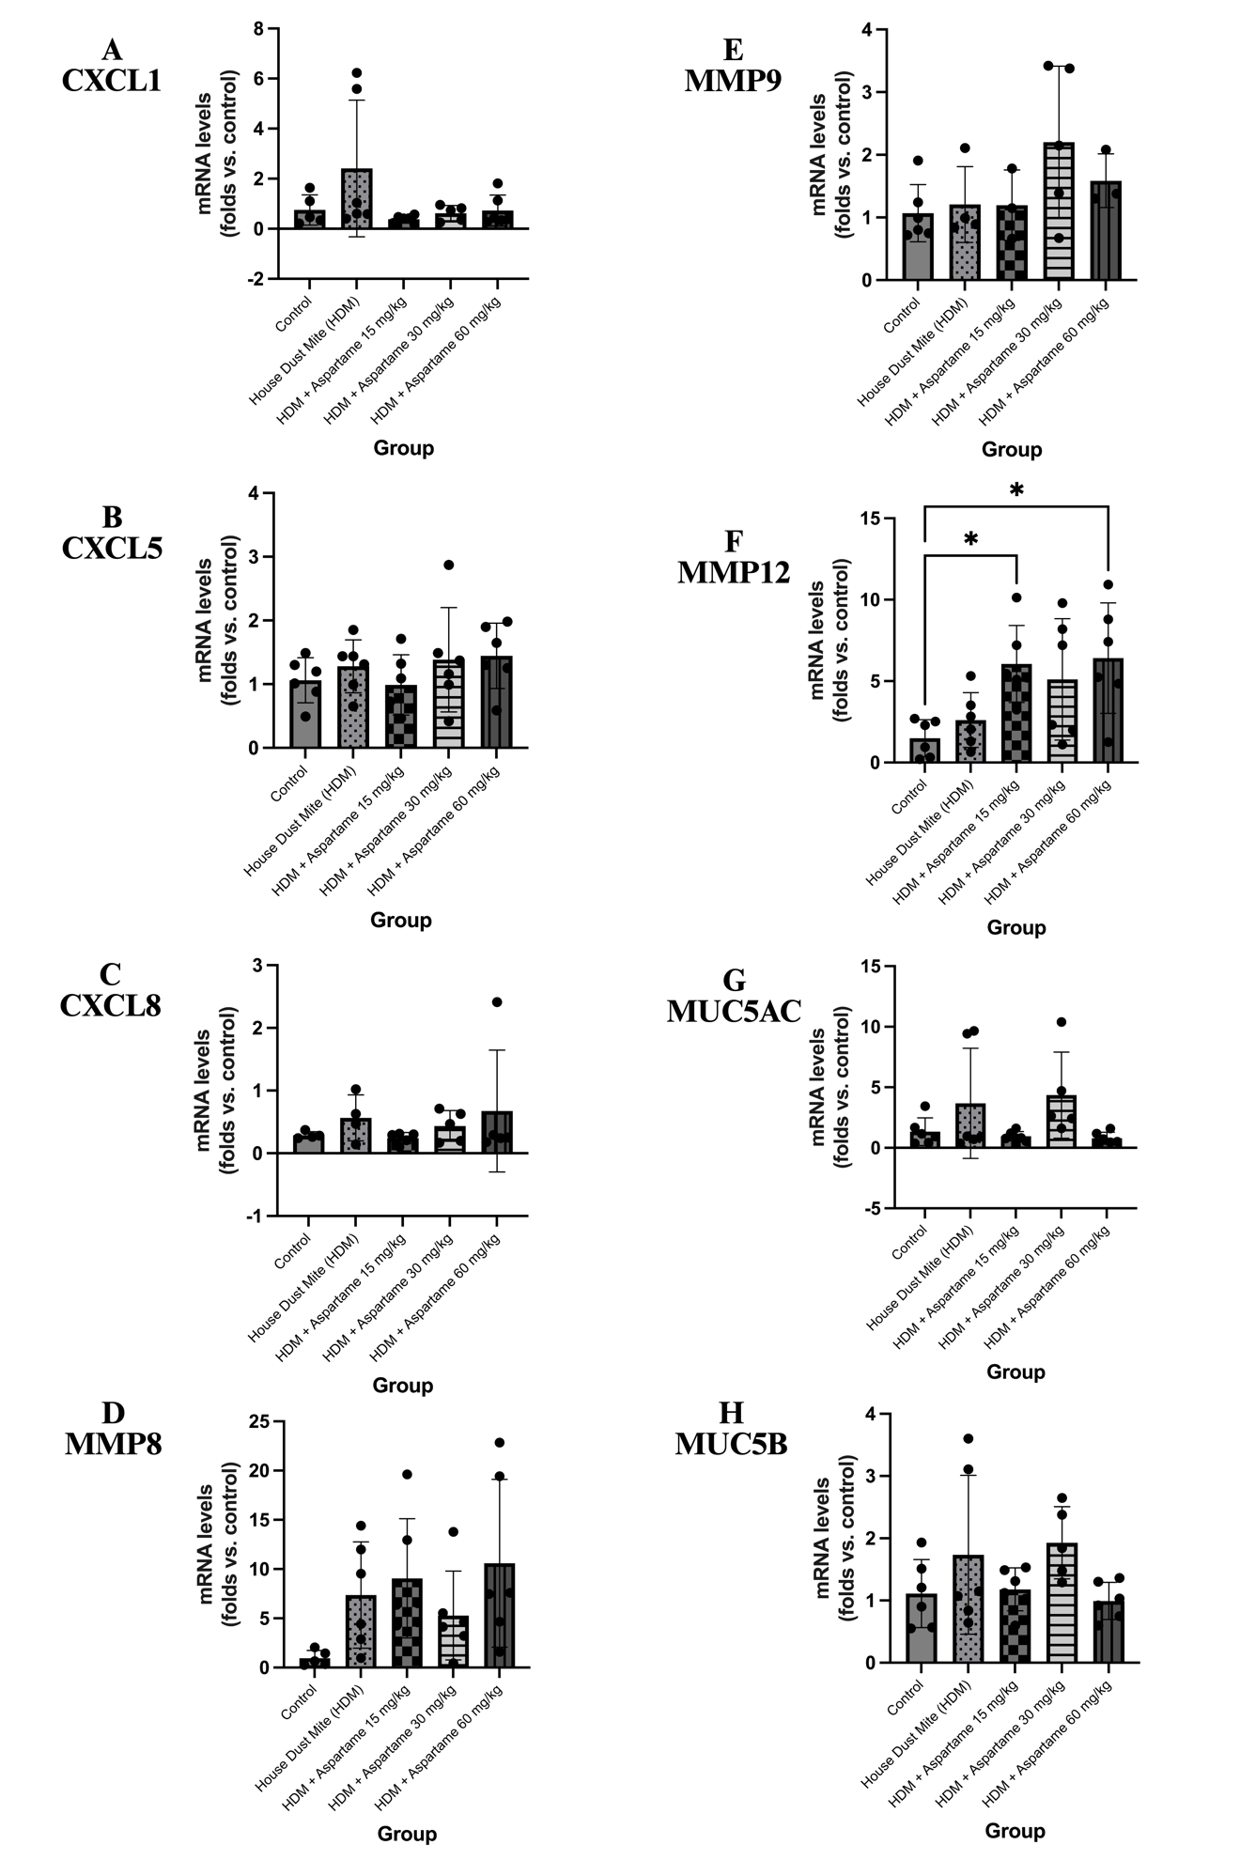
Figure S8. Pulmonary mRNA expression of chemokines, matrix metalloproteinases, and mucin-related genes in an HDM-induced asthma mouse model with aspartame exposure. Relative mRNA expression levels were quantified in lung tissue from male BALB/c mice in the Control, HDM, HDM + aspartame 15 mg/kg, HDM + aspartame 30 mg/kg, and HDM + aspartame 60 mg/kg groups. Panels depict expression of chemokines (A) Cxcl1, (B) Cxcl5, and (C) Cxcl8; matrix metalloproteinases (D) Mmp8, (E) Mmp9, and (F) Mmp12; and mucin-associated genes (G) Muc5ac and (H) Muc5b. Gene expression was measured by quantitative real-time PCR and normalized to an internal reference gene. Data are presented as mean ± SD with individual data points representing biological replicates. Statistical comparisons among groups were performed using one-way ANOVA followed by appropriate post hoc multiple-comparison tests; P < 0.05 indicated statistical significance. Sample sizes for each panel were as follows: (A) Cxcl1—Control (n = 5), HDM (n = 6), HDM + aspartame 15 mg/kg (n = 6), HDM + aspartame 30 mg/kg (n = 5), HDM + aspartame 60 mg/kg (n = 6); (B) Cxcl5—all groups n = 6; (C) Cxcl8—Control (n = 4), HDM (n = 4), HDM + aspartame 15 mg/kg (n = 5), HDM + aspartame 30 mg/kg (n = 5), HDM + aspartame 60 mg/kg (n = 5); (D) Mmp8—Control (n = 6), HDM (n = 4), HDM + aspartame 15 mg/kg (n = 3), HDM + aspartame 30 mg/kg (n = 5), HDM + aspartame 60 mg/kg (n = 3); (E) Mmp9—Control (n = 6), HDM (n = 4), HDM + aspartame 15 mg/kg (n = 3), HDM + aspartame 30 mg/kg (n = 5), HDM + aspartame 60 mg/kg (n = 3); (F) Mmp12—all groups n = 6; (G) Muc5ac—Control (n = 6), HDM (n = 6), HDM + aspartame 15 mg/kg (n = 6), HDM + aspartame 30 mg/kg (n = 5), HDM + aspartame 60 mg/kg (n = 6); and (H) Muc5b—Control (n = 6), HDM (n = 6), HDM + aspartame 15 mg/kg (n = 6), HDM + aspartame 30 mg/kg (n = 5), HDM + aspartame 60 mg/kg (n = 6).

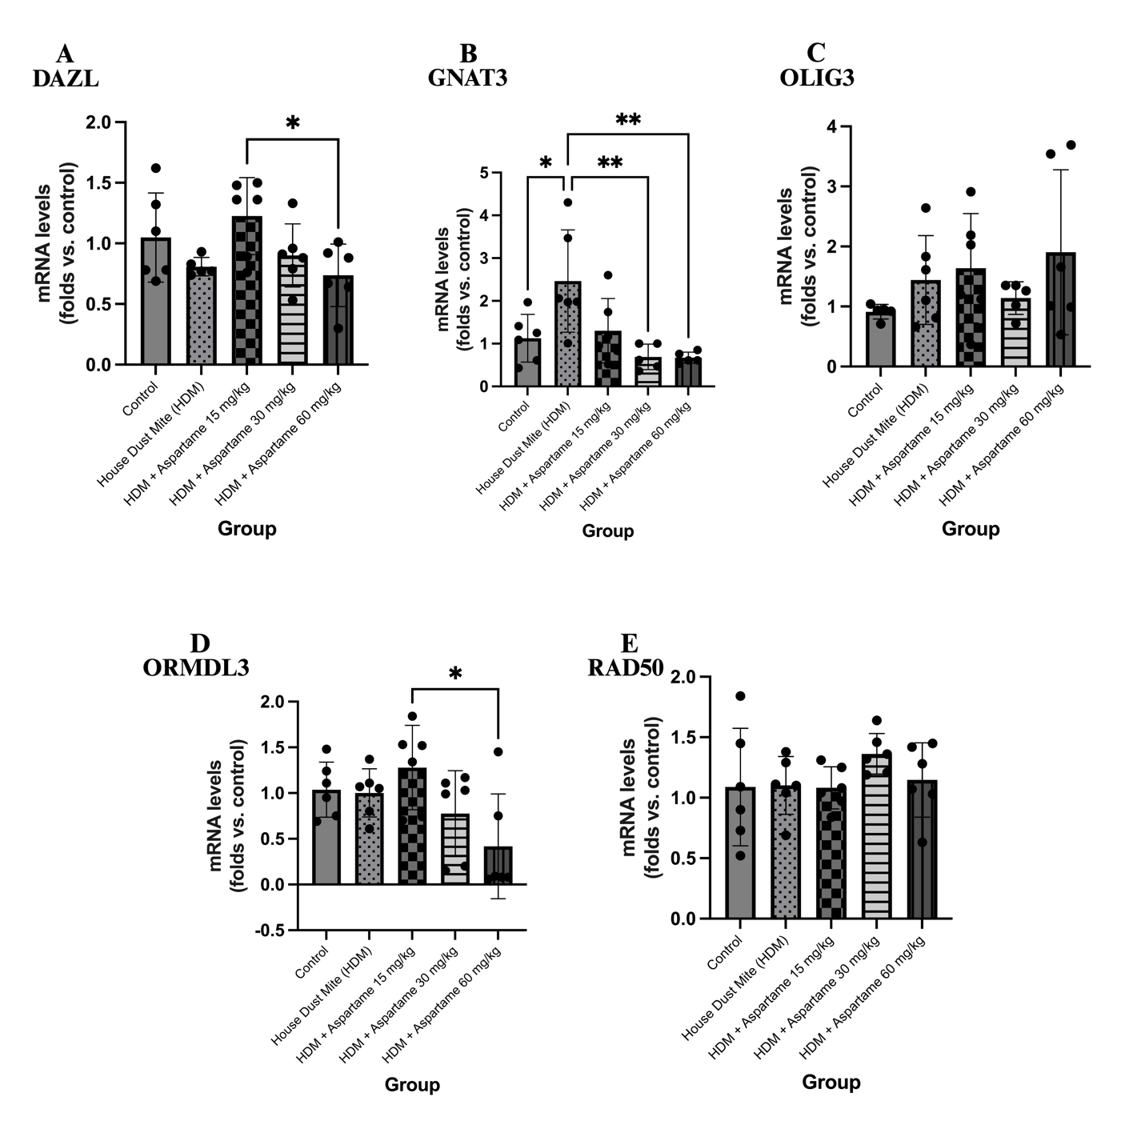
Figure S9. Pulmonary mRNA expression of selected asthma- and sensory-related genes in an HDM-induced asthma mouse model with aspartame exposure. Relative mRNA expression levels were quantified in lung tissue from male BALB/c mice in the Control, HDM, HDM + aspartame 15 mg/kg, HDM + aspartame 30 mg/kg, and HDM + aspartame 60 mg/kg groups. Panels depict expression of (A) Dazl, (B) Gnat3, (C) Olig3, (D) Ormdl3, and (E) Rad50. Gene expression was measured by quantitative real-time PCR and normalized to an internal reference gene. Data are presented as mean ± SD with individual data points representing biological replicates. Statistical comparisons among groups were performed using one-way ANOVA followed by appropriate post hoc multiple-comparison tests. Statistical significance is indicated as *P < 0.05 and **P < 0.01. Sample sizes for each panel were as follows: (A) Dazl—Control (n = 6), HDM (n = 5), HDM + aspartame 15 mg/kg (n = 6), HDM + aspartame 30 mg/kg (n = 6), HDM + aspartame 60 mg/kg (n = 6); (B) Gnat3—Control (n = 6), HDM (n = 6), HDM + aspartame 15 mg/kg (n = 6), HDM + aspartame 30 mg/kg (n = 5), HDM + aspartame 60 mg/kg (n = 5); (C) Olig3—Control (n = 5), HDM (n = 6), HDM + aspartame 15 mg/kg (n = 6), HDM + aspartame 30 mg/kg (n = 5), HDM + aspartame 60 mg/kg (n = 6); (D) Ormdl3—all groups n = 6; and (E) Rad50—all groups n = 6.

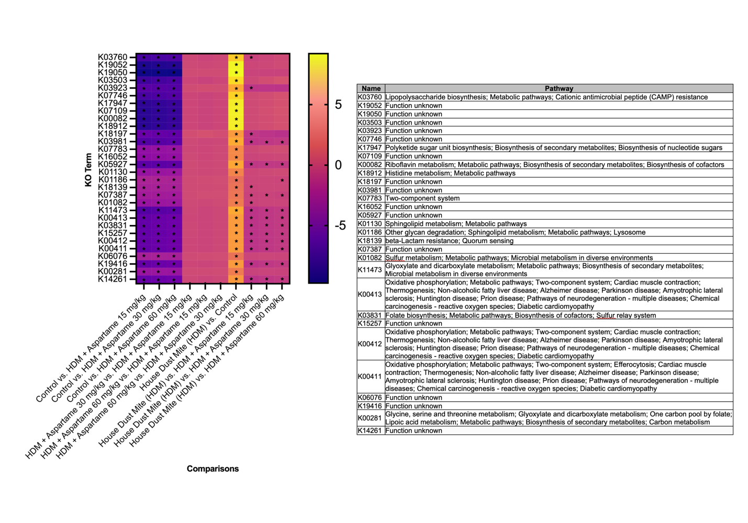
Figure S10. Differential KEGG Orthology (KO) functional profiles derived from fecal microbiota in mice exposed to HDM and aspartame supplementation. Heatmap visualization of significantly altered KEGG Orthology (KO) functional profiles predicted from mice across experimental comparisons. Rows represent individual KO terms, and columns indicate pairwise group comparisons, including Control versus HDM and HDM with or without aspartame supplementation (15, 30, and 60 mg/kg). Color intensity reflects standardized differences in KO abundance (z-scores), with warmer colors indicating relative enrichment and cooler colors indicating relative depletion. Asterisks denote statistically significant differences (P < 0.05). The accompanying table lists the functional annotations and the associated metabolic pathways for each KO term.

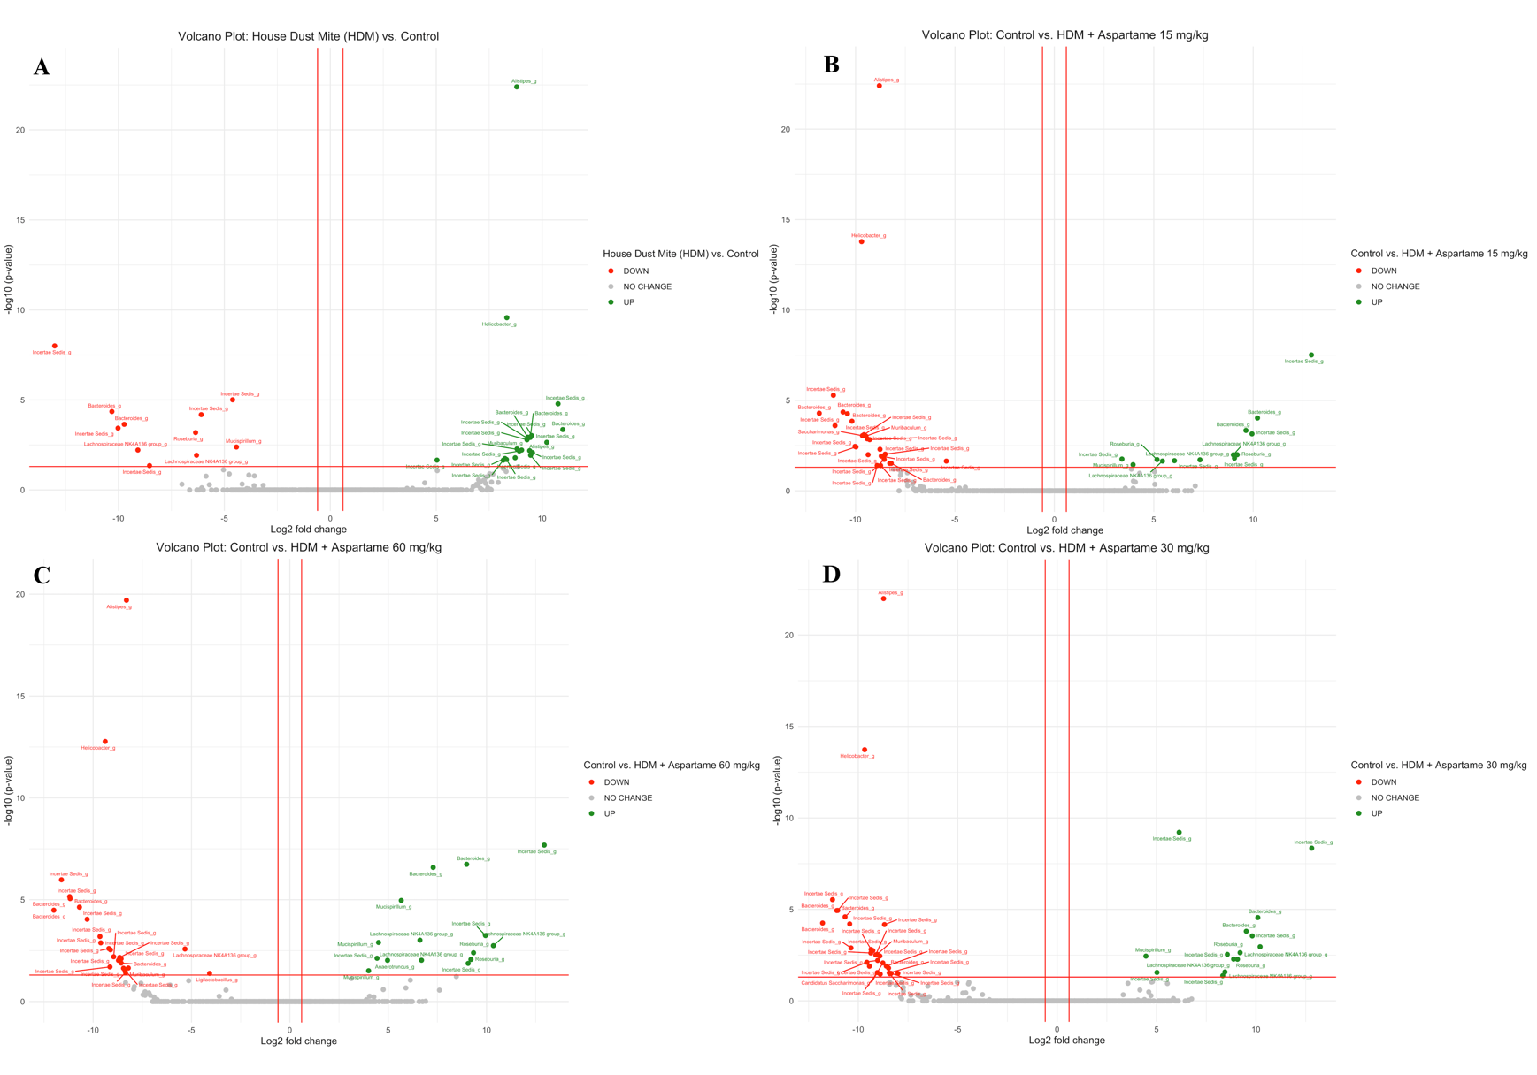
Figure S11. Differential gut microbial taxa derived from fecal samples of mice exposed to HDM and aspartame supplementation identified by volcano plot analysis. Volcano plots illustrate differential abundance analysis of gut microbial taxa with log₂ fold change (x-axis) and −log₁₀ (P value) (y-axis) across experimental comparisons. (A) House dust mite (HDM)–exposed mice versus Control; (B) Control versus HDM + aspartame 15 mg/kg; (C) Control versus HDM + aspartame 60 mg/kg; and (D) Control versus HDM + aspartame 30 mg/kg. Each point represents an individual microbial taxon. Red points indicate significantly decreased taxa, green points indicate significantly increased taxa, and gray points indicate taxa with no significant change. Vertical dashed lines denote the log₂ fold change thresholds, and the horizontal dashed line indicates the statistical significance threshold (P < 0.05). Selected taxa with significant differential abundance are annotated. Statistical analyses were performed using differential abundance testing with multiple-comparison correction.
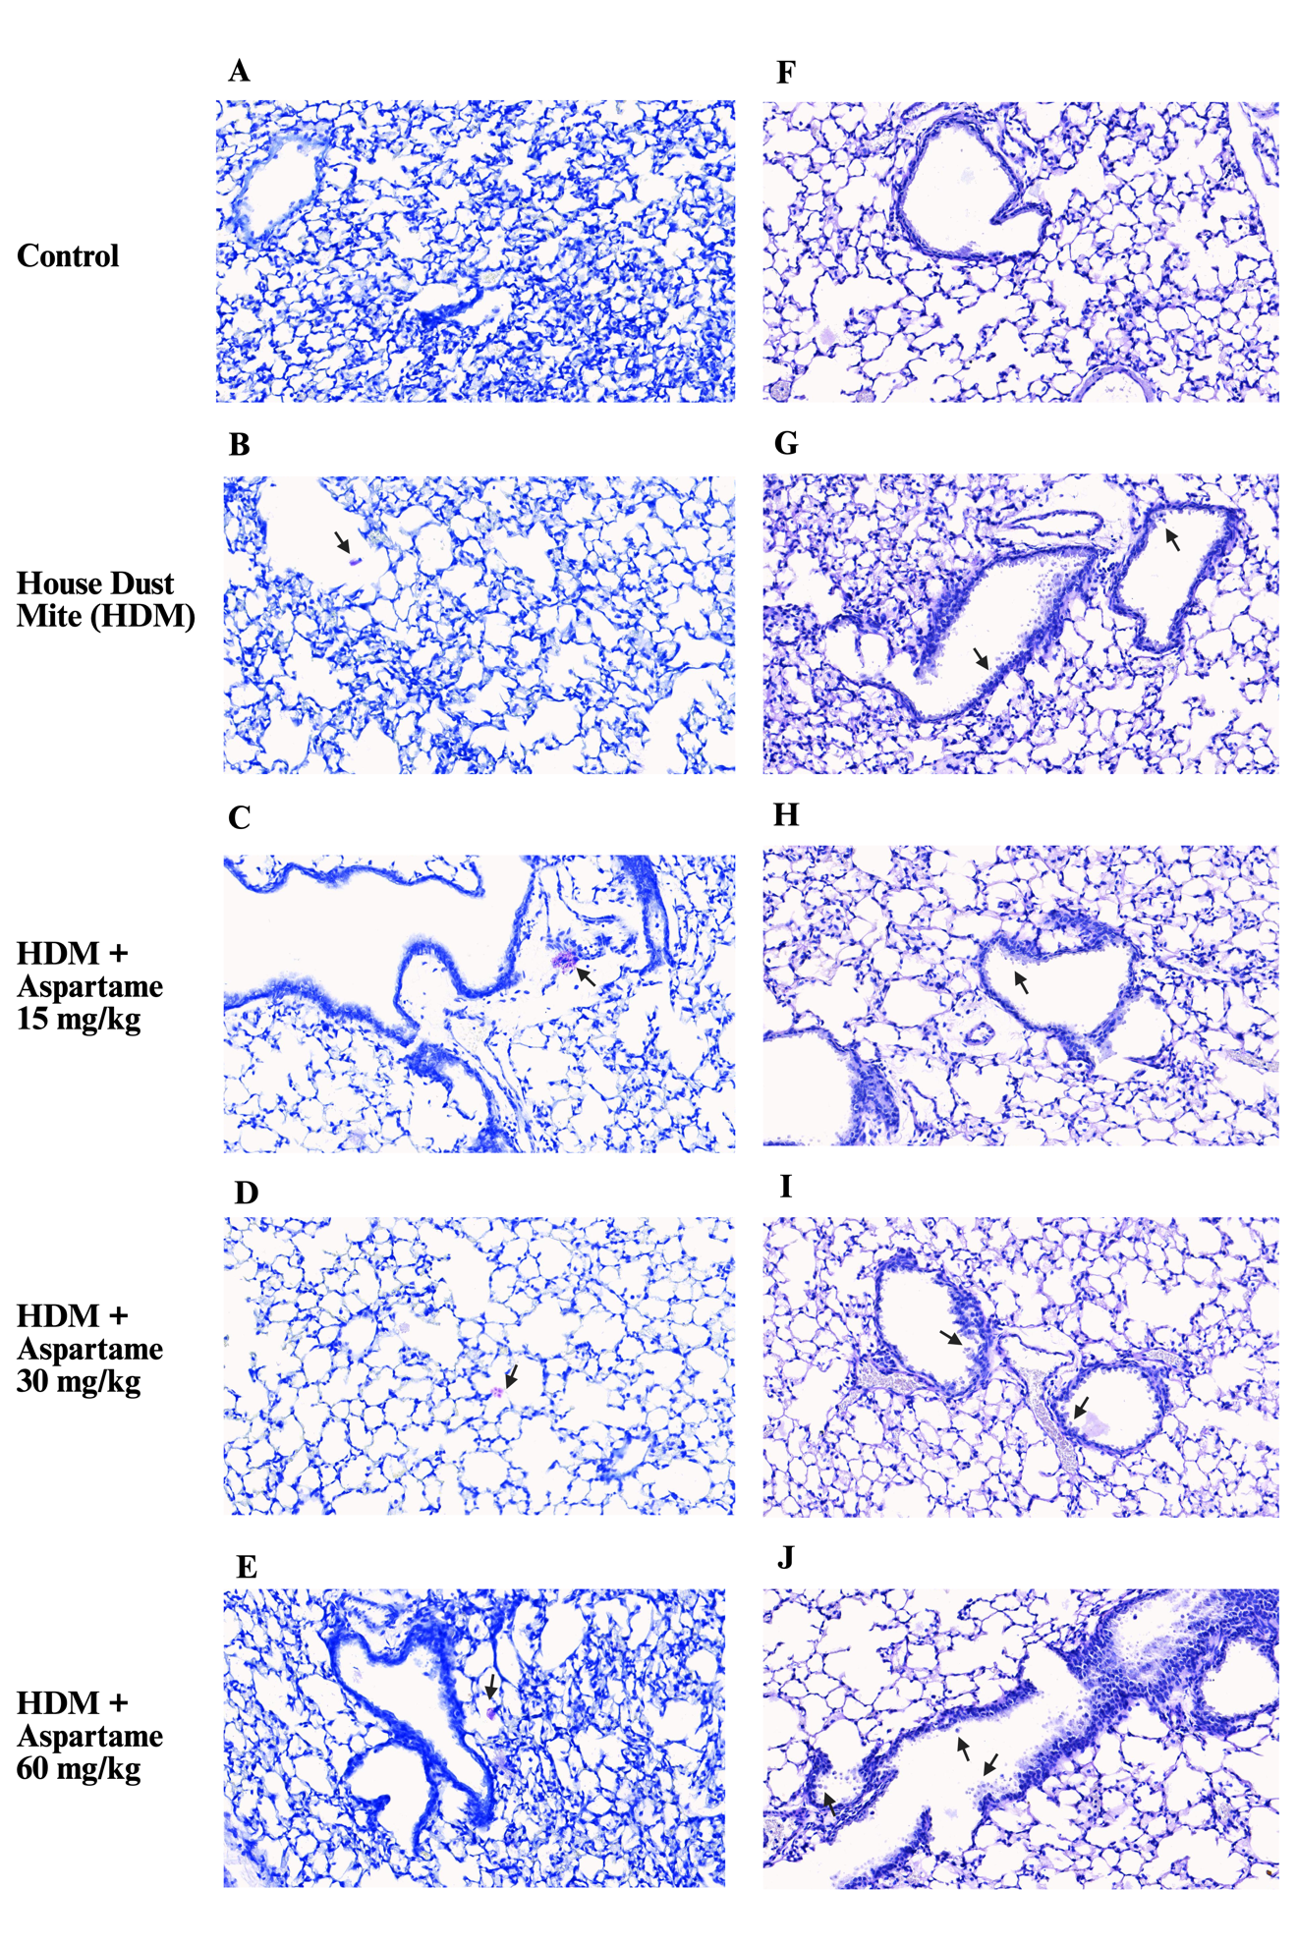
Figure S12. Toluidine blue staining illustrating mast cell infiltration in the lungs of HDM-induced asthmatic mice treated with aspartame (A-E). Periodic acid–Schiff staining does not exhibit mucus secretion clearly from goblet cells in the lungs of HDM-induced asthmatic mice treated with aspartame (F–J).

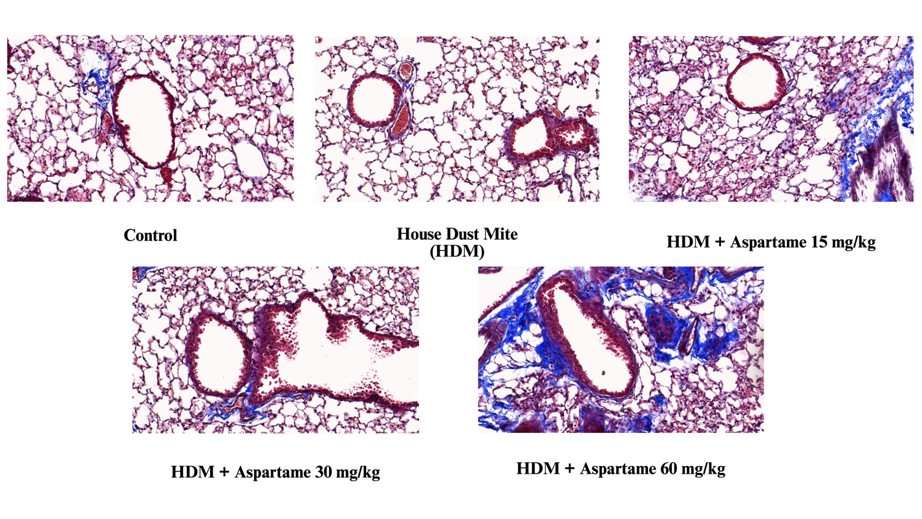
Figure S13. Collagen deposition in the lungs of HDM-induced asthmatic mice treated with aspartame. Lung tissues were stained with Masson’s trichrome (blue).

Table S1. Primers for quantitative Reverse Transcription Polymerase Chain Reaction
Gene Name | Forward Sequence (5’ 3’) | Reverse Sequence (5’ 3’)
TAS1R2 | CCTTCCAAAGCATCGCCTCCTA | CCAGGCTGGCAACTCTTAGAAC
TAS1R3 | TACAGTGTGGCTCAAGCCCTTC | CAAACTGTAGTGTCAAGTCTCGAG
Tgf-β | TGATACGCCTGAGTGGCTGTCT | CACAAGAGCAGTGAGCGCTGAA
Tnf-α | GGTGCCTATGTCTCAGCCTCTT | GCCATAGAACTGATGAGAGGGAG
IL-2 | GCGGCATGTTCTGGATTTGACTC | CCACCACAGTTGCTGACTCATC
IL-4 | ACG GAG ATG GAT GTG CCA AAC GTC | CGA GTC ATC CAT TTG CAT GAT GC
IL-5 | GATGAGGCTTCCTGTCCCTACT | TGACAGGTTTTGGAATAGCATTTCC
IL-10 | CGGGAAGACAATAACTGCACCC | CGGTTAGCAGTATGTTGTCCAGC
IFN-γ | CAGCAACAGCAAGGCGAAAAAGG | TTTCCGCTTCCTGAGGCTGGAT
IL-1β | GCT ACC TGT GTC TTT CCC GTC G | TTG TCG TTG CTT GGT TCT CCT TG
IL1RL1 | GGATTGAGGTTGCTCTGTTCTGG | TCGGGCAGAGTGTGGTGAACAA
IL-13 | AACGGCAGCATGGTATGGAGTG | TGGGTCCTGTAGATGGCATTGC
IL-17A | TCAACCGTTCCACGTCACCCTGGAC | TCAGCATTCAACTTGAGCTCTCATGC
IL-22 | ACCTTTCCTGACCAAACTCA | AGCTTCTTCTCGCTCAGACG
IL33 | CTACTGCATGAGACTCCGTTCTG | AGAATCCCGTGGATAGGCAGAG
Mcp-1 | AAAAACCTGGATCGGAACCAA | CGGGTCAACTTCACATTCAAAG
Cxcl1 | TCCAGAGCTTGAAGGTGTTGCC | AACCAAGGGAGCTTCAGGGTCA
Cxcl5 | GTTCCATCTCGCCATTCATGC | GCGGCTATGACTGAGGAAGG
Cxcl8 | AGACAGAAGTCATAGCCACTCTCAAG | CCTCCTTTCCAGGTCAGTTAGC
Mmp8 | TCCATTACTGATCTTCCTCCACACAC | TTGTTGATGTCTGCTTCTCCCTGTAA
Mmp9 | GCTGACTACGATAAGGACGGCA | TAGTGGTGCAGGCAGAGTAGGA
Mmp12 | CCC AGA GGT CAA GAT GGA TG | GGC TCC ATA GAG GGA CTG AA
Muc5ac | CCACT TTCTC CTTCT CCACA CC | GGTTG TCGAT GCAGC CTTGC TT
Muc5b | CTGAA GACCT GTCGG AACCC AA | GCCAC ACACT TCATC TGGTC CT
DAZL | TGACGTGGATGTGCAGAAGATAG | CAAAGGACGTGGCTGCACATGA
GNAT3 | CATGGCTACACTGGGGATTG | GATTTCAGCCAGCTGTGGAG
Olig3 | GGCGATATGGTCCAGAAGATGC | GTCCGTTGATCTTCAGCCGCAA
ORMDL3 | CATCTGGCTCTCCTACGTGCTG | GTCCCTTTCACGGTGTGCAGAA
RAD50 | TGGTAGACTGCCAGCGAGAACT | TCGGATGTGCTCTTGATGGCGA
Gapdh | CATCA CTGCC ACCCA GAAGA CTG | ATGCC AGTGA GCTTC CCGTT CAG
Abbreviations: Tgf-β, transforming growth factor beta; IL, interleukin; IFN- γ, interferon-gamma; IL1RL1, interleukin 1 receptor-like 1; Mcp-1, monocyte chemoattractant protein-1; Mmp, matrix metalloproteinase; Muc, mucin; GNAT3, guanine nucleotide-binding protein G(T) subunit alpha-3; Olig3, oligodendrocyte transcription factor 3; ORMDL3, orosomucoid like 3; Gapdh, glyceraldehyde 3-phosphate dehydrogenase.

