Supplementary Figures
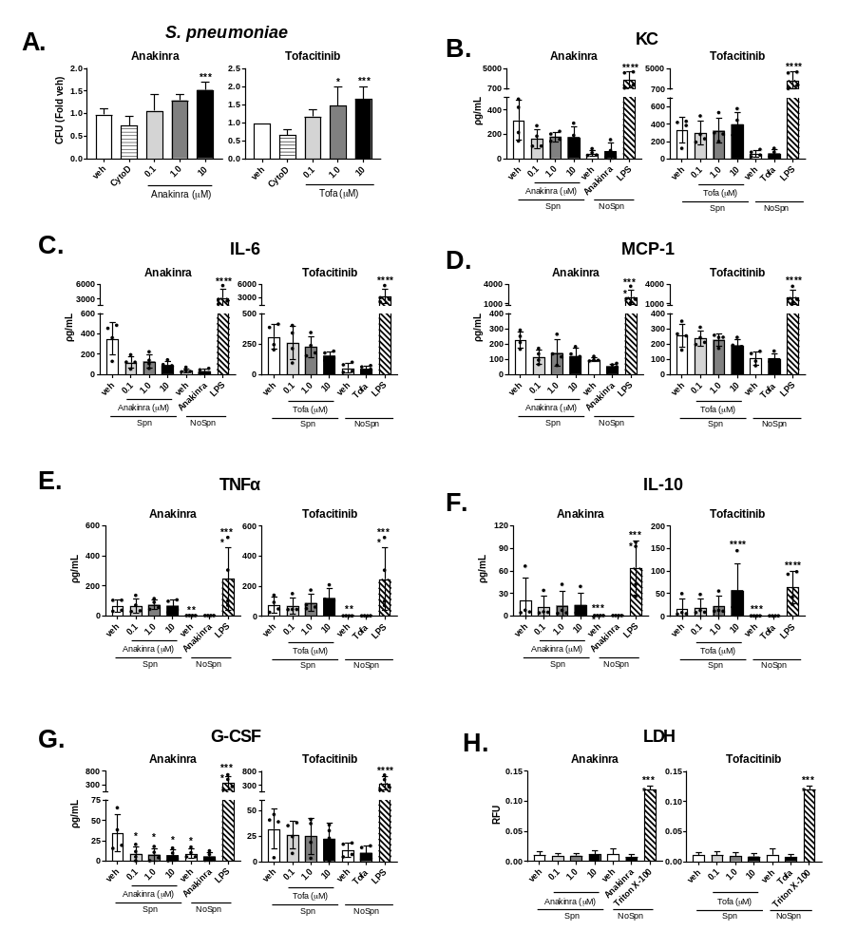
Supplementary figure 1. Immunomodulatory drugs increase pneumococcal adherence to and invasion of mouse PCLS whilst decreasing cytokine responses. (A) Association of S. pneumoniae (Spn) at 6 h with PCLS in the presence of Anakinra and Tofacitinib. (B-G) Cytokines released from PCLS in response to S. pneumoniae (6 h) in the presence of increasing doses of Anakinra or Tofacitinib. (H) LDH release from PCLS at 6 h post infection with S. pneumoniae in the presence of Anakinra or Tofacitinib. Data in figures are shown as mean ± SD of three or more independent experiments (three technical replicates per treatment with two lung slices per well) and analysed using two-way ANOVA Dunnett’s multiple tests in comparison with vehicle control in the presence of infection. *p < 0.05, **p < 0.01, ***p < 0.001, ****p < 0.0001

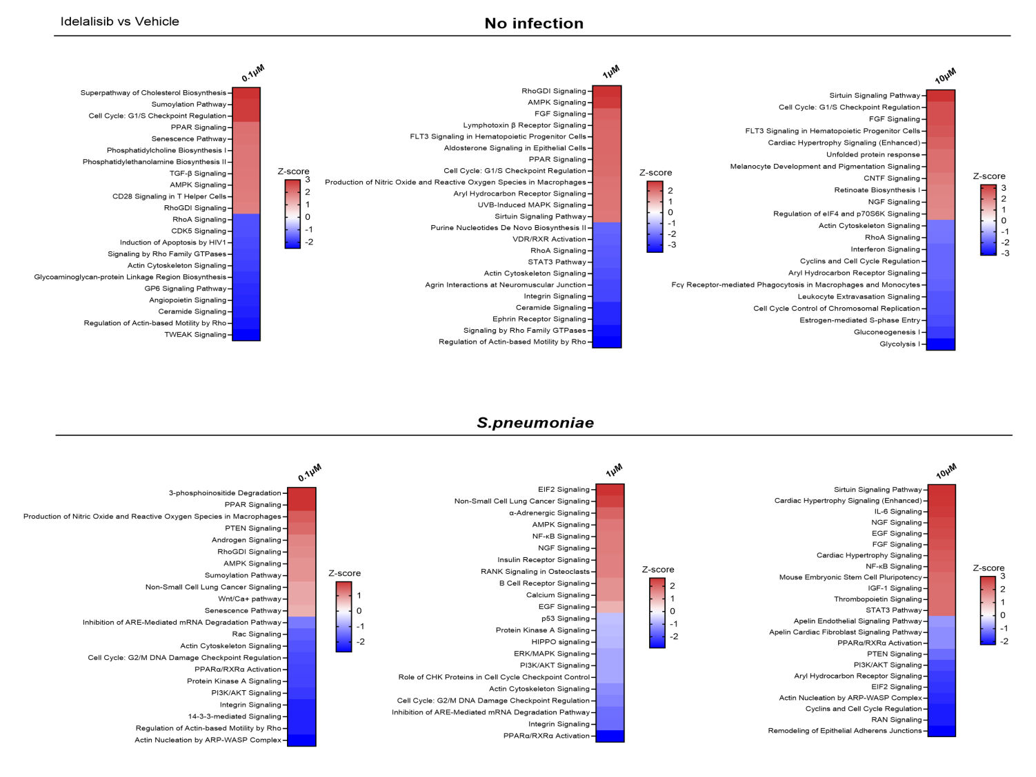
Supplementary figure 2. Top 10 up- and downregulated pathways in response to Idelalisib vs vehicle in absence and presence of S. pneumoniae infection in mouse PCLS.
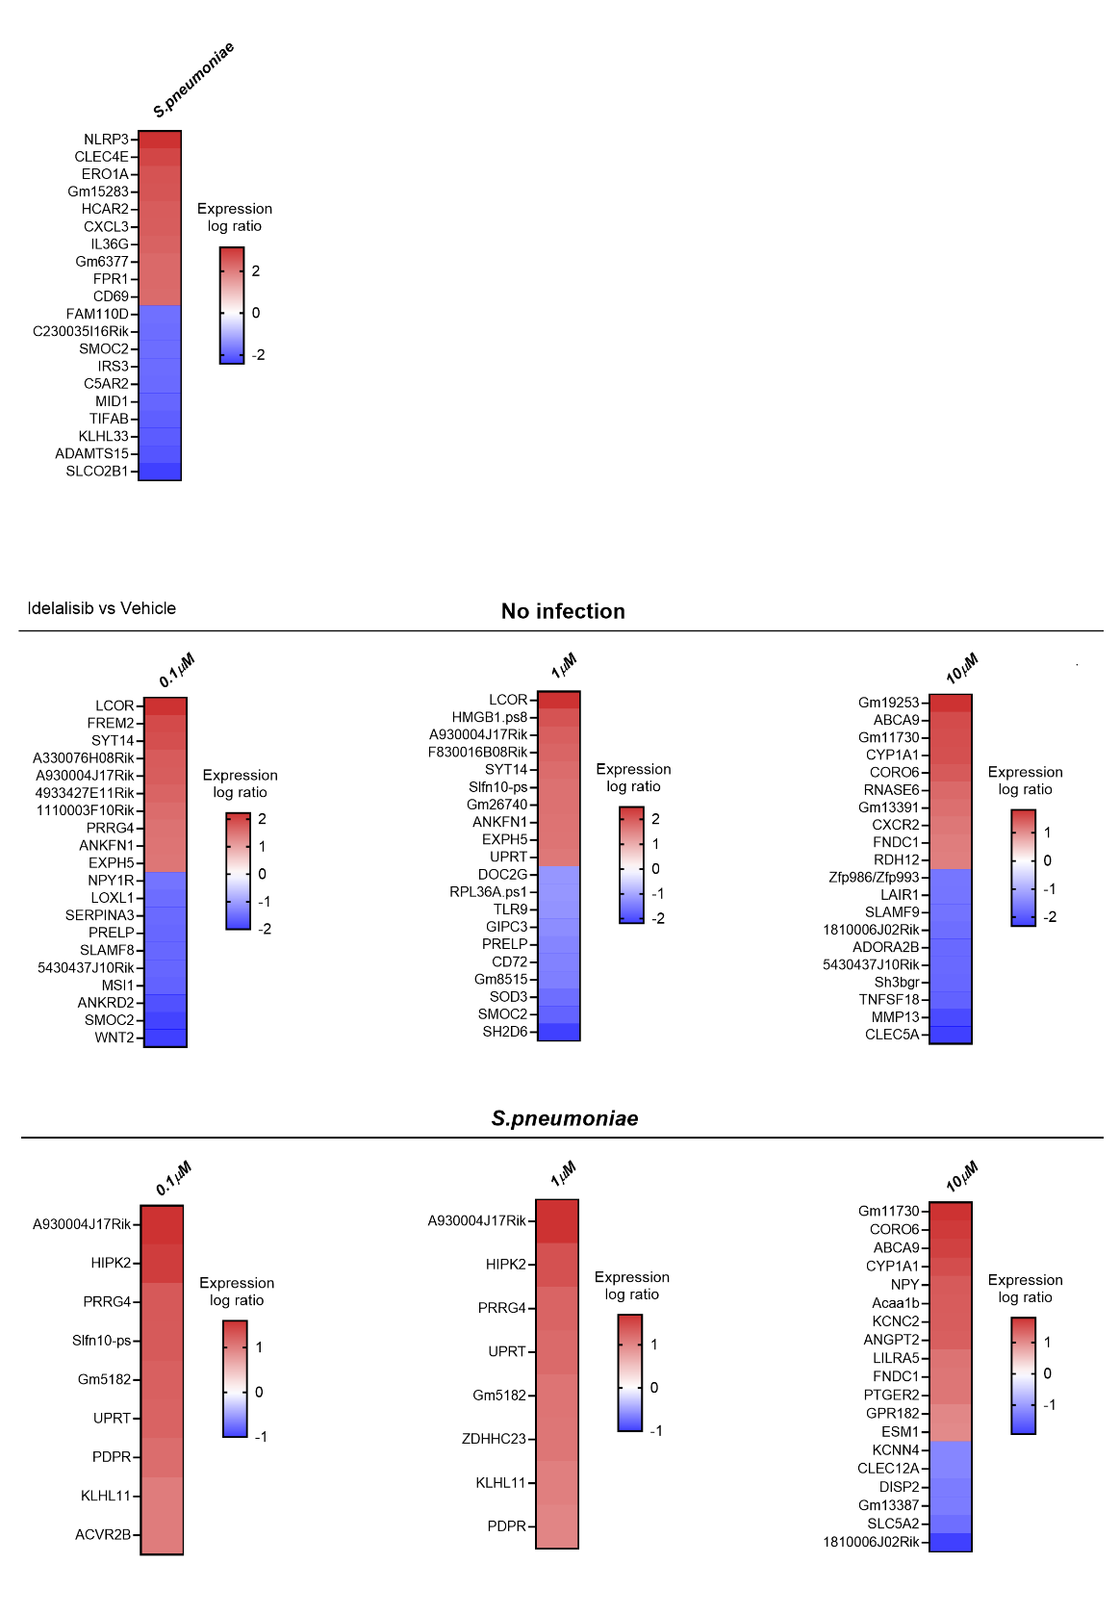
Supplementary figure 3. Top 10 up- and downregulated differentially expressed genes (DEGs) in response to Idelalisib vs vehicle in absence and presence of S. pneumoniae infection in mouse PCLS. DEGs identified over pairwise differential expression analyses at a significance threshold of log2 fold change > 1 or < -1, and false discovery rate < 0.01. No or limited number of significantly downregulated genes have been identified upon infection conditions.

